# **Remote Drawing Board**

|  |  |
| --- | --- |
| **Student’s Name** | **Student’s ID** |
| Lê Đức Thịnh | 17110076 |
| Nguyễn Hoàng Danh |  |

1. **Definition**

The drawing board provides users abilities to customize their drawings; we could find out some applications such as Windows Paint, Artweaver, GIMP… However, these programs only available for one user at the time.

We are in need of creating an application that can allow multiple users to draw on board simultaneously through a local network like cable connection, Wifi, or Bluetooth.

This application must meet some technical requirements:

* Programming language: **Java** (mainly), C#
* Platform: Windows

1. **Main Features**
2. Drawing abilities:

* Select
* Undo/Redo
* Change color
* Change the thickness of the pen
* Change type of pen
* Erase
* Add text
* Zoom in/out
* Export drawings into JPEG format

1. Local network connectivity:

* Invite other users to contribute to the drawing

1. **Conceptual Design**

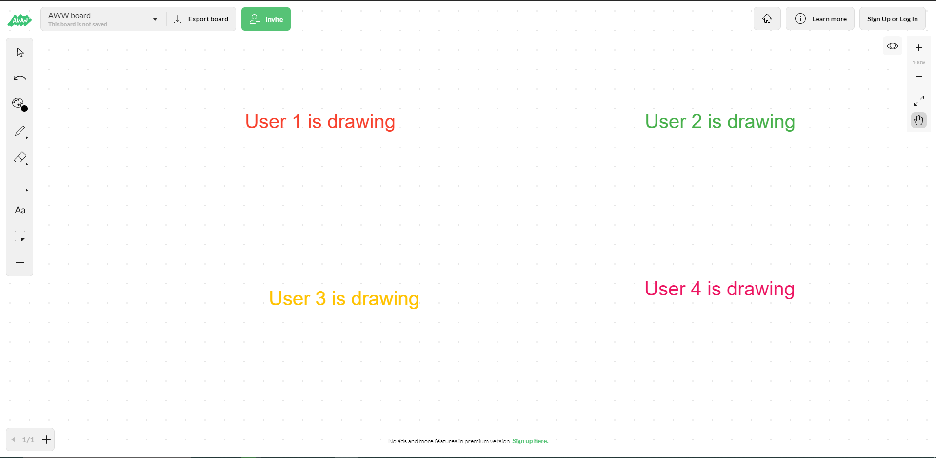

Figure Multi-users are drawing on one board

The picture beneath is a sample design we found out on the Internet; we would design our layout based on this view, but some components must be changed to make it personalized can convenient for users.