FiKi – Digital Market

Use-Case Specification: Manage Inventory

Version 1.0

Revision History

|  |  |  |  |
| --- | --- | --- | --- |
| **Date** | **Version** | **Description** | **Author** |
| 30/Nov/24 | 0.0 | Draft version | Tran Minh Duc |
| 03/Nov/24 | 1.0 | Final version | Tran Minh Duc |
|  |  |  |  |
|  |  |  |  |

Table of Contents

**1. Use-Case Name 4**

1.1 Brief Description 4

**2. Flow of Events 4**

2.1 Basic Flow 4

2.2 Alternative Flows 5

**3. Special Requirements** **5**

**4. Preconditions 5**

**5. Postconditions 5**

**6. Extension Points 5**

**7. Prototype 5**

Use-Case Specification: Manage Inventory

# Use-Case Name

## Brief Description

This use case allows Fiki sellers to manage their product inventory through the mobile application.

# Flow of Events

## Basic Flow

**Homepage:** After the seller successfully logs in, the system displays the management homepage. At the top is a “**search box”**, where the manager can input a products name to search for reports or statistics or products information, and next to that is a “**User**” icon that links to the user’s profile. Below the “**navigation bar”** are “**two statistics cards”** showing key metrics:

- Total products have been ordered (displayed as "968 orders”)

- Sales performance indicators (displayed as “12% interest”)

Under these cards, there is a “**filters** **bar**” that contains options to filter the list of products.

This list of products would be rendered right underneath that filter bar. At the bottom is a “**blue navigation bar**” containing the “**buttons”** that navigate to the homepage, stock checking interface, inventory updating interface, alert management interface and updating reports interface.

**Stock Checking Interface:** As the manager enters this page, there is a “**Camera”** that shows up for the manager to scan the products’ barcodes/QR codes. To perform scanning, there is a blue “**Button**” below the “**Camera**”, the manager can press that button and put the codes under the camera to look for the products. There is also a “**Manual Input** **Box**” at the top of the screen for the manager to manually search for a product. There is also a **“History Box”** that shows 15 recent scans below the scanning button. Once the code has been scanned, the product information, if exists in the inventory, would be displayed onto the screen, with the basic details such as its **name**, **code**, **stock** **level**, **price** and **expiration** **dates**. There is also a “**map”** that displays the product’s warehouse location. The manager can swipe right to access the “**quick actions menu”**, that would displays four **“buttons”** for adding, removing, transfering and returns processing for the current product. Once these buttons are pressed, the user would be navigated to the “**Updating Inventory Interface**”.

**Updating Inventory Interface:** When sellers access the “**Inventory Updates**” page, they are presented with a dashboard interface that shows four options arranged in a 4-tile grid layout. These four action are: “**ADD STOCK**”, “**REMOVE STOCK**”, “**TRANSFER STOCK**” and “**PROCESS RETURNS**”. Pressing on these buttons would display a camera for the manager to scan the products that need to be updated. There is also a “**Batch Update**”option to process multiple items simultaneously. The batch update interface displays a list format where staff can input quantities against scanned items, with a running total shown at the bottom. Each entry in the list has a “**Verify**” checkbox that be ticked once the quantity is confirmed. Once the inputting process has finished, the manager can choose either the “**Save Updates**”or the “**Save Draft**” option to save his process. Those draft versions can be accessed throught the “**Drafts**”button located at the top of the screen, next to the “**User Profile**” button.

**Alerts Management Interface:** When the manager access this page, there would be a “**Scrollable List**” of “**Alerts Boxes**” being displayed to the screen. These alerts would be listed, sorted by priority. “**Red”** indicates critical alerts, “**Yellow”** for warnings, and “**Blue”** for informational notices. Each “**Alert Card”** displays the product name, alert type and the subject of the alert. The manager can select to display different types of alerts using a “**Filter bar”** at the top of the screen, which includes options for "**Priority**", "**Category**", "**Location**", and "**Date Range**". There is also a direct "**Reorder**" button, next to that filter bar, that pre-fills a reorder form with suggested quantities. Pressing on an “**Alert box**” would pop up an “**Alert**” message that shows details about the notification, then the manager can choose either to “**Snooze**” or to “**Delegate**” the notification to an employee. If seller decides to “**Delegate**”, a “**Form**” would be displayed for inputting the employee code/name, indicating who would be responsible for handling the alert. Then the manager can choose “**Done**” or “**Cancel**” once finishing the process.

**Reporting Updates:** When accessing the "**Reports**" function from the main menu, the manager will be presented with a dashboard showing the list of reported updates. At the top of the screen, there is a “**Filter Bar**” where the manager can access different report types like "**Daily Movement**", "**Discrepancy Reports**" and "**Error Logs**". The interface includes options to "**Save Report Configuration**" for frequently used reports and "**Schedule Reports**" for automated generation. These features can be accessed through the **“Settings”** icon placed right next to the filter bar. Staff can export reports in various formats by tapping the "**Export**" button, which opens a modal with format options including PDF, Excel, and CSV. The report details interface also features a "**Quick Insights**" section that automatically highlights significant patterns or issues in the data through graphical representations, and a “**Delete**” button to delete the report that is being viewed.

## Alternative Flows

NA.

# Special Requirements

Internet connection required for real-time inventory updates.

Device storage access needed for product images.

Camera permission required for barcode scanning.

# Preconditions

The users have to be logged in successfully and have authorizes to access these interfaces.

# Postconditions

All inventory changes are synchronized with Tiki's main database.

Stock levels are updated in real-time across all sales channels.

Change history is logged and traceable.

# Extension Points

NA.

# Prototype

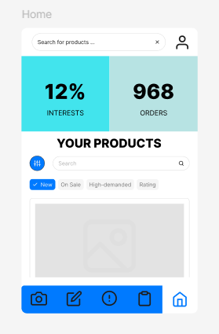

Figure 1. HomePage Interface.

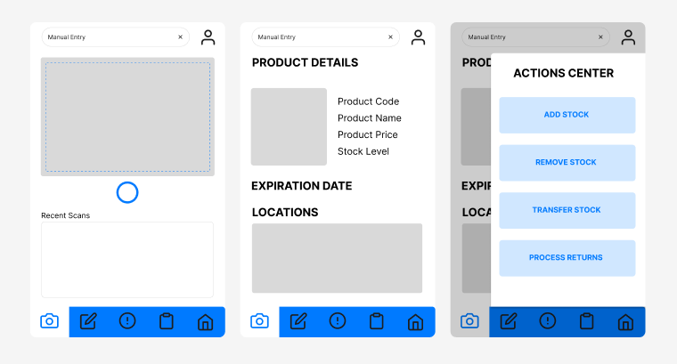

Figure 2. Stock Checking Interface.

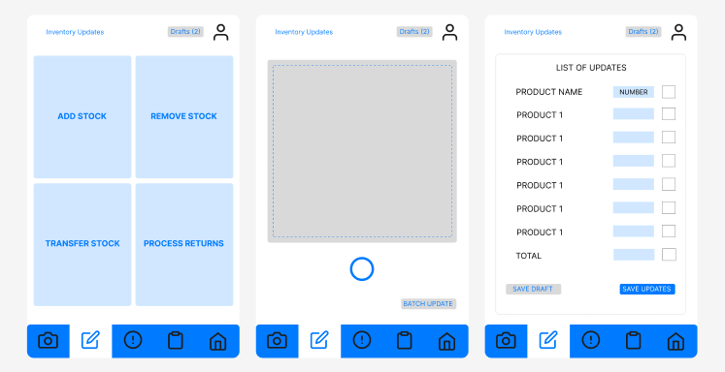

Figure 3. Inventory Updating Interface.

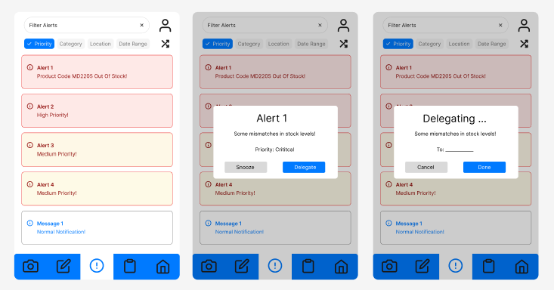

Figure 4. Alerts Management Interface.

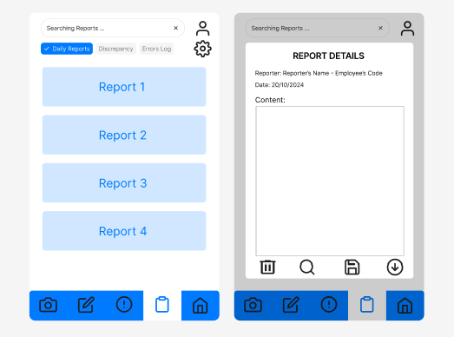

Figure 5. Updates Reporting Interface.