PRACTICE
Course: Test Case Design Methods – BlackBox (Decision Table)
Time: 115 minutes
- o0o –

Requirement
Counter Sales is a system which is installed at XYZ company’s branches to sell products to retail & non-retail customers. The following are requirements of the system.

Graphical User Interface
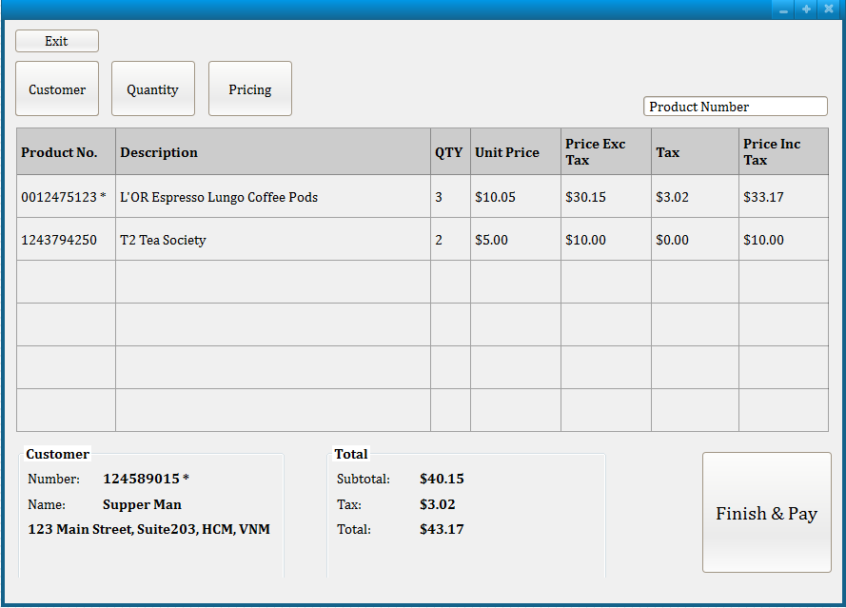

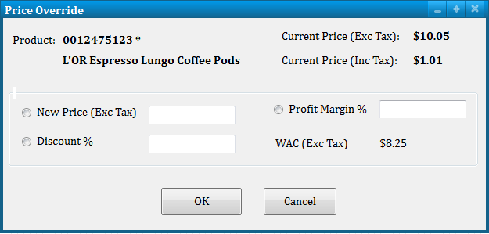

  - Controls

Control | Description
Product Number | Key-enter a product number.
Customer | Open Customer Search screen for the user to associate an existing customer.
Quantity | Open Product Quantity Change screen for the user to change ordered quantity.
Pricing | Open Product Price Change screen for the user to change product price.
Finish & Pay | Open Finalize Transaction screen for the user to make the payment.
Profit Margin% | When it loses focus, New Price will be recalculated.
Discount% | When it loses focus, New Price will be recalculated.
New Price | The user entered price or calculated price from Profit Margin & Discount.
OK | The product will be updated with new price.
Cancel | Return to parent screen without changes.
  - Business Requirements
Products can be sold to retail customer (customer is optional) or non-retail customers (customer is mandatory) within domestic or overseas.
At least one product is required to complete the selling.

Product Number field is masked to accept 10 digits only. Product number may have leading zeros.
If the product number is not found, message ‘Item not found’ or similar message should be displayed to the user.
If a product is taxable, its Product Number will be marked with an asterisk.
Similarly if a customer is taxable, Customer Number will be marked with an asterisk.
10% of tax will be charged to the customer if the selling occurs within domestic & both customer & product are taxable.
Price Exc Tax = Extension price excluding tax = QTY * Unit Price Price Inc Tax = Extension price including tax = Price Exc Tax + Tax Total
Subtotal: sum of Price Exc Tax of all product lines Tax: sum of Tax of all product lines
Total = Subtotal + Tax
WAC = weight average cost = trung bình trọng số chi phí vốn.
Profit Margin = lợi nhuận biên sai = lợi nhuận thu được khi bán 1 đơn vị sản phẩm Profit Margin % = ( - 1) * 100
New Price = (+ 1) * WAC
New Price = Current Price – (Current Price * ) Acceptable range of currency is $0 - 999,999.99
It’s requested that any selling must make at least 30% profit.

  - Information Architecture

Product
Column Name | Data Type |  | COMMENTS
ProductId | Bigint | Not null | Primary key (identity). This is system generated id for a product.

Active | Boolean | Not null | Indicate if a product is active or not. Valid values: Y/N  Default value: Y
Description | String | Not null | Product name or product description
Taxable | Boolean | Not null | Indicate if a product is taxable or not. Valid values: Y/N  Default value: N

Location
Column Name | Data Type |  | COMMENTS
LocationId | Bigint | Not null | Primary key (identity). This is system generated id for a branch.
Active | Boolean | Not null | Indicate if a branch is active or not. Valid values: Y/N  Default value: Y
Name | String | Not null | Branch name
Address Line 1 | String | Not Null | Number & street
Address Line 2 | String | Null | Apartment or suite or floor
City | String | Not Null
State | String | Null/ Not Null | Mandatory or optional depends on country
Country | String | Not Null | Country code, in 3 letters  Default value: VNM (Vietnam)

ProductLocation
Column Name | Data Type |  | COMMENTS
ProductId | Bigint | Not null | Foreign key
LocationID | Bigint | Not Null | Foreign key  The combination of Product ID & Location ID must be unique.
Active | Boolean | Not null | Indicate if a product is currently sold at the location.  Valid values: Y/N Default value: Y
Unit Price | Currency | Not Null | Default value: 0
WAC | Currency | Not Null | Default value: 0

Customer
Column Name | Data Type |  | COMMENTS
CustomerId | Bigint | Not null | Primary key (identity). This is system generated id for a non-retail customer.
Active | Boolean | Not null | Indicate if a customer is active or not. Valid values: Y/N  Default value: Y
Name | String | Not null | Customer name in this format: FirstName<a space>LastName
Address Line 1 | String | Null | Number & street
Address Line 2 | String | Null | Apartment or suite or floor

City | String | Null
State | String | Null
Country | String | Null | Country code, in 3 letters  (The validation of country code is handled from graphical user interface.)  See the following for valid country code list http://www.worldatlas.com/aatlas/ctycodes.htm

Exercises
Create test cases to test
Products can be sold to retail customer (customer is optional) or non-retail customers (customer is mandatory) within domestic or overseas. 10% of tax will be charged to the customer if the selling occurs within domestic & both customer & product are taxable.

Bài làm
- Tax Decision Table
Test: “10% of tax will be charged to the customer if the selling occurs within domestic & both customer & product are taxable.”
Each rule is one test case for this exercise

 | Rule 1 | Rule 2 | Rule 3 | Rule 4 | Rule 5 | Rule 6 | Rule 7 | Rule 8
Conditions
Selling Location | Domestic | Domestic | Domestic | Overseas | Overseas | Domestic | Overseas | Overseas
Customer Tax Status | Taxable | Taxable | Non-taxa ble | Taxable | Non-taxa ble | Non-taxab le | Taxable | Non-taxab le
Product Tax Status | Taxable | Non-taxabl e | Non-taxa ble | Taxable | Taxable | Taxable | Non-taxa ble | Non-taxab le
Actions
Apply Tax | X

No Apply Tax |  | X | X | X | X | X | X | X

- Finish & Pay Decision Table
Test: “Products can be sold to retail customer (customer is optional) or non-retail customers (customer is mandatory) within domestic or overseas”
Each rule is one test case for this exercise

 | Rule 1 | Rule 2 | Rule 3 | Rule 4
Conditions
Customer Type | Retail | Non-Retail | Retail | Non-Retail
Customer Tax Status | Taxable | Taxable | Non-Taxable | Non-Taxable
Actions
Allow Finish & Pay | X | X | X

