Group WIBU

Members:

* Nguyễn Đức Tông (Leader)
* Quản Đức Lộc
* Trần Minh Thắng
* Đặng Lê Thành Nam

Table of Contents

**Project/Assignment Report** 2

**I. Problem Definition** 2

**II. Customer Requirement Specification** 3

**III. Project Plan** 3

**IV. Object Oriented Diagram** 5

**V. Use-case diagram** 5

**VI. Algorithms** 6

**VII. Task Sheet** 6

**VIII. Project Review and Monitoring Report** 8

**IX. Unit Testing Checklist** 9

**X. Final Checklist** 10

## **Project/Assignment Report**

## **ATM**

### **I. Problem Definition**

Before the implementation of ATMs, processing customers’ transaction is manually done and requires lots of paperwork. It also makes the maintenance job difficult and increases the possibility of the discrepancies in data. In addition, data retrieving also becomes hectic with this manual system. In order to avoid all of these problems stated causing an unnecessary waste of time, a company has approached us to make an Automated System implementing ATM, that manages all of these mentioned paperwork above that was once manually handled.

ATM is the abbreviation for Automated Teller Machine, and it is also known as a Cash Machine and by several other names. The ATM is a computerized device that provides the clients the financial institution without the need for the cashier and is initially designed for the existing user (which means creating the account would be done by the administrators only). Each client is identified by first inserting a unique card number (card ID / user name) and some security information linked to that card ID. A user can only access the ATM system/screen only after entering the correct user name, and corresponding password/PIN (Personal Identification Number - a 4-digit number) associated with that username on the very first screen which is installed on the ATM room.

In a word, our target/goal is to create a fully functional ATM system, which resembles a real ATM system in real life, to replace the need of a cashier. The system we work on should have the properties of an actual ATM system as described above.

### **II. Customer Requirement Specification**

* Each time the user tries to enter the ATM, he/she needs to use the same password which is entered at the very first transaction (unless the user changes the password with the option of the ATM system). Also, the user is required to and must change the password in the very first transaction of him/her.
* Once the username and password are both verified, the ATM screen would appear. Each time a new user tries to enter the ATM room, they are supposed to first provide their login credentials before being able to access the system.
* The initial screen of the ATM screen should appear “Enter your card number” button along with the keypad.
* Once the card number is entered and button is clicked the ATM system should check its availability in the database. If it is not available, then an error message should be generated stating the user is invalid, else password field would appear, user needs to enter the password. Once the password is verified, the screen appears with following menu (the main menu):

Deposit

Withdrawal

Balance Enquiry

Change Password

### **III. Project Plan**

* Create 1 class dedicated for user authentication
* Create 1 class for data connection to the database
* Create 1 class to store user info temporarily
* Create 1 class for displaying the menu, with the admin menu and the user menu classes (both of them extended from the original menu class)
* Create 1 main class ATM for the main method
* In the admin menu, there are 10 options in total (including exit):
* Create new user account (for both admin and user)
* Change deposit-related limitations (deposit amount and number of deposits)
* Change withdrawal-related limitations (withdrawal amount and number of withdrawals)
* Create deposit report
* Create withdraw report
* Create account report
* Change user info (for both admin and user)
* Change current logged in admin account password (PIN)
* In the user menu, there are 5 options in total (including exit):
* Deposit
* Withdraw
* Balance Enquiry
* Change password
* For creating a new account, the random methods should be optimized to not giving a user ID that already exists in the database, but not the PIN.
* For changing the deposit-related limitations as well as withdrawal-related limitations options in the admin menu, there are sub-menus of options for the admin to choose, ranging from changing deposit/withdrawal amount, number of deposits/withdrawals and revert the values back to default (25000$ limit for each transaction and 5 times a day per user).
* For changing user info option in the admin menu, if an admin wants to change other admin info, they must input a password called “master password” first to avoid the situations where an admin is able to change all of the other admins’ info, thus destroy the whole system.
* There should be input checks to assure user input the right values

### **IV. Object Oriented Diagram**

### 

### **V. Use-case diagram**

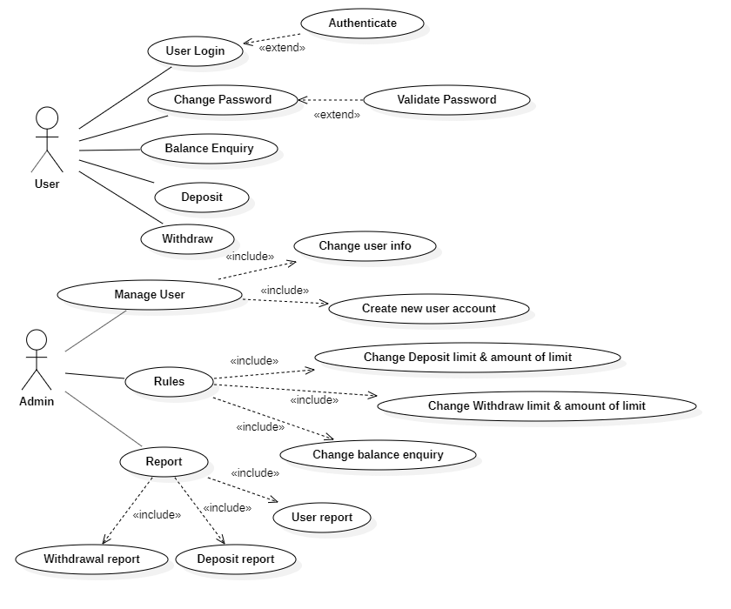

### **VI. Algorithms**

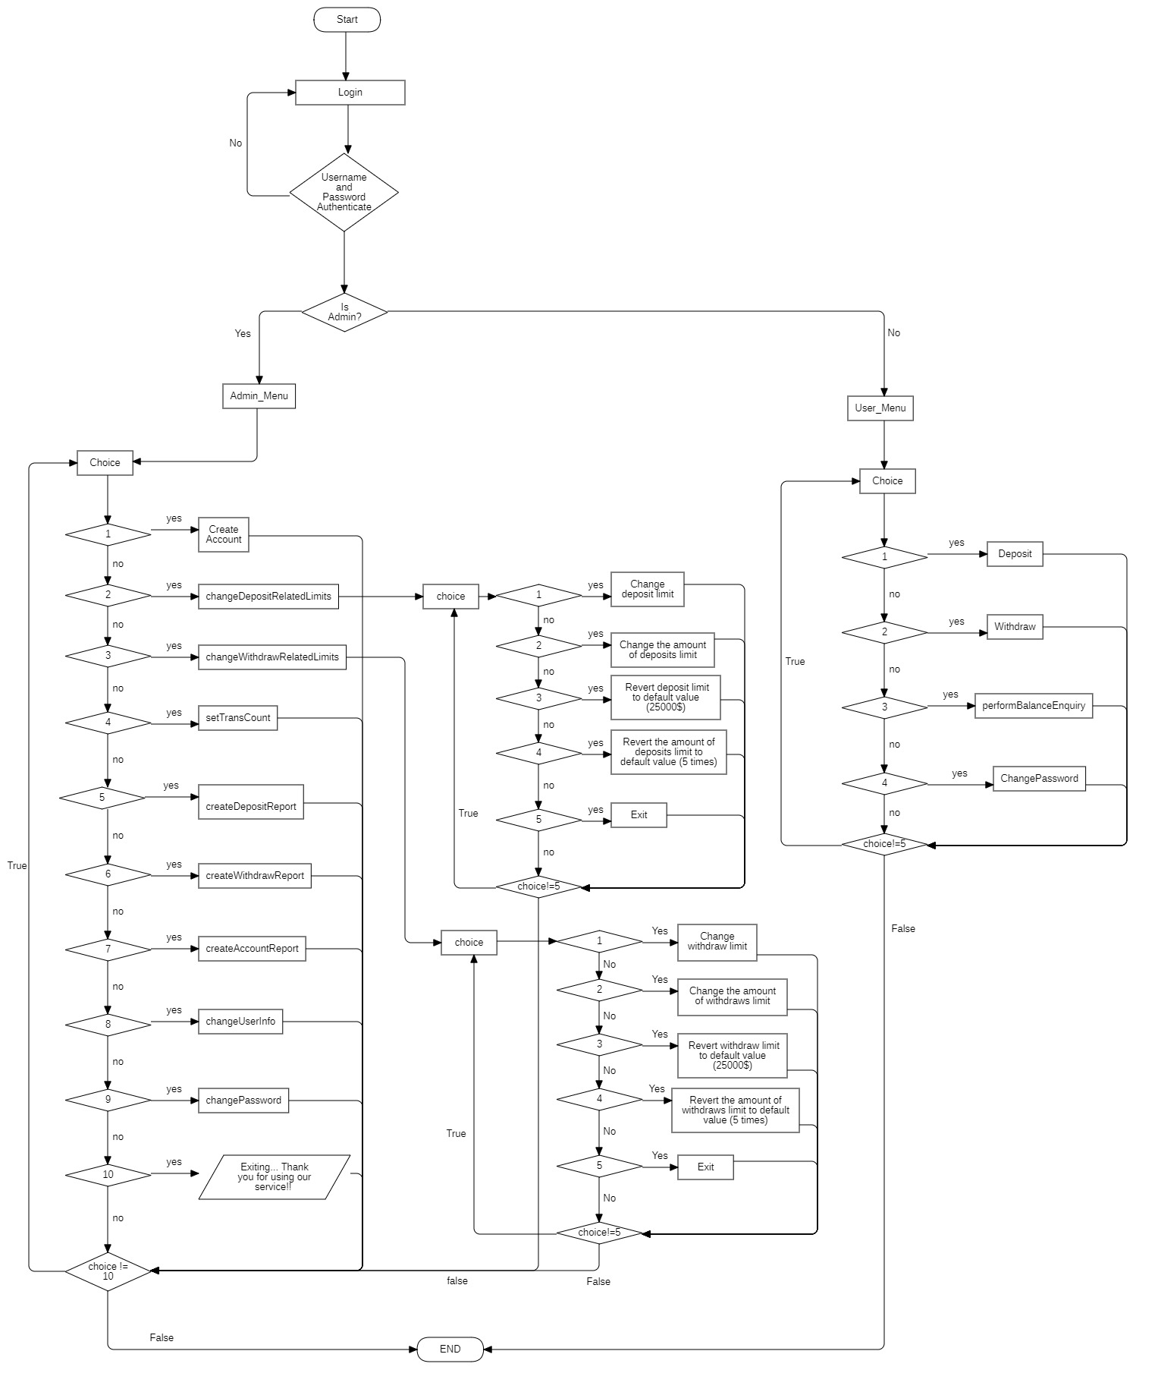

### **VII. Task Sheet**

|  |  |  |  |  |
| --- | --- | --- | --- | --- |
| **Start**  **from** | **Task name** | **Who is in charge** | **Estimated finish time** | **Actual finish time** |
| 21/11 | Choose project topic | All members | 21/11 | 21/11 |
| 23/11 | Gather information | All members | 23/11 | 23/11 |
| 25/11 | Member assignments | Tông | 25/11 | 26/11 |
| 25/11 | Create document outline and write part I, II, III | Lộc | 25/11 | 26/11 |
| 26/11 | Draw Object Oriented diagram and use-case diagram (part IV, V of the document) | Thắng | 29/11 | 30/11 |
| 29/11 | Create database and connect database to project | Tông | 30/11 | 1/12 |
| 30/11 | Create first source and upload to github | Tông | 30/11 | 01/12 |
| 1/12 | Configure database connections for all members | All members | 2/12 | 3/12 |
| 2/12 | Create login class and write login-related code | Tông | 2/12 | 3/12 |
| 2/12 | Create admin menu method outline | Lộc | 2/12 | 3/12 |
| 2/12 | Create new users method | Lộc | 2/12 | 3/12 |
| 2/12 | Create user menu outline | Nam | 3/12 | 3/12 |
| 3/12 | Change current password method | Nam | 3/12 | 4/12 |
| 3/12 | Change deposit and withdrawal related limits methods | Lộc | 3/12 | 4/12 |
| 3/12 | Create deposit report method | Thắng | 4/12 | 4/12 |
| 3/12 | Create withdraw report method | Thắng | 4/12 | 4/12 |
| 3/12 | Change user info details method | Tông | 4/12 | 4/12 |
| 4/12 | Change user info method menu outline | Lộc | 5/12 | 6/12 |
| 4/12 | Write deposit method | Nam | 4/12 | 4/12 |
| 4/12 | Write withdraw method | Nam | 4/12 | 4/12 |
| 4/12 | Write balance enquiry method | Nam | 4/12 | 5/12 |
| 5/12 | Create account report method | Thắng | 5/12 | 6/12 |
| 25/11 | Write and update Task Sheet (part VII of document) | Thắng | 9/12 | 9/12 |
| 9/12 | Write project review and monitoring report (part VIII of document) | Lộc | 9/12 | 9/12 |
| 9/12 | Draw algorithm flowchart (part VI of document) | Thắng | 9/12 | 9/12 |
| 9/12 | Testing and write the Unit Testing checklist (part IX of document) | Tông | 9/12 | 9/12 |
| 9/12 | Write final checklist (part X of document) | Tông | 9/12 | 9/12 |

### **VIII. Project Review and Monitoring Report**

* Overview:
* The project has been essentially completed with the important ideas all done according to the original project plan.
* There are some difficulties during the working process such as deadlines from other courses, GitHub merging errors but our group has managed to overcome all of them and complete the project.
* Although all of the important parts of the projects have been completed, our group has not managed to complete the project on time, and has just done it on yesterday.
* What we have completed:
* Connection to the database
* All of the options required for admin menu and user menu
* Add input checks to avoid user input is mismatch or is out of range
* Writing the document
* What we have not completed:
* Allow the administrators to access user menu
* Optimize the code
* Unable to complete the project on time (2 days before the date of presentation)
* Not yet added constraints for the database and make it more professionally organized
* There are some tasks we had not been able to get them done on time

### **IX. Unit Testing Checklist**

|  |  |  |  |
| --- | --- | --- | --- |
| No. | Testing problem | Yes | No |
| 1 | Check wrong card ID, requiring input again. | ✔ |  |
| 2 | Check right card ID but wrong PIN, requiring input card ID and PIN again. | ✔ |  |
| 3 | Show menu for each user role (for admin and user separately) | ✔ |  |
| 4 | Allow administrators to access user menu |  | ✔ |
| 5 | Check if cannot connect to database | ✔ |  |
| 6 | Check requiring input number when input card ID and PIN | ✔ |  |
| 7 | Check input PIN 4 digits, and only number | ✔ |  |
| 8 | Check card ID from 10000000 to 10099999 | ✔ |  |
| 9 | Generate unique card ID | ✔ |  |
| 10 | Create new user, change user info check PIN of 4 digits, number contact of 10 digits , and only numbers | ✔ |  |
| 11 | Check input mismatches | ✔ |  |
| 12 | Check withdrawals with input amount is larger than current balance | ✔ |  |
| 13 | Constraints for the database |  | ✔ |

### **X. Final Checklist**

|  |  |  |  |
| --- | --- | --- | --- |
| Start  from | Task name | Who is in charge | Complete |
| 21/11 | Choose project topic | All members | ✔ |
| 23/11 | Gather information | All members | ✔ |
| 25/11 | Member assignments | Tông | ✔ |
| 25/11 | Create document outline and write part I, II, III | Lộc | ✔ |
| 26/11 | Draw Object Oriented diagram and use-case diagram (part IV, V of the document) | Thắng | ✔ |
| 29/11 | Create database and connect database to project | Tông | ✔ |
| 30/11 | Create first source and upload to github | Tông | ✔ |
| 1/12 | Configure database connections for all members | All members | ✔ |
| 2/12 | Create login class and write login-related code | Tông | ✔ |
| 2/12 | Create admin menu method outline | Lộc | ✔ |
| 2/12 | Create new users method | Lộc | ✔ |
| 2/12 | Create user menu outline | Nam | ✔ |
| 3/12 | Change current password method | Nam | ✔ |
| 3/12 | Change deposit and withdrawal related limits methods | Lộc | ✔ |
| 3/12 | Create deposit report method | Thắng | ✔ |
| 3/12 | Create withdraw report method | Thắng | ✔ |
| 3/12 | Change user info details method | Tông | ✔ |
| 4/12 | Change user info method menu outline | Lộc | ✔ |
| 4/12 | Write deposit method | Nam | ✔ |
| 4/12 | Write withdraw method | Nam | ✔ |
| 4/12 | Write balance enquiry method | Nam | ✔ |
| 5/12 | Create account report method | Thắng | ✔ |
| 25/11 | Write and update Task Sheet (part VII of document) | Thắng | ✔ |
| 9/12 | Write project review and monitoring report (part VIII of document) | Lộc | ✔ |
| 9/12 | Draw algorithm flowchart (part VI of document) | Thắng | ✔ |
| 9/12 | Testing and write the Unit Testing checklist (part IX of document) | Tông | ✔ |
| 29/11 | Constraints for the database | Tông |  |