

Q1:

Software Requirements Specification

For: Automated University Library Circulation System (1) (0.2 points)
Version 1.0 approved
Prepared by
Tran Duc Trong – HE191761(2) (0.3 points)

Q2:

Context Diagram
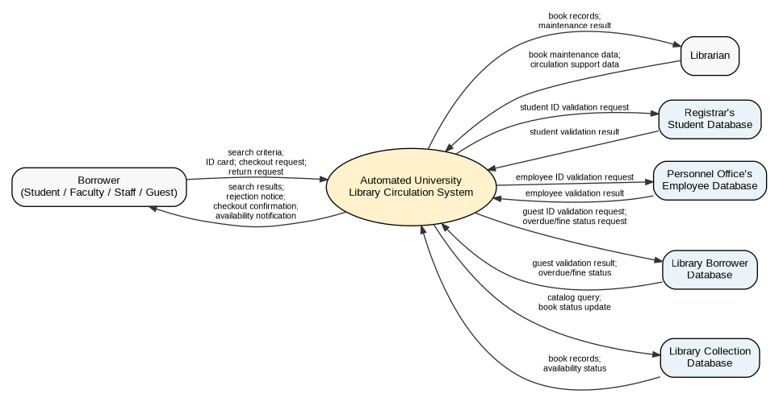
Figure 1. Context Diagram for Automated University Library Circulation System

Q3:
Use Case Diagram and Descriptions
Use Case Diagram
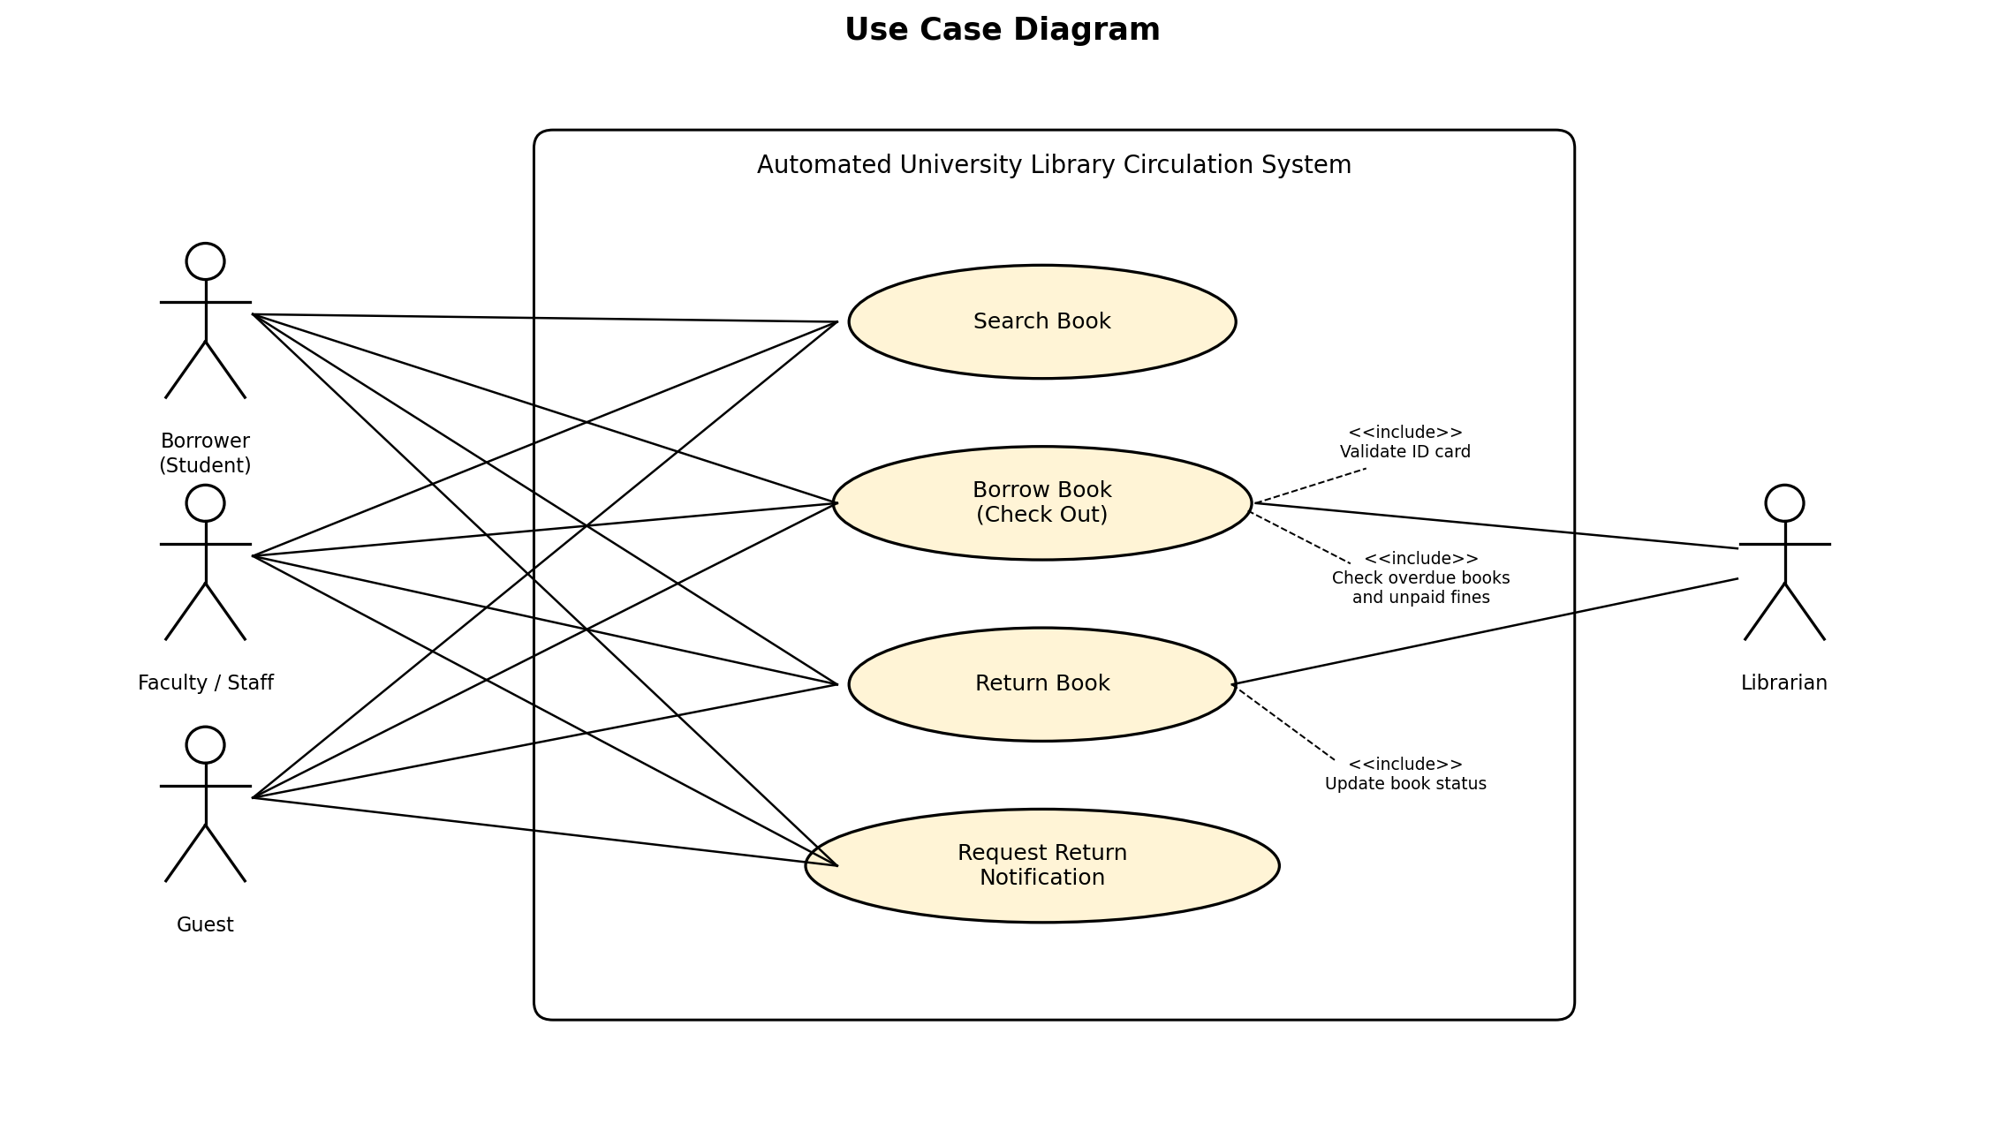
Figure 2. Use Case Diagram for Automated University Library Circulation System

Brief description of the actors:
# | Actor | Description
01 | Borrower (Student) | A university student who can search books, check out books, return books, and request a return notification. The system validates the student ID through the registrar's student database.
02 | Faculty/Staff | A university faculty or staff member who can search, borrow, return books, and request notification. The system validates the ID through the personnel office's employee database.
03 | Guest | An external borrower who can search, borrow, return books, and request notification. The system validates the guest ID through the library borrower database.
04 | Librarian | A library staff member who supports circulation activities and performs book-maintenance work such as adding, updating, or removing book records.

Brief description of the use cases:
# | Use Case | Actors | Description
UC-01 | Search Book | Borrower (Student, Faculty/Staff, Guest) | Allows borrowers to search the library collection by title, author, keywords, or ISBN using library terminals or the Web.
UC-02 | Borrow Book (Check Out) | Borrower (Student, Faculty/Staff, Guest), Librarian | Validates the borrower ID, checks overdue books and unpaid fines, then checks out the book and updates the collection database.
UC-03 | Return Book | Borrower (Student, Faculty/Staff, Guest), Librarian | Allows a borrowed book to be returned. The system checks the book back in and updates the book status in the collection database.
UC-04 | Request Return Notification | Borrower (Student, Faculty/Staff, Guest) | Allows a valid borrower to request notification when a currently checked-out book becomes available after it is returned.
Q4:
State Transition Diagram for Books
State Transition Diagram
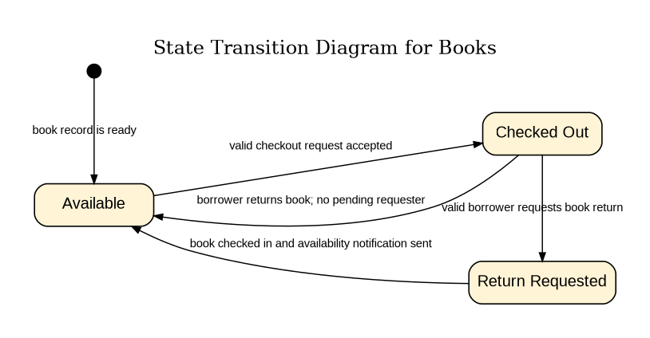
Figure 3. State Transition Diagram for Books

Brief description of the states:
# | State | Description
01 | Accepted | The Requester submitted a completed chemical request and the system accepted it for processing.
02 | Checked Out | The book has been borrowed by a valid borrower and is currently unavailable in the collection database.
03 | Return Requested | A valid borrower has requested notification for a book that is currently checked out. When the book is returned, the requester will be notified.

