Assignment 1
- Truth table
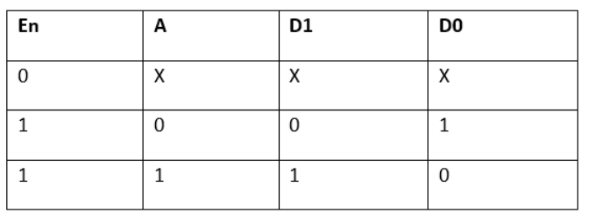
- Logic diagram
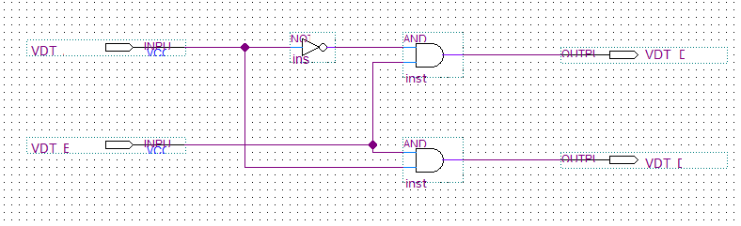
- Simulation
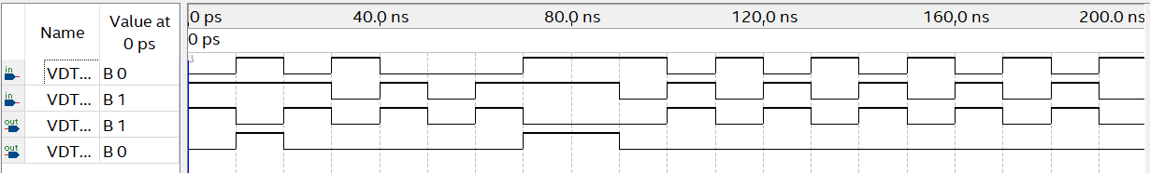

Assignment 2:
- Truth table
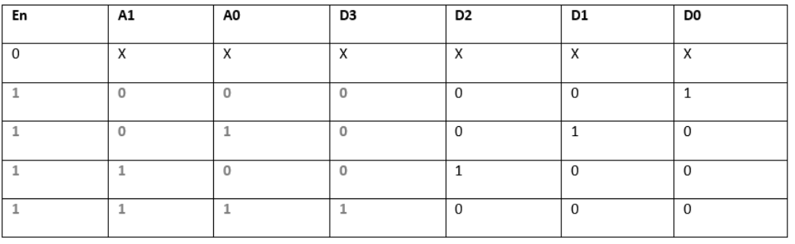

- Logic diagram

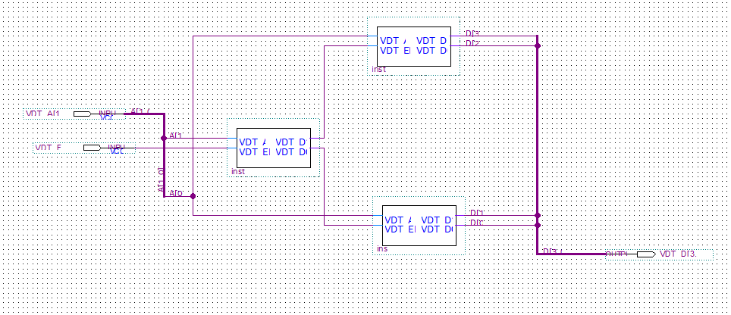

- Simulation
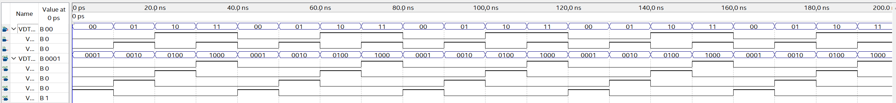

Assigment 3:
- Truth table:
En | A2 | A1 | A0 | D[7..0]
1 | 0 | 0 | 0 | 00000001
1 | 0 | 0 | 1 | 00000010
1 | 0 | 1 | 0 | 00000100
1 | 0 | 1 | 1 | 00001000
1 | 1 | 0 | 0 | 00010000
1 | 1 | 0 | 1 | 00100000
1 | 1 | 1 | 0 | 01000000
1 | 1 | 1 | 1 | 10000000

- Logic diagram

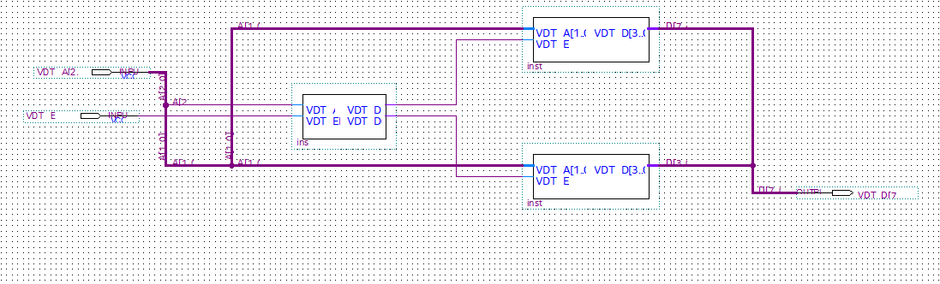

- Simulation

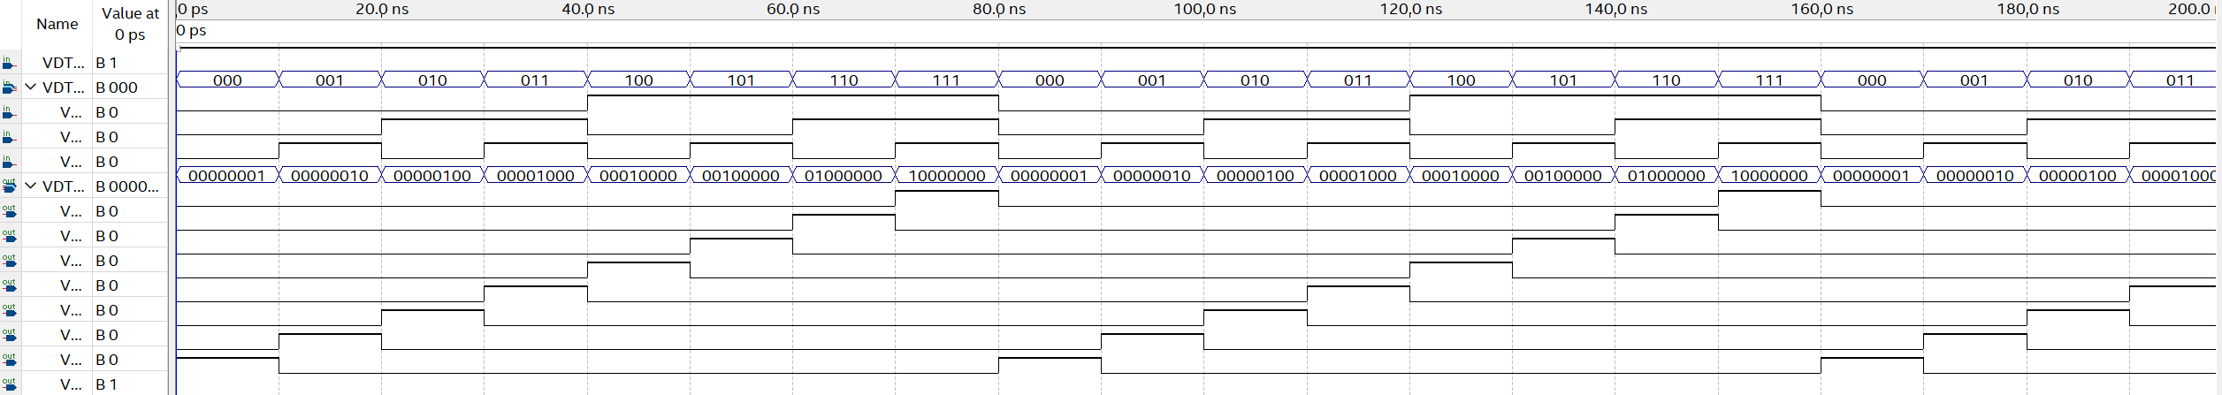
Assignment 4:
- Truth table:
A1 | A0 | S | Y
0 | 0 | 0 | 0
0 | 1 | 0 | 1
1 | 0 | 0 | 0
1 | 1 | 0 | 1
0 | 0 | 1 | 0
0 | 1 | 1 | 0
1 | 0 | 1 | 1
1 | 1 | 1 | 1
Y = S’A0 + SA1
- Logic diagram
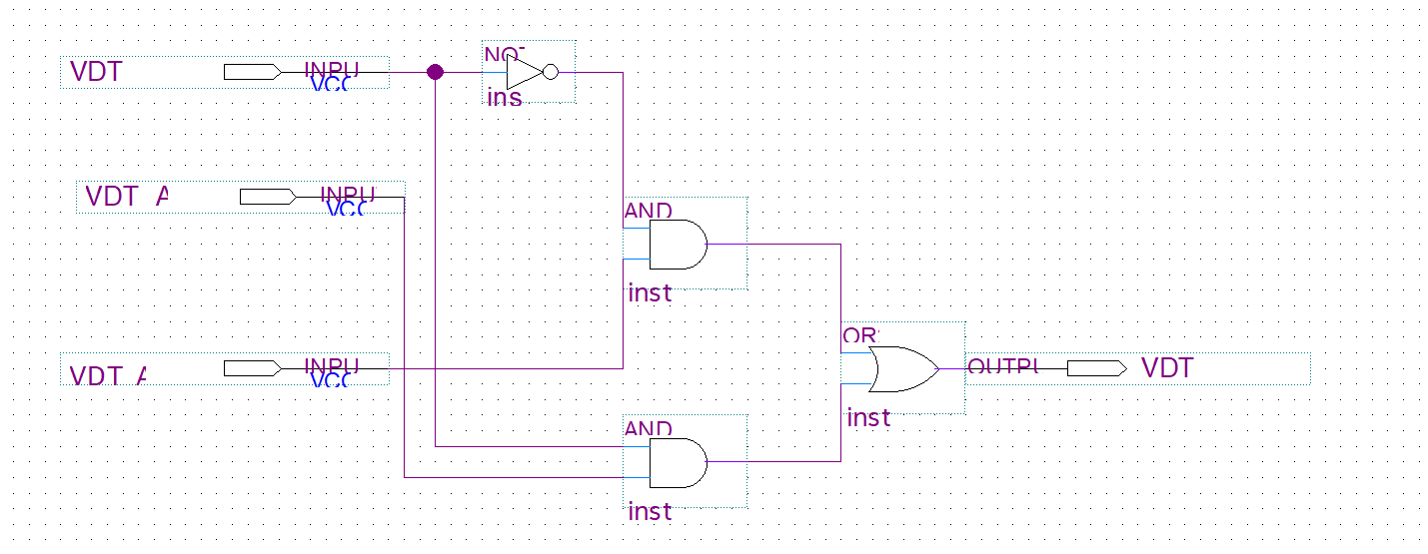

- Simulation

Assignment 5:

- Logic diagram
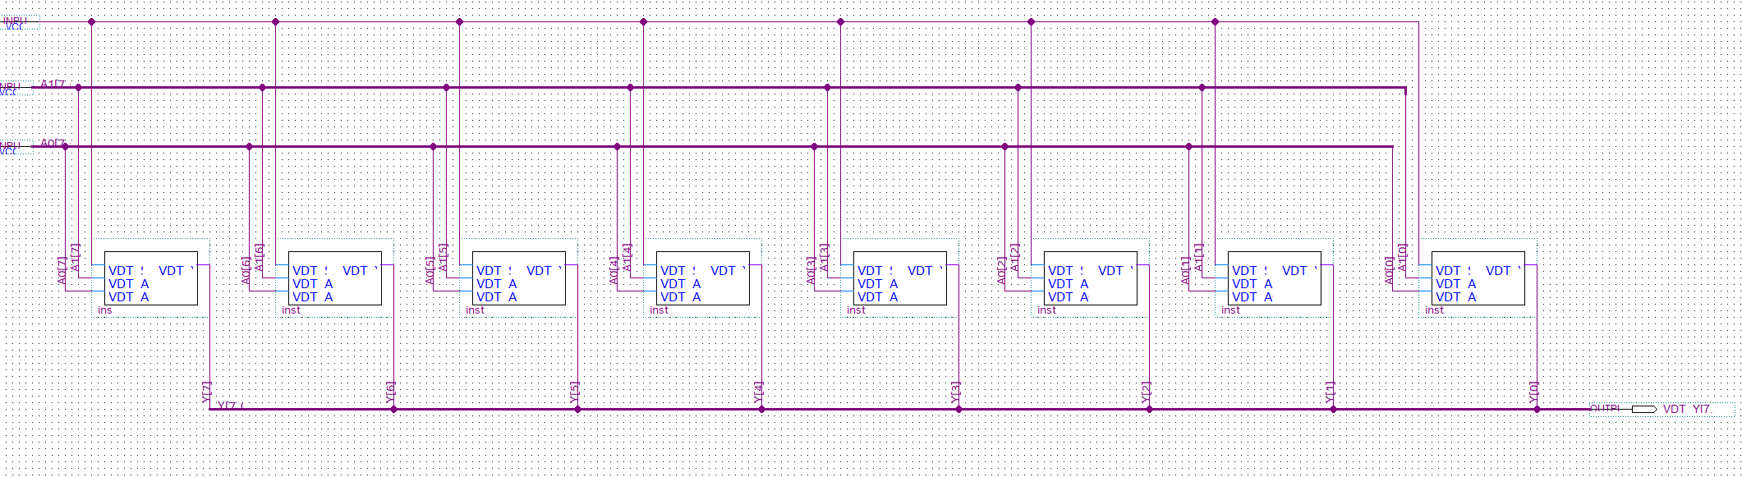

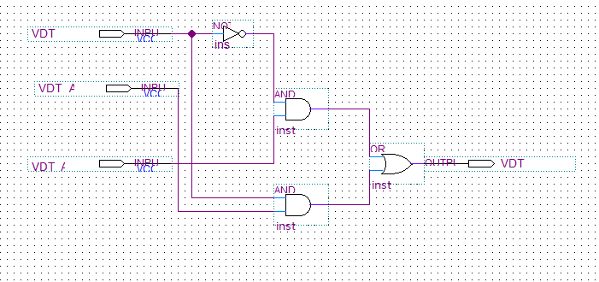
- Simulation

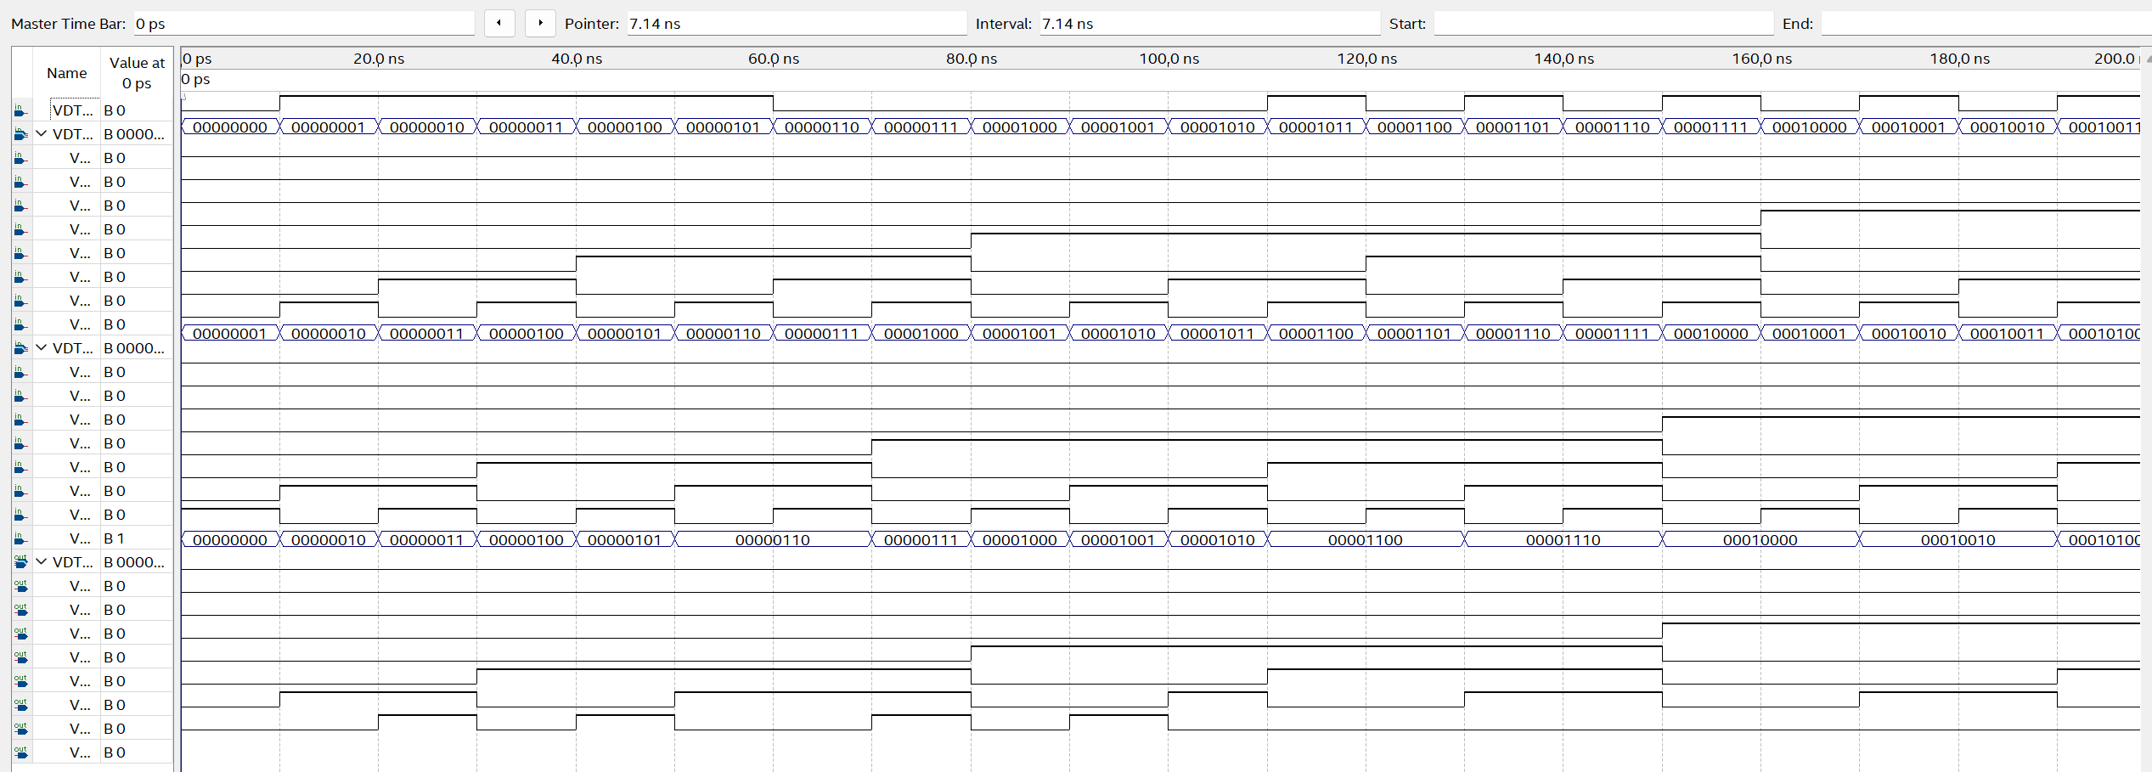
Assignment 6:
- Logic diagram

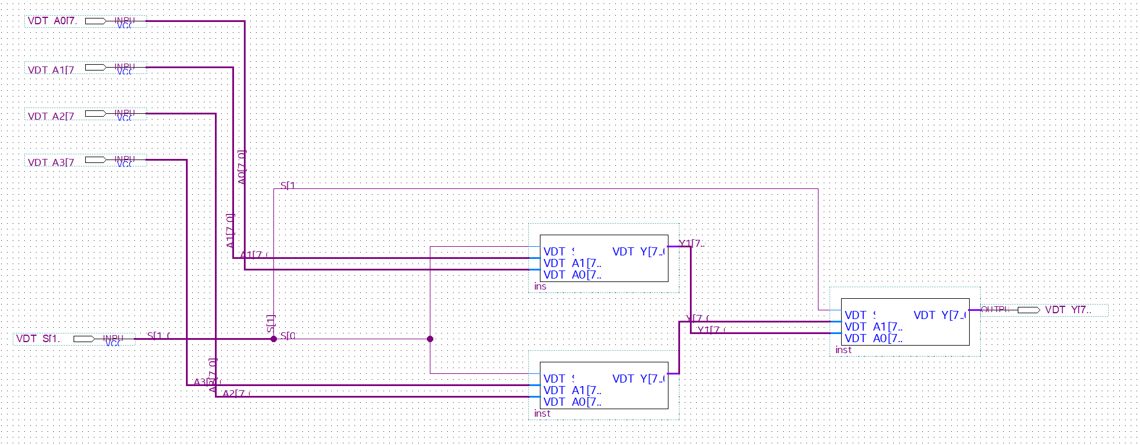
- Simulation

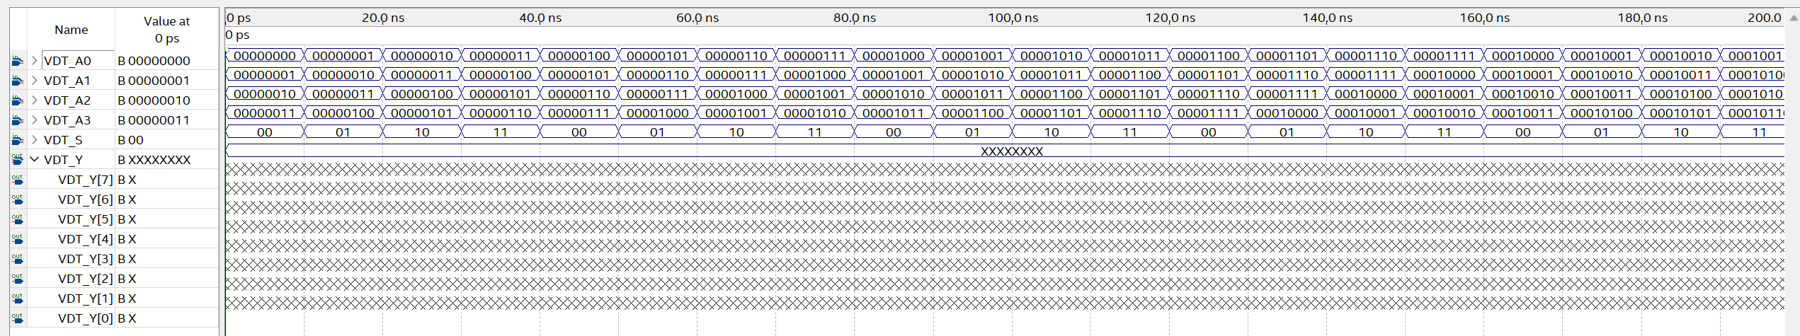

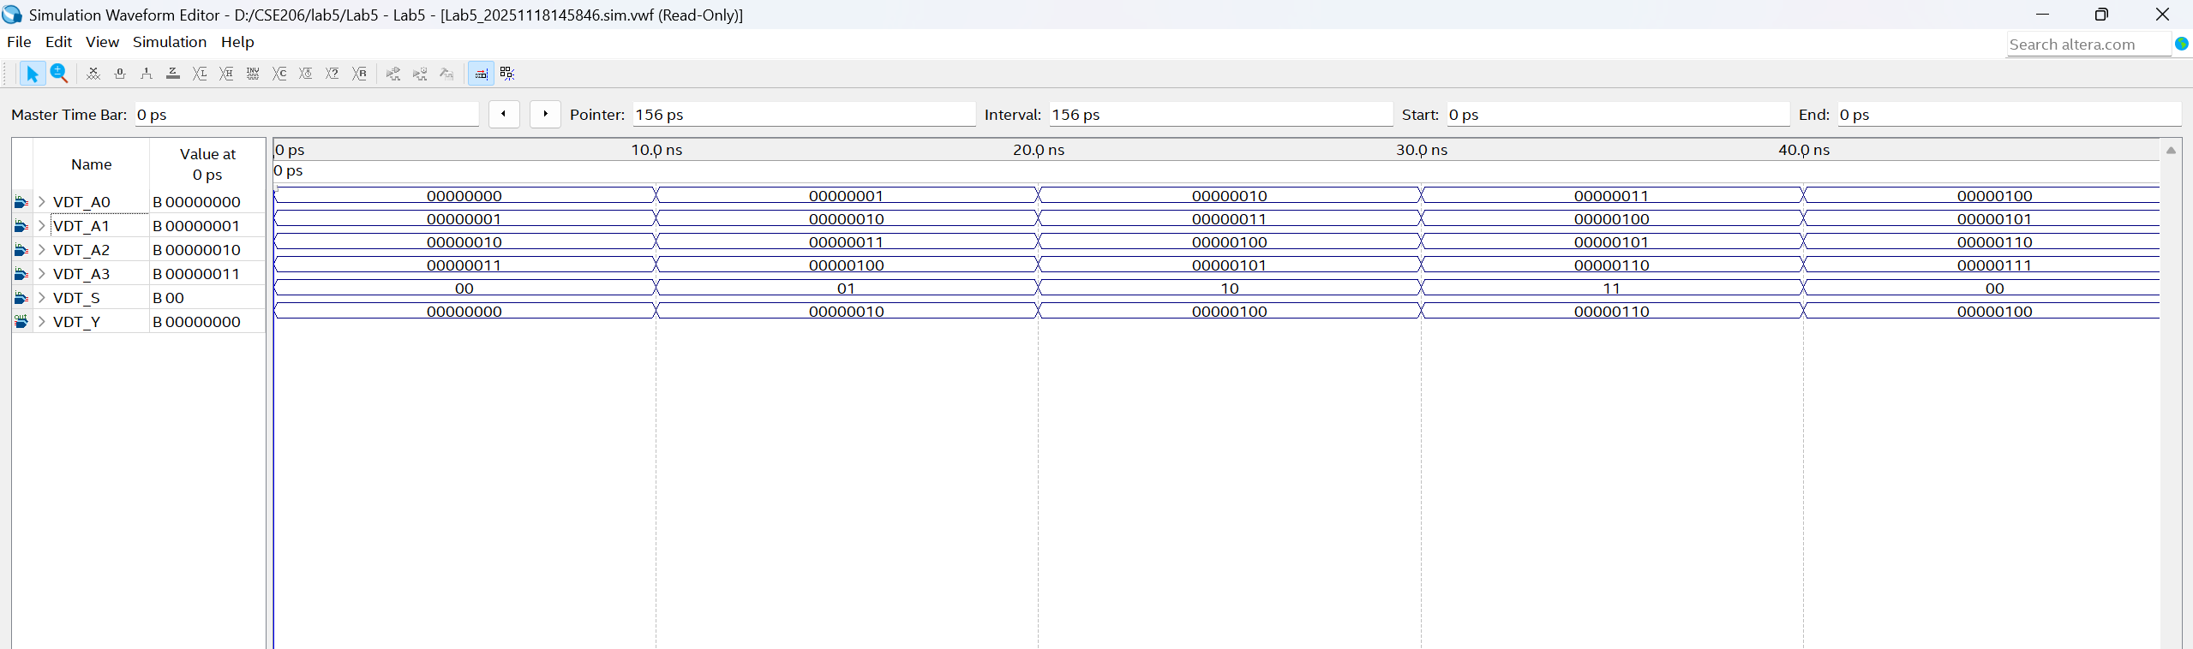

Assignment 7 :
- Logic diagram

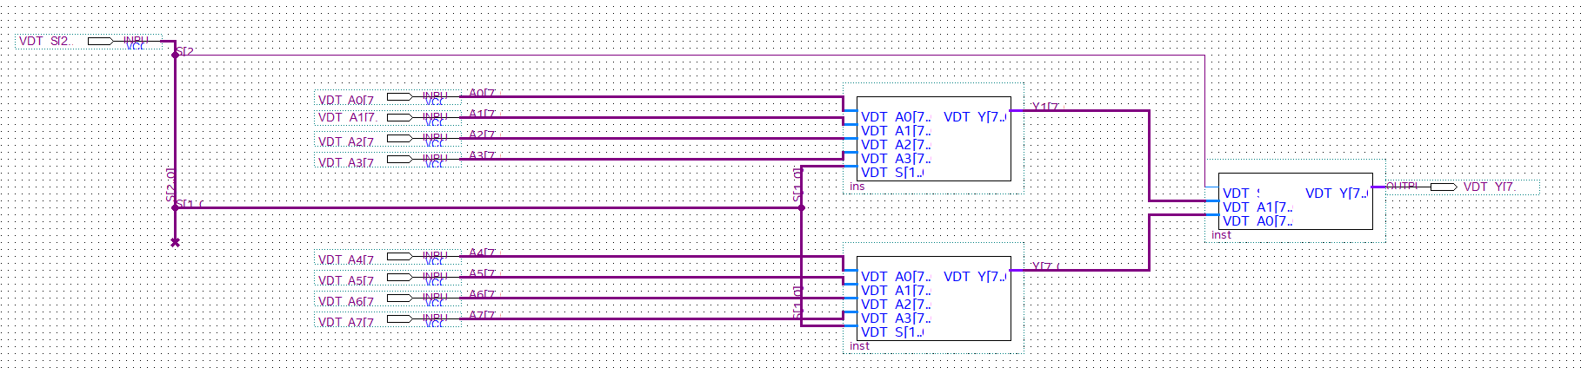

- Simulation

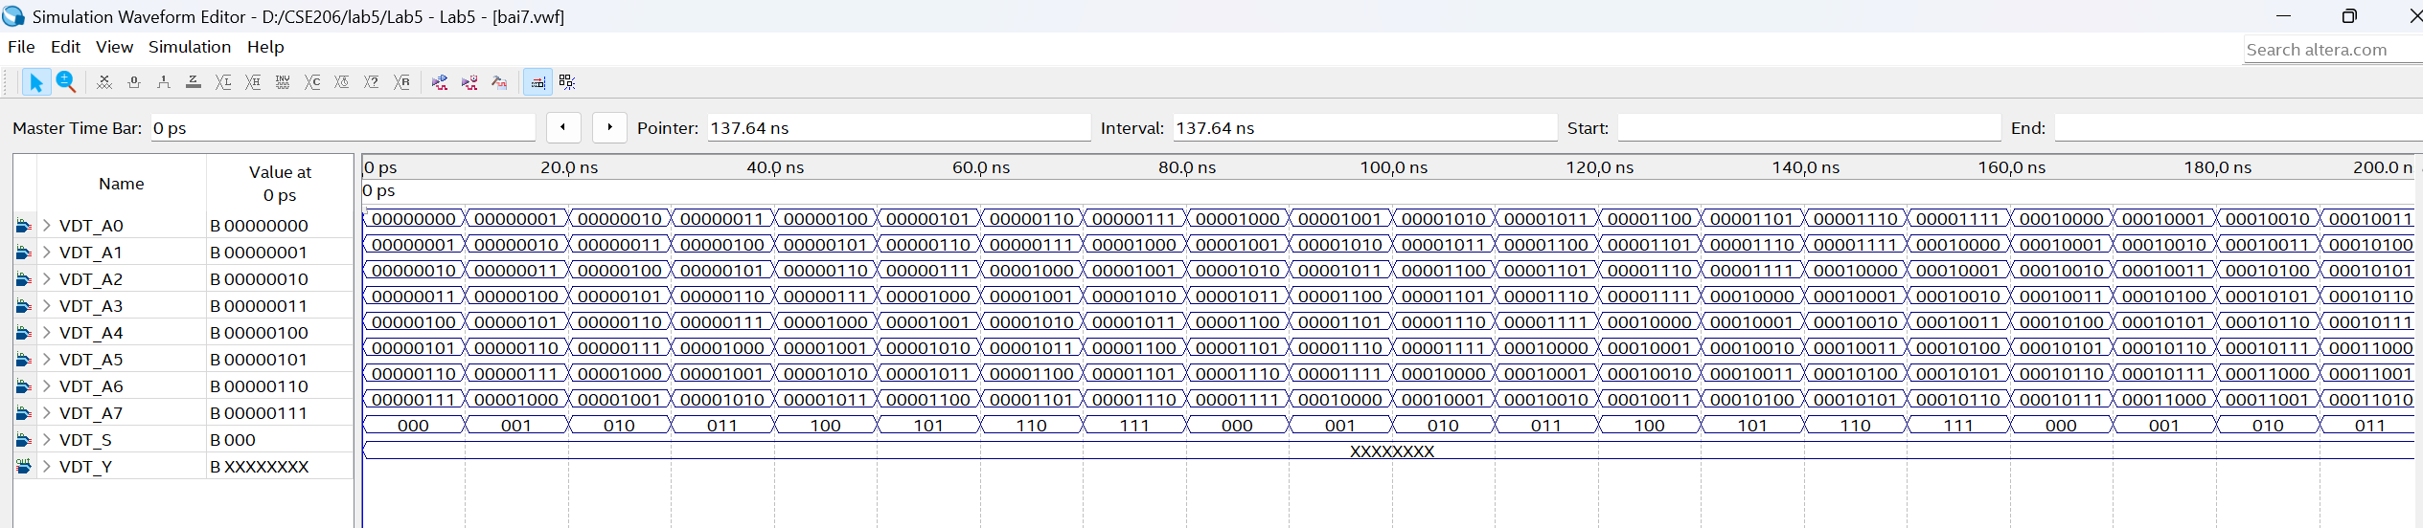

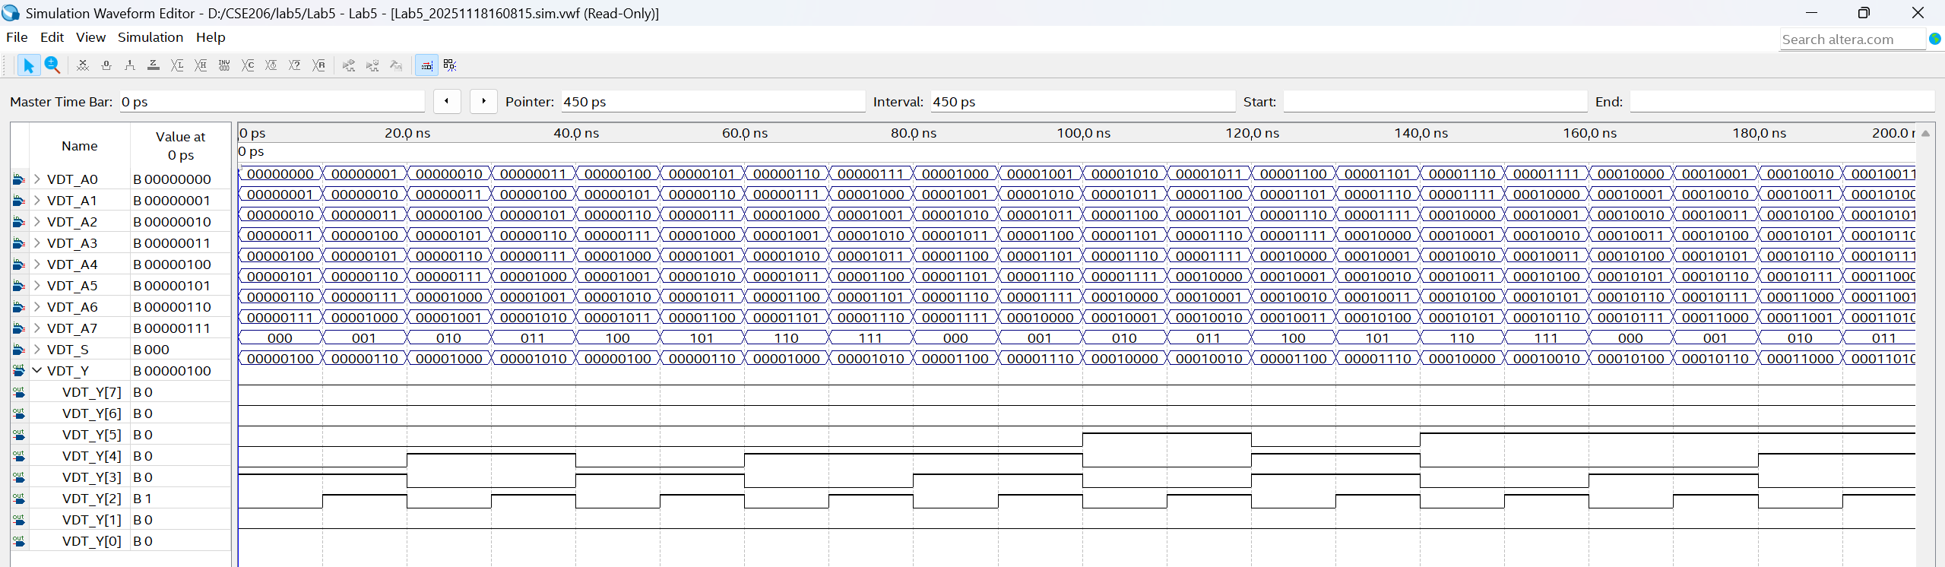

Assignment 8 :
- Logic diagram

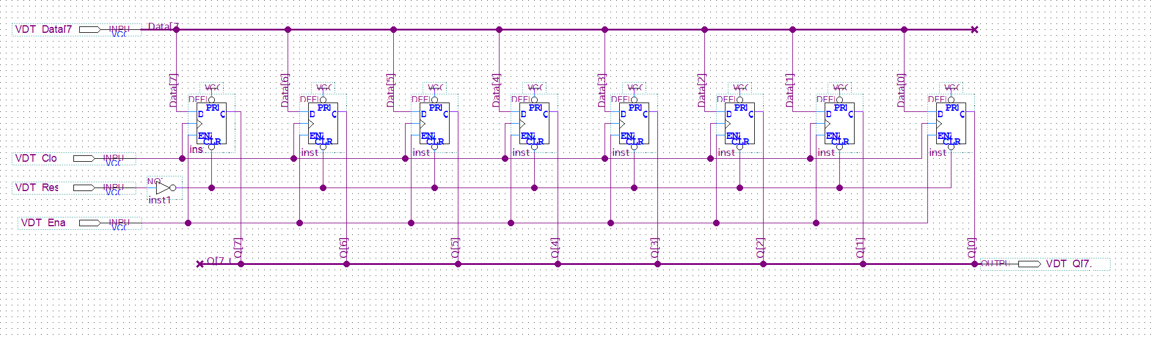

- Simulation

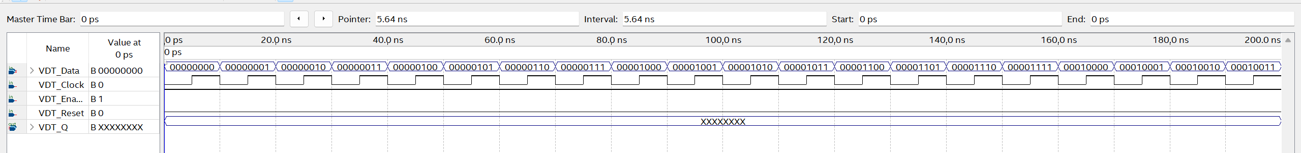

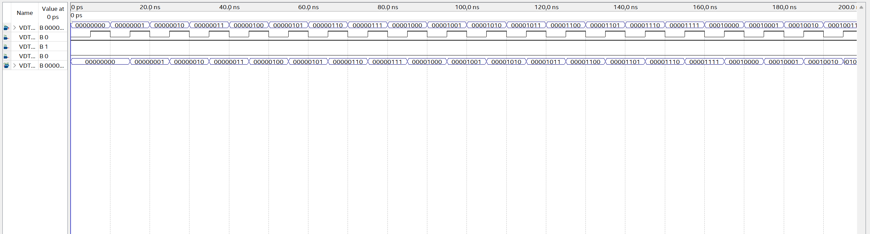

Assignment 9:
- Logic diagram

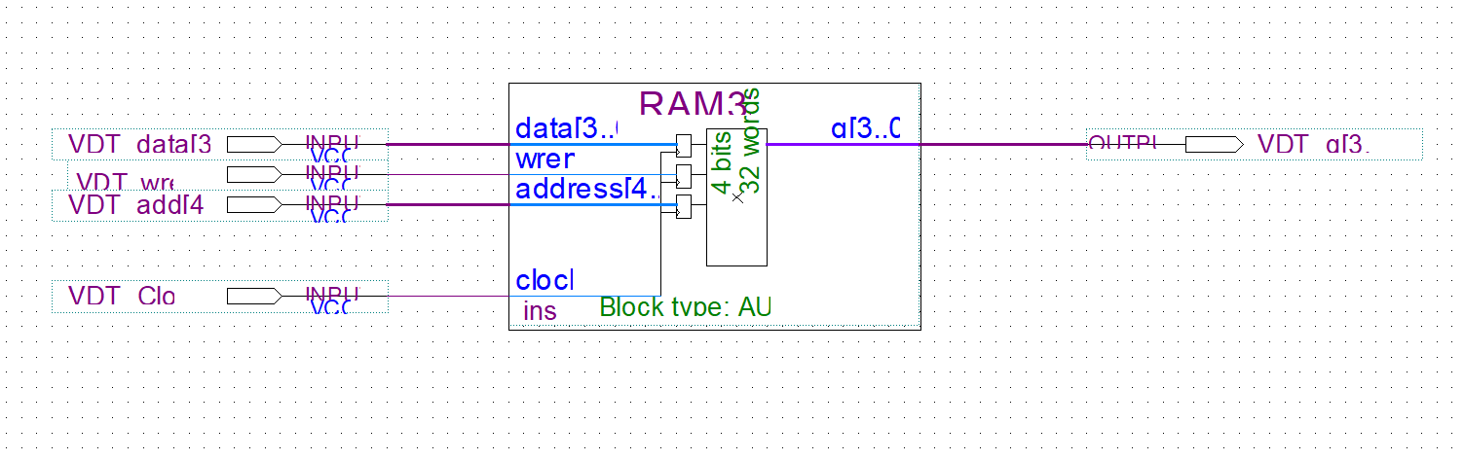

- Simulation

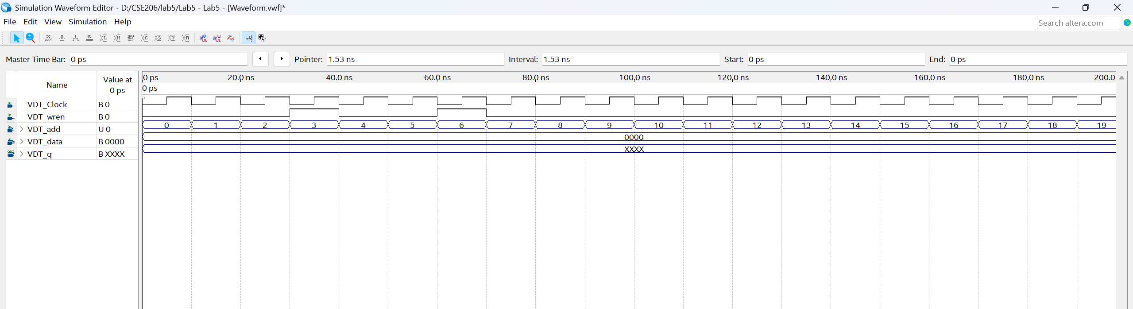

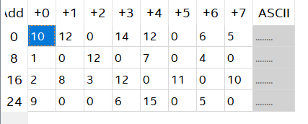
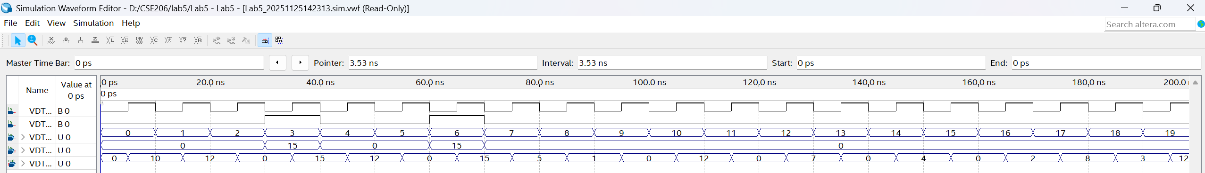

Assignment 10 :
- Logic diagram

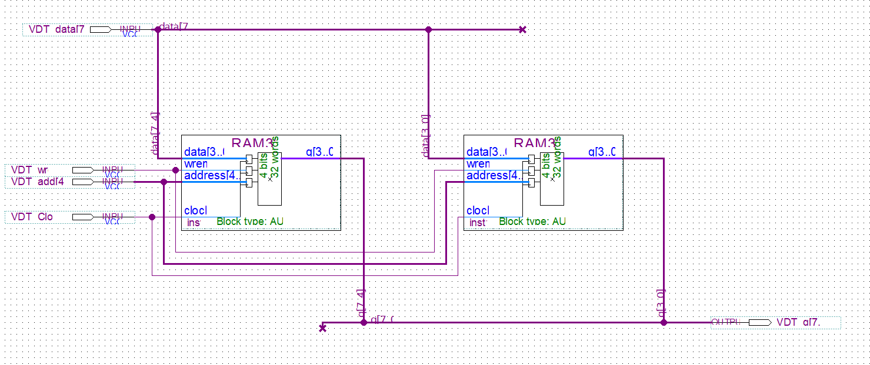

- Simulation

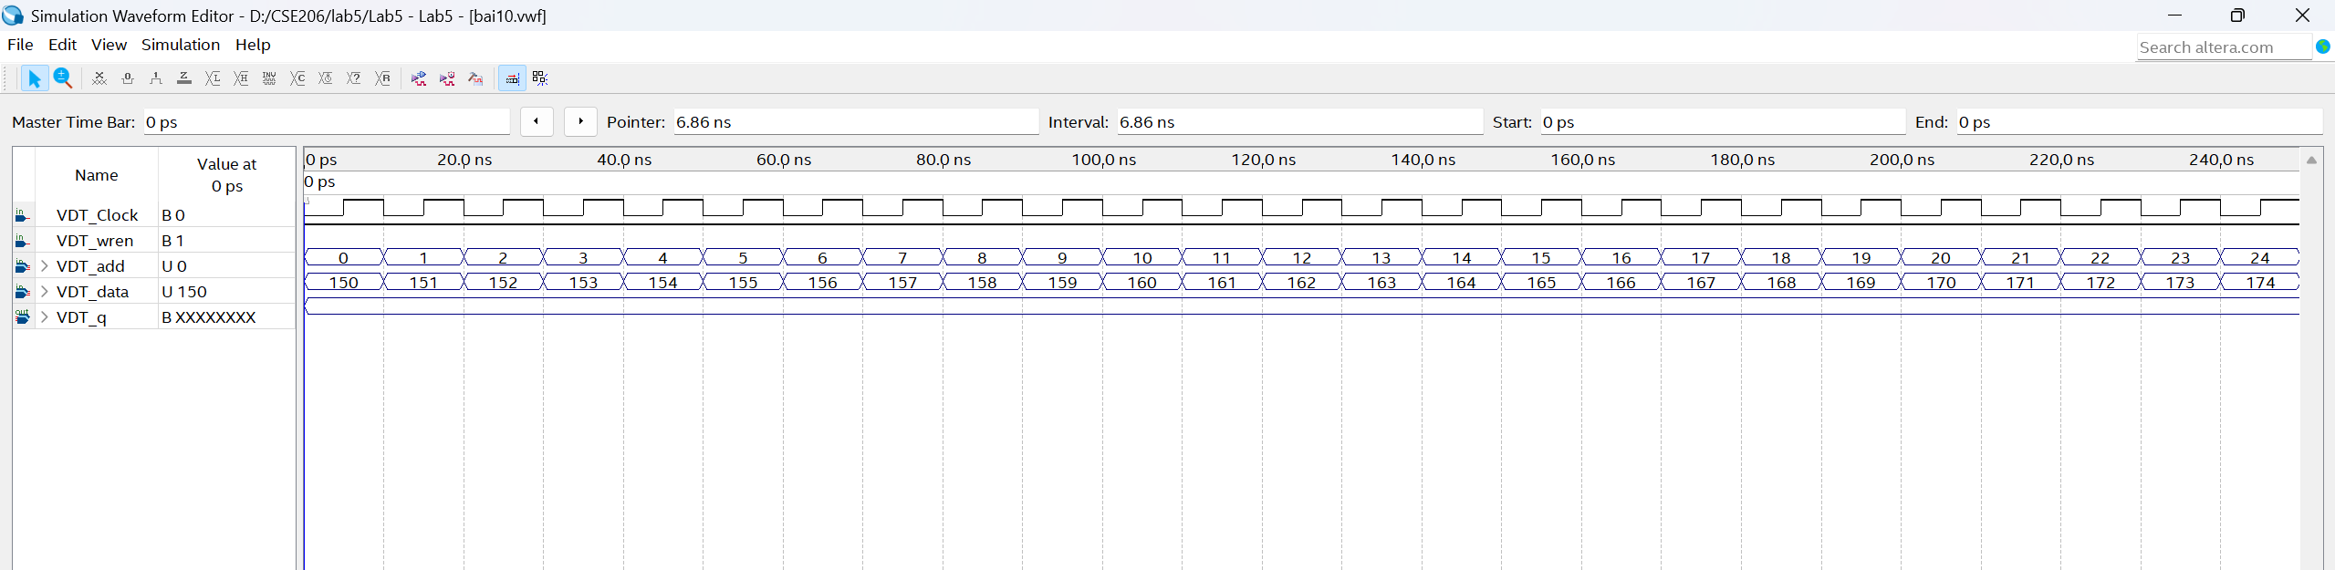

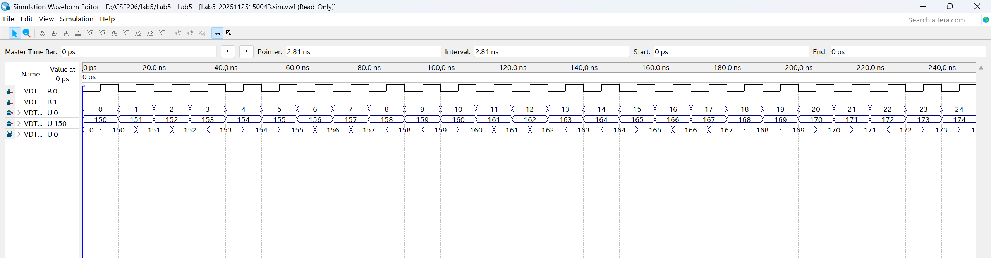

Assignment 11:
- Loigc điagram

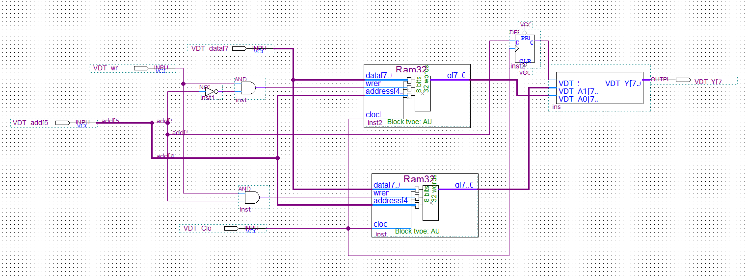

- Simulation

