Laboratory 6 (100 Points)

The file computer.pdf illustrates the block design of a simplified computer (a simple CPU, instruction RAM, and data RAM).
Each instruction occupies twenty-four bits.

The following figure lists the format for each instruction of our simplified computer.

 | Operation |  |  |  | Unused |  |  |  | Unused |  |  |  | Unused |  |  |  | Unused
Halt | 0 | 0 | 0 | 0
Halt

 | Operation |  |  |  | Reg A |  |  |  | Reg B |  |  |  | Reg C |  |  |  | Unused
Add | 0 | 0 | 0 | 1
Add RC, RA, RB RC ← RA + RB

 | Operation |  |  |  | Reg A |  |  |  | Unused |  |  |  | Reg C |  |  |  | Offset
Load | 0 | 0 | 1 | 0
Load RC, RA + offset RC ← MEM(RA + offset)

 | Operation |  |  |  | Reg A |  |  |  | Reg B |  |  |  | Unused |  |  |  | Offset
Store | 0 | 0 | 1 | 1
Store RA + Offset, RB MEM(RA + Offset) ← RB

 | Operation |  |  |  | Reg A |  |  |  | Unused |  |  |  | Unused |  |  |  | Offset
Jump | 0 | 1 | 0 | 0
Jump RA + Offset Program Counter ← RA + Offset

 | Operation |  |  |  | Unused |  |  |  | Unused |  |  |  | Reg C |  |  |  | Value
Mov | 0 | 1 | 0 | 1
Mov RC, value RC ← Value

 | Operation |  |  |  | RegA |  |  |  | Reg B |  |  |  | Unused |  |  |  | Unused
XOR | 0 | 1 | 1 | 0
XOR RA, RB RA XOR RB

Assignment 1 (20 Points)
Translate the following programs into instructions stored in memory (in hexadecimal format).
Program test 1
mov r1, 1 r1 <- 1 500101
mov r2, 3
xor r1,r2
add r5, r1, r2
halt

Program test 2: mov, load
mov r5, 5
load r6, r5 + 1
xor r5, r6
halt

Program test 3: mov, store, load
mov r2, A
mov r6, FF
store r3 + 2, r2
load r7, r5 + 4
halt

Program test 4: jump
Address 0: Mov r4, 1
Address 1: Jump r4 + 9
Address 2: add r5, r2, r3
Address 3: halt
…
Address 10: Mov r2, 5
Address 11: Mov r3, 7
Address 12: Mov r5, 1
Address 13: Jump r5 + 1

Assignment 2 (20 Points)
Design a logic diagram of a program counter. This program counter is an 8-bit register that contains the 8-bit address of the instruction being executed at the current time.

(8)
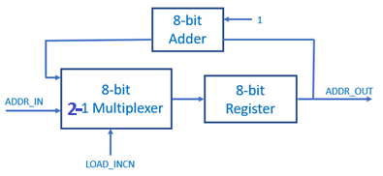
1
(1)
(8)
(8)
(8)
(8)
(8)

If LOAD_INCN = 1, the multiplexer passes the ARRD_IN into the register, otherwise the value in the program counter is increased by one and stored into the register.
1. Design the logic diagram to implement the program counter.
2. Simulate the circuit and check the result.

Assignment 3 (20 Points)
Design an instruction memory to hold the program to be executed. Instruction memory is an array of 24-bit words. The figure below illustrates how the value in a program counter is used as an address for the instruction memory.
1
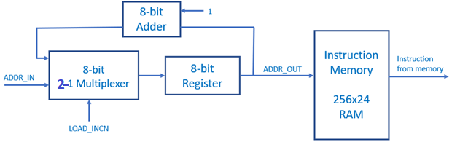
(24)
(8)
Program Counter

1. Design the logic diagram.
2. Initialize the instruction memory with the program test 1 in Assignment 1 and simulate the circuit.

Assignment 4 (20 Points)
Design an instruction decoder in our simplified computer. The instruction decoder should hold the instruction in a register and extract the operation field (3 bits), the register A id (3 bits), the register B id (3 bits), the register C id (3 bits), and the offset field (8 bits).
(3)
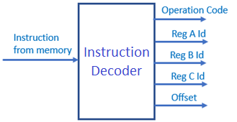
(8)
(3)
(3)
(3)
(24)

Assignment 5 (20 Points)
Design a register unit which hold all general registers. There are eight 8-bit registers in the unit. The register A id, register B id, and register C id from the instruction decoder are used to select registers A, B, and C respectively. Only the register selected by the register C id can be written.
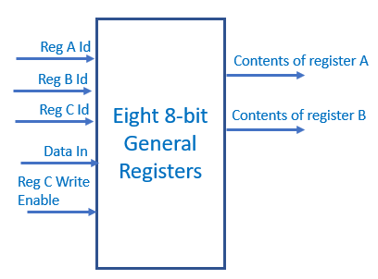
(1)
(8)
(3)
(3)
(3)
(8)
(8)

