Laboratory 6 (100 Points)

The file computer.pdf illustrates the block design of a simplified computer (a simple CPU, instruction RAM, and data RAM).
Each instruction occupies twenty-four bits.

The following figure lists the format for each instruction of our simplified computer.

Assignment 1:

Program test 1
mov r1, 1 r1 <- 1 500101
mov r2, 3 r2<- 3 500203
xor r1,r2 r1<- r1 xor r2 612000
add r5, r1, r2 r5<- r1+r2 112500
halt 000000

Program test 2: mov, load
mov r5, 5 r5<-5 500505
load r6, r5 + 1 r6<-MEM(r5+1) 250601
xor r5, r6 r5<-r5 xor r6 656000
halt 000000

Program test 3: mov, store, load
mov r2, A r2<- 10 50020A
mov r6, FF r6<- 255 5006FF
store r3 + 2, r2 MEM(r3+2)<- r2 332002
load r7, r5 + 4 r7<- MEM(r5+4) 250704
halt 000000

Program test 4: jump
Address 0: Mov r4, 1 r4<-1 500401
Address 1: Jump r4 + 9 PC<- r4+9 440009
Address 2: add r5, r2, r3 r5<- r2+r3 123500
Address 3: halt 000000
…
Address 10: Mov r2, 5 r2<- 5 500205
Address 11: Mov r3, 7 r3<- 7 500307
Address 12: Mov r5, 1 r5<- 1 500501
Address 13: Jump r5 + 1 PC<- r5+1 450001

Assignment 2:
-Logic diagram:

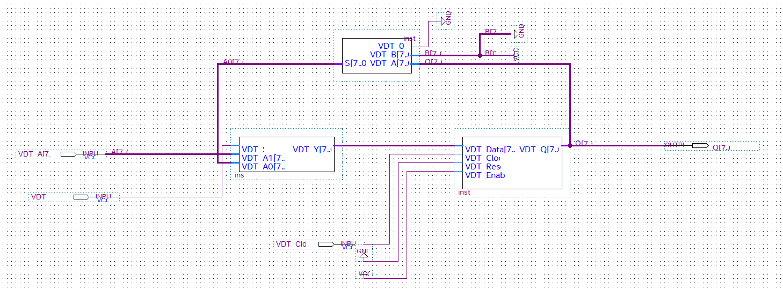

-The waveform :
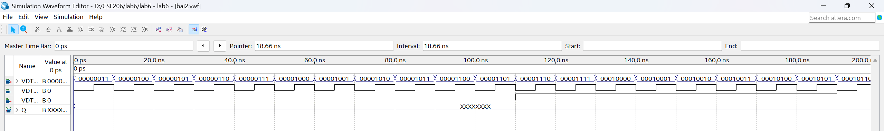

-The result:

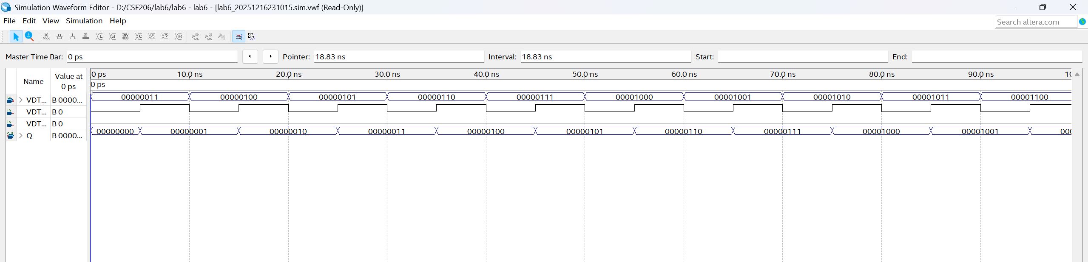

Assignment 3:

-Logic diagram:
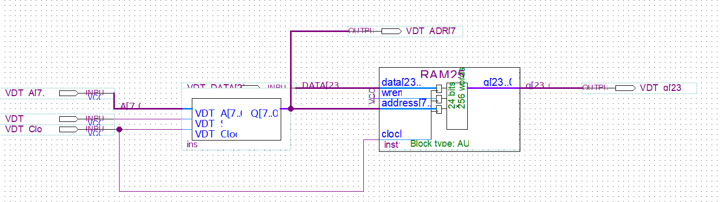

-The waveform :

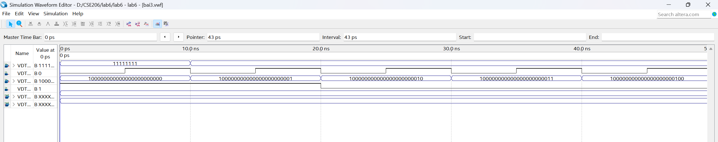
-The result:

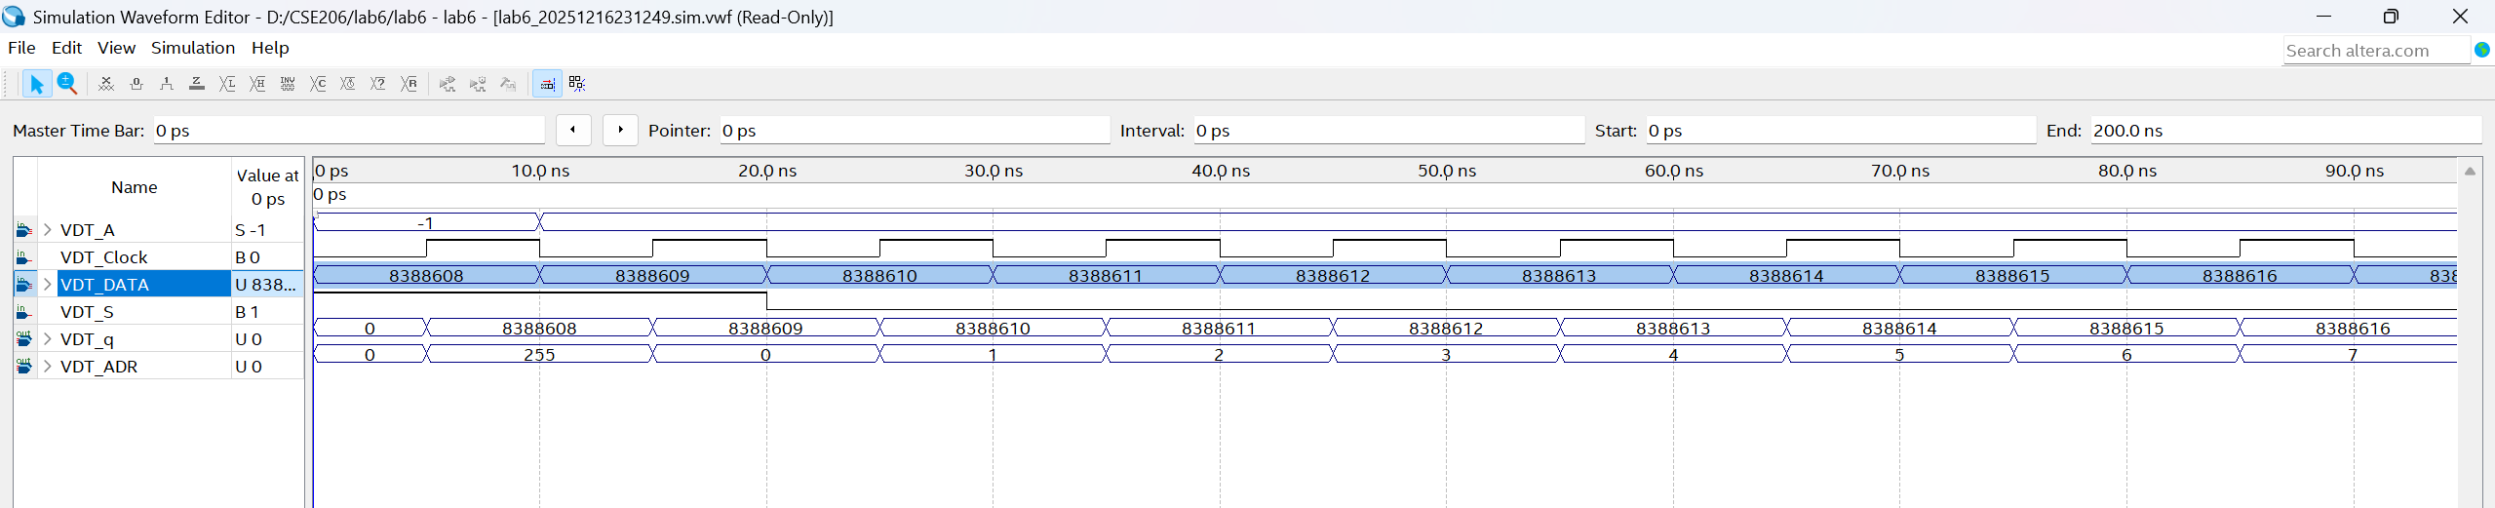

Assignment 4:

-The logic diagram:
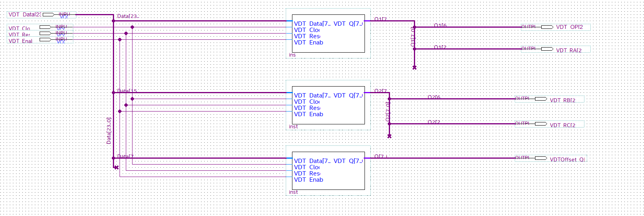

-The waveform:
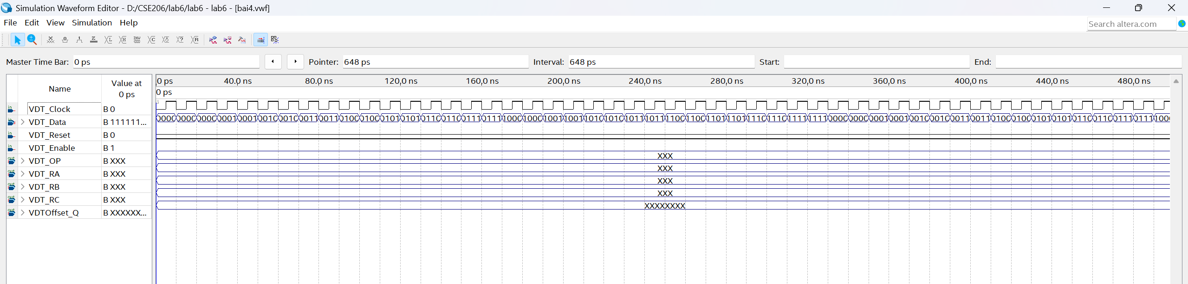

-The result:

