Assignment 1:
- Truth table
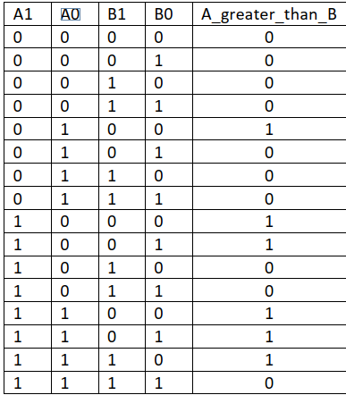
- Kanaugh map
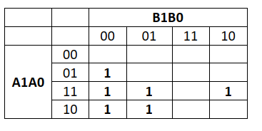
A_greater_than_B = A0B1’B0’ + A1A0B0’+A1B1’
- Logic diagram
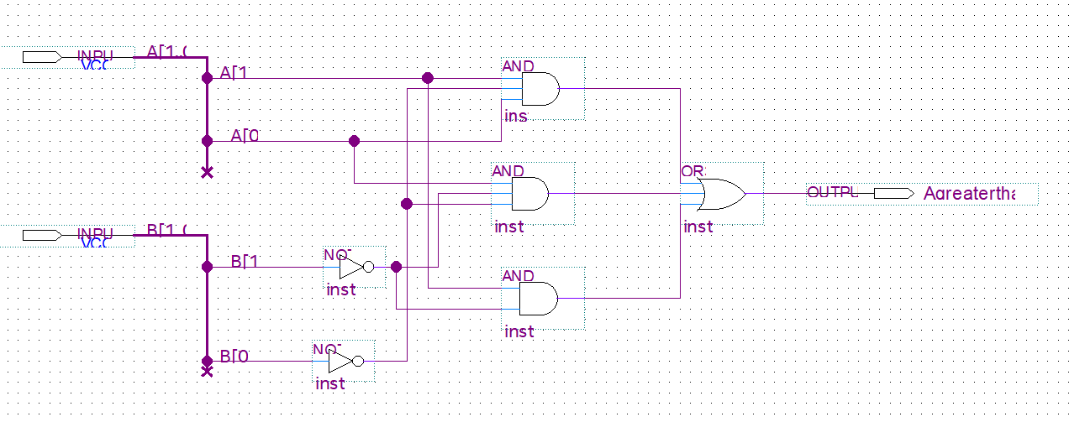
- Wareform set value
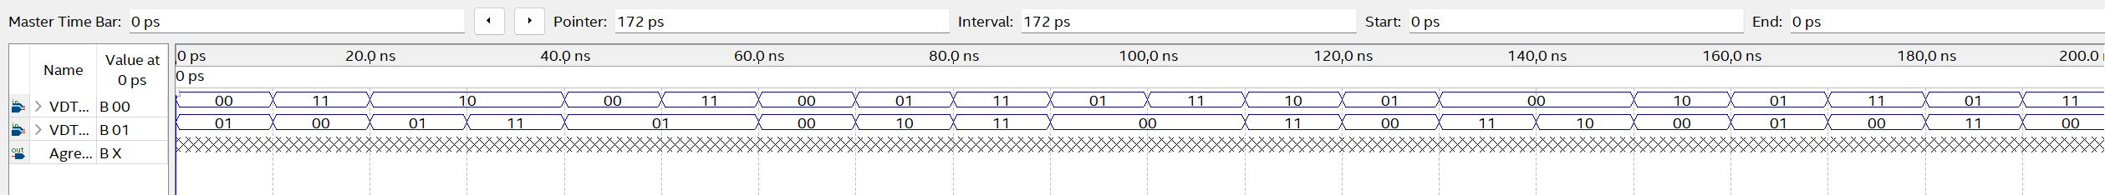
- Wareform result
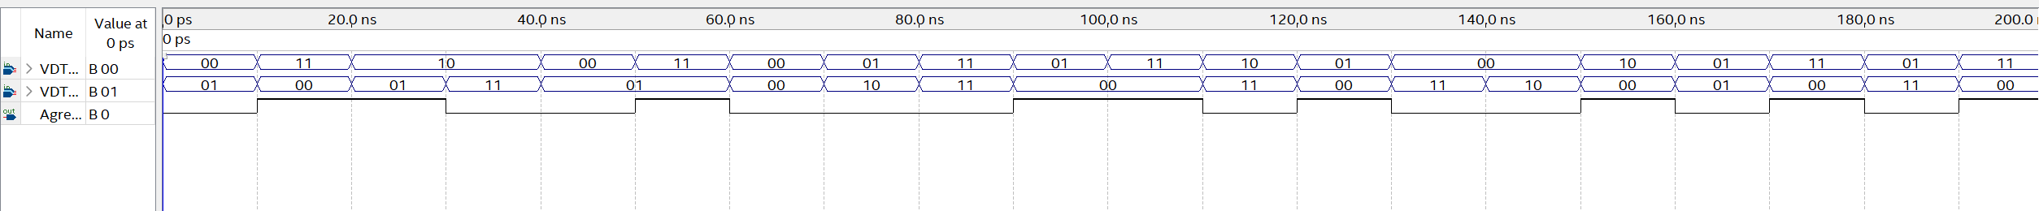
Assignment 2a:
- Logic expression:
AC +AC’+A’C = A ( C+C’ )+ A’C
= A. 1 + A’C
= (A + A’) ( A+C)
= 1. ( A + C)
= A + C

- Logic diagram
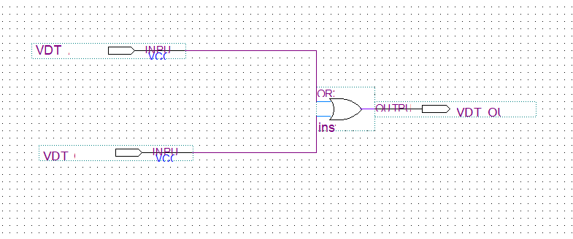

- Wareform set value

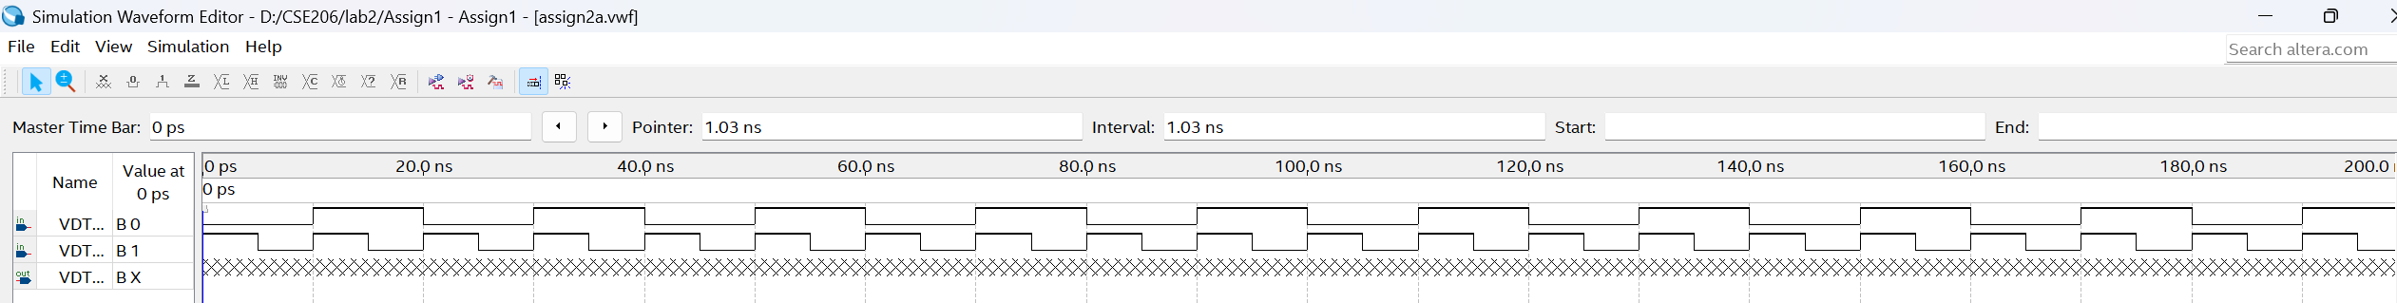

- Wareform result

Assignment 2b:
- Logic expression
AB + A ( B + C ) = AB + A.B’.C’
= A ( B + B’.C’)
= A ( [ ( B + B’) ( B + C’) ] )
= A ( 1 ( B + C’) )
= AB + AC’

- Logic diagram

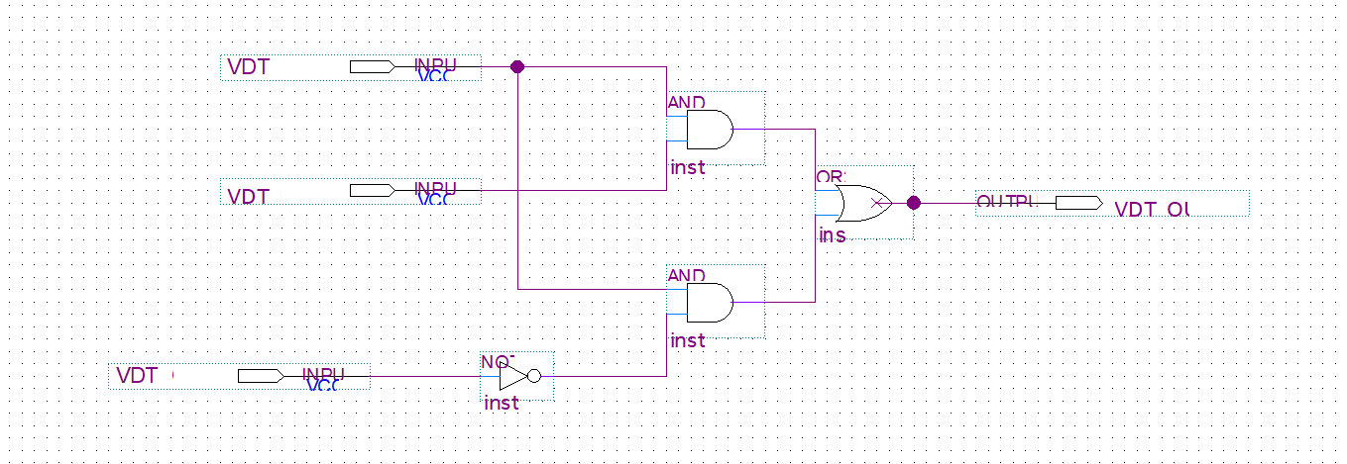

- Wareform set value

- Wareform result

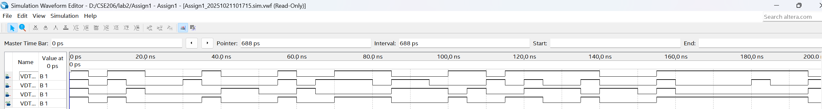
Assignment 2c:
- Logic expression

AB’C + B + BD’ + ABD’ + A’C = AB’C + B + A’C
( Set X = B X’ = B’ and Y = AC )
= X’Y + X + A’C
= ( X + X’) ( X + Y ) + A’C
= 1 ( X + Y) + A’C
= B + AC + A’C
= B + C ( A + A’ )
= B + C
- Logic diagram
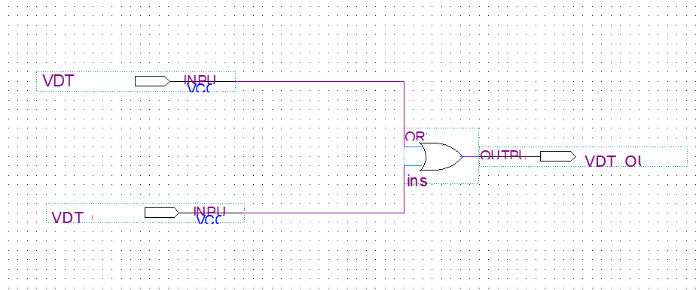

- Wareform set value

- Wareform result

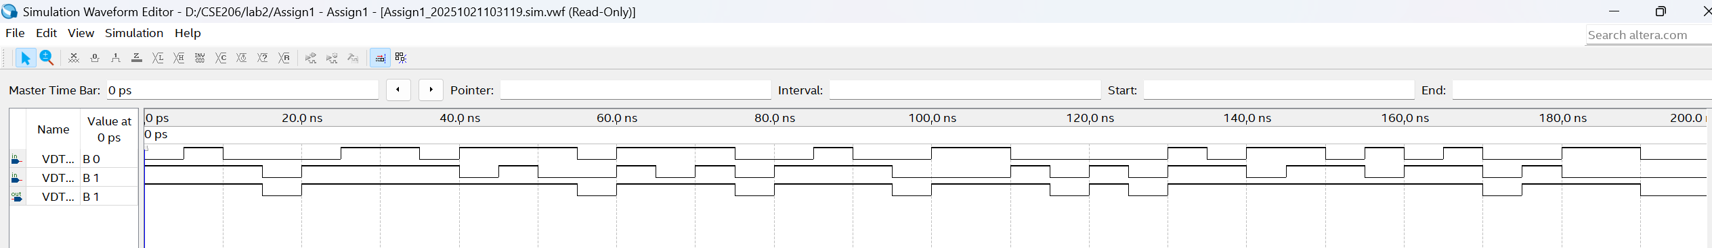

Assignment 3a:
- Logic expression
Z = ( AB + A ) . ( BC + B ) . (AB + C)
= A . B . (AB + C)
= A.B

- Truth table
A |  | B | A . B
0 | 0 |  | 0
0 | 1 |  | 0
1 | 0 |  | 0
1 | 1 |  | 1

Assignment 3b:
- Logic expression:
Z = ( [ A’ + ( A + B)’ ] . [ B’ + ( B + C )’])’
= ( [ A’ + A’ B’ ] . [ B’ + B’ C’ ] )’
= ( A’ . B’ )’
= A + B
- Truth table
A | B |  | A + B
0 | 0 | 0
0 | 1 | 1
1 | 0 | 1
1 | 1 | 1

Assignment 4a:
- Expression
$$m\left( 1, 3, 4 , 5 , 6 , 7\right)→ SOP$$

A2 | A1 | A0 | Z
0 | 0 | 0 | 0
0 | 0 | 1 | 1
0 | 1 | 0 | 0
0 | 1 | 1 | 1
1 | 0 | 0 | 1
1 | 0 | 1 | 1
1 | 1 | 0 | 1
1 | 1 | 1 | 1

- Kanaugh map
A2 \ A1A0 | 00 | 01 | 11 | 10
0 | 0 | 1 | 1 | 0
1 | 1 | 1 | 1 | 1
Z = A2 + A0

- Logic diagram.
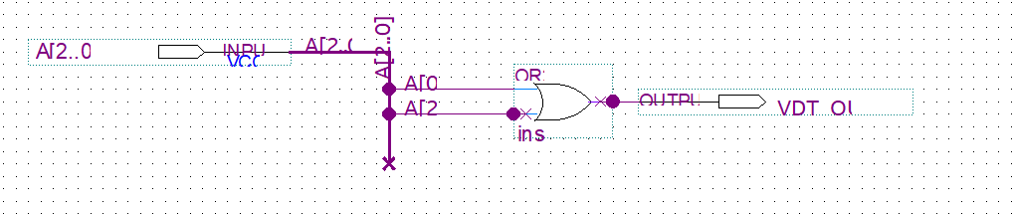
- Wareform set value

- Wareform result
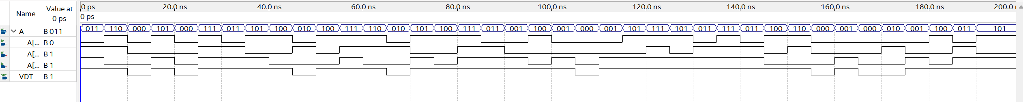

Assignment 4b:
- Expression : Π M(3,5,7) POS

A2 | A1 | A0 | Z
0 | 0 | 0 | 1
0 | 0 | 1 | 1
0 | 1 | 0 | 1
0 | 1 | 1 | 0
1 | 0 | 0 | 1
1 | 0 | 1 | 0
1 | 1 | 0 | 1
1 | 1 | 1 | 0

- Kanaugh map
A2 \ A1A0 | 00 | 01 | 11 | 10
0 | 1 | 1 | 0 | 1
1 | 1 | 0 | 0 | 1
Z=A0′+A2′⋅A1′

- Logic diagram
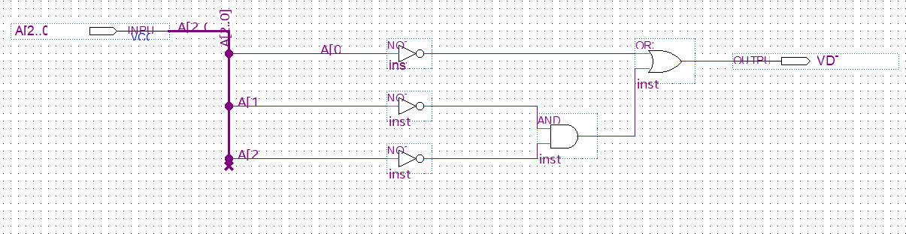

- Wareform set value
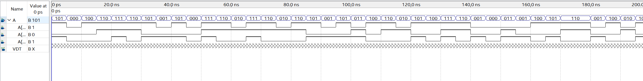

- Wareform result

Assignment 5a:
- Expression : F=Σm(0,1,2,3,4,6,9,11)

A3 | A2 | A1 | A0 | F
0 | 0 | 0 | 0 | 1
0 | 0 | 0 | 1 | 1
0 | 0 | 1 | 0 | 1
0 | 0 | 1 | 1 | 1
0 | 1 | 0 | 0 | 1
0 | 1 | 0 | 1 | 0
0 | 1 | 1 | 0 | 1
0 | 1 | 1 | 1 | 0
1 | 0 | 0 | 0 | 0
1 | 0 | 0 | 1 | 1
1 | 0 | 1 | 0 | 0
1 | 0 | 1 | 1 | 1
1 | 1 | 0 | 0 | 0
1 | 1 | 0 | 1 | 0
1 | 1 | 1 | 0 | 0
1 | 1 | 1 | 1 | 0

- Kanaugh map : F= A2’A0+ A3’A0’
A3A2 \ A1A0 | 00 | 01 | 11 | 10
00 | 1 | 1 | 1 | 1
01 | 1 | 0 | 0 | 1
11 | 0 | 0 | 0 | 0
10 | 0 | 1 | 1 | 0
- Logic diagram
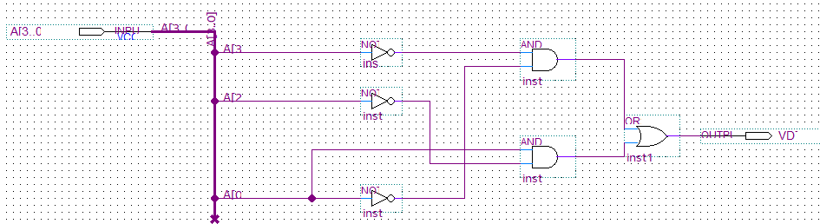
- Wareform set value
- Wareform result
Assignment 5b:
- Expression: F(A3,A2,A1,A0)=ΠM(1,3,4,5,6,9,10,11,12,13,14)

A3 | A2 | A1 | A0 | F
0 | 0 | 0 | 0 | 1
0 | 0 | 0 | 1 | 0
0 | 0 | 1 | 0 | 1
0 | 0 | 1 | 1 | 0
0 | 1 | 0 | 0 | 0
0 | 1 | 0 | 1 | 0
0 | 1 | 1 | 0 | 0
0 | 1 | 1 | 1 | 1
1 | 0 | 0 | 0 | 1
1 | 0 | 0 | 1 | 0
1 | 0 | 1 | 0 | 0
1 | 0 | 1 | 1 | 0
1 | 1 | 0 | 0 | 0
1 | 1 | 0 | 1 | 0
1 | 1 | 1 | 0 | 0
1 | 1 | 1 | 1 | 1

- Kanaugh map
A3A2/ A1A0 | 00 | 01 | 11 | 10
00 | 1 | 0 | 0 | 1
01 | 0 | 0 | 1 | 0
11 | 0 | 0 | 1 | 0
10 | 1 | 0 | 0 | 0
F = A3’ A2' A0' + A2' A1' A0' + A2 A1 A0
- Logic diagram
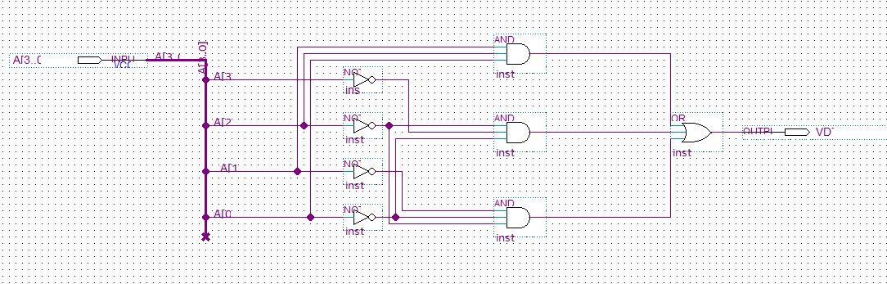
- Wareform set value
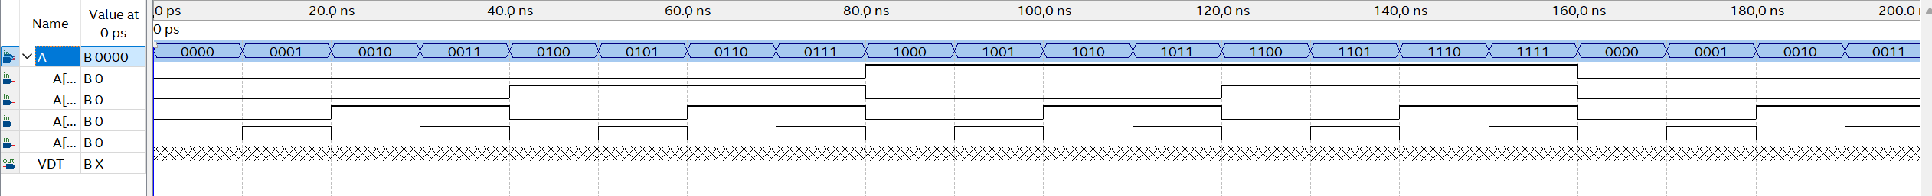
- Wareform result

