Assignment 1:
A3A2A1A0 | B3B2B1B00 | Z
0 | 0 | 0
2 | 1 | 3
7 | 5 | 12
15 | 15 | 30
- Truth table

- Logic diagram
- FULL ADDER
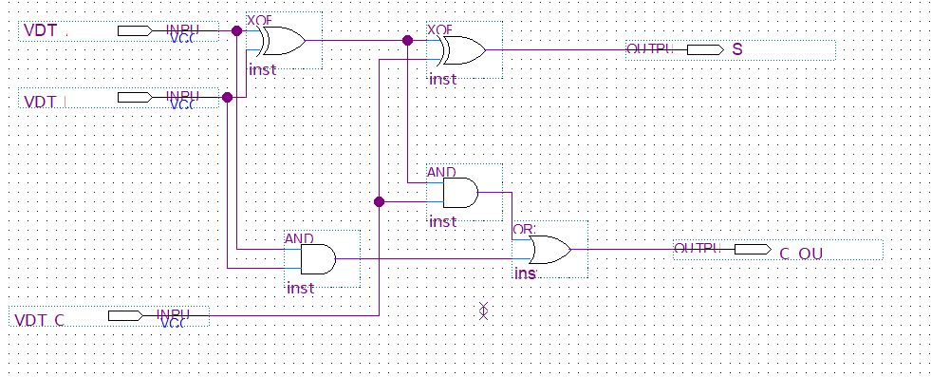
- 4 – BIT ADDER
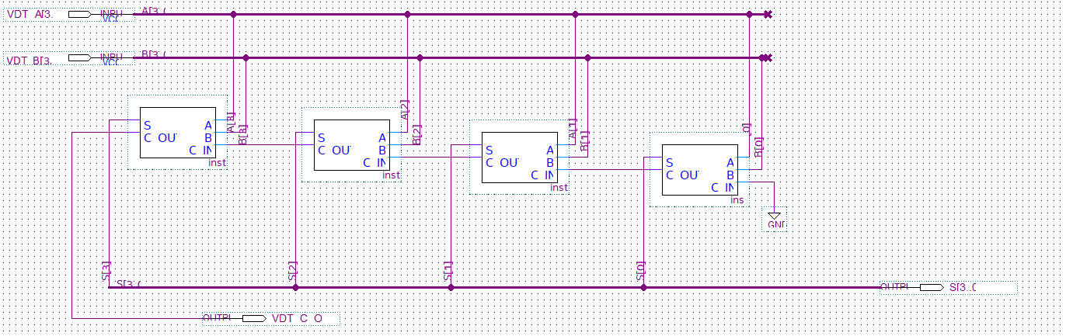
- Wareform set value
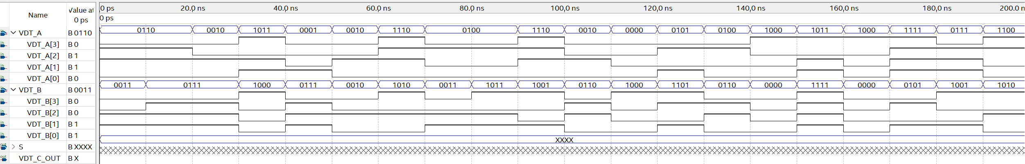
- Wareform result

Assignment 2:
A3A2A1A0 | B3B2B1B00 | C | Z
10 | 10 | 1 | 0
6 | 11 | 0 | `7
13 | 12 | 1 | 1
15 | 15 | 0 | 30
- Truth table
- Logic diagram
- FULL ADDER
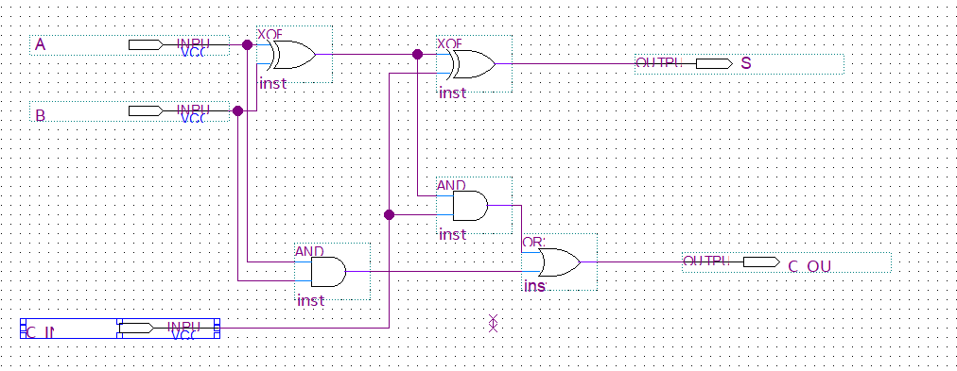
- 4 – BIT ADDER
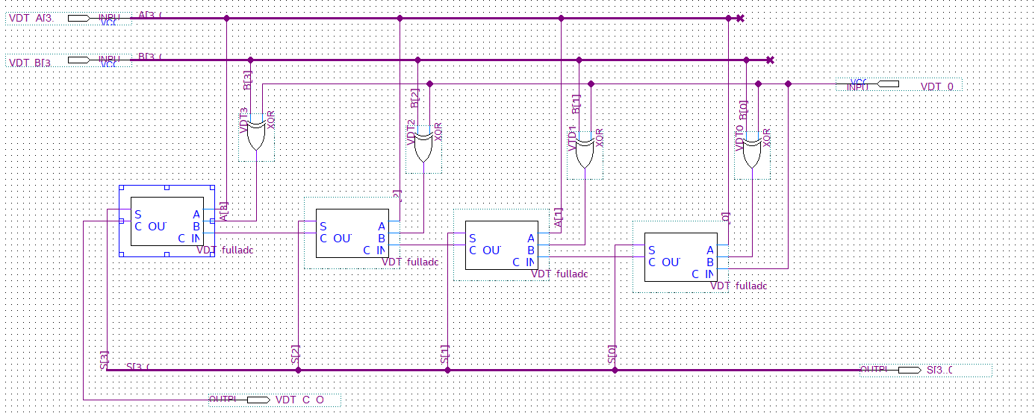
- Wareform set value
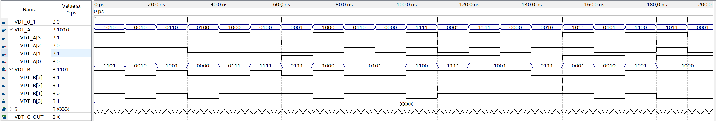
- Wareform result
Assignment 3:
- Kmap and equations:
- B3: B3= A3A2’A1’
A3A2 \ A1A0 | 00 | 01 | 11 | 10
00 | 0 | 0 | 0 | 0
01 | 0 | 0 | 0 | 0
11 | X | X | X | X
10 | 1 | 1 | X | X

- B2: B2 = A3’A2 + A3 A2’A1’
A3A2 \ A1A0 | 00 | 01 | 11 | 10
00 | 0 | 0 | 0 | 0
01 | 1 | 1 | 1 | 1
11 | X | X | X | X
10 | 1 | 1 | X | X

- B1: B1 = A3’A2’A1 + A3’A2A1’
A3A2 \ A1A0 | 00 | 01 | 11 | 10
00 | 0 | 0 | 1 | 1
01 | 1 | 1 | 0 | 0
11 | X | X | X | X
10 | 0 | 0 | X | X

- B0: B0 = A3’A1’A0 + A3’A1A0’ + A2’A1’A0
A3A2 \ A1A0 | 00 | 01 | 11 | 10
00 | 0 | 1 | 0 | 1
01 | 0 | 1 | 0 | 1
11 | X | X | X | X
10 | 0 | 1 | X | X

- Logic diagram
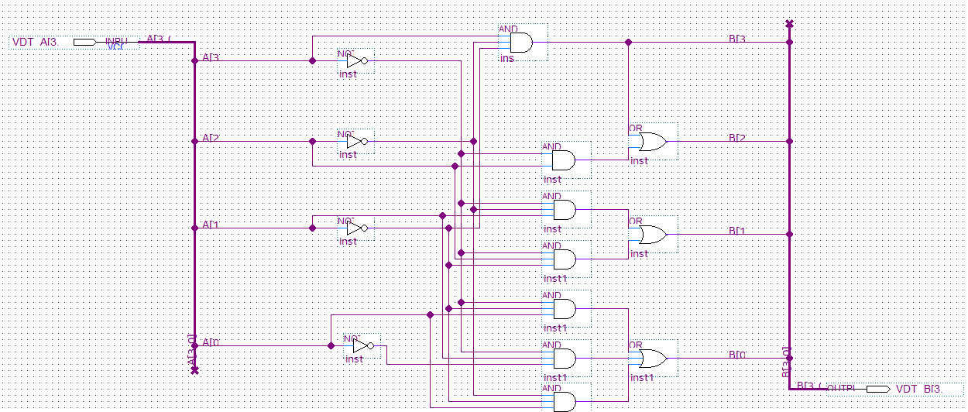

- Wareform set value

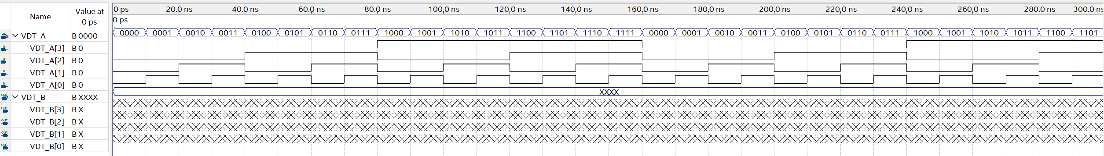

- Wareform resut

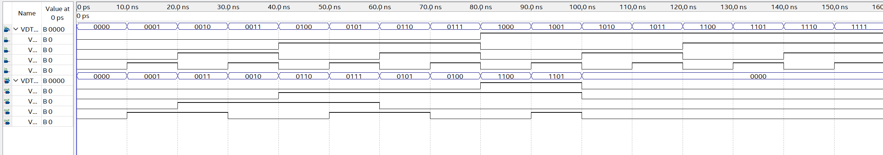
Assignment 3:
- Kmap and equations:
- D7 = A3’A2’A1+ A3’A2A1’+A3A2’A1’+A3’A1A0’

A3A2 \ A1A0 | 00 | 01 | 11 | 10
00 | 0 | 0 | 1 | 1
01 | 1 | 1 | 0 | 1
11 | X | X | X | X
10 | 1 | 1 | X | X

- D6 = A3’A2A1’+A3A2’A1’+A2’A1’A0’+A3’A2A0’

A3A2 \ A1A0 | 00 | 01 | 11 | 10
00 | 1 | 0 | 0 | 0
01 | 1 | 1 | 0 | 1
11 | X | X | X | X
10 | 1 | 1 | X | X

- D5 = A3’A1A0’ +A2’A1’A0’

A3A2 \ A1A0 | 00 | 01 | 11 | 10
00 | 1 | 0 | 0 | 1
01 | 0 | 0 | 0 | 1
11 | X | X | X | X
10 | 1 | 0 | X | X

- D4 = A3’A2’A1+ A3’A1A0’+A2’A1’A0’+A3’A2A1’A0
A3A2 \ A1A0 | 00 | 01 | 11 | 10
00 | 1 | 0 | 1 | 1
01 | 0 | 1 | 0 | 1
11 | X | X | X | X
10 | 1 | 0 | X | X

- D3 = A3’A2+A3’A0+A2’A1’
A3A2 \ A1A0 | 00 | 01 | 11 | 10
00 | 1 | 1 | 1 | 0
01 | 1 | 1 | 1 | 1
11 | X | X | X | X
10 | 1 | 1 | X | X

- D2 = A3’A2’+A2’A1’+A3’A1’A0’+A3’A1A0
A3A2 \ A1A0 | 00 | 01 | 11 | 10
00 | 1 | 1 | 1 | 1
01 | 1 | 0 | 1 | 0
11 | X | X | X | X
10 | 1 | 1 | X | X
- D1 = A3’A2’A0’+A3’A1+A3’A2A0+A3A2’A1’
A3A2 \ A1A0 | 00 | 01 | 11 | 10
00 | 1 | 0 | 1 | 1
01 | 0 | 1 | 1 | 1
11 | X | X | X | X
10 | 1 | 1 | X | X
- Logic diagram
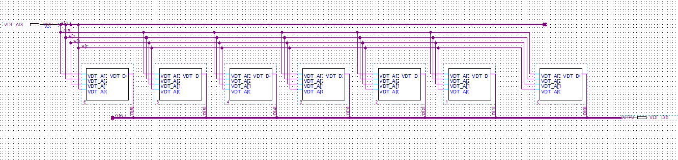

- D1
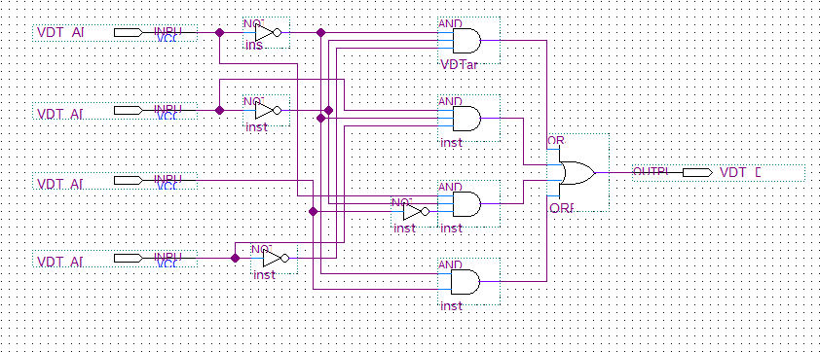
- D2
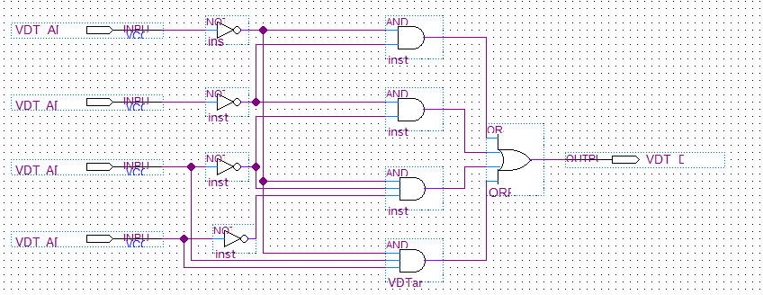
- D3
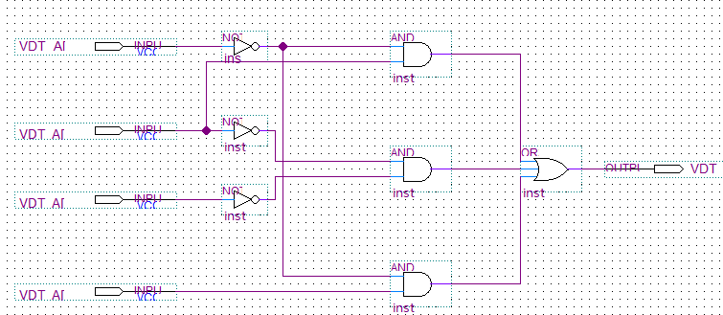
- D4
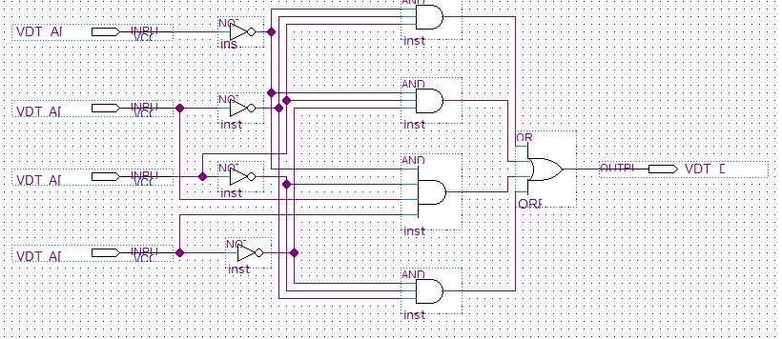
- D5
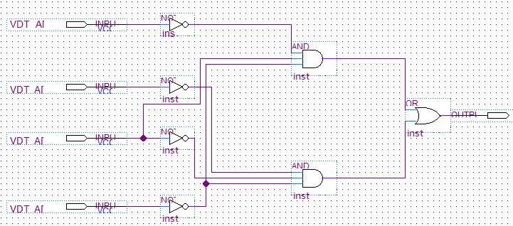
- D6
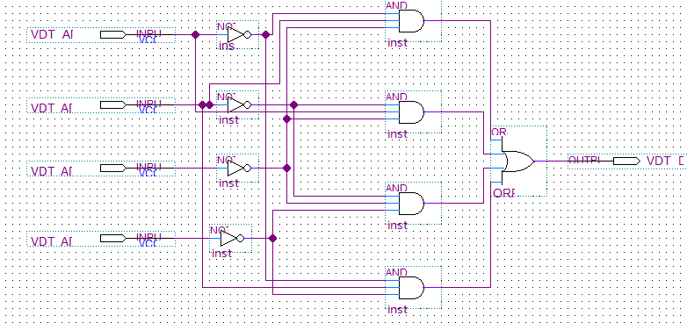
- D7
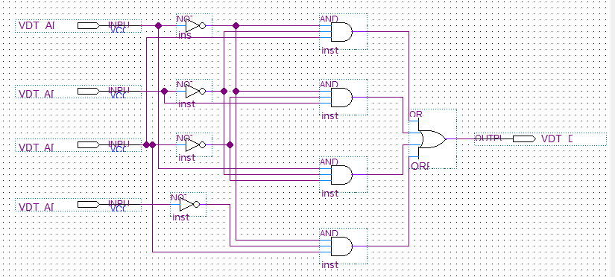

- Wareform set value
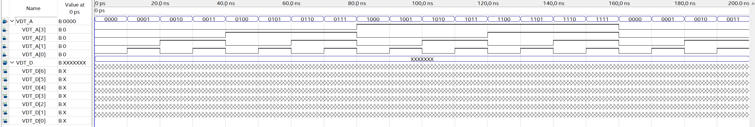
- Wareform result
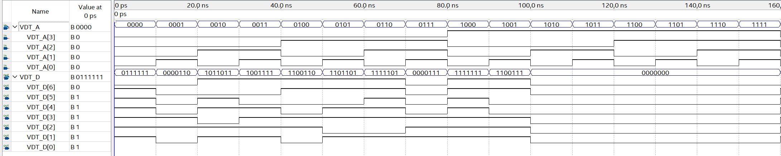

Assignment 4:
- Kmap and equations:
- Z5 = A2.A1
A2 \ A1A0 | 00 | 01 | 11 | 10
0 | 0 | 0 | 0 | 0
1 | 0 | 0 | 1 | 1

- Z4 = A2A1’ + A2A0
A2 \ A1A0 | 00 | 01 | 11 | 10
0 | 0 | 0 | 0 | 0
1 | 1 | 1 | 1 | 0

- Z3 = A2’A1A0 + A2A1’A0
A2 \ A1A0 | 00 | 01 | 11 | 10
0 | 0 | 0 | 1 | 0
1 | 0 | 1 | 0 | 0

- Z2 = A1A0’
A2 \ A1A0 | 00 | 01 | 11 | 10
0 | 0 | 0 | 0 | 1
1 | 0 | 0 | 0 | 1

- Z1 =0
A2 \ A1A0 | 00 | 01 | 11 | 10
0 | 0 | 0 | 0 | 0
1 | 0 | 0 | 0 | 0

- Z0 = A0
A2 \ A1A0 | 00 | 01 | 11 | 10
0 | 0 | 1 | 1 | 0
1 | 0 | 1 | 1 | 0

- Logic diagram
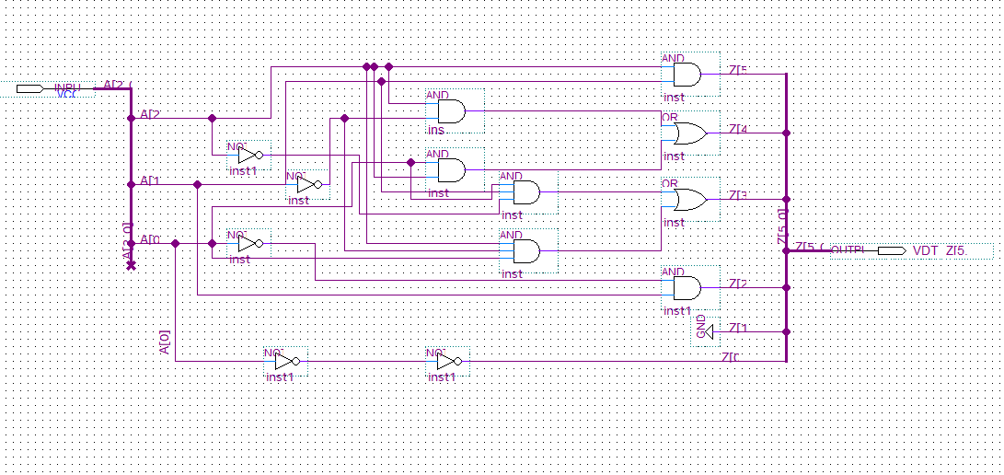

- Wareform set value

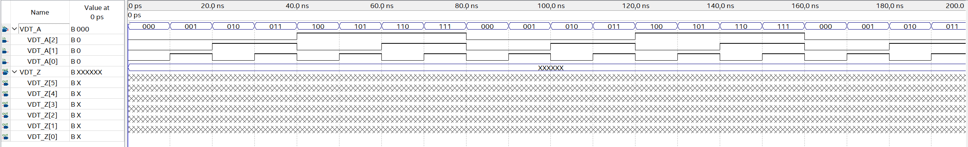
- Wareform result

