Assigment 1:
- COMP2
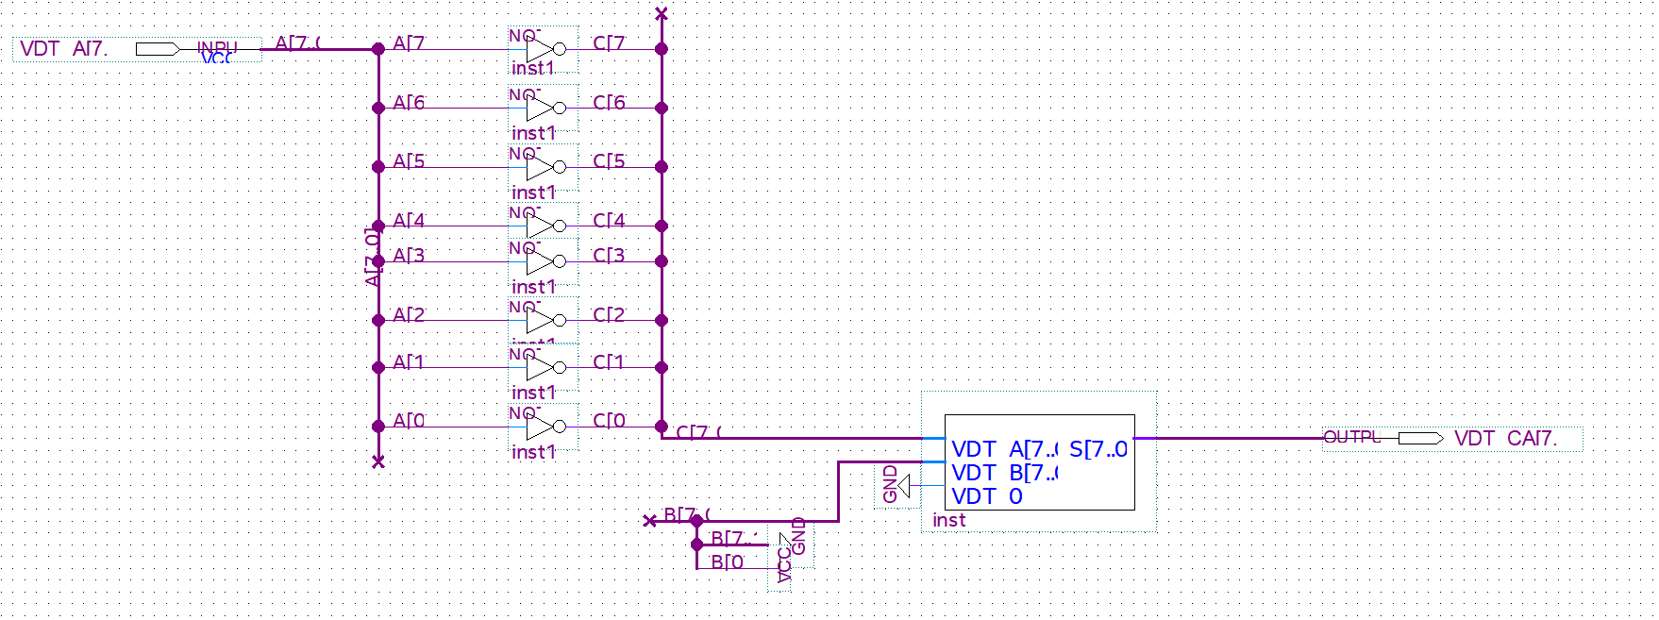
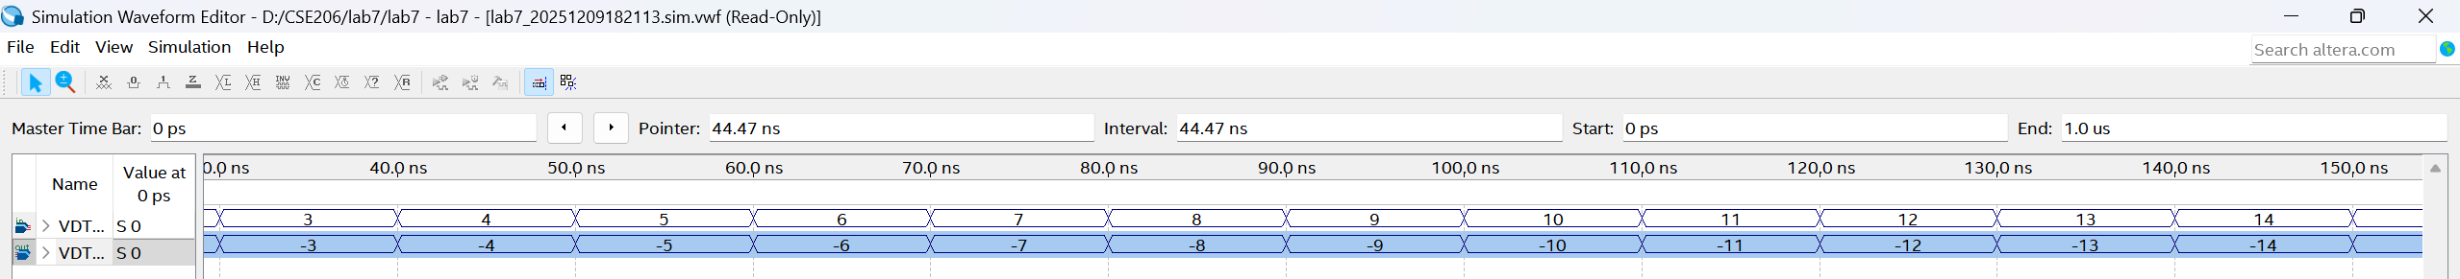

- ALU
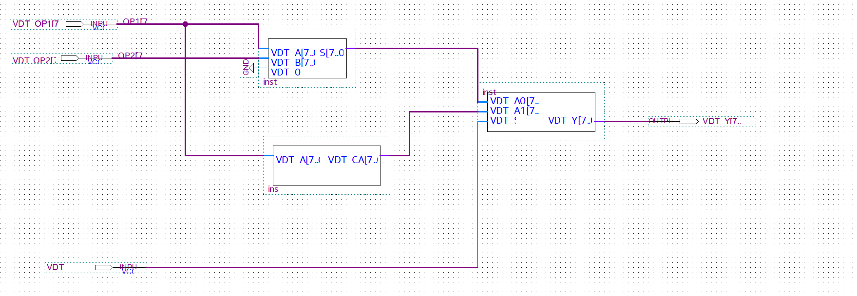

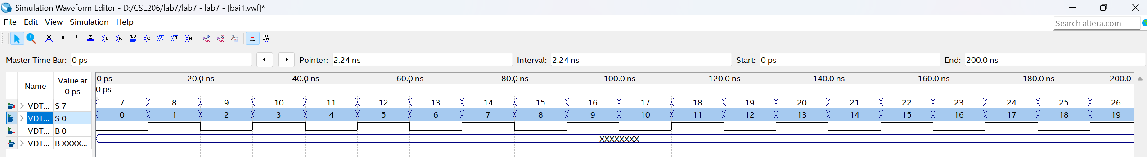
Assignment 2
- Derive the state diagram.
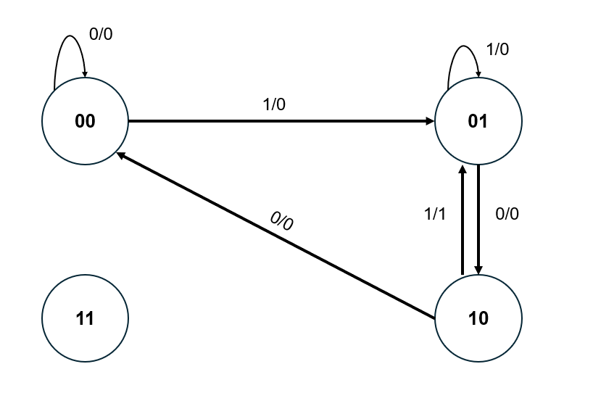
b. Derive the state table.
Present State |  | Input | Next state |  | Output
A | B | X | DA | DB | Y
0 | 0 | 0 | 0 | 0 | 0
0 | 0 | 1 | 0 | 1 | 0
0 | 1 | 0 | 1 | 0 | 0
0 | 1 | 1 | 0 | 1 | 0
1 | 0 | 0 | 0 | 0 | 0
1 | 0 | 1 | 0 | 1 | 1
1 | 1 | 0 | X | X | X
1 | 1 | 1 | X | X | X

c. Derive simplified expressions.
A / DA | 00 | 01 | 11 | 10
0 |  |  |  | 1
1 |  |  | X | X
DA = BX’
A / DB | 00 | 01 | 11 | 10
0 |  | 1 | 1
1 |  | 1 | X | X
DB = X
A / Y | 00 | 01 | 11 | 10
0
1 |  | 1 | X | X
Y = AX
d. Design the logic diagram.
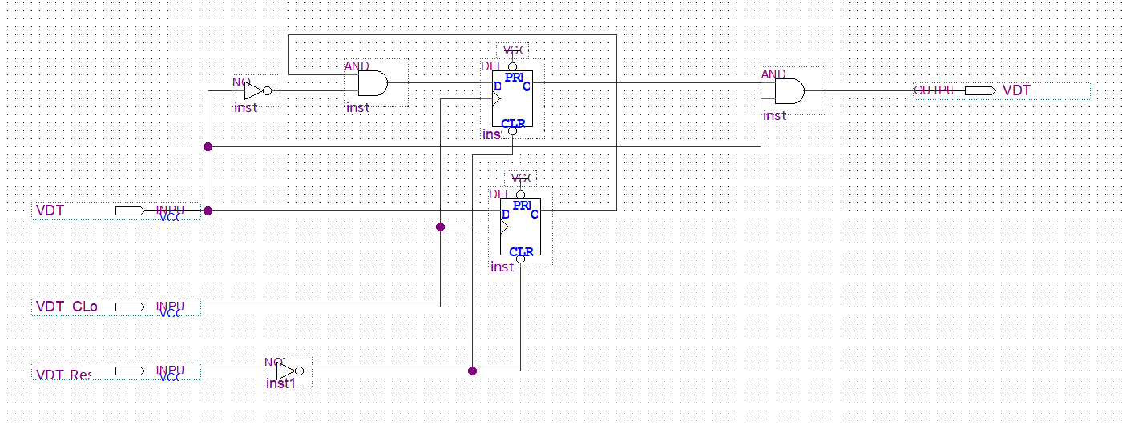
e. Simulate the circuit with the following requirements.
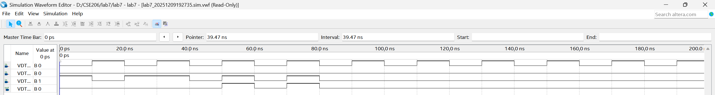

Assignment 3
- Derive the state diagram.
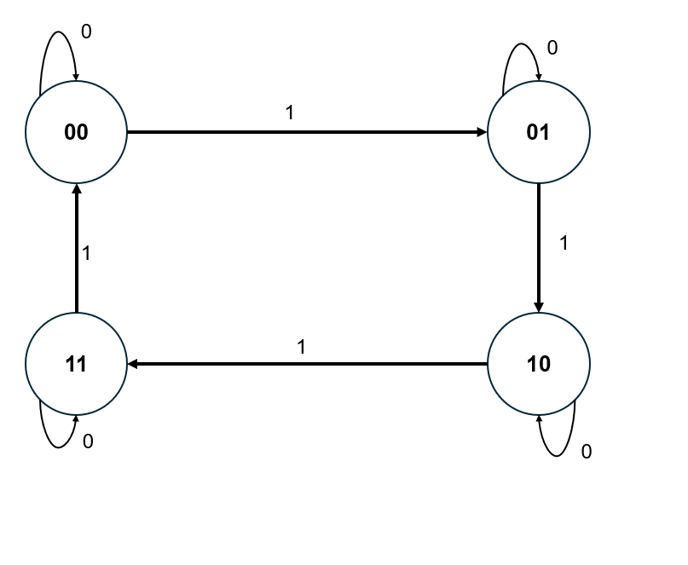
b. Derive the state table.

Present State |  | Input | Next state
A | B | X | DA | DB
0 | 0 | 0 | 0 | 0
0 | 0 | 1 | 0 | 1
0 | 1 | 0 | 0 | 1
0 | 1 | 1 | 1 | 0
1 | 0 | 0 | 1 | 0
1 | 0 | 1 | 1 | 1
1 | 1 | 0 | 1 | 1
1 | 1 | 1 | 0 | 0

c. Derive simplified Boolean expressions for D flip-flop inputs.

A/BX | 00 | 01 | 11 | 10
0 |  |  | 1
1 | 1 | 1 |  | 1
DA = AB’ + AX’ + A’BX
A / DA | 00 | 01 | 11 | 10
0 |  |  |  | 1
1 |  |  | X | X
DB = B’X + BX’

d. Design the logic diagram of the circuit.
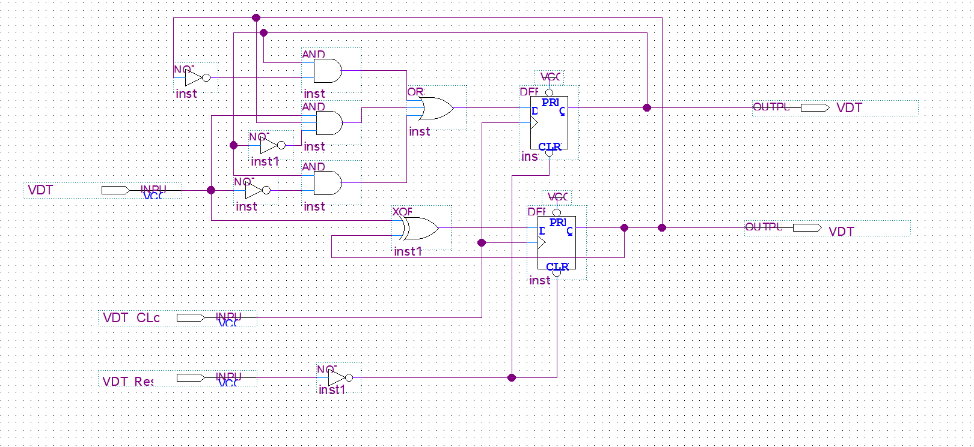
e. Simulate the circuit with the following requirements
