Name : Vũ Đức Tùng
IRN: 2331300132
Course : CSE 203
Lab 4
Problem 1 - 2 - 3:

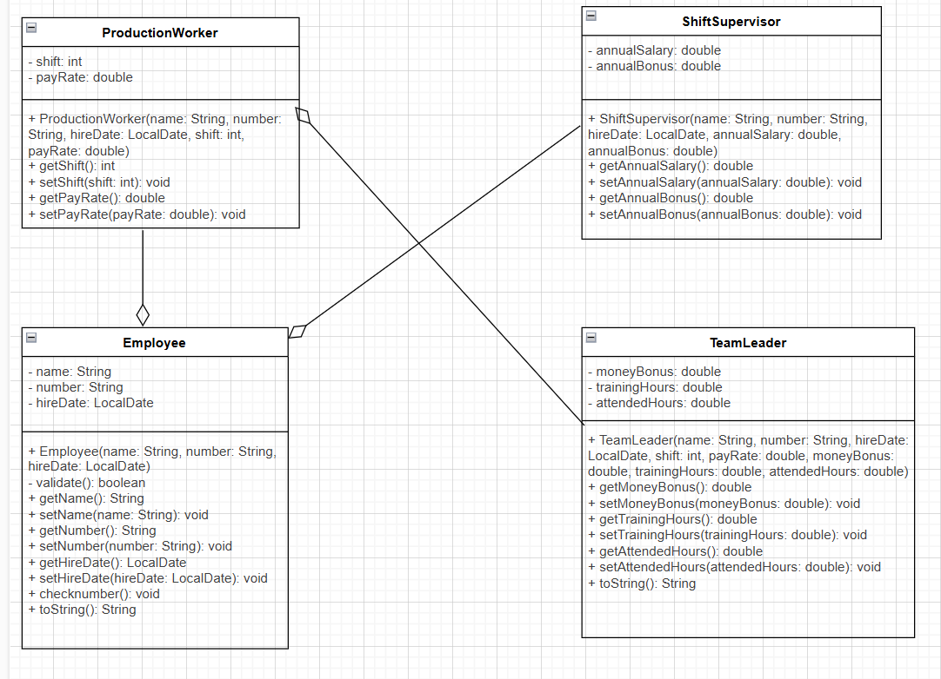

Problem 4 – 5 - 6:
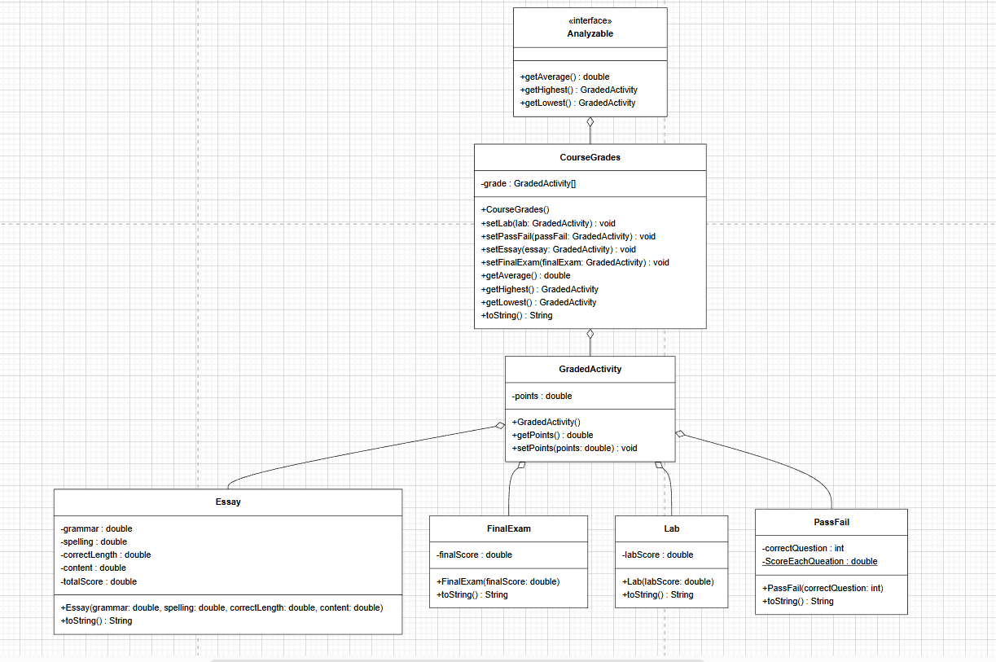

Problem 7 - 8:
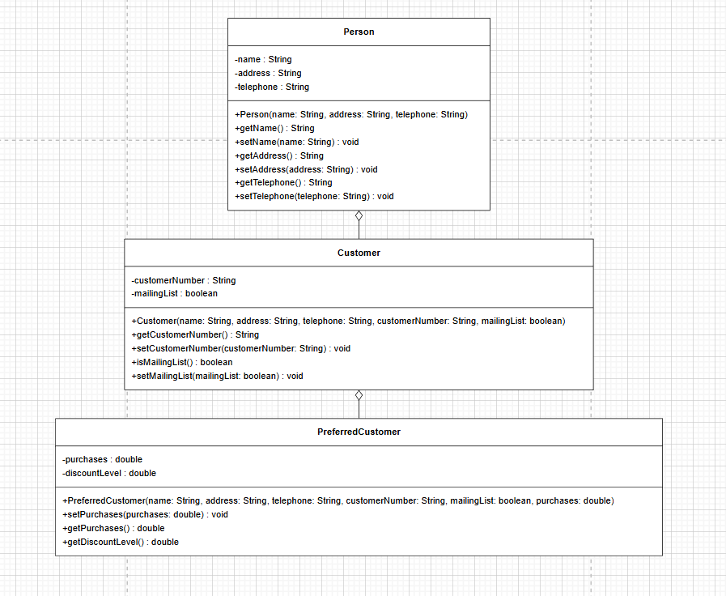

Problem 9:
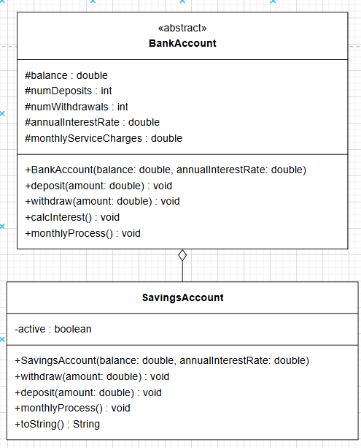

Problem 10:
