Name : Vũ Đức Tùng
IRN: 2331300132
Course : CSE 203
Lab 5
Problem 1, 5 : none
Problem 2:
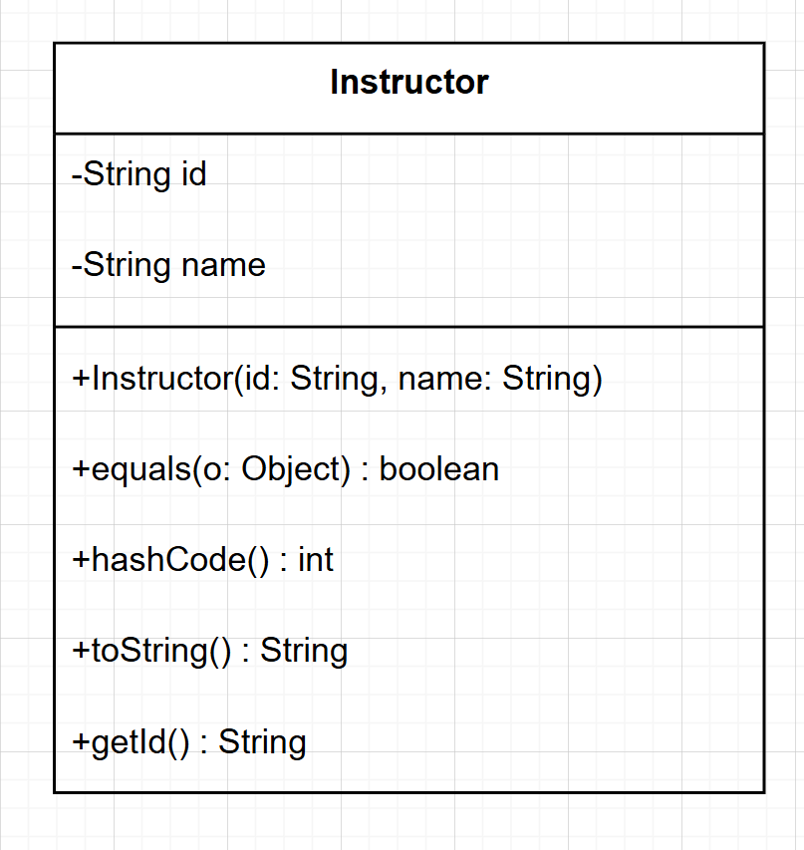

Problem 3 :
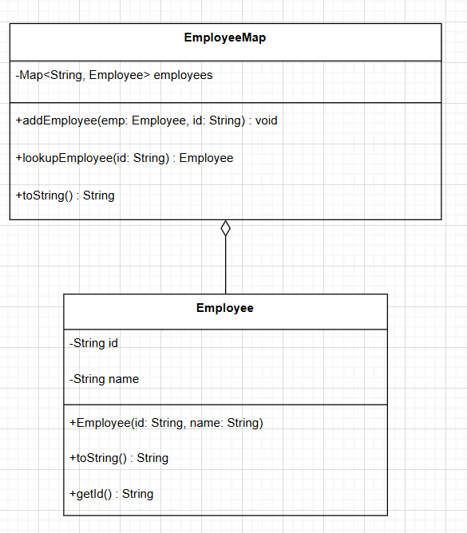

Problem 4:
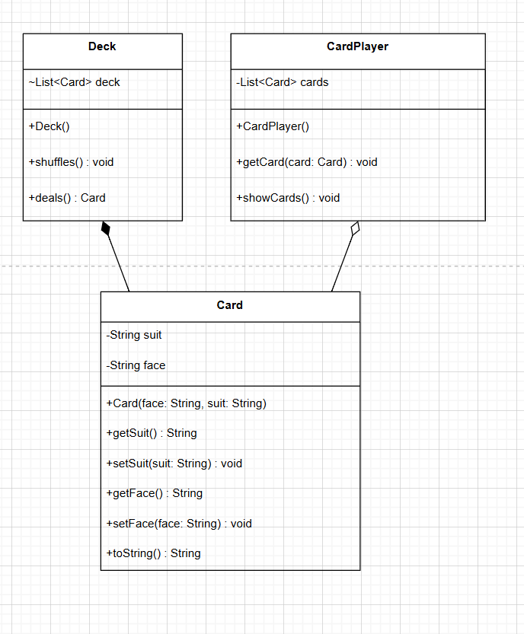

Problem 6 - 7:
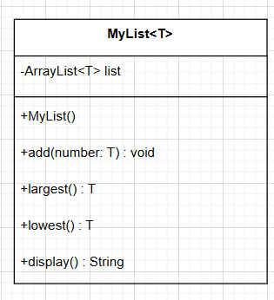

Problem 8 -9:
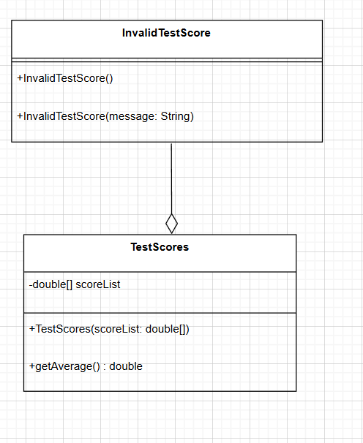

Problem 10 -11:
