Name : Vũ Đức Tùng
IRN: 2331300132
Course : CSE 203
Lab 7
Problem 1:
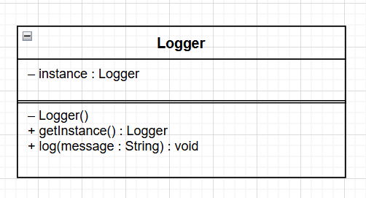
Problem 2:
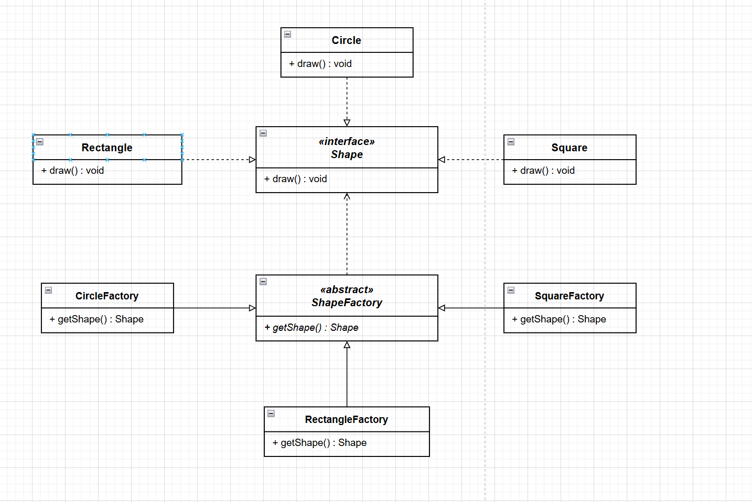
Problem 3:
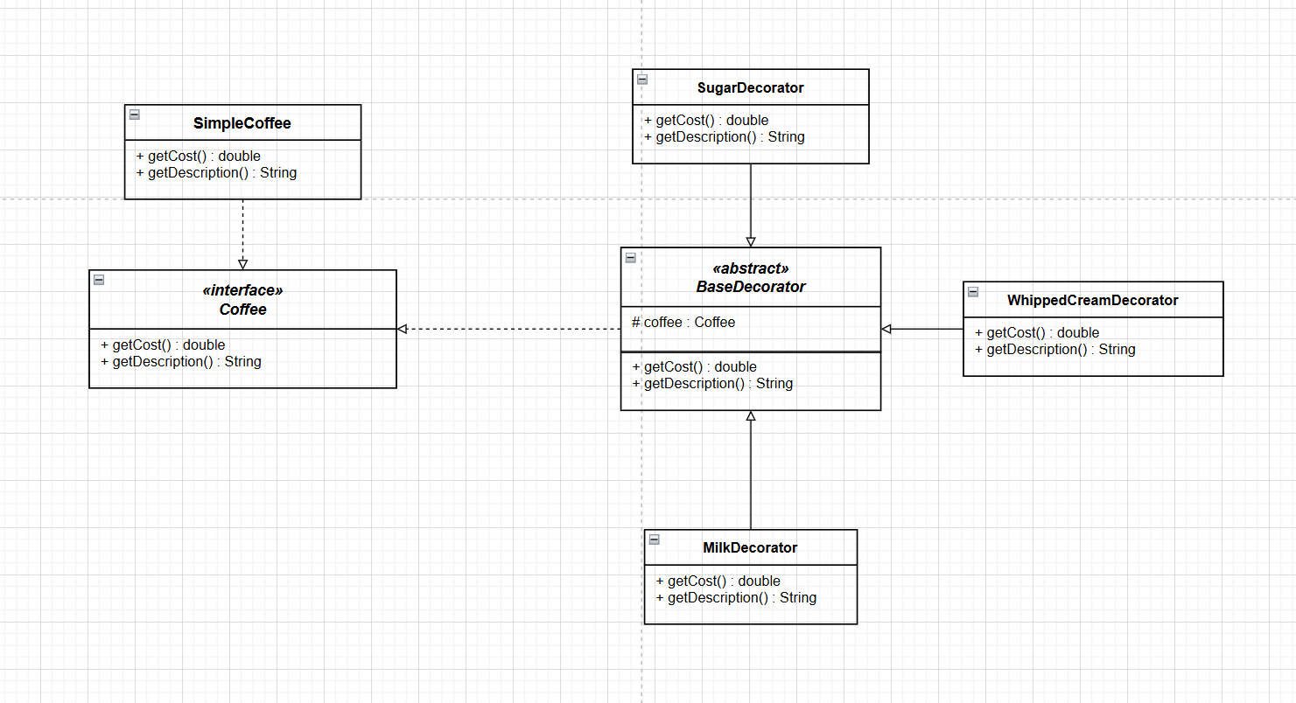
Problem 4:
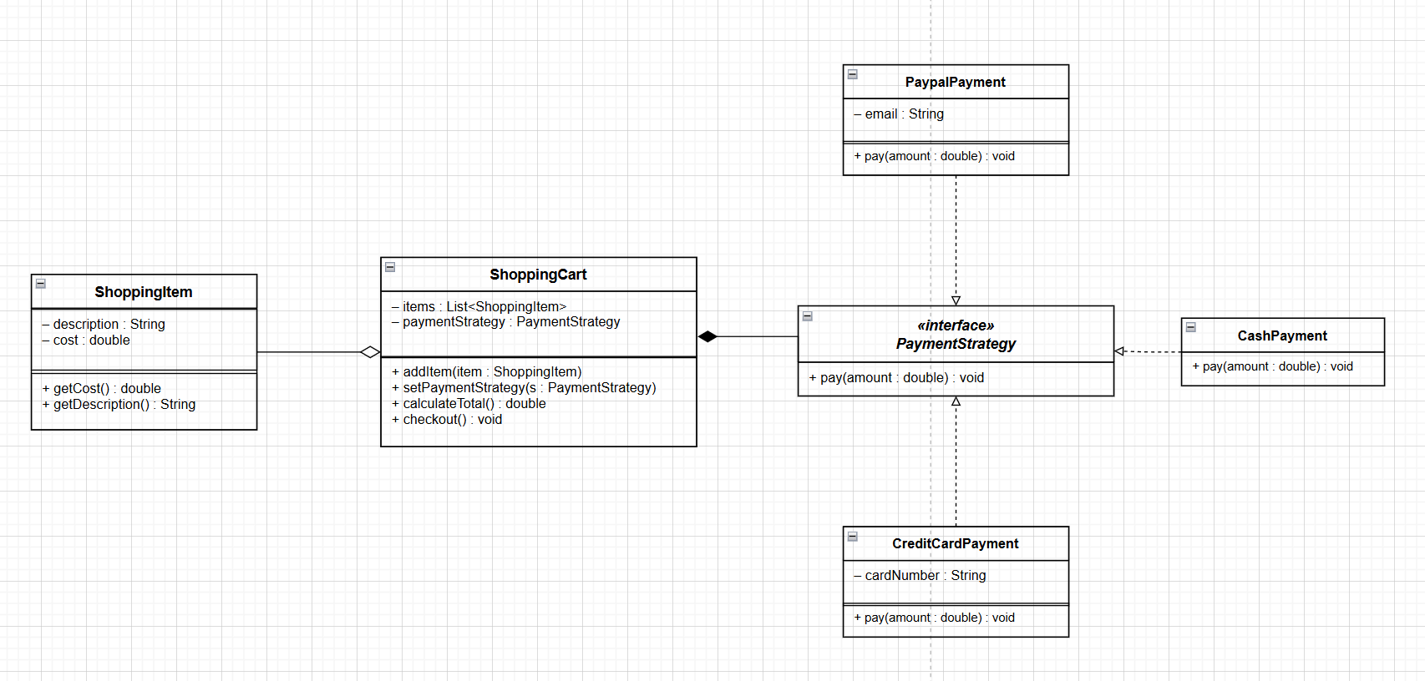

Problem 5:

