Abstract

Previous works
- Not good with continous long-tail response distribution
- Missed to optimize the accuracy of ranking uplift among individuals, which is the core of uplift modelling

Solutions
- Use Zero-inflated lognormal (ZILN loss) to regress the responses, customize models to adapt with uplift models
- Analyze theoritical of uplift ranking and propose 2 tighter errors bound as the additional loss terms to the convetional respone regression loss
- Directly modelize uplift ranking errors for whole dataset using listwise uplift ranking loss

Uplift modelling

Definition
- A set of techniques used to model the incremental impact of an action or treatment on a customer outcome.
- Its primary objective is to predict the expected difference in response between the treated group and the control group

Conversion and Revenue uplift modelling
- Conversion: binary variable 0/1. Neglecting the importance of Uplift ranking among the population
- Revenue: response label is a continuos variable with unlimited value range and irregular distribution

Learning to rank

Pointwise and pairwise
- Pointwise:
- Transforming ranking problem to a regression or classification task on each single object
- Models are trained to predict how relevant an object is for given query
- Cons:
- Exists a deviation between its optimization objective and the original ranking task
- Approach only considers the ranking problem from the perspective of a single individual, they can hardly consider all individuals at a time
- Pairwise:
- An alternative to pointwise
- Consider object in pairs
- Transform a ranking task to a binary classification task
- The models are designed to judge whether the order of each pair is wrong relative to the ground truth
- Pros:
- More promising results in practice compared to pointwise, because it comes closer to the nature of ranking than pointwise method
- Cons:
- Only consider from the perspective of an individual pair, make it hard when considering with all individuals.
- Significant drawback: ignoring the discrepancy among different pairs
- Mainly based on classification, hence, having big difficulty distinguishing the inner-pair uplift distance among different pairs
- More suitable with binary responses, such as conversion uplift problems
- In Revenue uplift scenerio, where responses are continous, performance can hardly be satisfied

Listwise
- Listwise:
- Most advanced approach, offering a comprehensive solution to overcome the drawbacks of pointwise and pairwise methods
- Consider all objects (or individuals) simultaneously
- Directly minmize the overall ranking error of all individiuals in the population
- Circumvent the limitation of pointwise and pairwise approaches
- In Uplift modelling, listwise methods are favored becasue they can discern the difference in continous outcomes
- Application in RERUM Framework:
- The RERUM Framework ultilizes a listwise uplift ranking loss (L lu-rank) to explicitly optimize the uplift model’s rankability
- This loss term is crucial because it directly models the uplift ranking error for the entire population
- The L lu-rank is specifically calculated using Cross-Entropy to measure the distance between the list of true uplift scores and the list of predicted uplift scores

Conditional Average Treatment Effect (CATE)

Definition and formula
- Defined as the expected difference in response between the treatment and the control groups, conditioned on the observed covariates (xi)
- Mathematical formulation:
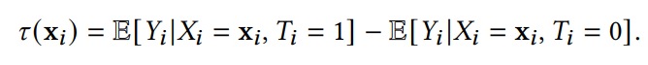
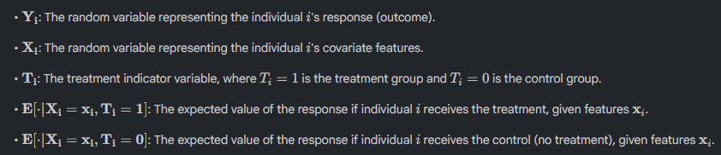

CATE in Uplift modeling context
- Uplift modeling is related to both Casual Inference and Machine learning problems. The concept originates from the Neyman-Rubin potential outcome framework
- Individiual treatment effect (ITE): defined as . However, due to the fundamental problem of Casual Inference, we can never observe potential outcomes for an individual
- Estimation CATE: Because ITE cannot directly observe, CATE is used as an practical alternative. CATE estimates the uplift effect for studied individual
- Response regression: CATE estimating requires accurate revenue response regression for both the treatment and control group

The role of CATE in rankability
- In practical applications like online marketing, CATE plays a critical role in the usefulness of the uplift model
- Core objective: The ultimate purpose of the uplift model is to determine the individuals who are more susceptible to the treatment and then intervene with them differently according to the ranking of their uplift values
- The relationship between Rankability and CATE: the model’s rankability is maximized when the uplift is estimated perfectly. Therefore, precise estimation of the CATE is paramount for successful uplift ranking. The RERUM framework focuses on enhancing the precision of rankability because previous methods ignore optimizing it, which is the core of uplift modeling

Backbones

Meta learners
- They are pioneer works aimed at estimating the personalized uplift effect across different individuals. They ultilize base supervised learning or regression methods to construct the CATE estimate
- S-Learner (Single-Learner)
- Use single estimator to predict the response, making treatment indicator (T) as a feature.
- Uplift is estimated by subtracting the estimation when T=1 and when T=0
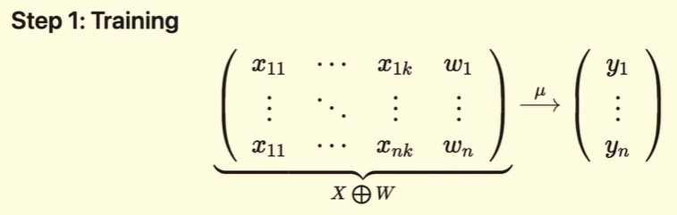
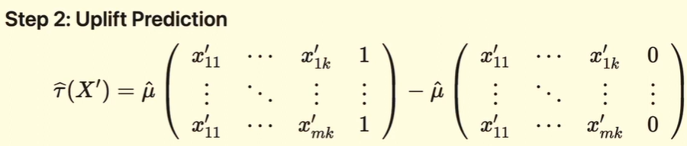
- T-Learner (Two-model)
- Train 2 seperated estimators on the treated and control group data, respectively.
- Uplift is estimated as the difference between two predictions
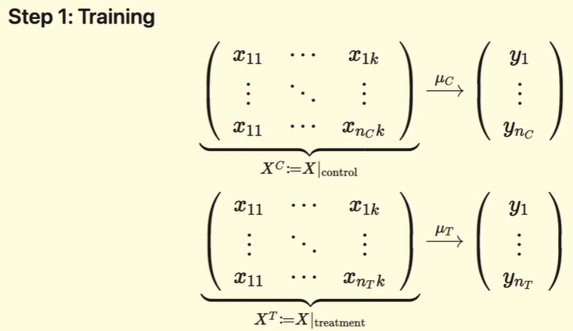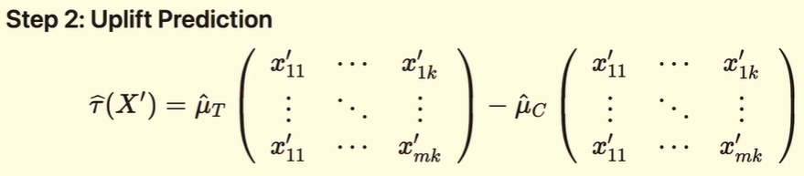
- X-Learner
- Perform particularly well when the treatment groups are imbalanced.
- 2 Stages:
- Stage 1: Impute missing potential outcomes
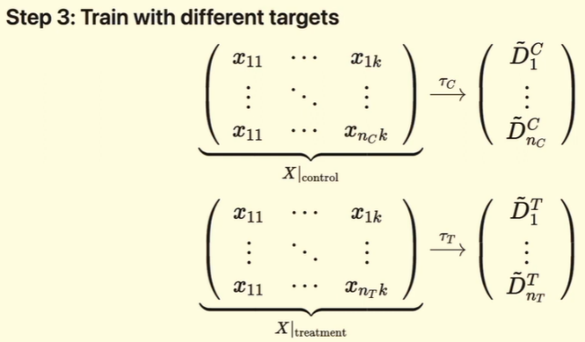
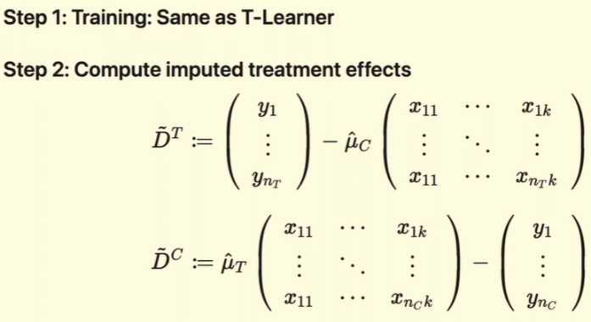
- Stage 2: Create imputed treatment effects to train CATE models
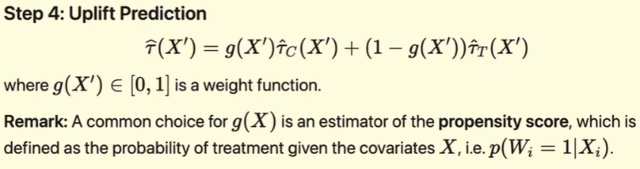

Tree-based methods
- Random forest-based model that directly estimates the treatment effect. These models adapt the splitting criteria of conventional decision trees to address issues like sample imblance
- Direct uplift models: Use existing machine learning algorithms to directly infer a treatment effect.

Deep learning
- These mothods represent the currently dominant approach in uplift modeling, ultilizing deep neural networks
- These are Representation Learning methods that primarily focus on balancing the representation distributions of individuals in the treated and control groups
- RERUM chooses these deep learning models to be the backbones becasue they have strong abilities to capture complex and non-linear relationships between covariates and responses

Specific models

TAR (Treatment-Agnostic Representation)
- Definition: a commonly used deep learning-based uplift model
- Mechanism
- Compared to T-Learner, TAR ignores the additional imputed treatment effects fitting sub-models. Instead, it introduces shared layers for the treated and control response networks
- Benefit: Shared network parameters help minimize sample imbalance issue between the treatment and control groups

CFR (Counterfactual Regression), including and
- Definition: is built on the basis of TAR
- Mechanism: apply additional loss term to TAR, which forces the learned treated and control covariate distributions to be closer
- Variants: CFR udes different distance measurement loss functions to evaluate the performance
- : Uses the Wasserstein distance
- : Uses the Maximum Mean Discreapancy (MMD) distance

StableCFR
- This variant improves CFR by upsampling the underrepresented data and balancing covariates using an epsilon-greedy matching mechanism to achieve higher estimation accuracy for the underrepresented population

CITE (Contrastive Indiviual Treatment Effects Estimation)
- Mechanism: is a causal inference model based on a contrastive task. It effectively exploits self-supervison information hidden in the data to achieve balanced and predictive representations

DragonNet

Definition and core principle
- Basis: is an advanced deep neural network architecture for Causual Effect Estimation, relying on the sufficiency of the propensity score for estimation adjustment
- Purpose: provide an end-to-end process to estimate both the conditional outcome and propensity score
- Intuition: the model works based on the intuition that only covariates (x) relevent for predicting the treatment assignment (T) are necessary for causal effect estimation. Other covariates are relevant only to outcome Y but not to T acts noise

The Three-headed architecture
- DragonNet is often called the “three-headed architecture” because it contains a shared representation layer feeding into three distinct output heads

Ta có

Incremental impact: tác động gia tăng
Ground truth: thứ tự đúng
Ignoring discrepency: bỏ qua sự khác biệt
Representation learning methods (phương pháp học biểu diễn) là các kỹ thuật trong machine learning, đặc biệt là deep learning, nhằm tự động trích xuất, xây dựng, và tối ưu những biểu diễn (representations) hữu ích từ dữ liệu thô. Trong lĩnh vực uplift modeling/causal inference là tự động học các đặc trưng của dữ liệu sao cho đảm bảo tính cân bằng giữa các nhóm—nhằm kiểm soát nhiễu, tăng tính chính xác và khả năng áp dụng của mô hình trong thực tế.
Propensity score: xác suất một cá nhân nhận được treatment dựa trên các đặc trưng đã quan sát. Được sử dụng để cân bằng đặc trưng giữa nhóm can thiệp và nhóm đối chứng, giúp giảm sai lệch lựa chọn và cải thiện độ chính xác khi ước tính ảnh hưởng của treatment

