title

*Note: Sub-titles are not captured in Xplore and should not be used

line 1: 1st Given Name Surname   
line 2: *dept. name of organization   
(of Affiliation)*  
line 3: *name of organization   
(of Affiliation)*line 4: City, Country  
line 5: email address or ORCID

line 1: 4th Given Name Surname  
line 2: *dept. name of organization*  
*(of Affiliation)*  
line 3: *name of organization   
(of Affiliation)*line 4: City, Country  
line 5: email address or ORCIDline 1: 2nd Given Name Surname  
line 2: *dept. name of organization   
(of Affiliation)*  
line 3: *name of organization   
(of Affiliation)*line 4: City, Country  
line 5: email address or ORCID

line 1: 5th Given Name Surname  
line 2: *dept. name of organization   
(of Affiliation)*  
line 3: *name of organization   
(of Affiliation)*line 4: City, Country  
line 5: email address or ORCIDline 1: 3rd Given Name Surname  
line 2: *dept. name of organization   
(of Affiliation)*  
line 3: *name of organization   
(of Affiliation)*line 4: City, Country  
line 5: email address or ORCID

line 1: 6th Given Name Surname  
line 2: *dept. name of organization   
(of Affiliation)*  
line 3: *name of organization   
(of Affiliation)*line 4: City, Country  
line 5: email address or ORCID

*Abstract* - - Finding path problem studied by many researchers, have been growing fast and have remarkable results in the 21st century. The problem of finding path is defined as the discovery and plotting of an optimal route between two points on a plane. Its applications can be used on many real – life task. This article is about to explore deeper isnto some finding path algorithms, then build a simple robot to simulate the finding path problem on an already setup map[1]. We choose Breadth-First Search, A* Search and a Markov Decison Process approach for algorithms with briefly explanations and how to implement them. For the robot, we will build a LEGO EV3 Mindstorm line-follwer robot, and explain how the robot works and how it uses two color sensors to recognise path on the map and traverse through it. Then, we calculate the time needed for the robot to traverse from starting point to destination point for each algorithm used. From that, we make explanations, comparisons between those algorithms and conclusions about the problem. Furthermore, we also discuss about applying a newly Reinforcement Learning method on the problem, which tend to deal with the main disadvantage of previous methods.

Keywords—component, formatting, style, styling, insert (key words)

# Introduction (*Heading 1*)

This template, modified in MS Word 2007 and saved as a “Word 97-2003 Document” for the PC, provides authors with most of the formatting specifications needed for preparing e.

# EApplied algorithrm

## BFS

Depthfirst search (DFS) is an algorithm for traversing or searching tree or graph data structures. The algorithm starts at the root node (selecting some arbitrary node as the root node in the case of a graph) and explores as far as possible along each branch before backtracking.

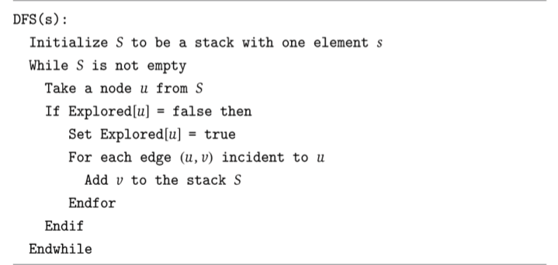

## MDP

Markov Decision Process (MDP) is meant to be a straightforward framing of the problem of learning from interaction to achieve a goal.

The agent and the environment interact continually, the agent selecting actions and the environment responding to these actions and presenting new situations to the agent.

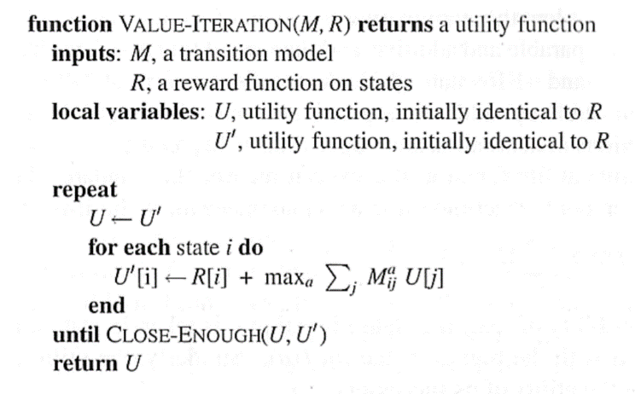

## A*

The equations are an exception to the prescribed specifications of this template. You will need to determine whether or not your equation should be typed using either the Times New Roman or the Symbol font (please no other font). To create multileveled equations, it may be necessary to treat the equation as a graphic and insert it into the text after your paper is styled.

Number equations consecutively. Equation numbers, within parentheses, are to position flush right, as in (1), using a right tab stop. To make your equations more compact, you may use the solidus ( / ), the exp function, or appropriate exponents. Italicize Roman symbols for quantities and variables, but not Greek symbols. Use a long dash rather than a hyphen for a minus sign. Punctuate equations with commas or periods when they are part of a sentence, as in:

*a*  *b*    

# Discussion & evaluation

After the text edit has been completed, the paper is ready for the template. Duplicate the template file by using the Save As command, and use the naming convention prescribed by your conference for the name of your paper. In this newly created file, highlight all of the contents and import your prepared text file. You are now ready to style your paper; use the scroll down window on the left of the MS Word Formatting toolbar.

## Authors and Affiliations

**The template is designed for, but not limited to, six authors.** A minimum of one author is required for all conference articles. Author names should be listed starting from left to right and then moving down to the next line. This is the author sequence that will be used in future citations and by indexing services. Names should not be listed in columns nor group by affiliation. Please keep your affiliations as succinct as possible (for example, do not differentiate among departments of the same organization).

### For papers with more than six authors: Add author names horizontally, moving to a third row if needed for more than 8 authors.

### For papers with less than six authors: To change the default, adjust the template as follows.

#### Selection: Highlight all author and affiliation lines.

#### Change number of columns: Select the Columns icon from the MS Word Standard toolbar and then select the correct number of columns from the selection palette.

#### Deletion: Delete the author and affiliation lines for the extra authors.

## Identify the Headings

Headings, or heads, are organizational devices that guide the reader through your paper. There are two types: component heads and text heads.

Component heads identify the different components of your paper and are not topically subordinate to each other. Examples include Acknowledgments and References and, for these, the correct style to use is “Heading 5”. Use “figure caption” for your Figure captions, and “table head” for your table title. Run-in heads, such as “Abstract”, will require you to apply a style (in this case, italic) in addition to the style provided by the drop down menu to differentiate the head from the text.

Text heads organize the topics on a relational, hierarchical basis. For example, the paper title is the primary text head because all subsequent material relates and elaborates on this one topic. If there are two or more sub-topics, the next level head (uppercase Roman numerals) should be used and, conversely, if there are not at least two sub-topics, then no subheads should be introduced. Styles named “Heading 1”, “Heading 2”, “Heading 3”, and “Heading 4” are prescribed.

## Figures and Tables

#### Positioning Figures and Tables: Place figures and tables at the top and bottom of columns. Avoid placing them in the middle of columns. Large figures and tables may span across both columns. Figure captions should be below the figures; table heads should appear above the tables. Insert figures and tables after they are cited in the text. Use the abbreviation “Fig. 1”, even at the beginning of a sentence.

1. Table Type Styles

| Table Head | Table Column Head | | |
| --- | --- | --- | --- |
| Table column subhead | Subhead | Subhead |
| copy | More table copya |  |  |

1. Sample of a Table footnote. (*Table footnote*)
2. Example of a figure caption. (*figure caption*)

Figure Labels: Use 8 point Times New Roman for Figure labels. Use words rather than symbols or abbreviations when writing Figure axis labels to avoid confusing the reader. As an example, write the quantity “Magnetization”, or “Magnetization, M”, not just “M”. If including units in the label, present them within parentheses. Do not label axes only with units. In the example, write “Magnetization (A/m)” or “Magnetization {A[m(1)]}”, not just “A/m”. Do not label axes with a ratio of quantities and units. For example, write “Temperature (K)”, not “Temperature/K”.

##### Acknowledgment *(Heading 5)*

The preferred spelling of the word “acknowledgment” in America is without an “e” after the “g”. Avoid the stilted expression “one of us (R. B. G.) thanks ...”. Instead, try “R. B. G. thanks...”. Put sponsor acknowledgments in the unnumbered footnote on the first page.

##### References

The template will number citations consecutively within brackets [1]. The sentence punctuation follows the bracket [2]. Refer simply to the reference number, as in [3]—do not use “Ref. [3]” or “reference [3]” except at the beginning of a sentence: “Reference [3] was the first ...”

Number footnotes separately in superscripts. Place the actual footnote at the bottom of the column in which it was cited. Do not put footnotes in the abstract or reference list. Use letters for table footnotes.

Unless there are six authors or more give all authors’ names; do not use “et al.”. Papers that have not been published, even if they have been submitted for publication, should be cited as “unpublished” [4]. Papers that have been accepted for publication should be cited as “in press” [5]. Capitalize only the first word in a paper title, except for proper nouns and element symbols.

For papers published in translation journals, please give the English citation first, followed by the original foreign-language citation [6].

1. G. Eason, B. Noble, and I. N. Sneddon, “On certain integrals of Lipschitz-Hankel type involving products of Bessel functions,” Phil. Trans. Roy. Soc. London, vol. A247, pp. 529–551, April 1955. *(references)*
2. J. Clerk Maxwell, A Treatise on Electricity and Magnetism, 3rd ed., vol. 2. Oxford: Clarendon, 1892, pp.68–73.
3. I. S. Jacobs and C. P. Bean, “Fine particles, thin films and exchange anisotropy,” in Magnetism, vol. III, G. T. Rado and H. Suhl, Eds. New York: Academic, 1963, pp. 271–350.
4. K. Elissa, “Title of paper if known,” unpublished.
5. R. Nicole, “Title of paper with only first word capitalized,” J. Name Stand. Abbrev., in press.
6. Y. Yorozu, M. Hirano, K. Oka, and Y. Tagawa, “Electron spectroscopy studies on magneto-optical media and plastic substrate interface,” IEEE Transl. J. Magn. Japan, vol. 2, pp. 740–741, August 1987 [Digests 9th Annual Conf. Magnetics Japan, p. 301, 1982].
7. M. Young, The Technical Writer’s Handbook. Mill Valley, CA: University Science, 1989.

**IEEE conference templates contain guidance text for composing and formatting conference papers. Please ensure that all template text is removed from your conference paper prior to submission to the conference. Failure to remove template text from your paper may result in your paper not being published.**

We suggest that you use a text box to insert a graphic (which is ideally a 300 dpi TIFF or EPS file, with all fonts embedded) because, in an MSW document, this method is somewhat more stable than directly inserting a picture.

To have non-visible rules on your frame, use the MSWord “Format” pull-down menu, select Text Box > Colors and Lines to choose No Fill and No Line.