Plant Protection Product Evaluation Report
Issuing authority: Fictional Crop Science Authority (FCSA) · Report ID: FCSA-PPR-2026-0042 · Issued on: 2026-04-18 (v1.0)
Overall summary. This report covers 2 products; 1 of them under conditional approval. Average efficacy across all applications: 86.3%.

AgriShield 250 EC

HIGH RISK NOTICE
This product carries a composite risk score of 78 out of 100 and requires elevated regulatory scrutiny. Consult the Restrictions section before authorising any application.

Active substance: Fictoxazole (250 g/L) · Formulation: Emulsifiable concentrate (EC) · Manufacturer: Demo CropChem GmbH
Germany: Zugelassen gem. PflSchG — Status: conditional. Valid from 2025-01-01 to 2027-12-31.
This product is registered for 3 crops with an average efficacy of 83.7%.

Applications
Crop | Target pest | Stage  (BBCH) | Dose | Max/  season | Efficacy | PHI  (days)
Winter wheat | Septoria tritici | 31-39 | 1 L/ha | 2 | 88% | 35
Winter barley | Ramularia collo-cygni | 37-49 | 1.25 L/ha | 2 | 84% | 35
Winter oilseed rape | Phoma lingam | 14-20 | 0.8 L/ha | 1 | 79% | 56

Toxicity Indicators
Ld50 Oral Rat Mg Per Kg | 1450
Ld50 Dermal Rat Mg Per Kg | 2000
Fish Lc50 96H Mg Per L | 0.89
Bee Ld50 Oral Microg Per Bee | 12.4
Earthworm Lc50 14D Mg Per Kg | 145

Risk Components
Human Health | 45
Ecotoxicology | 82
Environmental Fate | 78
Residue In Food | 30

Efficacy by crop
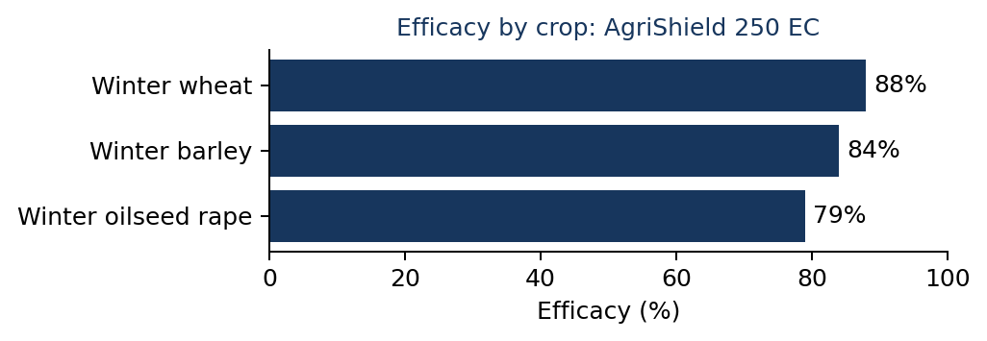

Restrictions
• Do not apply within 10 m of surface water bodies.
• Use closed-cab application equipment.
• Maximum two applications per growing season.
• Field re-entry only after spray deposit has dried.

Environmental notes
• Persistent in soil under cool, dry conditions; field DT50 = 92 days.
• Low risk of leaching to groundwater under typical European conditions.
• Moderate risk to non-target arthropods at edge-of-field.

Verdura 75 WG
Active substance: Lumicarb-methyl (750 g/kg) · Formulation: Water-dispersible granules (WG) · Manufacturer: Demo CropChem GmbH
Country: FR · Approval status: approved. Valid from 2024-06-01 to 2029-05-31.
This product is registered for 2 crops with an average efficacy of 89.0%.

Applications
Crop | Target pest | Stage  (BBCH) | Dose | Max/  season | Efficacy | PHI  (days)
Tomato (greenhouse) | Botrytis cinerea | 61-89 | 0.6 kg/ha | 3 | 91% | 7
Grapevine | Erysiphe necator (powdery mildew) | 53-81 | 0.4 kg/ha | 4 | 87% | 21

Toxicity Indicators
Ld50 Oral Rat Mg Per Kg | 3200
Ld50 Dermal Rat Mg Per Kg | 5000
Fish Lc50 96H Mg Per L | 4.6
Bee Ld50 Oral Microg Per Bee | 89
Earthworm Lc50 14D Mg Per Kg | 480

Risk Components
Human Health | 38
Ecotoxicology | 51
Environmental Fate | 36
Residue In Food | 44

Efficacy by crop
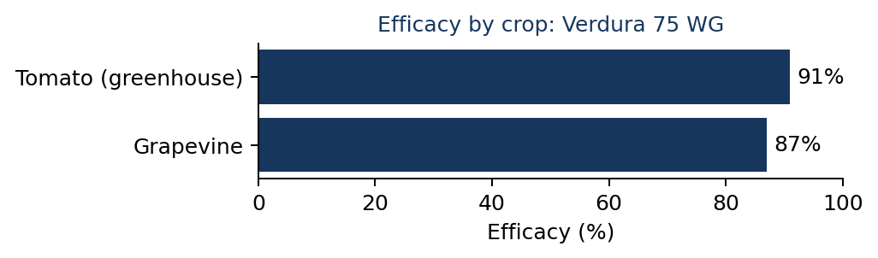

Environmental notes
• Rapid degradation in soil; field DT50 = 8 days.
• Low bioaccumulation potential.
• Acceptable risk to bees under good agricultural practice.

