Plant Protection Product Evaluation Report
Fictional Crop Science Authority (FCSA)
Report ID | FCSA-PPR-2026-0042
Issued on | 2026-04-18
Version | 1.0
Locale | en-EU
Classification | INTERNAL

Executive Summary
Products assessed | 2
Conditional approvals | 1
High-risk products | 1
Overall average efficacy | 86.3%
This report was generated from structured JSON input after schema validation, business-rule mapping, chart generation, and DOCX template rendering.

AgriShield 250 EC
Product ID: FCSA-PROD-AS250
Active substance: Fictoxazole (250 g/L)
Formulation: EC - Emulsifiable concentrate
Manufacturer: Demo CropChem GmbH
Germany: Zugelassen gem. PflSchG - Status: conditional. Valid from 2025-01-01 to 2027-12-31.
Risk score: 78
Applications assessed: 3
Average efficacy: 83.7%

HIGH RISK NOTICE / HOCHRISIKO-HINWEIS: This product exceeds the high-risk threshold with a risk score of 78. Additional regulatory review is required.

Applications
Crop | Target pest | BBCH | Dose | Max apps | Efficacy | PHI days
Winter wheat | Septoria tritici | 31-39 | 1 L/ha | 2 | 88% | 35
Winter barley | Ramularia collo-cygni | 37-49 | 1.25 L/ha | 2 | 84% | 35
Winter oilseed rape | Phoma lingam | 14-20 | 0.8 L/ha | 1 | 79% | 56

Risk Components
Component | Score
Human Health | 45
Ecotoxicology | 82
Environmental Fate | 78
Residue In Food | 30

Toxicity Indicators
Indicator | Value
Ld50 Oral Rat Mg Per Kg | 1450
Ld50 Dermal Rat Mg Per Kg | 2000
Fish Lc50 96H Mg Per L | 0.89
Bee Ld50 Oral Microg Per Bee | 12.4
Earthworm Lc50 14D Mg Per Kg | 145

Efficacy Chart
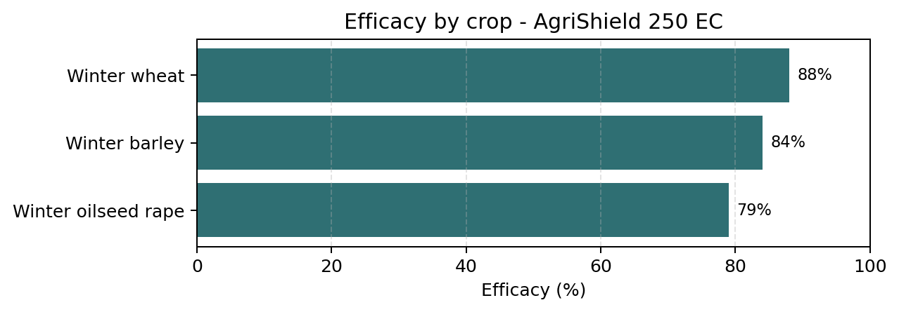

Auflagen und Beschrankungen

- Do not apply within 10 m of surface water bodies.

- Use closed-cab application equipment.

- Maximum two applications per growing season.

- Field re-entry only after spray deposit has dried.

Environmental Notes

- Persistent in soil under cool, dry conditions; field DT50 = 92 days.

- Low risk of leaching to groundwater under typical European conditions.

- Moderate risk to non-target arthropods at edge-of-field.

References

- EFSA Journal (fictional): FIC-2026-12345

Verdura 75 WG
Product ID: FCSA-PROD-VR075
Active substance: Lumicarb-methyl (750 g/kg)
Formulation: WG - Water-dispersible granules
Manufacturer: Demo CropChem GmbH
Country: FR. Status: approved. Valid from 2024-06-01 to 2029-05-31.
Risk score: 42
Applications assessed: 2
Average efficacy: 89.0%

Applications
Crop | Target pest | BBCH | Dose | Max apps | Efficacy | PHI days
Tomato (greenhouse) | Botrytis cinerea | 61-89 | 0.6 kg/ha | 3 | 91% | 7
Grapevine | Erysiphe necator (powdery mildew) | 53-81 | 0.4 kg/ha | 4 | 87% | 21

Risk Components
Component | Score
Human Health | 38
Ecotoxicology | 51
Environmental Fate | 36
Residue In Food | 44

Toxicity Indicators
Indicator | Value
Ld50 Oral Rat Mg Per Kg | 3200
Ld50 Dermal Rat Mg Per Kg | 5000
Fish Lc50 96H Mg Per L | 4.6
Bee Ld50 Oral Microg Per Bee | 89
Earthworm Lc50 14D Mg Per Kg | 480

Efficacy Chart
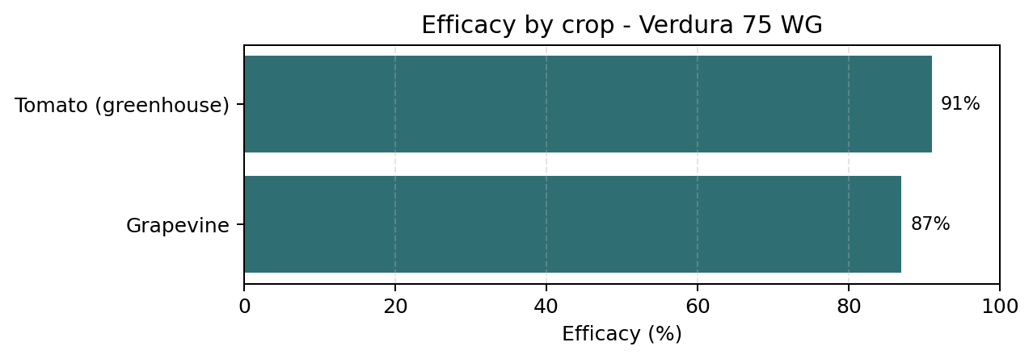

Environmental Notes

- Rapid degradation in soil; field DT50 = 8 days.

- Low bioaccumulation potential.

- Acceptable risk to bees under good agricultural practice.

References

- EU Pesticides Database (fictional): FIC-EUPD-2024-00911

