**Accessing your School Shared Calendar in Outlook**

*Your new ‘000 – Shared Calendar’ should add itself to Outlook automatically. If it does not, please follow this process.*

1. Open Outlook and go to Calendar
2. Right click “My Calendars” > Select **Add Calendar** > **From Address Book**  
     
   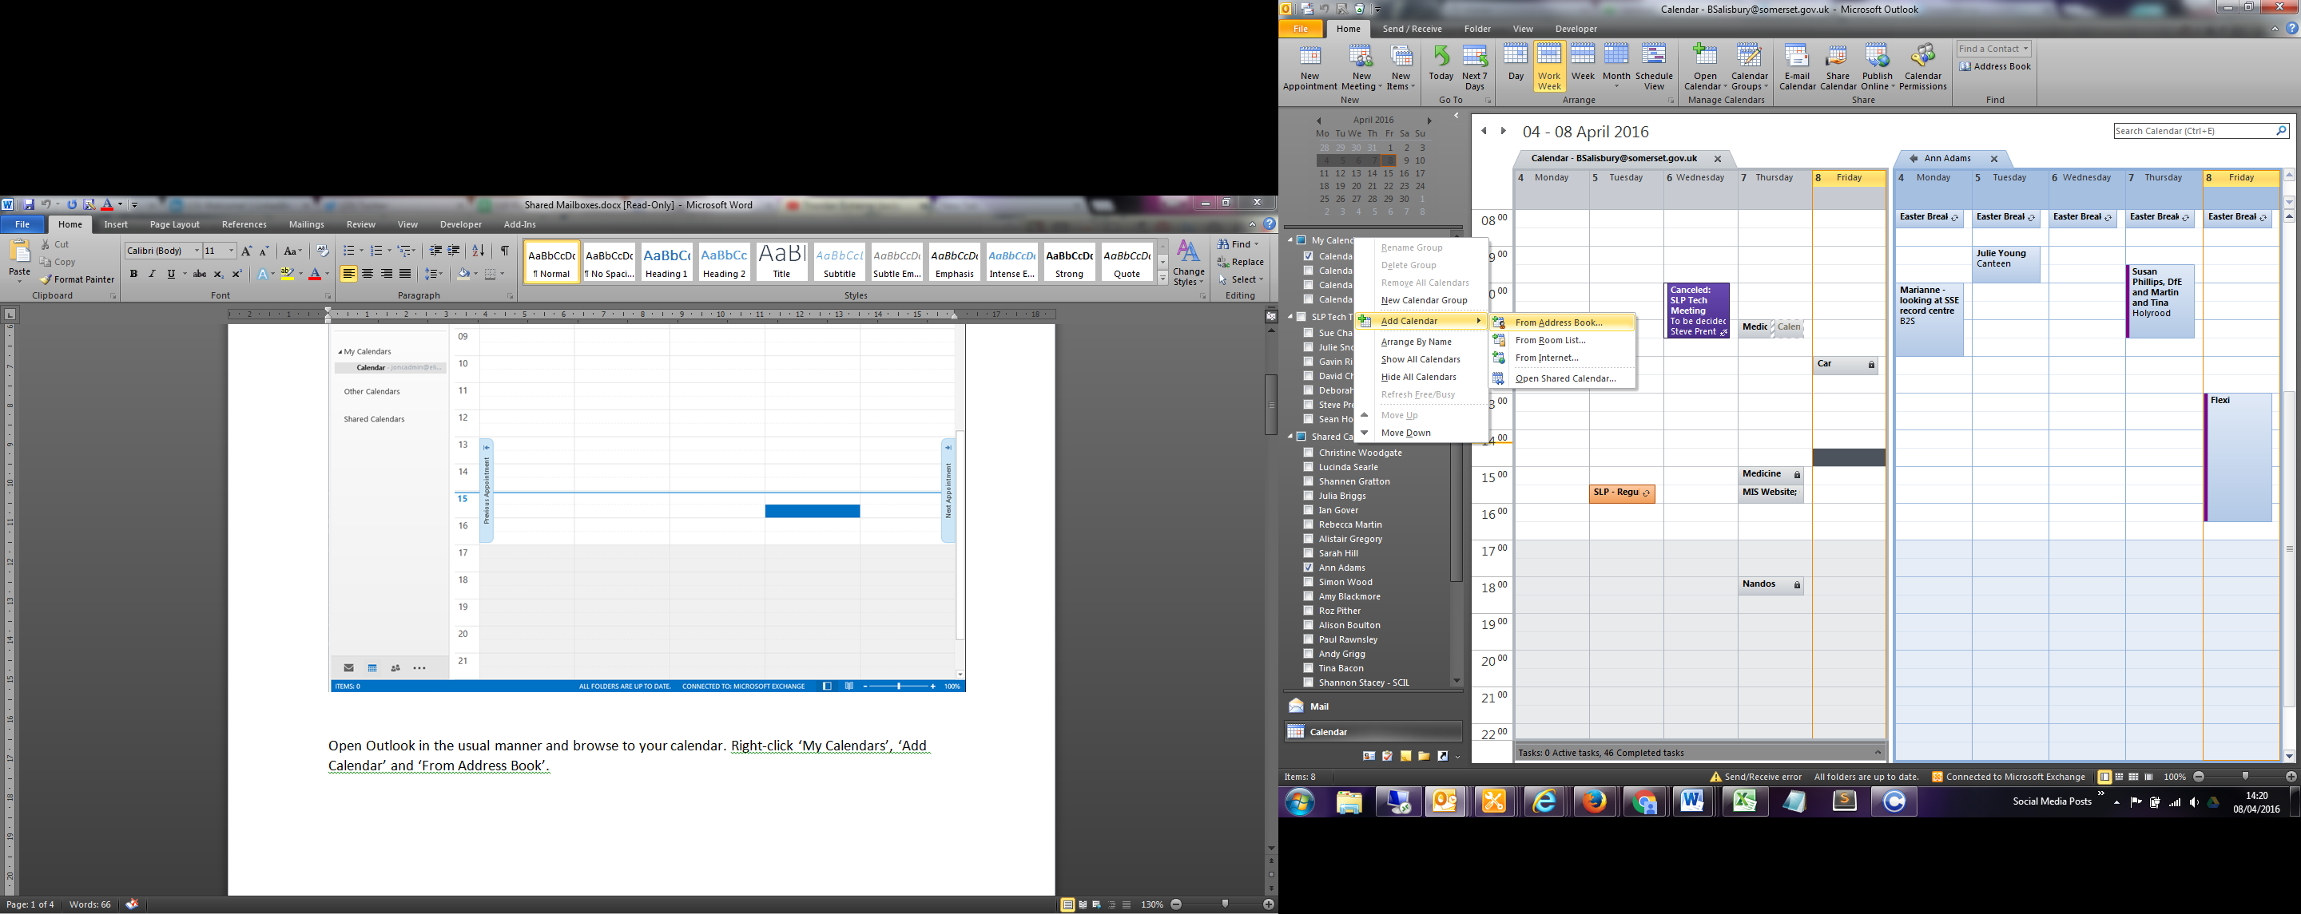  
     
   In the prompt box, type **000 – Shared Calendar**  
     
   Select your Calendar, Click **Calendar ->** and then **OK**  
   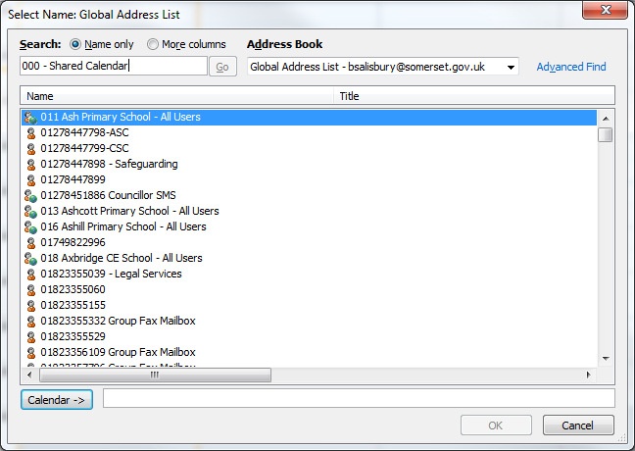
3. Your Calendar will then begin adding itself to Outlook.