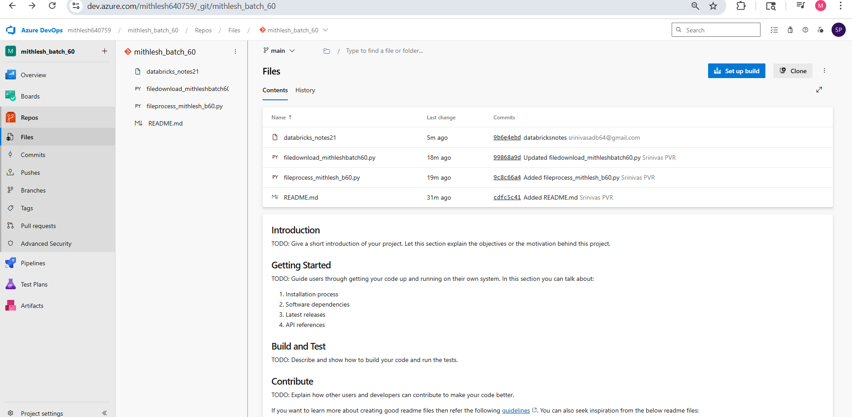

Go to repos and initialize the main branch:

Then create files and then for creating new branch just clock new branch and add or modify files in new branch and create pr to merge changes to main

Click on create repo
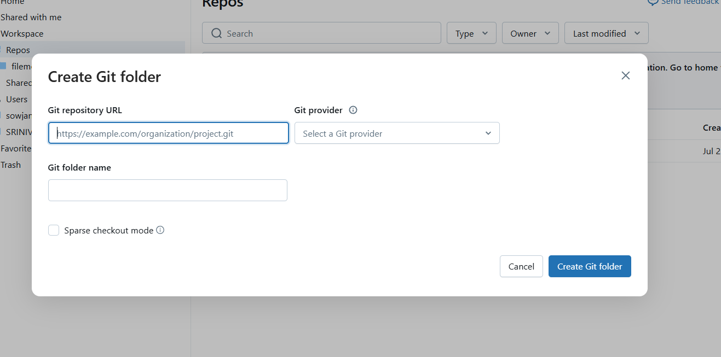

Url copy from azure dev aex ,by clicking clone and paste in git repository url to connect to azure devops.

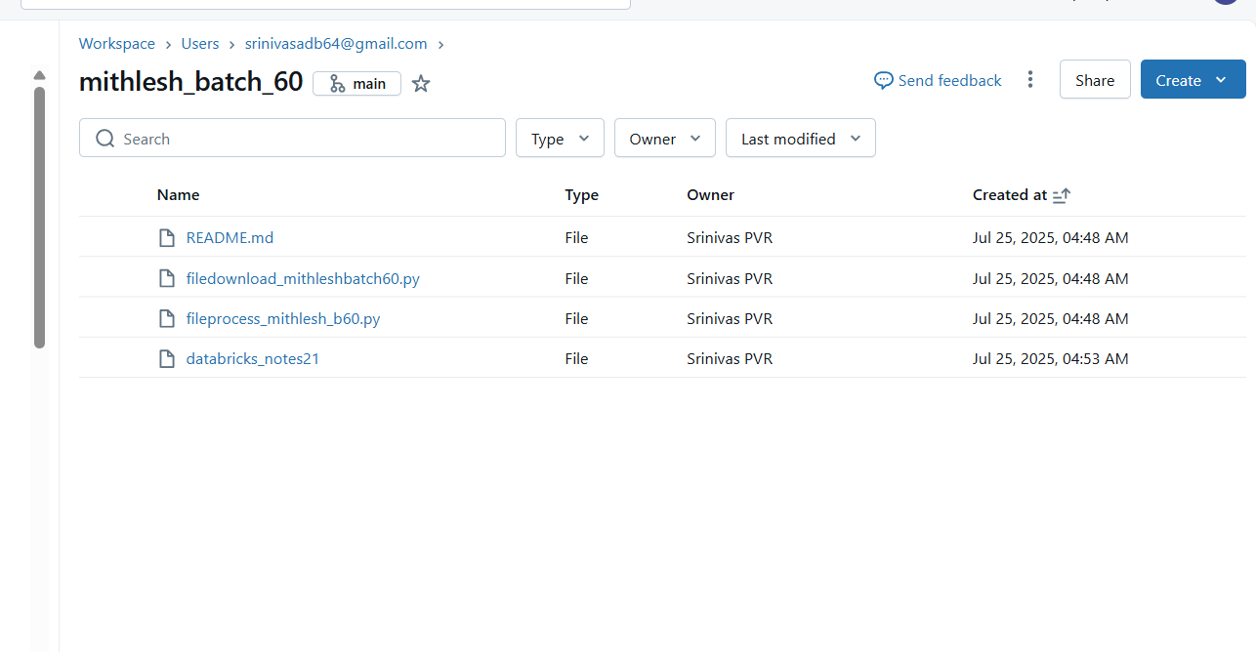
Once created click on the main button and create a new branch in window as below and do pull

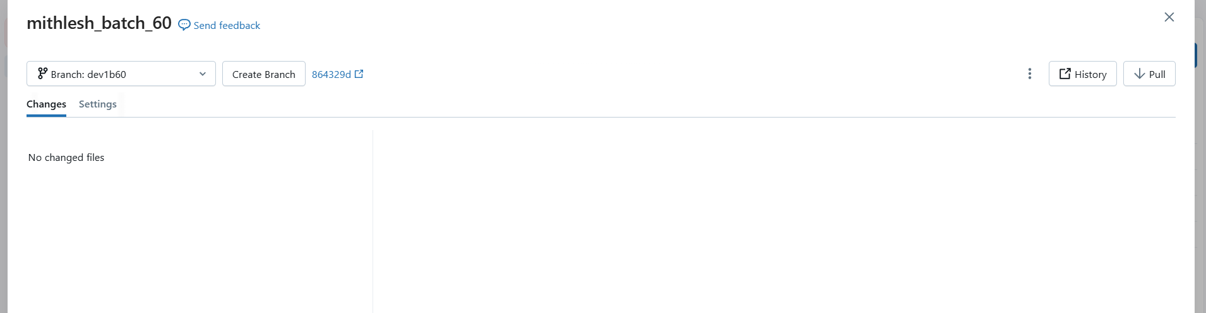

Do a clone for transfer file from local folder to the nwe branch

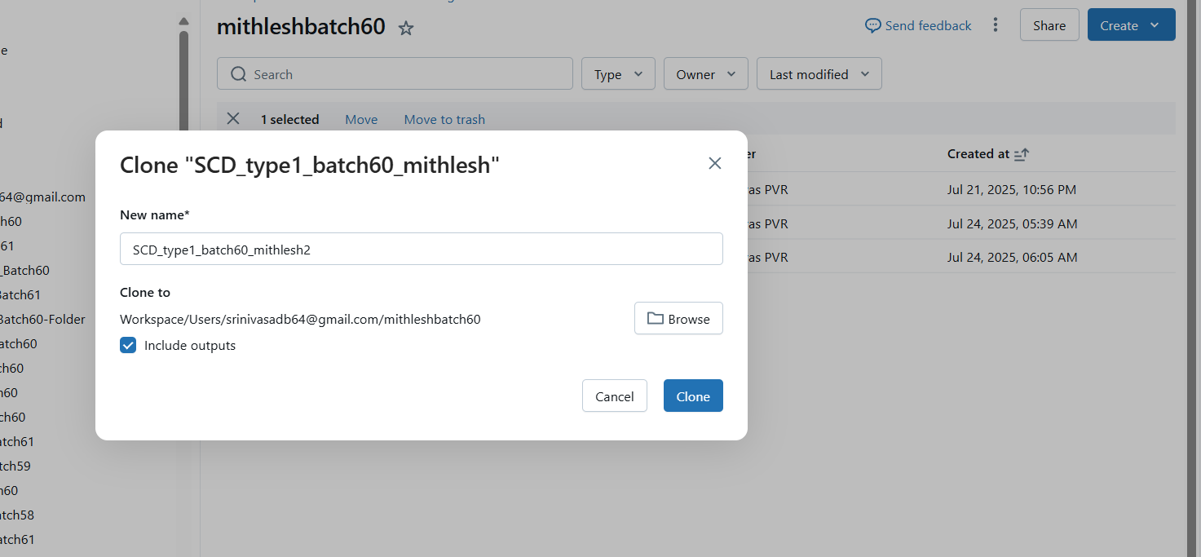

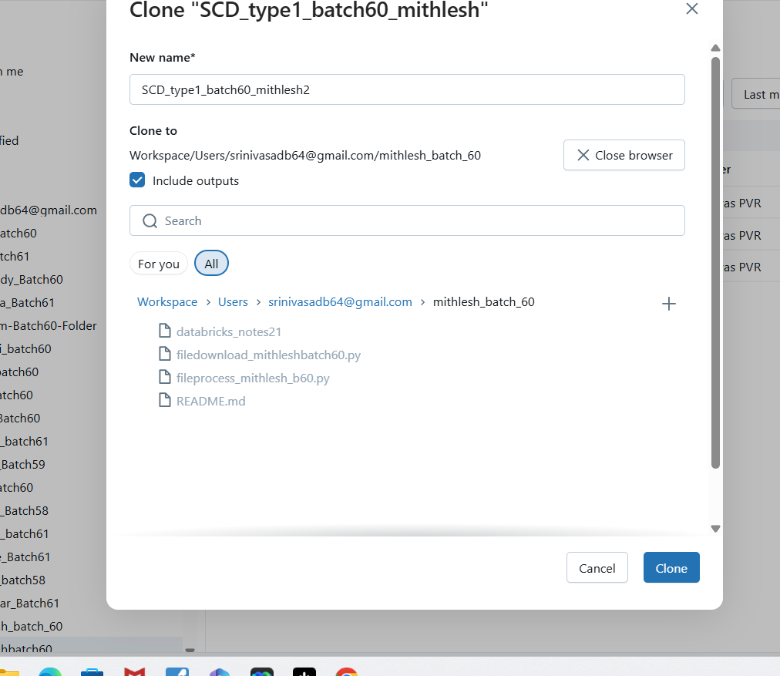

Your branch a file is added:

These change are performed in local branch dev1b60

New file SCD is added
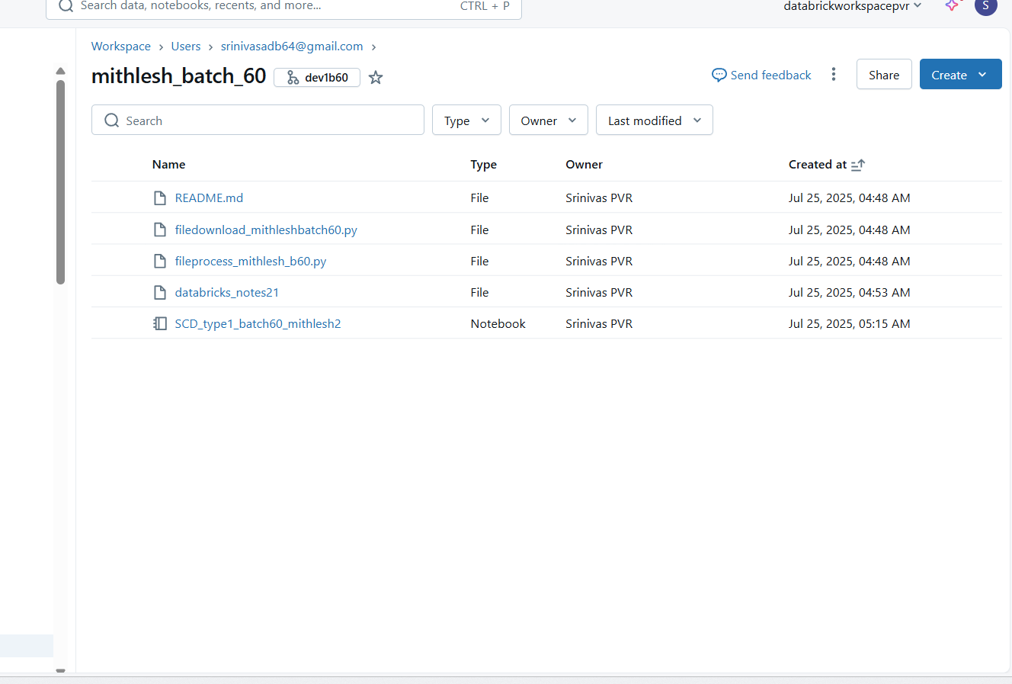

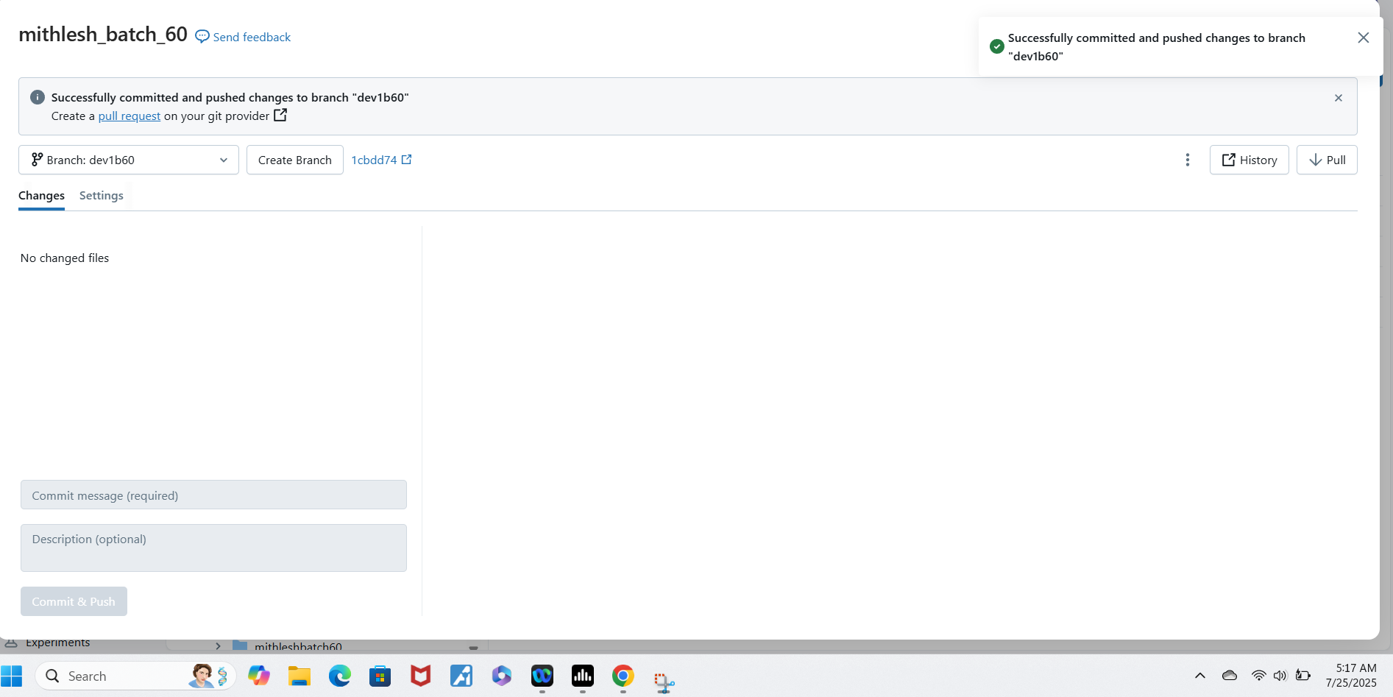

CREATE PR:

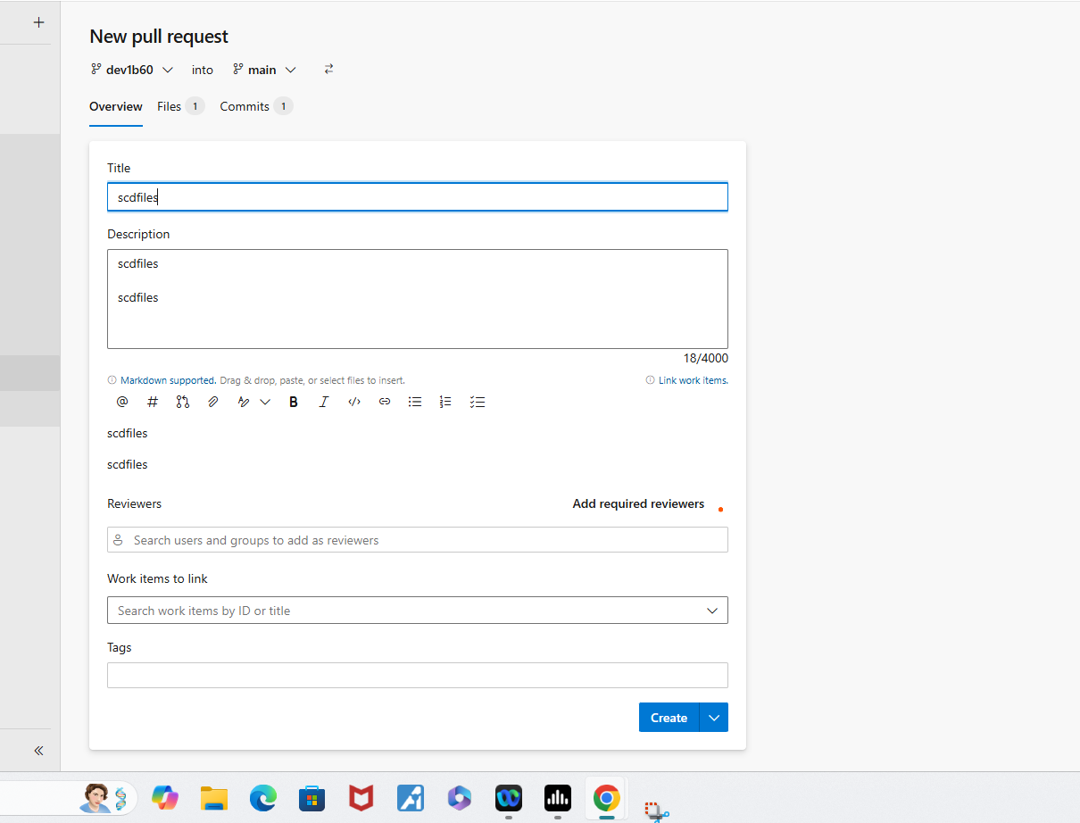

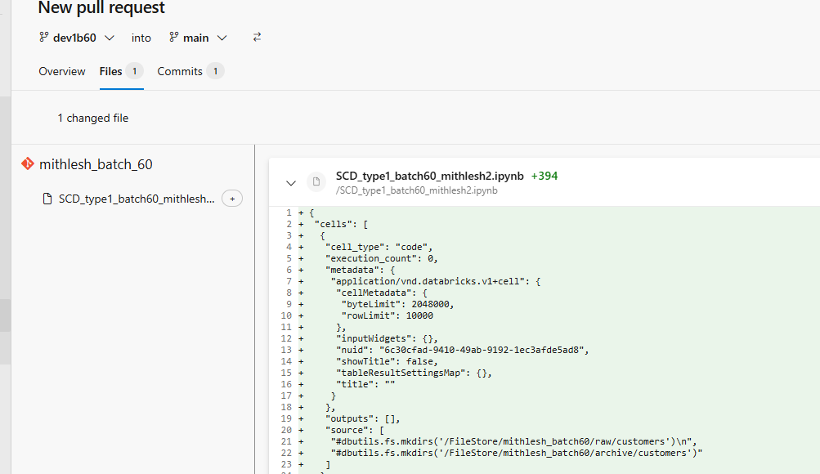

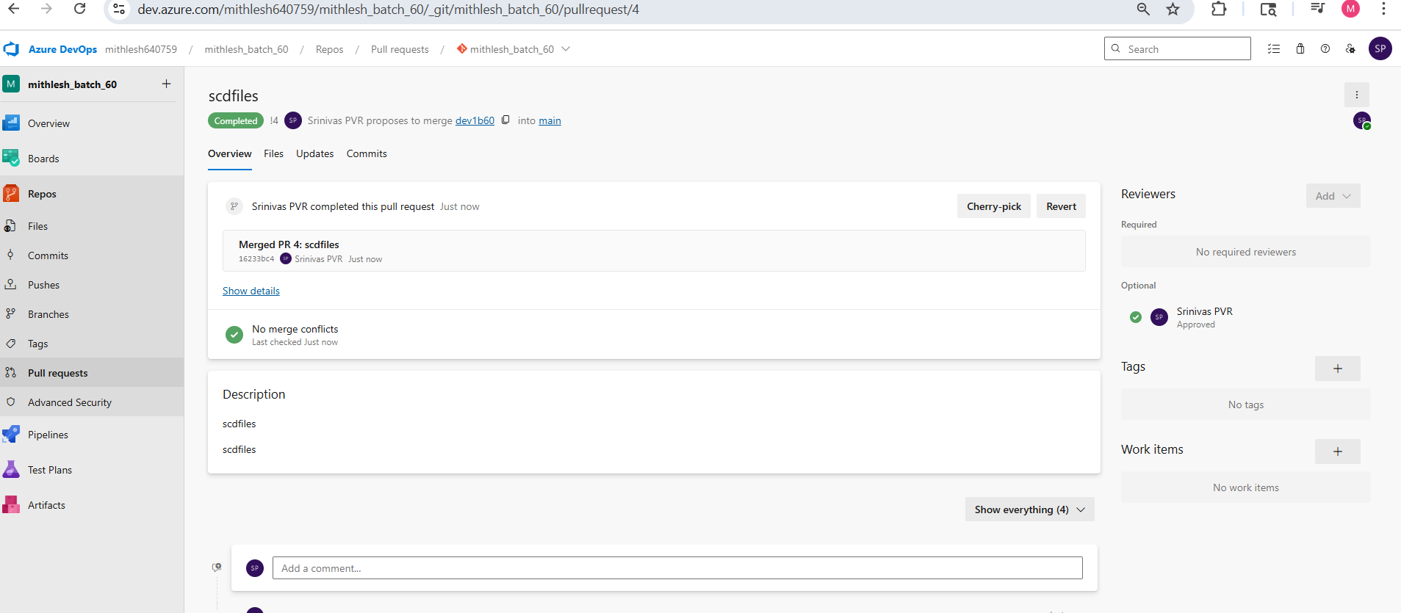

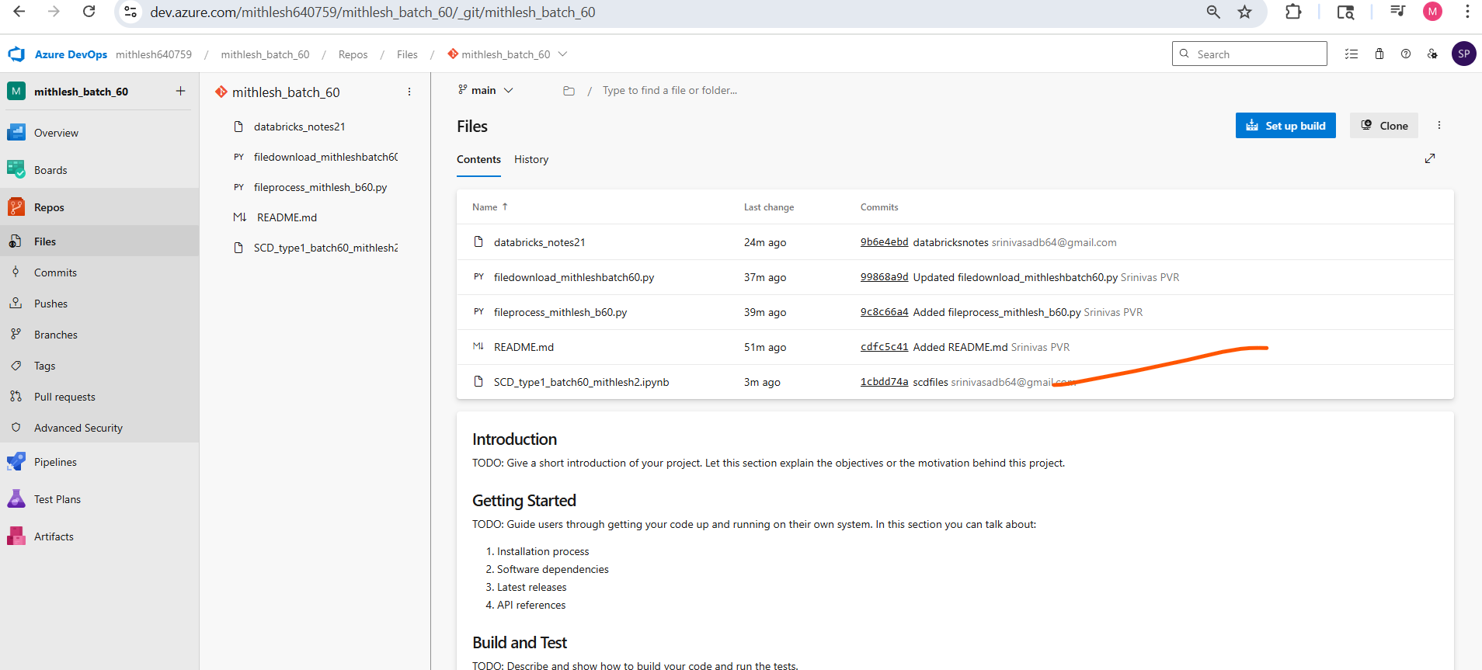

SCD is added now

For moving changes to cloud click dev1b60 and raise PR

