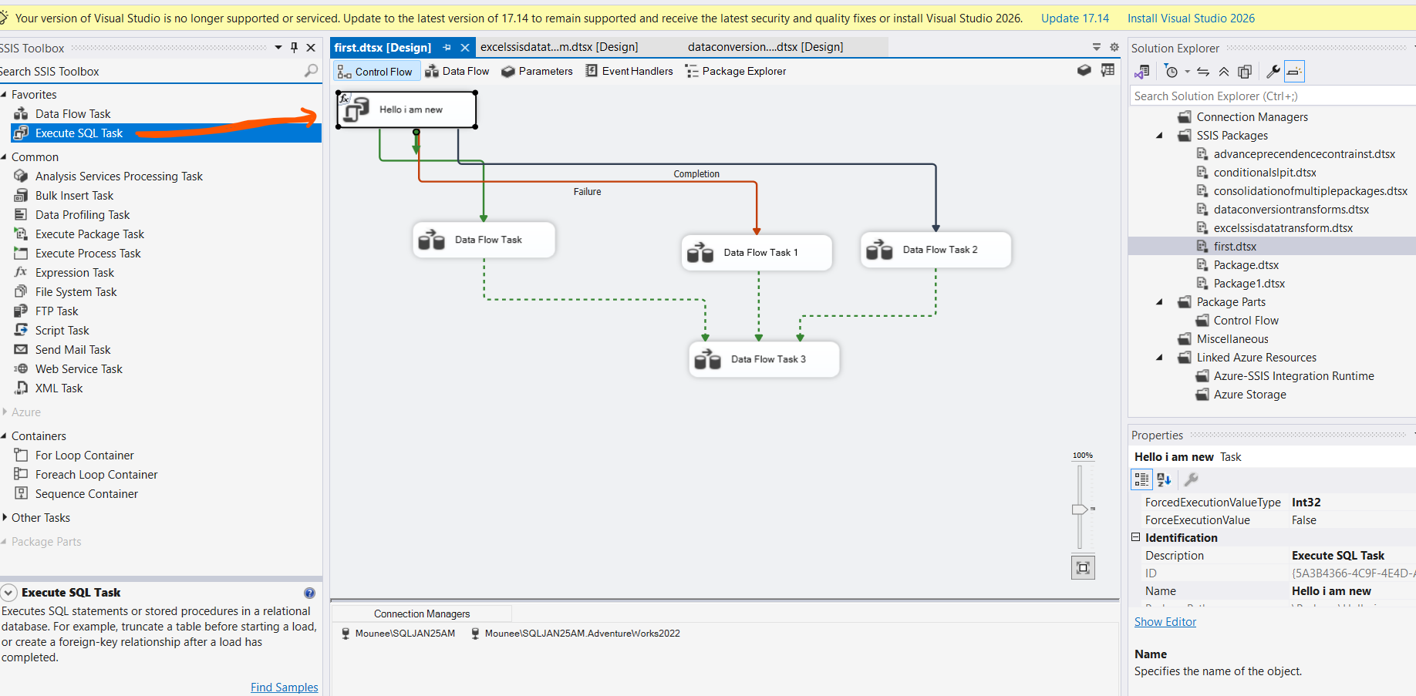

Execute task:

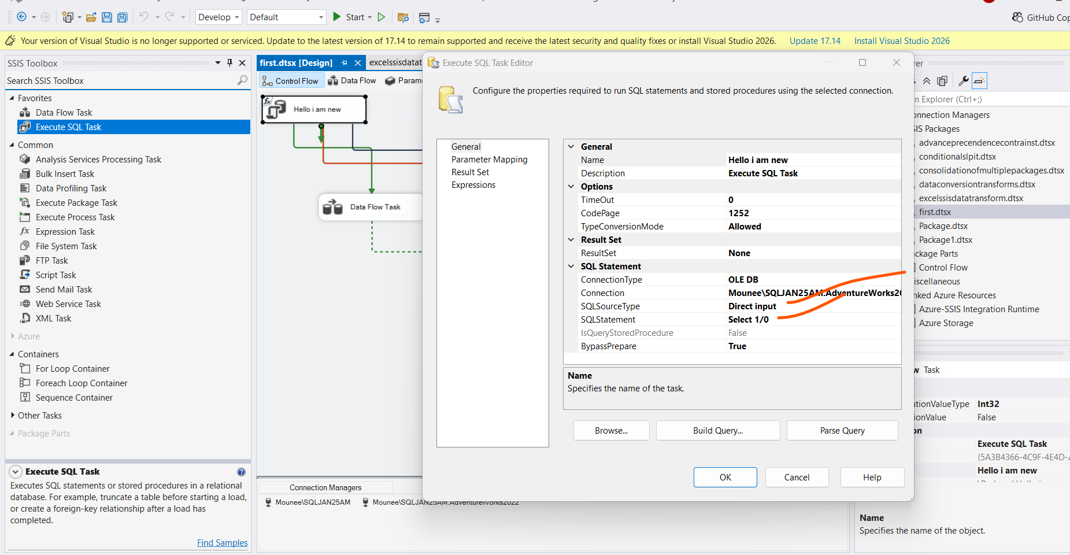

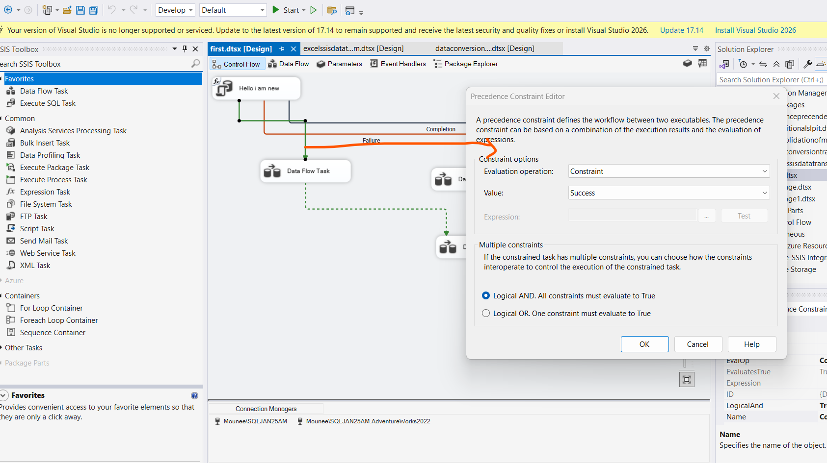

Why we need Execute SQL task:

Data Flow task:

If there are more than one constraints , then ssis uses logical and condition.

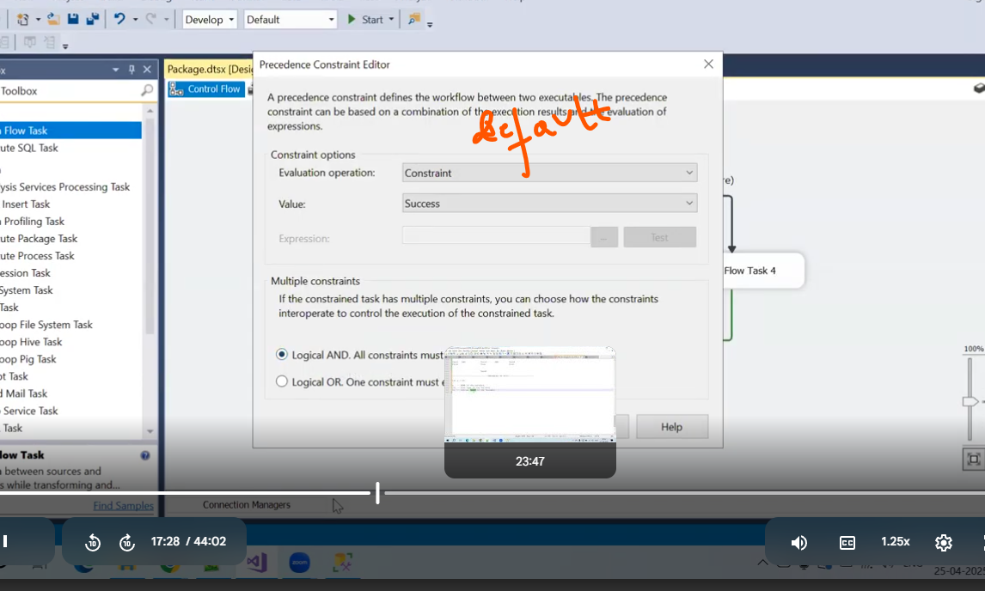

To change name of task at run time:

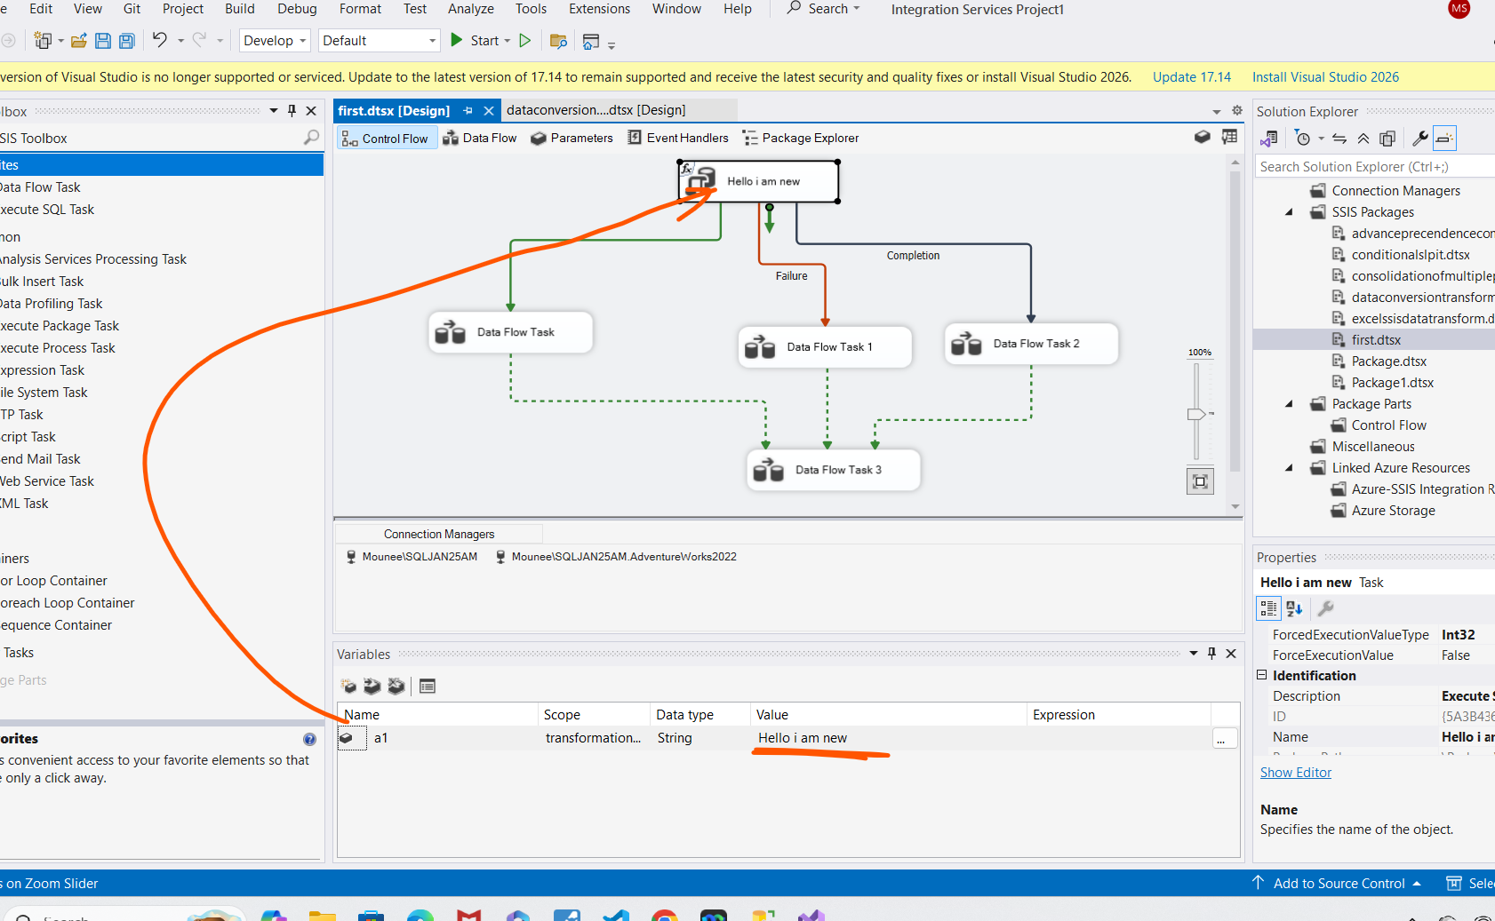

Vairables:

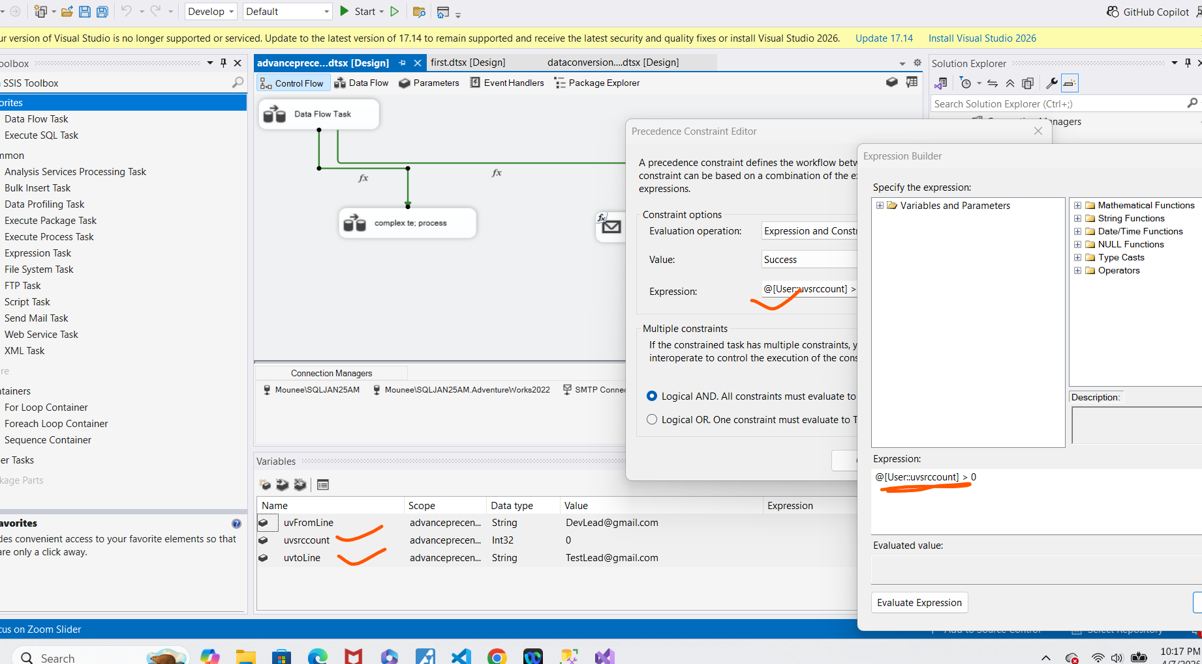

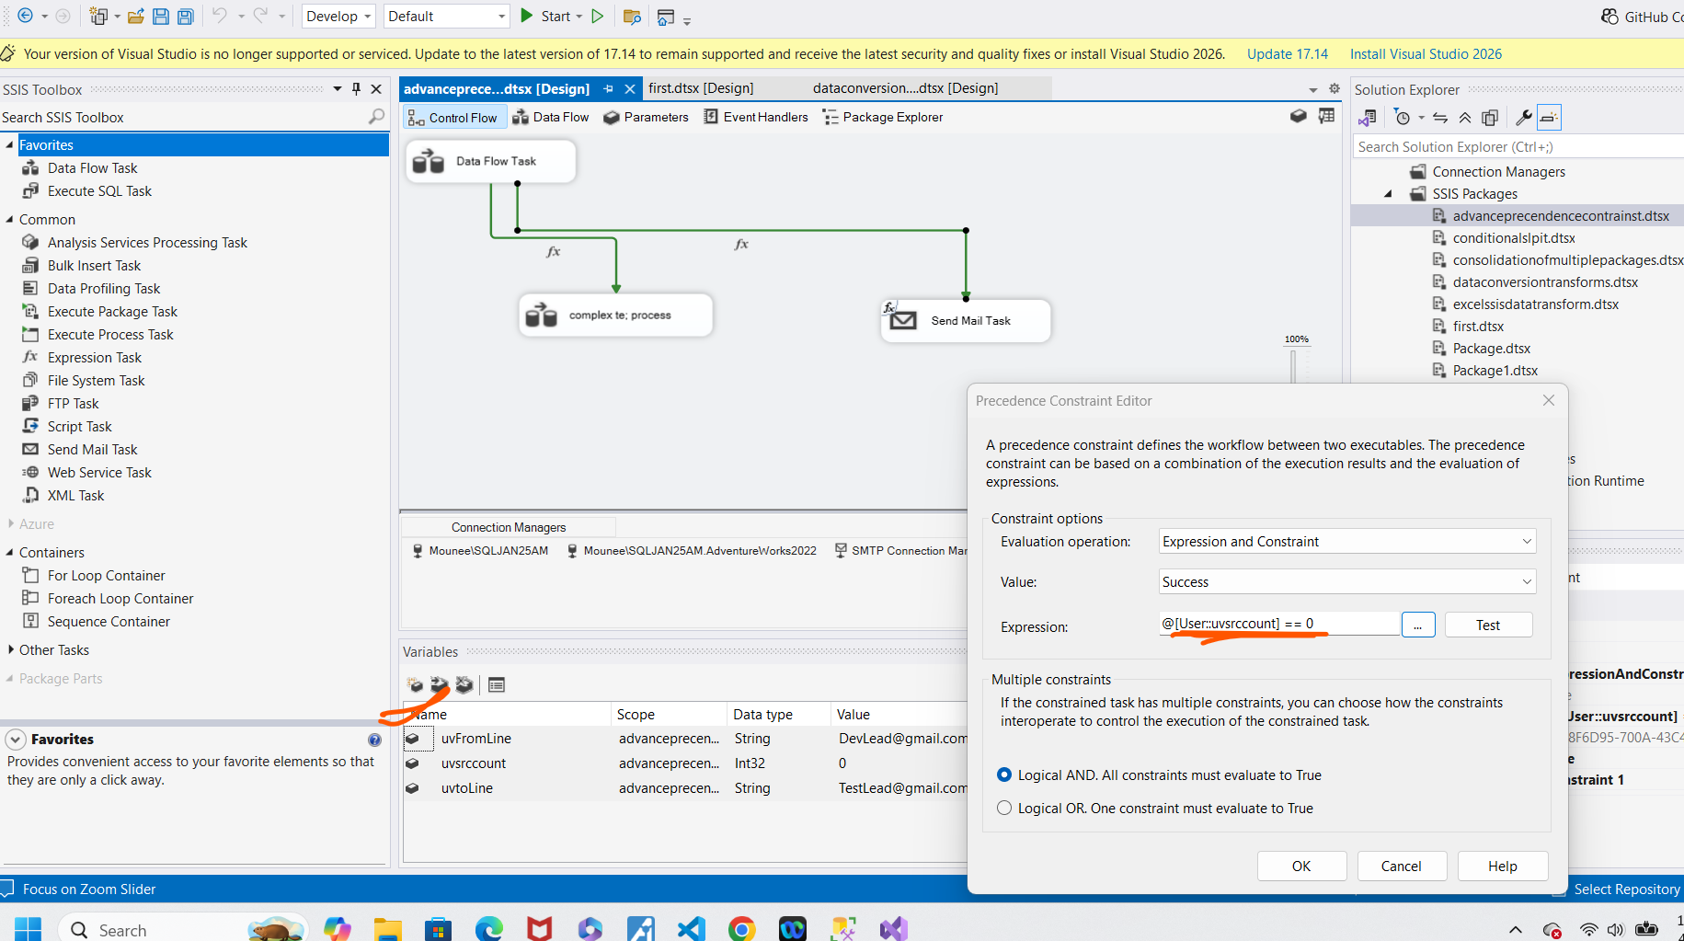

Control flow has multiple data flow tasks:

Dataflow task: load data from source to destination and implement transformations between.

source—Exectree1—-transform1—excetree2—-Transform2—-destination

Based on buffersize
Rowbyrow operations–lookup,rowcount,derived –it uses previously created buffers

Bulk inserts imports the data from flat file to sql server:based on batch size
Firstrow
Lastrow
Sorting

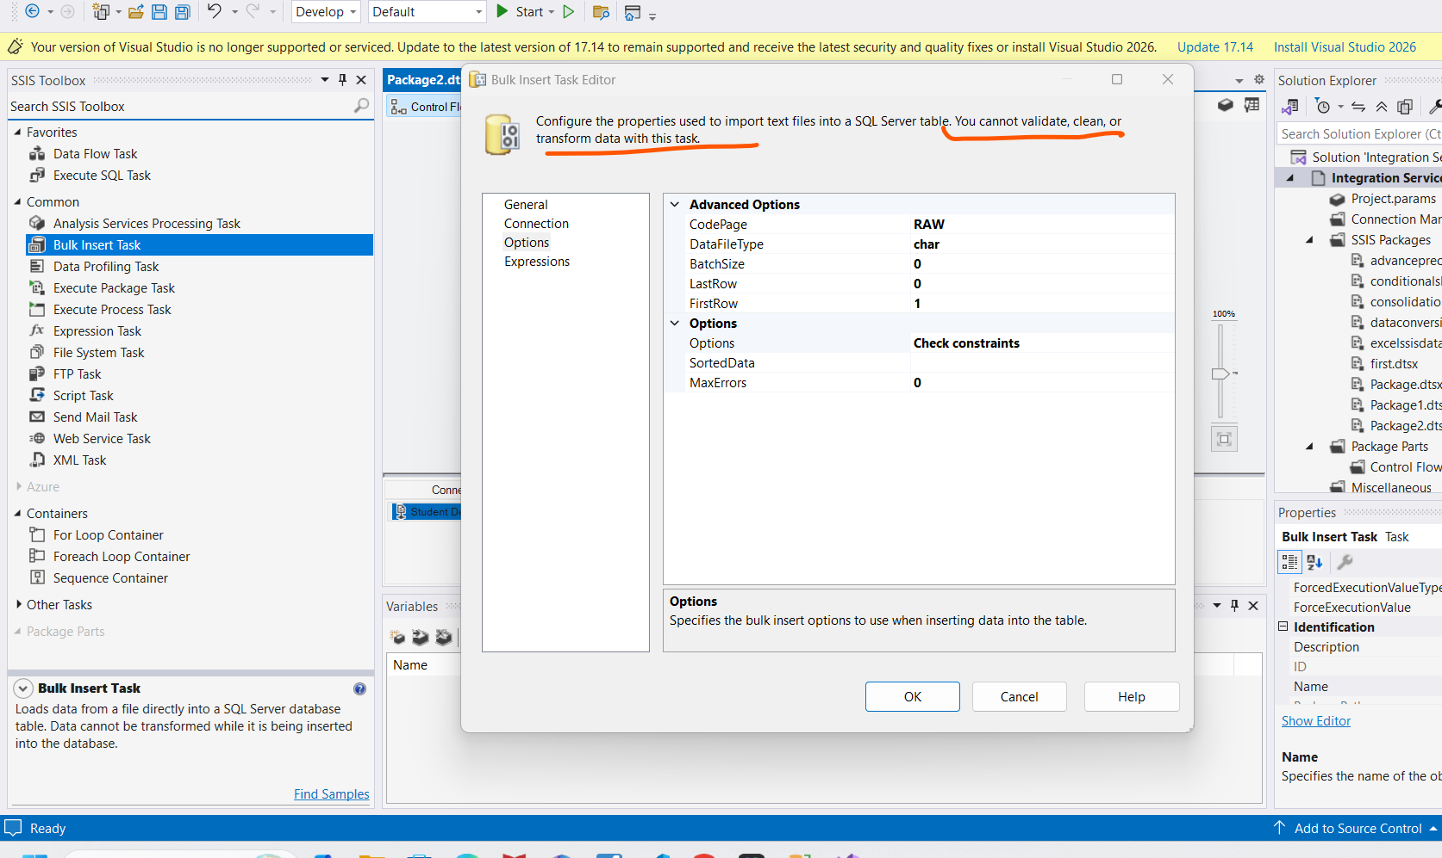

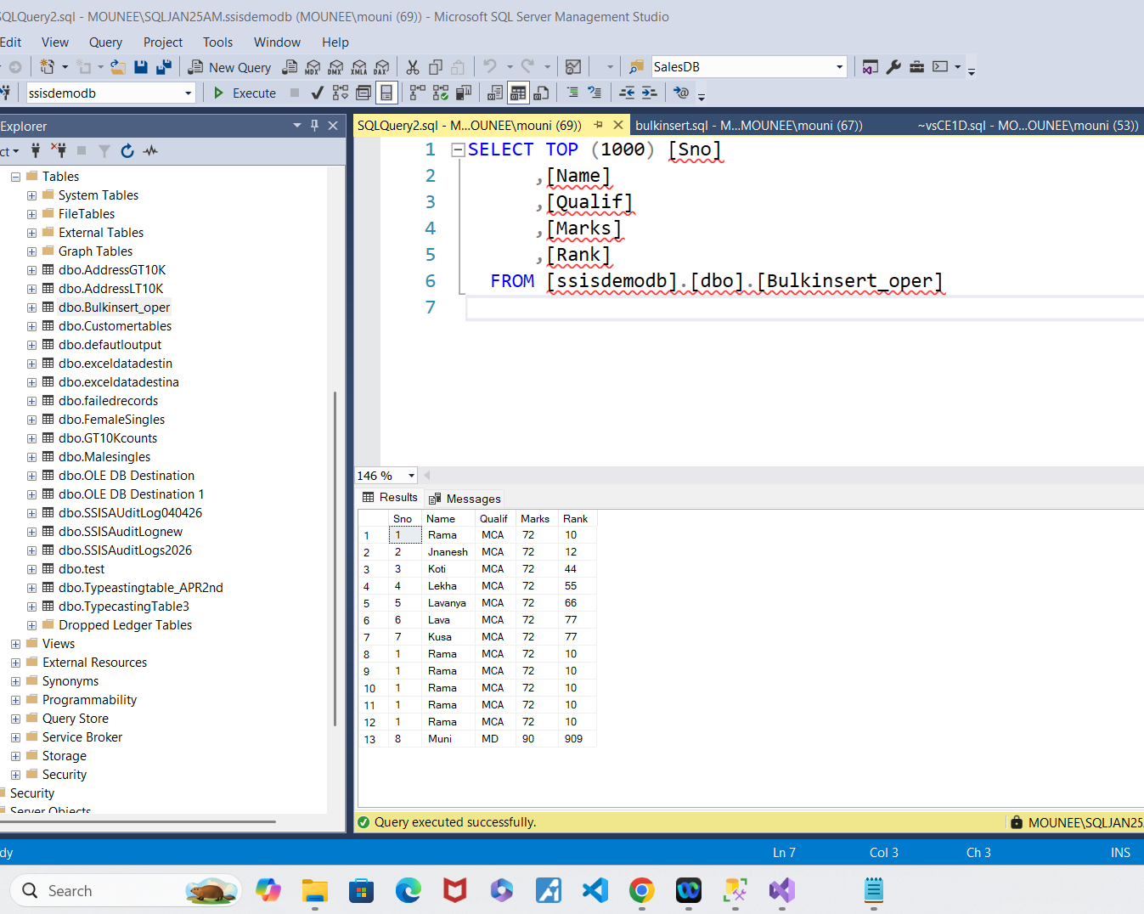

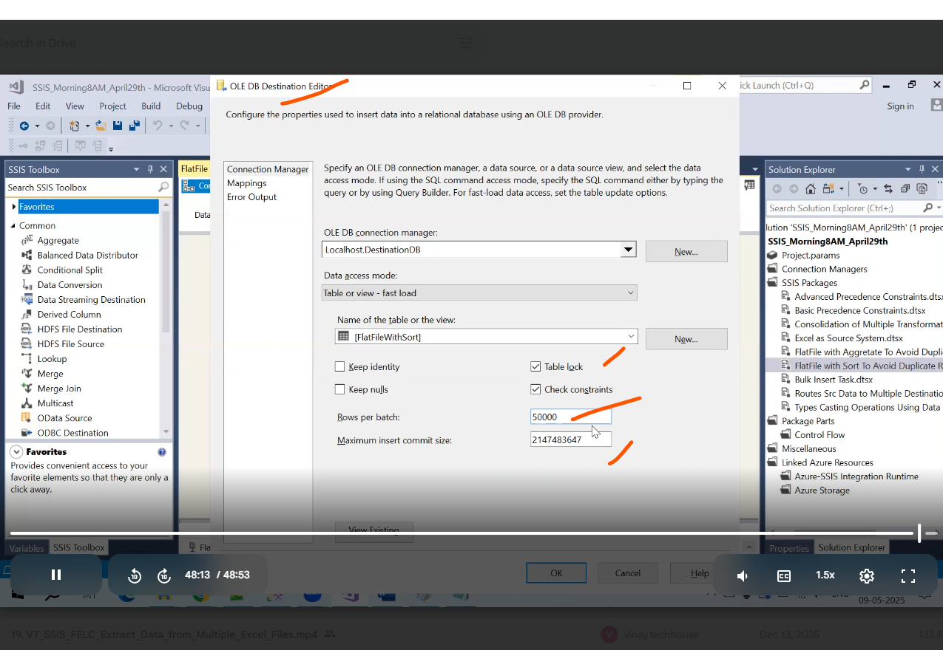

Destination table batch size….

