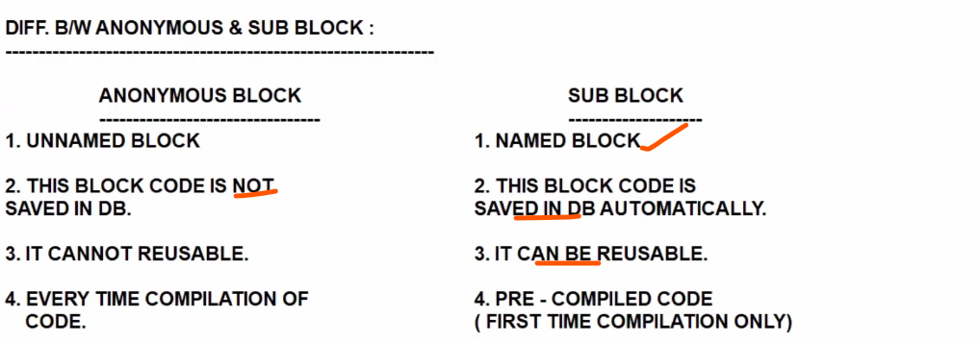

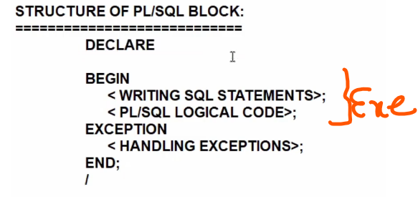

Declare
X varchar2 10;
Begin
X :=10
Dbms_output.line (x)
End ;

&takes a input in runtime.

DECLARE
x number(10);
y number(10);
z number(10);

BEGIN
x := &x;
y := &y;
z := x+y;
DBMS_OUTPUT.PUT_LINE(z);
END;
/

Select a,b in to x,y from emp where emp=1;

SET SERVEROUTPUT ON;
DECLARE
eemp number(10);
efirst_name varchar2(10);
BEGIN
SELECT employee_id, first_name INTO eemp, efirst_name FROM HR.employees WHERE ROWNUM = 1;
DBMS_OUTPUT.PUT_LINE('eemp '|| eemp || 'efirst ' || efirst_name);
END;
/

SELECT employee_id, first_name INTO eemp, efirst_name FROM HR.employees WHERE EMPLOYEE_ID = &EMPLOYEE_ID;

– if database table datatype change from varchar to date, plsql program associate variable i have to change. Otherwise mismatch works.

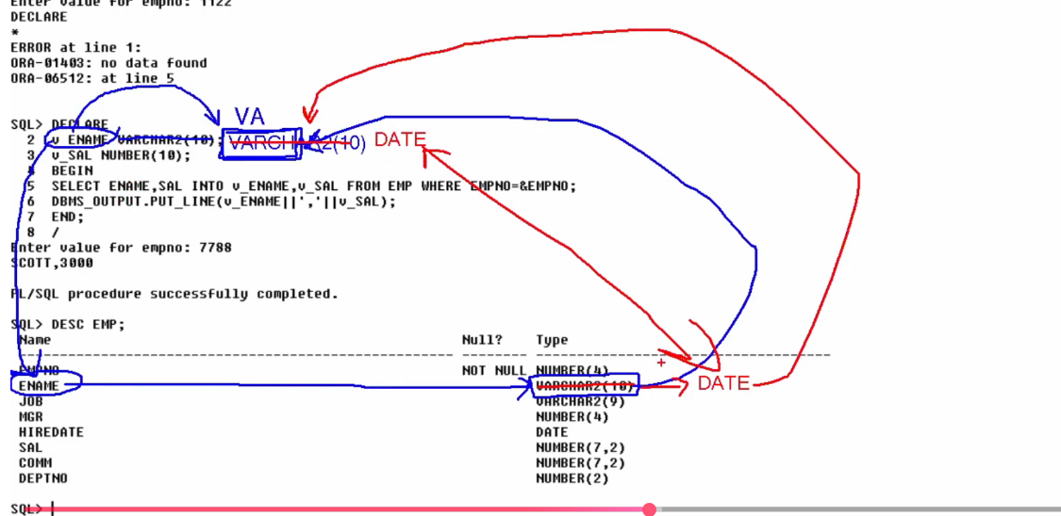

Automatically v ename datatype changes , advantages of anchor notations:

Column level
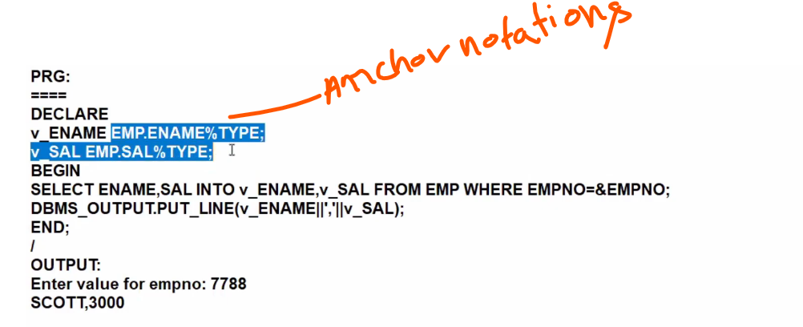

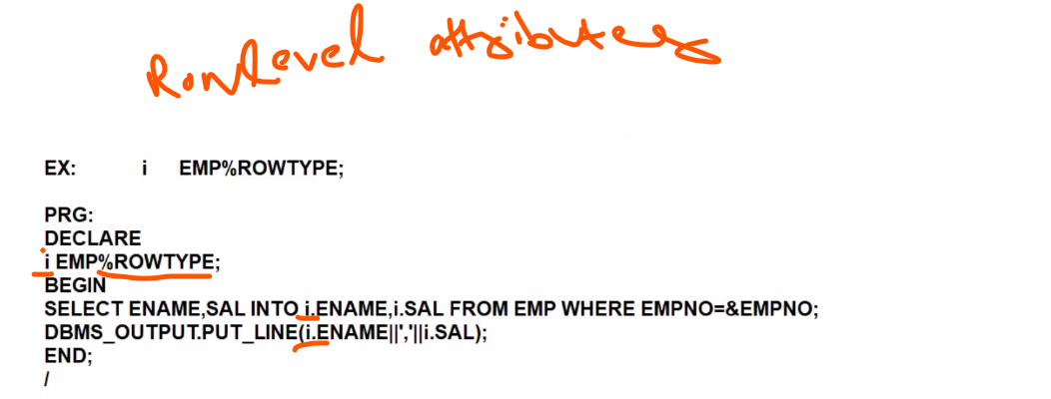

declare
vsal HR.employees.salary%type; —-> scalar variable
begin
select salary into vsal from hr.employees
where employee_id=100;
dbms_output.put_line('c1...' || (vsal));
end;

Implicit cursor:
Created by default when DML operations are performed.

To handle more than one row we use cursor or composite variable>

Cursor is rowlevel operation, if you want to fetch more than one row then its cursocr

Cursor Attributes:
Cursonrnameisopen
cursor_name%found
cursor_name%notfound
cursor_name%rowcount

Explicit Currosrs:

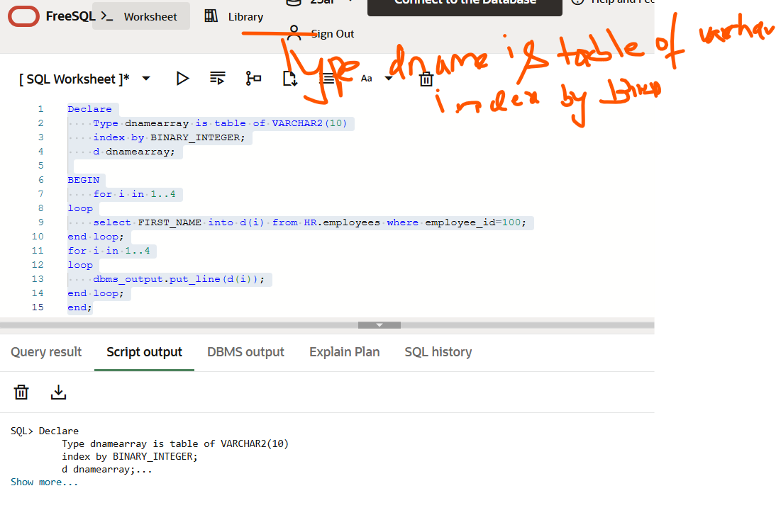
.
..
d dnamearray; → declare array variable
d(i) → access one value in that array

Peformance and logic issue

To overcome we used Bulk collect: fetch all elements from db and stored in dname
No of requests to db is reduced and performance is increased using Bulk collect.

