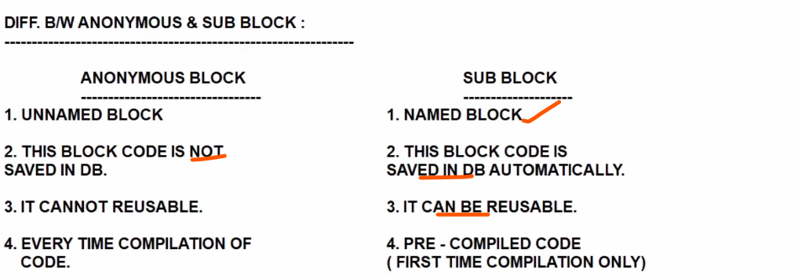

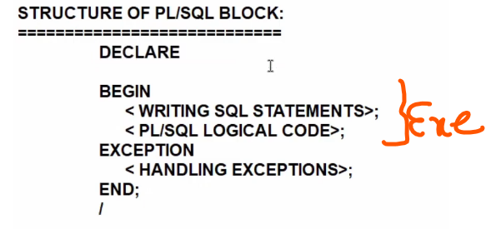

Declare
X varchar2 10;
Begin
X :=10
Dbms_output.line (x)
End ;

&takes a input in runtime.

DECLARE
x number(10);
y number(10);
z number(10);

BEGIN
x := &x;
y := &y;
z := x+y;
DBMS_OUTPUT.PUT_LINE(z);
END;
/

Select a,b in to x,y from emp where emp=1;

SET SERVEROUTPUT ON;
DECLARE
eemp number(10);
efirst_name varchar2(10);
BEGIN
SELECT employee_id, first_name INTO eemp, efirst_name FROM HR.employees WHERE ROWNUM = 1;
DBMS_OUTPUT.PUT_LINE('eemp '|| eemp || 'efirst ' || efirst_name);
END;
/

SELECT employee_id, first_name INTO eemp, efirst_name FROM HR.employees WHERE EMPLOYEE_ID = &EMPLOYEE_ID;

– if database table datatype change from varchar to date, plsql program associate variable i have to change. Otherwise mismatch works.

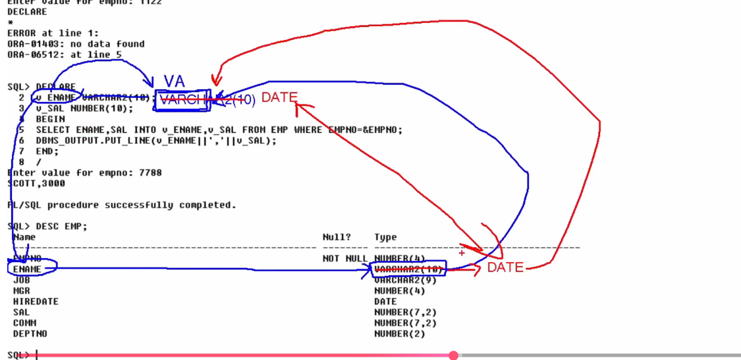

Automatically v ename datatype changes , advantages of anchor notations:

Column level
