**STA 121 ASSIGNMENT**

Name: **Ude Daniel Chinedu**

Matric Number: **243485**

**Procedure:**

This is a program demonstrating simple random sampling using R. To start, I used the ***set.seed()*** function to make sure that it’s the same sequence of random numbers that are generated every time the code is run. Then, I used the ***runif()*** function to generate a random sequence of 30 scores.

I took 100 samples of size 5 from the population and use the sample to plot a histogram of the data distribution. The population mean is also indicated on the histogram. Finally, using R built in functions I generated the population mean, standard deviation and standard error.

**Code:**

#for reproducibility

set.seed(42)

#generate 30 random scores

scores <- runif(30, min = 0, max=100)

#creating 100 samples

samples <- replicate(100, sample(scores, size = 5, replace = FALSE))

#generate the sample means

sample_means <- apply(samples, 2, mean)

#print first 10 sample means

print(sample_means[1:10])

#plot histogram

hist(sample_means, main = "Histogram of sample means",

    xlab = "Sample Mean",

    col = "skyblue",

    border = "white",

    breaks = 10)

#get population mean, SD and SE

population_mean <- mean(scores)

population_sd <- sd(scores)

population_se <- population_sd/sqrt(length(scores))

cat("population mean: ", population_mean, "\n")

cat("population SD: ", population_sd, "\n")

cat("population SE: ", population_se, "\n")

#displays the population mean on the histogram

abline(v = population_mean, col = "red", lwd = 2, lty =2)

legend("topright", legend = c("Population Mean"),

col= c("red"), lty = c(2), lwd = c(2))

**Output:**

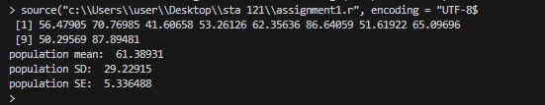

**Graph**

