INDEPENDENT PRODUCT MANAGEMENT CASE STUDY

Netflix After Hours
  - Evidence aligned late night viewing concept and deployment ready interactive prototype
Chidumebi Nkwo | AI Product Manager | November 2026
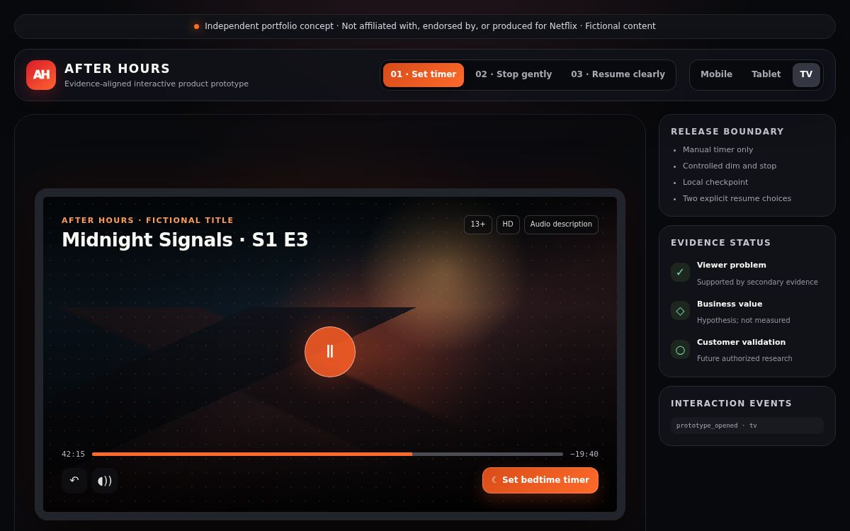
The evidence-aligned release shows a manual bedtime timer, controlled stop, local checkpoint, and two explicit resume choices.
This is an independent portfolio concept. It was not produced for or with Netflix and does not represent Netflix customer research, telemetry, economics, UAT, or production delivery.

01 PRODUCT CASE

Executive decision
The case closes with a credible viewer problem and a deliberately bounded pilot, but without a demonstrated positive financial case.

Decision
Proceed only as a small, instrumented learning pilot if an authorized organization chooses to sponsor further validation. Do not use the current model to claim revenue, savings, ROI, or a Netflix investment decision.
Decision area | Final position
Viewer need | Directionally supported by independent secondary evidence
Pilot experience | Manual timer, cancellable dim and stop, local checkpoint, and resume choice
Customer validation | Not completed; future authorized research required
Economic result | Positive case not demonstrated
Portfolio outcome | Completed independent concept to decision case

What this case demonstrates
- Evidence governance that separates facts, hypotheses, targets, simulations, and missing inputs.
- A product-scope correction made when the original concept exceeded the available evidence.
- A complete chain from problem framing through research, prototype, measurement design, and investment decision.
- The willingness to close a gate honestly when a favourable answer cannot be supported.

02 PRODUCT CASE

Problem and opportunity
Late-night viewers can wake several episodes ahead, lose their true stopping point, or continue playback unintentionally. The product opportunity is to make that moment gentler and more recoverable.

Customer job
When I watch in bed and may fall asleep, help me stop playback without a disruptive interruption and return later without guessing where I was.

Original opportunity thesis
The original suite combined manual sleep controls, display dimming, sleep-point recovery, optional audio transitions, wearable automation, Premium positioning, and delivery-cost savings. It offered a broad vision but treated several unvalidated mechanisms as if they belonged in one release.

Evidence-led reframing
Original assumption | Evidence decision
Wearables can infer sleep reliably | Deferred to a future feasibility track
Advanced audio improves sleep | Removed; no therapeutic or sleep-quality claim
Premium prompts create conversion | Removed from pilot and held at zero in the model
Unattended playback creates measurable savings | Retained only as a measurable operational hypothesis
A fixed late-night window fits all viewers | Replaced with user-initiated controls

03 PRODUCT CASE

Research strategy
Direct Netflix customer research was not appropriate for an independent portfolio project, so Phase 2 used public secondary evidence to test the baselines without implying sponsorship or access.

Research governance
- No respondent was represented as a Netflix customer recruited for this project.
- No internal Netflix data, product metrics, costs, or confidential information were used.
- Public evidence established context and adjacent interaction patterns, not product-specific outcomes.

Baseline result
Baseline | Disposition | Implication
Bedtime viewing is a credible context | Supported | Continue the customer-problem track
Manual timers are an established pattern | Supported | Use a familiar user-controlled interaction
Falling asleep during paid streaming is frequent | Unresolved | Do not claim incidence
Recovery choices improve satisfaction | Unresolved | Test desirability and correction rate
Retention or conversion improves | Unsupported | Set financial contribution to zero
Delivery savings are material | Unresolved | Require internal marginal-value inputs

Gate 2 therefore passed conditionally: the context was credible enough to prototype, but severity, frequency, desirability, and economics remained unvalidated.

04 PRODUCT CASE

Pilot product
The first viable release is intentionally small. It tests whether viewers value intentional stopping and transparent recovery before the product takes on device integrations or commercial packaging.

Release promise
Set a simple bedtime stop, receive a low-disruption warning, and return later with two clear choices about where to resume.
Included | Deferred or excluded
15, 30, and 45 minute timers | Wearable sleep detection
End of episode option | Cross-device checkpoint synchronization
Gradual display dimming | Binaural or therapeutic audio
Immediate cancellation through input | Premium upsell
Local checkpoint | Fixed global late-night activation
Checkpoint and latest-position choices | Quantified retention, conversion, or savings claims

Safety and trust principles
- User initiation and immediate cancellation take priority over automation.
- Recovery choices explain their source instead of silently changing playback history.
- Local state is sufficient for the concept; cloud synchronization requires a separate privacy and feasibility decision.

05 PRODUCT CASE

Experience design
The prototype demonstrates three linked user journeys across TV, tablet, and mobile layouts. Each state is fictional and instrumented only in the browser session.
Journey | User action | Product response
Set timer | Choose 15, 30, 45 minutes, or episode end | Confirm the choice without leaving playback
Stop gently | Allow the countdown or cancel through input | Dim, show a clear countdown, then save locally
Resume clearly | Choose checkpoint or latest position | Resume from the explicitly selected state

06 PRODUCT CASE

Prototype verification
The release was rebuilt as a self-contained static application so it can be audited, deployed, and reviewed without third-party runtime dependencies.
Verification area | Result
Build parity | Root, prototype mirror, and static deployment output match
Runtime dependencies | No external scripts, fonts, images, APIs, analytics, or storage calls
Interaction paths | Timer, controlled stop, resume choice, and device switching rendered successfully
Keyboard and dialog behaviour | Focus state, Escape close, focus trap, and reduced-motion support implemented
Browser console | No application errors observed; extension-only messages excluded
Deployment | Private sandbox deployment completed; repository remains host-ready

Maturity boundary
Deployment verifies the front-end interaction package. It does not establish a production service, Netflix integration, telemetry pipeline, cloud synchronization, device certification, security review, or UAT completion.

Repository release
The active release is available in the public GitHub repository with a one-command check, static-host instructions, archived original artifacts, and the full decision trail.

07 PRODUCT CASE

Measurement and experiment design
The pilot is designed to learn whether viewers use the control, accept the stop, recover successfully, and avoid unwanted interruptions. Targets are decision thresholds, not results.
Question | Primary measure | Decision use
Do eligible viewers activate it? | Activation rate | Desirability and discoverability
Does the timer complete as intended? | Controlled-stop completion | Core interaction value
Is the stop unwanted? | Cancellation and immediate restart | Guardrail and trust
Does recovery help? | Checkpoint selection and correction | Resume-value validation
Does behaviour change? | Avoided continuation minutes | Operational value input
Does it affect retention? | Experiment retention delta | Future commercial evidence only

Evidence labels
Observed telemetry, experiment estimates, model assumptions, research benchmarks, and product targets must remain separate fields in any dashboard or decision memo. Synthetic metrics can validate computation but cannot validate customer behaviour.

08 PRODUCT CASE

Value case
The normalized model can calculate physical stream-hours under labelled assumptions, but it cannot support a positive financial conclusion without internal marginal-value and cost inputs.
Value pathway | Conservative treatment | Reason
Retention | Zero | No causal customer evidence
Premium conversion | Zero | No observed conversion evidence
Avoided stream-hours | Computable | Requires assumed activation, completion, and minutes
Marginal delivery value | Unavailable | Not available from public evidence
Implementation cost | Unavailable | Requires engineering and certification estimates
Operating cost | Unavailable | Requires an authorized operating model

Gate 4 conclusion
Gate 4 closed as not demonstrated rather than failed. The product hypothesis was not disproven; the investment conclusion could not be evaluated responsibly with the evidence available to an independent portfolio case.
Approval of this disposition records a completed decision process. It is not approval of a positive business case.

09 PRODUCT CASE

Roadmap and future evidence
Any future work should earn the right to expand the concept. Evidence precedes feature growth.
Stage | Outcome | Evidence required to advance
1 Authorized discovery | Estimate frequency, severity, and desirability | Recruitment approval and documented sample
2 Usability pilot | Validate timer and resume comprehension | Task success, correction, unwanted-stop evidence
3 Instrumented experiment | Measure behaviour change | Eligible sessions, activation, completion, avoided minutes
4 Economic review | Reopen Gate 4 | Marginal value plus build and run cost estimates
5 Feasibility tracks | Consider sync and wearables | Privacy, platform, certification, and reliability proof

Future evidence backlog
The backlog should be managed as evidence work, not assumed delivery scope. Each item must name the decision it unlocks, the evidence class it produces, and the claim it is permitted to change.

10 PRODUCT CASE

Product leadership reflection
The strongest outcome of this case is not a favourable forecast. It is a more defensible product decision and a clear record of how the concept changed under evidence.

What changed
The original concept was broad and visually compelling, but it combined customer, technical, health, and commercial assumptions. Research narrowed the pilot to a user-controlled interaction that can be tested without making unsupported claims. The original suite remains archived as a traceable learning artifact.

What I would do inside an authorized organization
- Partner with legal, research, privacy, finance, playback, and device-platform owners before recruitment or instrumentation.
- Run a small usability study before exposing any stop automation to live viewing sessions.
- Pre-register success and guardrail thresholds, then hold the financial gate until internal cost inputs exist.
- Use the first release to learn, not to justify the original concept retroactively.

Final portfolio statement
Netflix After Hours is a completed independent concept-to-decision product case with a deployment-ready interactive prototype. The viewer problem is credible, the first pilot is bounded, and the evidence gaps are explicit. Customer validation, production feasibility, and positive economics remain future work.
Repository: https://github.com/dudedumebi-gif/netflix-after-hours-product-case
Portfolio: https://dumebi-ai-ba-portfolio.dudedumebi.chatgpt.site/

