**VERY SIMPLE LEADERBOARD DOCUMENTATION**

**For Android :**

You have to download the last official Google Play Game SDK here :

<https://github.com/playgameservices/play-games-plugin-for-unity>

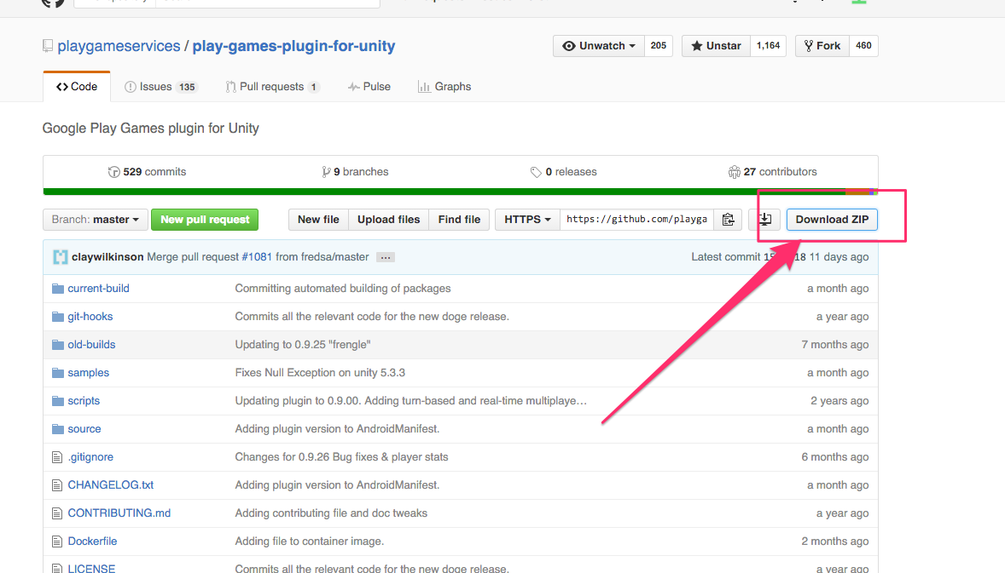

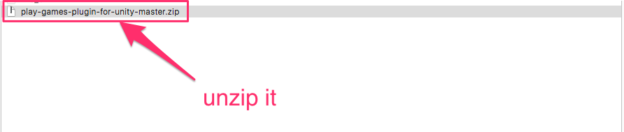

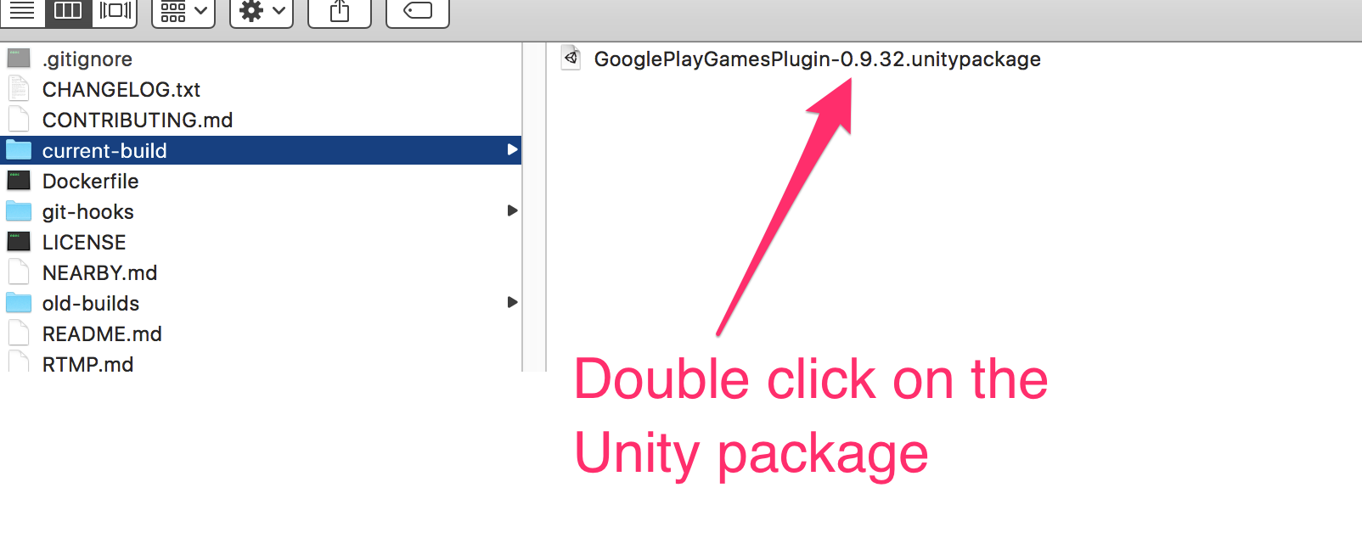

**HOW TO CREATE A LEADERBOARD?**

Follow the official tuorial here :

<https://github.com/playgameservices/play-games-plugin-for-unity>

**For iOS:**

You have nothing to do, the Game Center is already include by default on iOS build ☺

**HOW TO CREATE A LEADERBOARD?**

Follow the Apple guide here :

<https://developer.apple.com/library/ios/documentation/NetworkingInternet/Conceptual/GameKit_Guide/Introduction/Introduction.html>

**HOW TO ADD MY LEADERBOARD ID IN VERY SIMPLE LEADERBOARD ?**

**1/ Add your leaderboard id to the setting editor :**

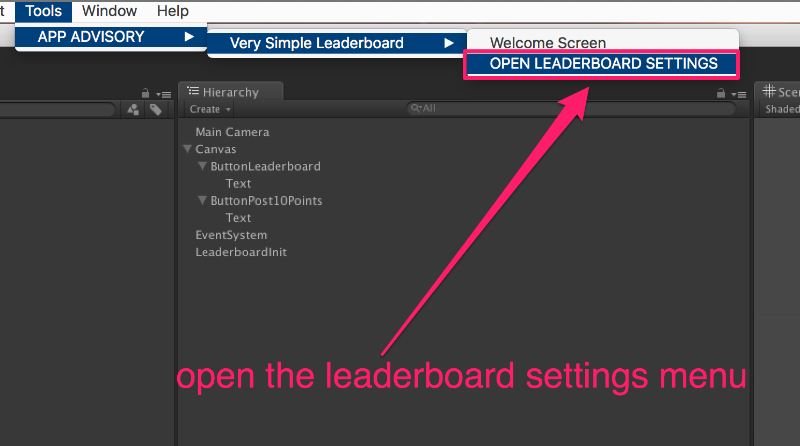

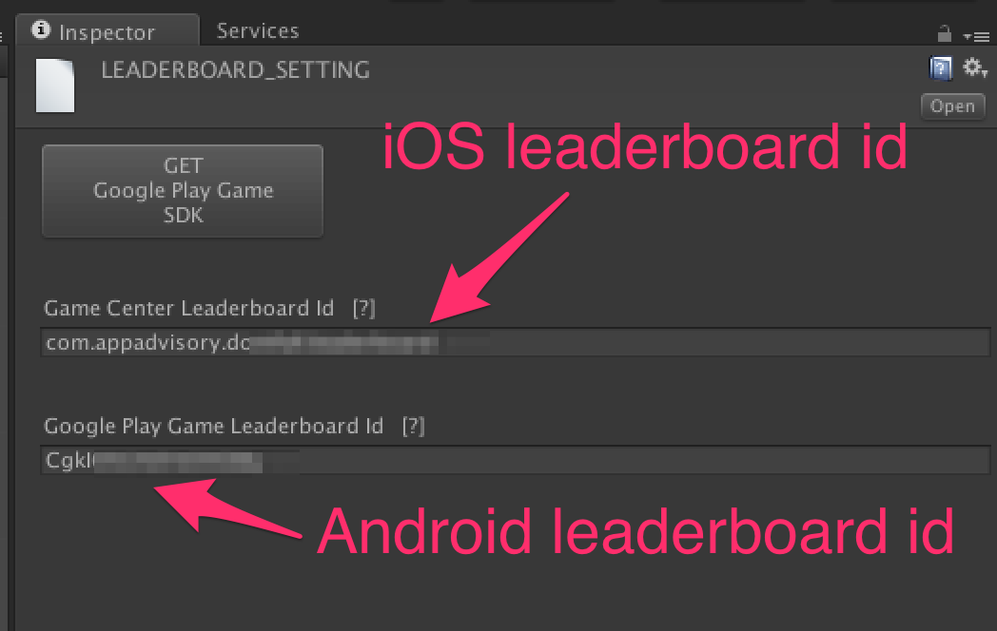

**2/ Add the LeaderboardInit to the scene :**

Right click on the Hierarchy view, in an empty place (not on a GameObject) and select « CREATE LeaderboardInit » :

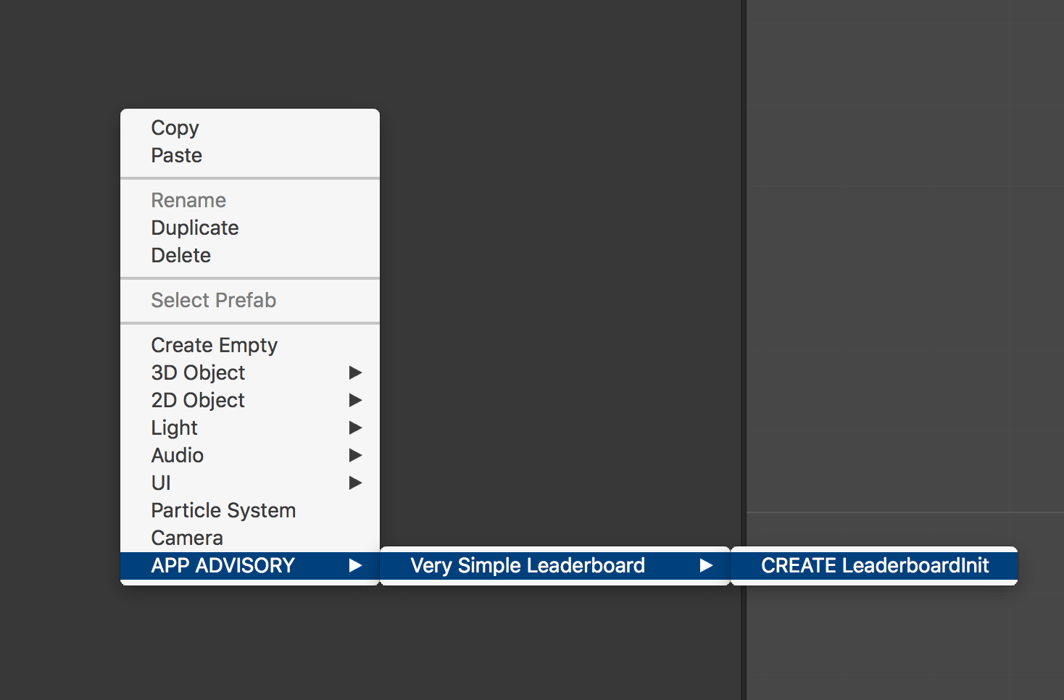

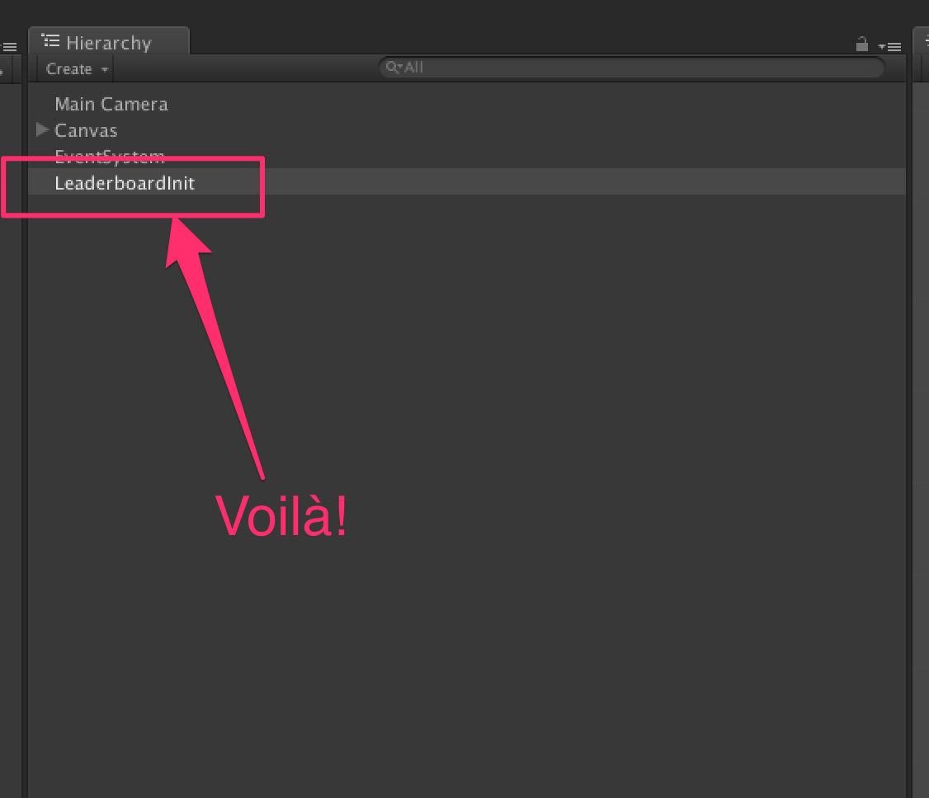

**NOW YOU ARE READY TO USE LEADERBOARD FEATURE IN YOUR IOS AND ANDROID GAME !**

The initialization is automatic.

But you need to know 2 things :

**HOW TO SHOW THE LEADERBOARD UI ?**

**../../../../../Captures%20d'écran/Capture%20d'écran%202016-04-11%2020.41.17.png**

**HOW TO REPORT A SCORE ?**

**../../../../../Captures%20d'écran/Capture%20d'écran%202016-04-11%2020.43.28.png**

Thanks !

Our other assets : <http://u3d.as/9cs>

Contact : [contact@app-advisory.com](mailto:contact@app-advisory.com)