How to Collect GlobalProtect Client Troubleshooting Logs

1. Open the GlobalProtect Application (from your taskbar, show hidden items)

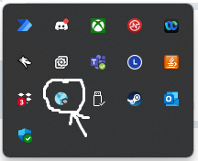

1. Click on the 3 bars in the upper right corner of the GlobalProtect window and select ‘settings’

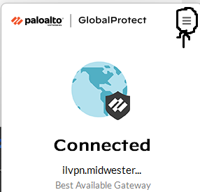

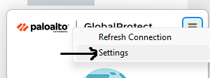

The ‘settings’ window will show you your current status and how much longer you have before you are auto-disconnected from the service (each connection is hard limited to 13 hours).

1. Click on ‘Troubleshooting’.

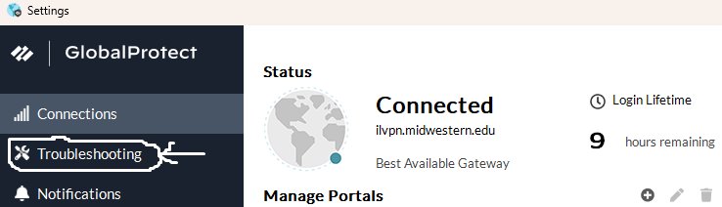

1. Click on the ‘Collect Logs’ button on the next screen.

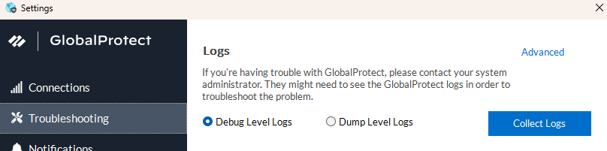

1. The system will prompt you for a location to save the file (default is ‘documents’)
2. Send an email with the created file attached to the person who is assigned your support ticket.

This file contains information about your GlobalProtect client and connections from your device’s perspective. We can use this file to determine why you are experiencing problems with your connection and identify a solution.