**Outlook Profile Reset Procedure**

1. Close any open instances of Outlook.
2. Open “Control Panel” and click on “Mail (Microsoft Outlook)”.

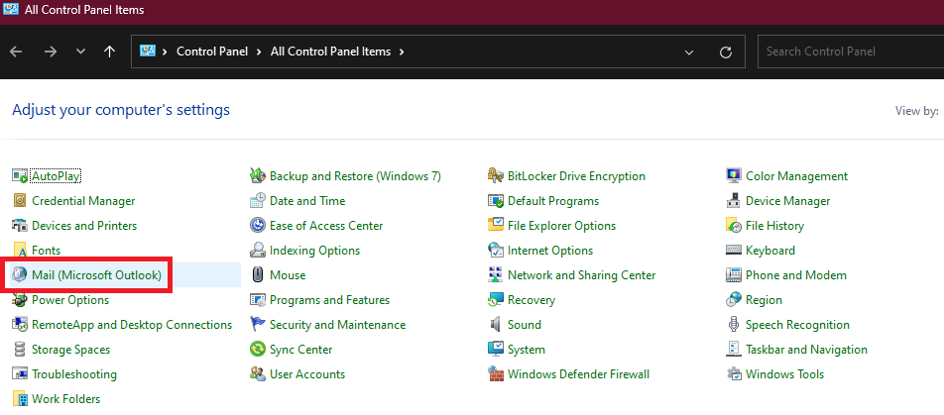

1. Select “Show Profiles…”

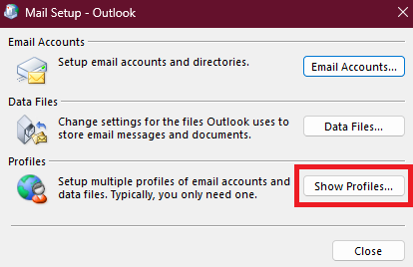

1. Click “Add…” and create a new profile titled “New” and click “OK”.

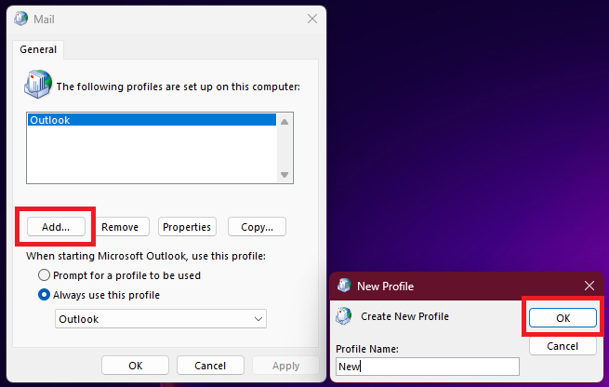

1. Click through the Auto Account Setup helper (the information should be pre-filled in) to add the “New” profile.

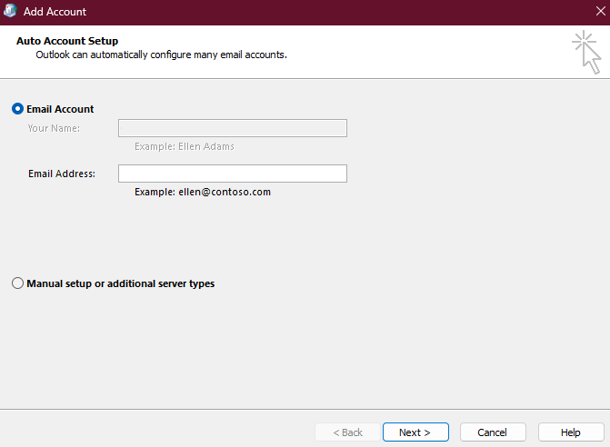

1. Select the “New” profile and be sure to check the radio button labelled “Always use this profile” and select “New” from the dropdown menu.
2. Click “Apply” and reopen Outlook (the mailbox will synchronize in the background and the user is free to continue their regular tasks while synchronizing).