**Igor Dudek**

**Index – s7079**

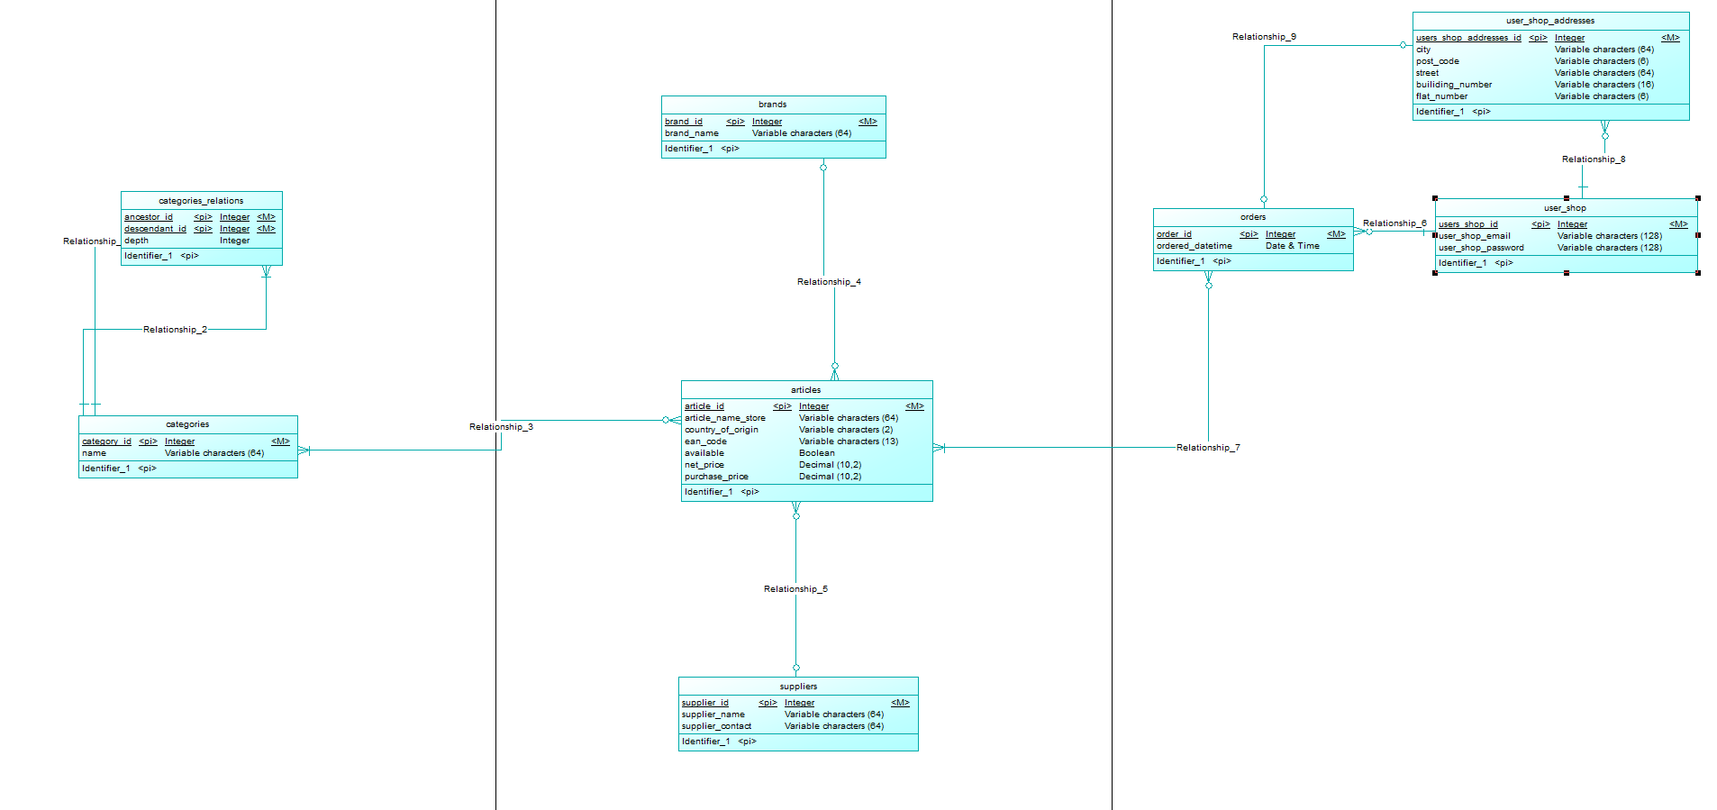**Pkt.1 Diagramy**

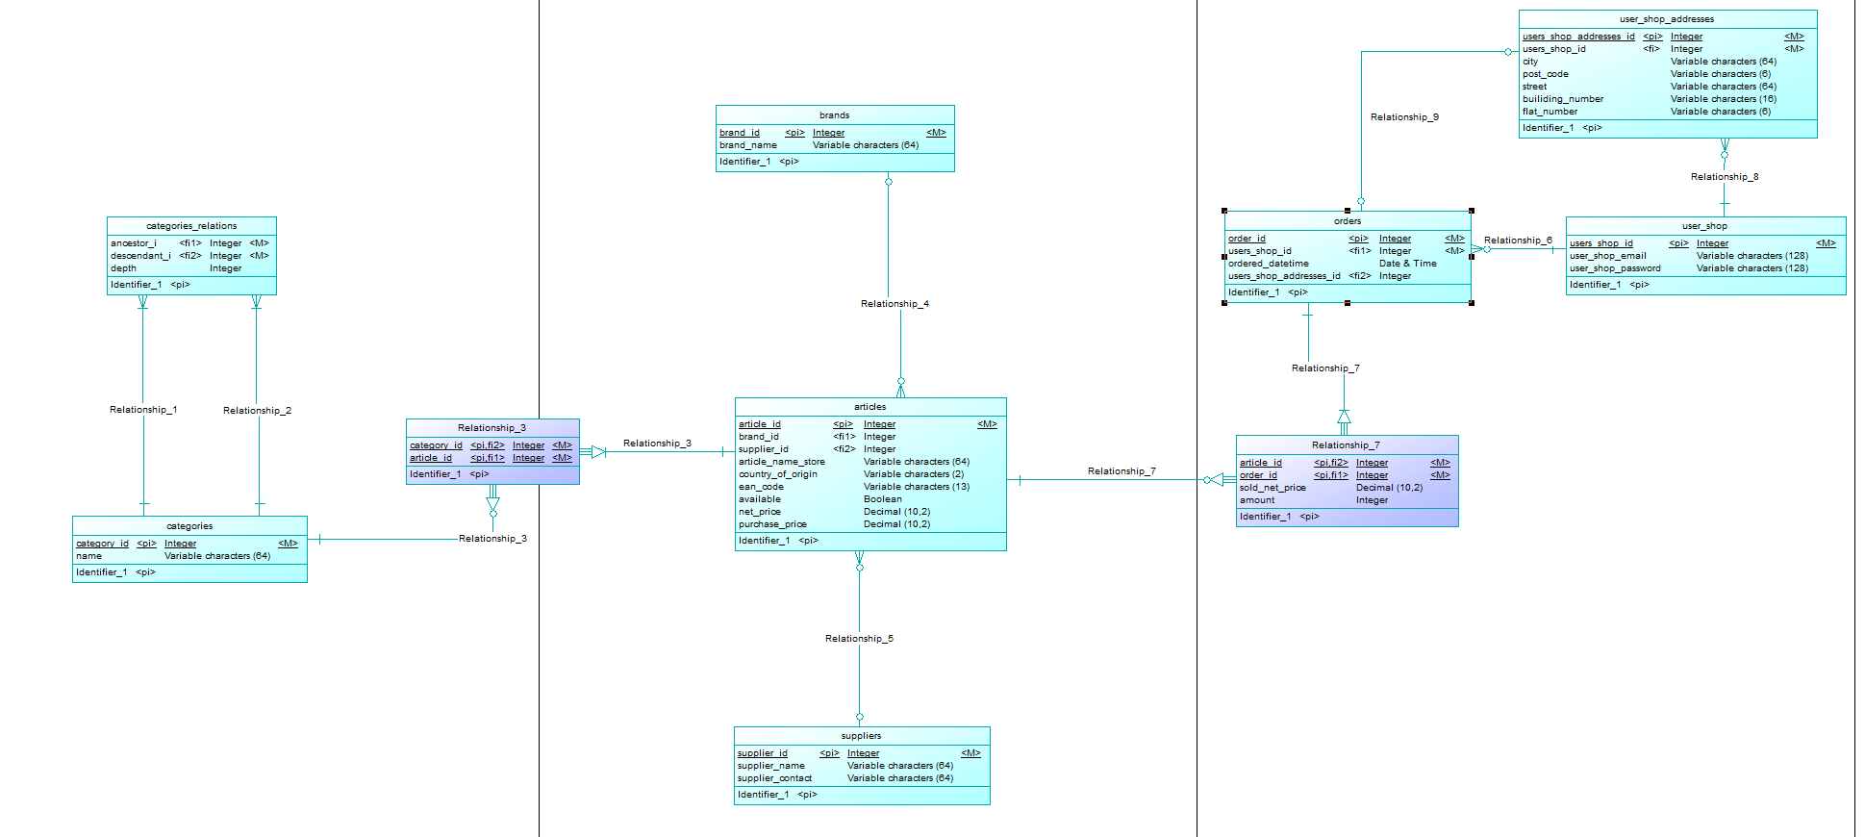

**Pkt.2 Skrypt Sql – w pliku**

**Pkt.3 Zapytania `Insert`**

1. Kategorie

INSERT INTO `categories`(`name`) VALUES ("Buty"),( "Sport"),("Nike"),( "Adidas"),("Piłka Nożna"),("Koszykówka");

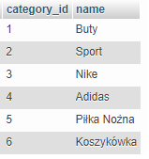

1. Tabela domykająca dla katgorii

INSERT INTO `categories_relations`(`ancestor_i`, `descendant_i`, `depth`) SELECT category_id, category_id, 0 FROM categories;

INSERT INTO `categories_relations`(`ancestor_id`, `descendant_id`, `depth`) VALUES

((SELECT category_id FROM categories WHERE category_id=1),(SELECT category_id FROM categories WHERE category_id=2), 1),

((SELECT category_id FROM categories WHERE category_id=1),(SELECT category_id FROM categories WHERE category_id=3), 1),

((SELECT category_id FROM categories WHERE category_id=2),(SELECT category_id FROM categories WHERE category_id=5), 1),

((SELECT category_id FROM categories WHERE category_id=2),(SELECT category_id FROM categories WHERE category_id=6), 1);

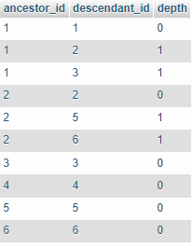

1. Marki
   1. INSERT INTO `brands`(`brand_name`) VALUES ("Nike"), ("Adidas"), ("Reebok"), ("Puma"), ("Umbro"), ("Jordan");

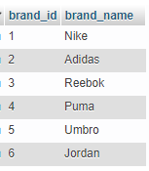

1. Dostawcy
   1. INSERT INTO `suppliers`(`supplier_name`, `supplier_contact`) VALUES ('Zalando','790350123'),('Hurtownia Adidas','780350123'),('Hurtownia Nike','770350123'),('Hurtownia rzeczy do koszykówki','760350123'),('Hurtownia rzeczy do piłki nożnej','750350123');

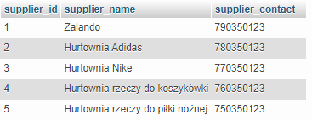

1. Artykuły

INSERT INTO `articles`( `brand_id`, `supplier_id`, `article_name_store`, `country_of_origin`, `ean_code`, `available`, `net_price`, `purchase_price`) VALUES

((SELECT brand_id FROM brands WHERE brand_id=1),(SELECT supplier_id FROM suppliers WHERE supplier_id=3),' Piłka do piłki nożnej','PL','5907069002004','1',15.99 ,13.20),

((SELECT brand_id FROM brands WHERE brand_id=2),(SELECT supplier_id FROM suppliers WHERE supplier_id=2),' Znaczniki,'DE','7613034944849','1',119.99,100.23),

((SELECT brand_id FROM brands WHERE brand_id=6),(SELECT supplier_id FROM suppliers WHERE supplier_id=4),'Piłka do koszykówki','EN','5903189076314','0',499.99,458.12),

((SELECT brand_id FROM brands WHERE brand_id=1),(SELECT supplier_id FROM suppliers WHERE supplier_id=1),'Super buty do piłki nożnej','GB','3052910056469','1',599.99,501.20),

((SELECT brand_id FROM brands WHERE brand_id=2),(SELECT supplier_id FROM suppliers WHERE supplier_id=1),'Super buty do koszykówki','PL','3052911145094','1',799.99,756.10); 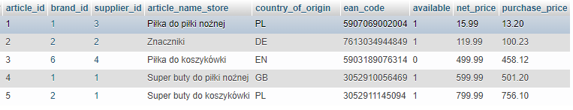

1. Kategorie do Artykułów

INSERT INTO `Relationship_3`(`category_id`, `article_id`) VALUES

((SELECT category_id FROM categories WHERE category_id=5),(SELECT article_id FROM articles WHERE article_id=1)),

((SELECT category_id FROM categories WHERE category_id=3),(SELECT article_id FROM articles WHERE article_id=2)),

((SELECT category_id FROM categories WHERE category_id=6),(SELECT article_id FROM articles WHERE article_id=3)),

((SELECT category_id FROM categories WHERE category_id=5),(SELECT article_id FROM articles WHERE article_id=4)),

((SELECT category_id FROM categories WHERE category_id=4),(SELECT article_id FROM articles WHERE article_id=4)),

((SELECT category_id FROM categories WHERE category_id=6),(SELECT article_id FROM articles WHERE article_id=5)),

((SELECT category_id FROM categories WHERE category_id=3),(SELECT article_id FROM articles WHERE article_id=5));

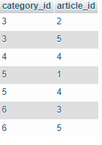

1. Użytkownicy

INSERT INTO `user_shop`(`user_shop_email`, `user_shop_password`) VALUES

('superMail@gmail.com','$2a$12$6RZTjp7Uiv7C2sH/lcVnbeZAKzMkWeJhaq.nrC2Vid2cH6EP6BR5u'),

('johnDoe@gmail.com','$2a$12$39CP0tkl3c244D3W2MRQeuvZ7FwDf1vc1UB5oCZeVKIbf.9ST/h1a'),

('marcinNowak@gmail.com','$2a$12$mVrvnhRxiWl3u5WxYNEFaucwoUK5BudyW/CTrq817s461IydnslMG'),

('123Nowak@gmail.com','$2a$12$GHSycU6MxphjHJdihjW0euwBkPBjHBJ5qabnlajvAhsopAL0EVEDu'),

('janKOwalski@gmail.com','$2a$12$9bk2df5f7DTqVxKco9UjZOfx4W1U5oEoR.mR8t9tPoTRvVtBMVeAC');

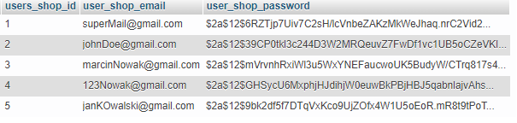

1. Adresy Użytkowników

INSERT INTO `user_shop_addresses`(`users_shop_id`, `city`, `post_code`, `street`, `builiding_number`, `flat_number`) VALUES

((SELECT users_shop_id FROM user_shop where users_shop_id=1),'Wrocław','54-345','Grabiszyńska','13A','11'),

((SELECT users_shop_id FROM user_shop where users_shop_id=2),'Poznań','61-745','Maricnkowsiego','9','13'),

((SELECT users_shop_id FROM user_shop where users_shop_id=3),'Warszawa','00-001','Łączności','32','1'),

((SELECT users_shop_id FROM user_shop where users_shop_id=4),'Kraków','09-890','Trzebnicka','12','9'),

((SELECT users_shop_id FROM user_shop where users_shop_id=5),'Gdańsk','78-765','Legnicka','AB1','123'); 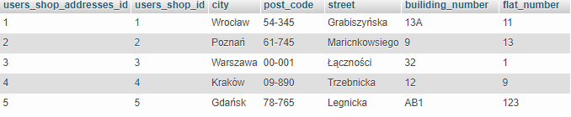

1. Zamówienia

INSERT INTO `orders`(`users_shop_id`, `ordered_datetime`) VALUES

((SELECT users_shop_id FROM user_shop where users_shop_id=1),NOW(),(SELECT user_shop_addresses FROM user_shop_addresses WHERE users_shop_id=1)),

((SELECT users_shop_id FROM user_shop where users_shop_id=2),NOW(),(SELECT user_shop_addresses FROM user_shop_addresses WHERE users_shop_id=2),

((SELECT users_shop_id FROM user_shop where users_shop_id=3),NOW(),(SELECT user_shop_addresses FROM user_shop_addresses WHERE users_shop_id=3),

((SELECT users_shop_id FROM user_shop where users_shop_id=4),NOW(),(SELECT user_shop_addresses FROM user_shop_addresses WHERE users_shop_id=4),

((SELECT users_shop_id FROM user_shop where users_shop_id=5),NOW(),(SELECT user_shop_addresses FROM user_shop_addresses WHERE users_shop_id=5);

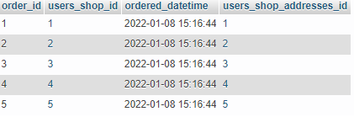

1. Zamówione Artykuły

INSERT INTO `Relationship_7`(`order_id`,`article_id`, `sold_net_price`, `amount`) VALUES

((SELECT order_id FROM orders WHERE order_id=1),(SELECT article_id FROM articles WHERE article_id=1),(SELECT net_price FROM articles WHERE article_id=1),2),

((SELECT order_id FROM orders WHERE order_id=1),(SELECT article_id FROM articles WHERE article_id=3),(SELECT net_price FROM articles WHERE article_id=3),4),

((SELECT order_id FROM orders WHERE order_id=1),(SELECT article_id FROM articles WHERE article_id=2),(SELECT net_price FROM articles WHERE article_id=2),4),

((SELECT order_id FROM orders WHERE order_id=2),(SELECT article_id FROM articles WHERE article_id=2),(SELECT net_price FROM articles WHERE article_id=2),10),

((SELECT order_id FROM orders WHERE order_id=2),(SELECT article_id FROM articles WHERE article_id=5),(SELECT net_price FROM articles WHERE article_id=5),1),

((SELECT order_id FROM orders WHERE order_id=3),(SELECT article_id FROM articles WHERE article_id=1),(SELECT net_price FROM articles WHERE article_id=1),9),

((SELECT order_id FROM orders WHERE order_id=3),(SELECT article_id FROM articles WHERE article_id=5),(SELECT net_price FROM articles WHERE article_id=5),8),

((SELECT order_id FROM orders WHERE order_id=4),(SELECT article_id FROM articles WHERE article_id=1),(SELECT net_price FROM articles WHERE article_id=1),5),

((SELECT order_id FROM orders WHERE order_id=4),(SELECT article_id FROM articles WHERE article_id=2),(SELECT net_price FROM articles WHERE article_id=2),3),

((SELECT order_id FROM orders WHERE order_id=5),(SELECT article_id FROM articles WHERE article_id=3),(SELECT net_price FROM articles WHERE article_id=3),2),

((SELECT order_id FROM orders WHERE order_id=5),(SELECT article_id FROM articles WHERE article_id=4),(SELECT net_price FROM articles WHERE article_id=4),1); 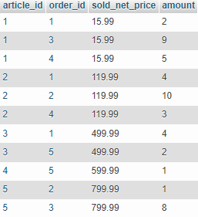

**Pkt.4 Zapytania `SELECT` na pojedynczych tabelach (+projekcja, min.10)**

1. SELECT `article_name_store`, `country_of_origin`, `ean_code`, `available`, `net_price`, `purchase_price` FROM `articles`; 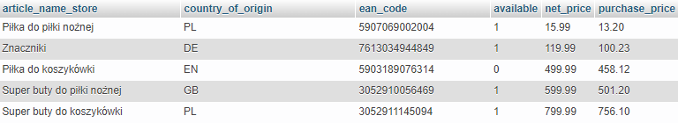
2. SELECT `article_name_store` FROM `articles` where net_price BETWEEN 400 AND 600;

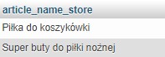

1. SELECT users_shop_id FROM `orders` WHERE DATE(ordered_datetime) <= DATE(NOW());

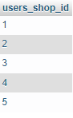

1. SELECT name FROM `categories`;

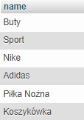

1. SELECT ancestor_id, descendant_id, depth FROM `categories_relations` WHERE depth > 0;

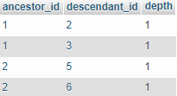

1. SELECT ancestor_id, descendant_id, depth FROM `categories_relations` WHERE depth = 0;

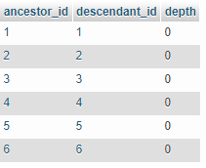

1. SELECT * FROM `brands` where brand_name LIKE '%a%';

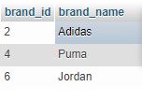

1. SELECT post_code, street, builiding_number,flat_number FROM `user_shop_addresses` WHERE CITY IN ("Wrocław", "Poznań", "Warszawa"); 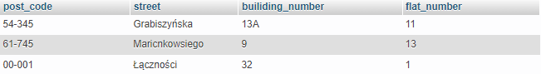
2. SELECT order_id, sold_net_price, amount FROM `Relationship_7` WHERE sold_net_price > 100 AND amount > 2;

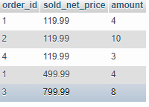

1. SELECT user_shop_email FROM `user_shop`;

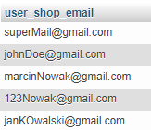

**Pkt.5 Zapytania `SELECT` na pojedynczych tabelach (+agregacja, fn. arytmetyczne, grupujące, min.10**

* 1. SELECT MIN(net_price) AS najtańszy_produkt FROM articles;
  2. SELECT MAX(net_price-purchase_price) AS największą_marża FROM articles;
  3. SELECT COUNT(article_id) AS amount, country_of_origin FROM `articles` GROUP BY country_of_origin ORDER BY amount DESC;
  4. SELECT CAST(AVG(net_price) AS DECIMAL(10,2)) FROM `articles`;
  5. SELECT SUM(amount*sold_net_price), order_id FROM `Relationship_7` GROUP BY order_id;
  6. SELECT v1.user_shop_email, v2.* FROM `user_shop` v1 LEFT JOIN user_shop_addresses v2 ON v1.users_shop_id=v2.users_shop_addresses_id;
  7. SELECT v1.name FROM categories AS v1 JOIN categories_relations AS v2 ON v1.category_id = v2.descendant_id WHERE v2.ancestor_id=1;
  8. SELECT v1.article_name_store, v2.brand_name, v3.supplier_name, v3.supplier_contact FROM `articles` v1 INNER JOIN brands v2 ON v1.brand_id=v2.brand_id INNER JOIN suppliers v3 ON v1.supplier_id=v3.supplier_id;
  9. SELECT * FROM categories_relations v1 INNER JOIN categories v2 ON v1.ancestor_id=v2.category_id OR v1.descendant_id=v2.category_id LEFT JOIN Relationship_3 v3 ON v1.descendant_id=v3.category_id INNER JOIN articles v4 ON v3.article_id=v4.article_id WHERE ancestor_id!=descendant_id;
  10. SELECT v1.ordered_datetime, v2.user_shop_email, CONCAT(v3.street, ' ', v3.builiding_number, '/', v3.flat_number, ' ', v3.city, ' ', v3.post_code) AS address, SUM(v4.sold_net_price*v4.amount) AS order_sum FROM `orders` v1 INNER JOIN user_shop v2 ON v1.users_shop_id=v2.users_shop_id INNER JOIN user_shop_addresses v3 ON v1.users_shop_addresses_id=v3.users_shop_addresses_id INNER JOIN Relationship_7 v4 ON v1.order_id=v4.order_id LEFT JOIN articles v5 ON v4.article_id=v5.article_id GROUP BY ordered_datetime, user_shop_email, address;

**Pkt.6 Zapytania Update (min.10)**

1. UPDATE `brands` SET brand_name='ASICS' WHERE id=1
2. UPDATE `user_shop_addresses` SET `city`='Szczecin',`post_code`='12-345',`street`='Nowa',`builiding_number`='7b',`flat_number`='1' WHERE users_shop_addresses_id=4;
3. UPDATE `articles` SET `supplier_id`=2 WHERE brand_id=1;
4. UPDATE `orders` SET `ordered_datetime`=NOW() WHERE order_id=5
5. UPDATE `categories_relations` SET `ancestor_id`=2 WHERE `ancestor_id`=1,`descendant_id`=3;
6. UPDATE `suppliers` SET supplier_contact`='890123654' WHERE supplier_id=1;
7. UPDATE `articles` SET `net_price`=net_price+10;
8. UPDATE `articles` SET `purchase_price`= purchase_price-0.10 WHERE id < 3;
9. UPDATE `articles` SET `article_name_store`=CONCAT(`article_name_store`,' ', `country_of_origin`) WHERE country_of_origin='PL'
10. UPDATE `articles` v1 INNER JOIN `brands` v2 ON v1.brand_id=v2.brand_id SET v1.`article_name_store`=CONCAT(v2.`brand_name`,' ',v1.`article_name_store`);