MANUAL

Program sinsyn.m and model singen.mdl collectively used to simulate single machine infinite bus system. It can be used to simulate the following disturbances:

1) Step change in Tm
2) Step change in Vref
3) Step change in Eb
4) Step change in reference value of omega
5) Step change in infinite bus angle

Following component models are used in the program and model.

GENERATOR MODEL

Generator is represented by 1.1 model.

Input file:machine.dat

Data to be entered:
Ra
X_{q}
X_{d}
X¹_{q}
X¹_{d}
T¹_{do}
T¹_{qo}
H
D
f

EXCITATION SYSTEM:

User can opt for any type of Excitation system among IEEE Type-1 Excitation system and Static Excitation system, or excitation system can be excluded. Block diagram for both Excitation system are shown below.

Input file for IEEE type-1 Excitation system: excieee1.dat

Data to be entered:
A
B
T_{R}
T_{A}
T_{F}
T_{E}
K_{A}
K_{F}
K_{E}
Vrmax
Vrmin

Input file for Static Excitation system: excst1.dat

Data to be entered:
T_{C}
T_{B}
K_{A}
T_{A}
Efdmax
Efdmin

IEEE Type-1 Excitation system

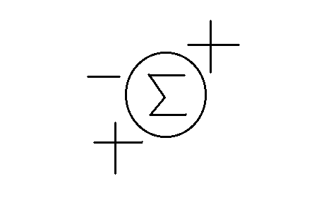
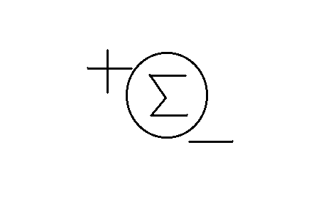
vg Vref vrmax Efd
1
1+T_{R}
K_{A}
1+sT_{A}
1
K_{E}+sT_{E}

Vs vrmin
S_{E}=f(E_{FD})

sK_{F}
1+sT_{F}

Static Excitation system
Efdmax
1+sT_{C}

1+sT_{B}
K_{A}

1+sT_{A}
Vref Efd
-vg
vs
Efdmin
vref - AVR reference voltage
vg - Generator terminal voltage
vs -PSS output voltage

POWER SYSTEM STABILIZER

User can opt for power system stabilizer or it can be excluded. Block diagram of PSS is shown below.

Input file: pss.dat
Data to be entered:
Ks
Tw
T1
T2
T3
T4
Vsmax
Vsmin
vsmax
sT_{W}

1+sT_{W}
K_{S}(1+sT₁)(1+sT₃)

(1+sT₂)(1+sT₄)
Sm vs

(slip) vsmin

GOVERNOR-TURBINE

User can opt for either Hydro governor-turbine model or steam governor-turbine model. Governor-turbine can also be excluded. Block diagram for Hydro governor-turbine and steam governor-turbine are given below.

Input file for hydro governor-turbine: hydrogov.dat
Data to be entered:
T_{r}
T_{g}
T_{p}
Delta
Sigma
T₂
T_{w}
Pmax
Pmin

Input file for steam governor-turbine: steamgov.dat
Data to be entered:
T_{ch}
T_{rh}
T_{co}
F_{hp}
F_{ip}
F_{lp}
T₁
T₂
T₃
Sigma
Pup
Pdown
Pmax
Pmin

SPEED GOVERNOR FOR HYDROTURBINE
K(1+sT₂)

(1+sT₁)(1+sT₃)

Pmax
__
Δω Pgv

Pmin

HYDROTURBINE MODEL
1-sT_{W}

1+0.5sT_{W}

Pgv Pm

SPEED GOVERNOR FOR STEAM TURBINE

_ .
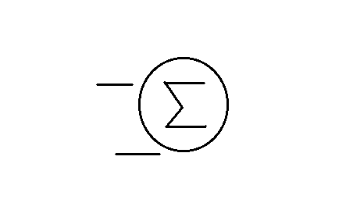
Δω Pup Pmax Pgv
K(1+sT₂)

(1+sT₁)
1
T₃
1
s
.
Pdown Pmin

STEAM TURBINE MODEL

1
1+sT_{ch}
1
1+sT_{rh}
1
1+sT_{co}
Pgv Pm

F_{hp}
F_{ip}
F_{lp}
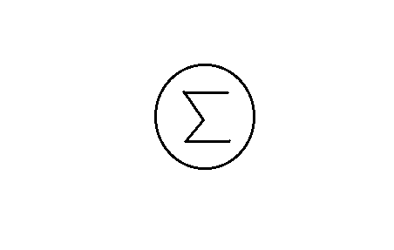

NETWORK

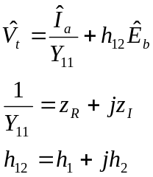Network is represented by h and z parameters at generator terminal. That is

Where V_{t} is the generator terminal voltage, E_{b} is the infinite bus voltage, Y₁₁ is the short circuit self admittance of the network, measured at the generator terminals and h₁₂ is the open circuit voltage gain. Value of h1,h2,z_{R} and z_{I} will have to be entered in the MATLAB program sinsyn.m

Simulink model

User is prompted to select the type of disturbance and to decide presence of excitation system, governor turbine and pss by clicking on the self explanatory blocks. User can obtain help regarding entering data by clicking on help button provided. Output plots can be observed in the scopes provided for different parameters.

Different data has to be entered in the input files created by user. All data files namely(machine.dat, hydrogov.dat, steamgov.dat, excieee1.dat, excst1.dat, pss.dat) program file(sinsyn.m) and model file(singen.mdl) has to be kept in same directory.
For running this program MATLAB command window has to be opened and sinsyn.m is typed in the command window. System can be simulated with singen.mdl model file after sinsyn.m is executed.

Initial value of different parameters can be viewed in MATLAB command window just by typing variable name of parameter. They are listed below.

Parameter Variable name

terminal voltage,angle vg,thetao
Active and reactive power pg,qg
Ia iao
Eq eqo
rotor angle deltao
Id ido
Iq iqo
Vd vdo
Vq vqo
Efd efdo
Eq¹ eqo1
Ed¹ edo1
Tm tmo

