Power Automate Developer

Agenda

# Prerequisites

* Power Apps or Power Automate per user (or Premium) license,
* Microsoft Office 365 (email, OneDrive for Business),
* Read/write access to a SharePoint folder,
* An environment with a Microsoft Dataverse database,
* A table the business process flow is associated with, e.g. D365 CE with demo data deployed,
* Basic knowledge of how to customize D365 CE applications
* A plan in Microsoft Planner (<https://support.microsoft.com/office/create-a-plan-in-planner-cbbf3772-4fdd-4f49-aa92-dc2203c062d7>)
* A list with read/write access in Microsoft Lists
* Access to Azure SQL database (Users will create a table in SQL and write to it)
* A tool for executing T-SQL scripts (e.g. Azure Data Studio)
* Each student needs individual:
  + D365 FinOps environment with demo data (Contoso) installed. A user must be admin of the environment
  + Data Verse environment with D365 CE apps provisioned (D365 Sales)
  + Dual Write installed and not configured. During the lab, students are going to setup DualWrite and virtual entities), for details see <https://learn.microsoft.com/en-us/dynamics365/fin-ops-core/dev-itpro/data-entities/dual-write/connection-setup>

# Modules

## Module 1 - Introduction

[Automate a business process using Power Automate - Training | Microsoft Learn](https://learn.microsoft.com/en-us/training/paths/automate-process-power-automate/)

1. Introducing the worlModule 1d of **microservices:**
   1. There is a lot of applications available via the Internet.
   2. The applications perform operations in response to a web-service call (such a call is a request or a web-request)
   3. Web applications spread from very simple to very complex, here are some examples of web applications:
      1. Facebook (Meta)
      2. Office Outlook
      3. SharePoint
      4. Excel Online
      5. OneDrive
      6. D365 FnO
      7. DataVerse
      8. KseF
      9. Orlen Paczka
      10. Azure (via APIs)
      11. Amazon WS
      12. Apache Kafka
      13. Azure Service Bus
      14. **many, many, many others**
   4. The web-requests return data (e.g. our corporate Office application can respond with e-mail address of my manager)
   5. The web request can by any operation internal to a remote application, e.g.:
      1. Outlook can send an email,
      2. FinOps can create a new Customer
      3. SharePoint can create a file, etc.
   6. All such applications know nothing or very little about each other. The only mean to make them communicating is to **orchestrate** a sequence of web-calls.
2. **What is Power Automate**
   1. Power Automate is a platform for creating and running such orchestrations
3. Are there other systems for web-services orchestrations? **Yes, plenty of them**, a few examples:
   1. Apache Airflow
   2. AWS Step Functions
   3. ActiveBatch
   4. BMC Control-M
   5. Redwood RunMyJobs
   6. Azure LogicApps
   7. BizTalk Server
4. What happens in an orchestratrion?
   1. Maintaingin connectivity to the endpoints (the orchestrator logs in to a remote endpoint)
   2. Sending requests and receiving responses from web-calls in sequence defined in a flow,
   3. Tracking the performance and issues with the web-calls
5. A flow is a ‘recipe’ that specifies the sequence of the web-calls
6. What is a **Power Automate Flow**
   1. A flow is a the sequence of the web-calls,
   2. A flow can be considered a program coordinating communication between the remote endpoints.
7. **Is Power Automate better or worse** than the competition
   1. Depending on the purpose :-)
   2. Main advantages imho[1]:
      1. very low cost on the infrastructure maintanance – it ‘just works’ as part of the Power Platform
      2. A platitude of connectors to various endpoints
8. [Get started with Power Automate - Training | Microsoft Learn](https://learn.microsoft.com/en-us/training/modules/get-started-flows/)
   1. Introducing Power Automate
      1. Cloud flows – orchestration runs in as a service, in MS Cloud
      2. Desktop flows – orchestration runs on a Windows computer
      3. Model-driven flows (limited to DataVerse internal APIs)
   2. Exercises:
      * 1. [Exercise - Create recurring flows](https://learn.microsoft.com/en-us/training/modules/get-started-flows/6-flow-scheduled-flows), solution: Labs\001_Create_a_recurring_flow\001_Create_a_recurring_flow_20241216150154.zip
      1. [Exercise - Monitor incoming emails](https://learn.microsoft.com/en-us/training/modules/get-started-flows/flow-monitor-incoming-emails), solution: Labs\002\002_OutlookAttachmentsToSharepoint_20241216174650.zip
      2. [Exercise - Share flows](https://learn.microsoft.com/en-us/training/modules/get-started-flows/8-flow-share-flows)
         1. Demo, switch to another user.
   3. Troubleshooting flows
9. [**Build approval flows with Power Automate**](https://learn.microsoft.com/en-us/training/modules/build-approval-flows/)
   1. Exercises:
      1. [Exercise - Build an approval request](https://learn.microsoft.com/en-us/training/modules/build-approval-flows/2-create-approval-request)
         1. Labs\004\004_AprovalWorkflow_20241216192028.zip
      2. [Exercise - Create a business process flow](https://learn.microsoft.com/en-us/training/modules/build-approval-flows/5-create-business-process-flow)
         1. Labs\005\rdu_pow_automats_demo_1_0_0_1.zip
      3. [Exercise - Create a business process flow that has conditions](https://learn.microsoft.com/en-us/training/modules/build-approval-flows/6-branching)
         1. Labs\006\rdu_bpf_car_sales_process_1_0_0_2.zip
10. [**Build flows to manage user information**](https://learn.microsoft.com/en-us/training/modules/manage-user-information/)
    1. Exercises:
       1. [Exercise - Build a flow that uses information like locations or date](https://learn.microsoft.com/en-us/training/modules/manage-user-information/2-tokens)
          1. Labs/Module01_Introduction/007/rdu_send_email_to_coworkers_20241218104818.zip
       2. [Exercise - Build a flow accepts user input when run](https://learn.microsoft.com/en-us/training/modules/manage-user-information/3-user-input)
          1. Labs/Module01_Introduction/008/rdu_send_me_a_reminder_20241218.zip
       3. [Exercise - Create a flow that blocks time on your calendar](https://learn.microsoft.com/en-us/training/modules/manage-user-information/4-store-documents)
          1. Labs/Module01_Introduction/009/rdu_block_out_my_calendar_20241218131515.zip
11. [**Power Automate's deep integration across multiple data sources**](https://learn.microsoft.com/en-us/training/modules/multiple-data-sources/)
    1. Exercises
       1. [Exercise - Build a flow that runs when an event in Dynamics 365 occurs](https://learn.microsoft.com/en-us/training/modules/multiple-data-sources/2-event)
          1. Labs/Module01_Introduction/010/rdu_create_task_when_account_created_20241218152754.zip
          2. Labs/Module01_Introduction/010/rdu_create_planner_task_for_activity_20241218161002.zip
       2. [Exercise - Build a flow that uses SQL](https://learn.microsoft.com/en-us/training/modules/multiple-data-sources/3-sql)
          1. Labs/Module01_Introduction/011/rdu_sync_sharepoint_list_and_sql_db_20241219114823.zip
       3. [Exercise - Integrate Power Apps, Power Automate, and SharePoint](https://learn.microsoft.com/en-us/training/modules/multiple-data-sources/4-integrate)
       4. [Exercise - Monitor flows](https://learn.microsoft.com/en-us/training/modules/multiple-data-sources/5-monitor)
12. [**Use the Admin center to manage environments and data policies in Power Automate**](https://learn.microsoft.com/en-us/training/modules/administer-flows/)
    1. Administer flows – admin center
       1. <https://admin.powerplatform.microsoft.com/>
    2. Export and import flows
       1. exercise – follow syllabus <https://learn.microsoft.com/en-us/training/modules/administer-flows/2-flow-export-import>
13. [**Use AI Builder in Power Automate**](https://learn.microsoft.com/en-us/training/modules/ai-builder-power-automate/)
    1. [Introduction to AI Builder usage in Power Automate](https://learn.microsoft.com/en-us/training/modules/ai-builder-power-automate/1-introduction/?ns-enrollment-type=learningpath&ns-enrollment-id=learn-bizapps.automate-process-using-flow)
    2. Exercises:
       1. [Exercise - Create a flow to route Helpdesk requests to different mailboxes based on language](https://learn.microsoft.com/en-us/training/modules/ai-builder-power-automate/exercise/?ns-enrollment-type=learningpath&ns-enrollment-id=learn-bizapps.automate-process-using-flow)
          1. Labs/Module01_Introduction/014/rdu_email_summarize_gpt_20241219144613.zip
       2. [Exercise - Use AI Builder actions in Power Automate](https://learn.microsoft.com/en-us/training/modules/ai-builder-power-automate/3-ai-builder-actions/?ns-enrollment-type=learningpath&ns-enrollment-id=learn-bizapps.automate-process-using-flow)
          1. Labs/Module01_Introduction/015/RDUAIBuildersolution_1_0_0_1.zip
       3. <https://learn.microsoft.com/en-us/training/modules/ai-builder-power-automate/4-advanced-usage>
          1. Labs/Module01_Introduction/016/016_readme.md
14. [**Optimize your business process with process advisor**](https://learn.microsoft.com/en-us/training/modules/business-process-optimization-process-advisor/)
    1. [Get familiar with process advisor](https://learn.microsoft.com/en-us/training/modules/business-process-optimization-process-advisor/2-get-familiar/?ns-enrollment-type=learningpath&ns-enrollment-id=learn-bizapps.automate-process-using-flow)
    2. Labs/Module01_Introduction/017/017_readme.md
15. [**Create and Manage Automated Processes by using Power Automate SC-5002** - Training | Microsoft Learn](https://learn.microsoft.com/en-us/training/paths/create-manage-automated-processes-by-using-power-automate/) - [Guided Project - Create and manage automated processes with Power Automate](https://learn.microsoft.com/en-us/training/modules/create-manage-automated-processes-with-power-automate/)
    1. Exercise: <https://learn.microsoft.com/en-us/training/modules/create-manage-automated-processes-with-power-automate/3-exercise-build-flow-to-send-automated-emails>
    2. Labs/Module01_Introduction/018/018_readme.md

## Module 2 – Integrate with FinOps

[Integrate finance and operations apps with Microsoft Power Platform - Training | Microsoft Learn](https://learn.microsoft.com/en-us/training/paths/integrate-finance-operations-apps-power-platform/)

1. Introducing integration concepts (no lab)
   1. [Explore finance and operations apps integration concepts](https://learn.microsoft.com/en-us/training/modules/explore-finance-operations-apps-integration-concepts/)
2. Dual-write setup
   1. Exercise/Demo – deployment of Dataverse environment and installing **Dual-write core solution** app takes long, so the steps will be described and final result demonstrated - [Set up dual-write in finance and operations apps](https://learn.microsoft.com/en-us/training/modules/set-up-dual-write-finance-operations/)

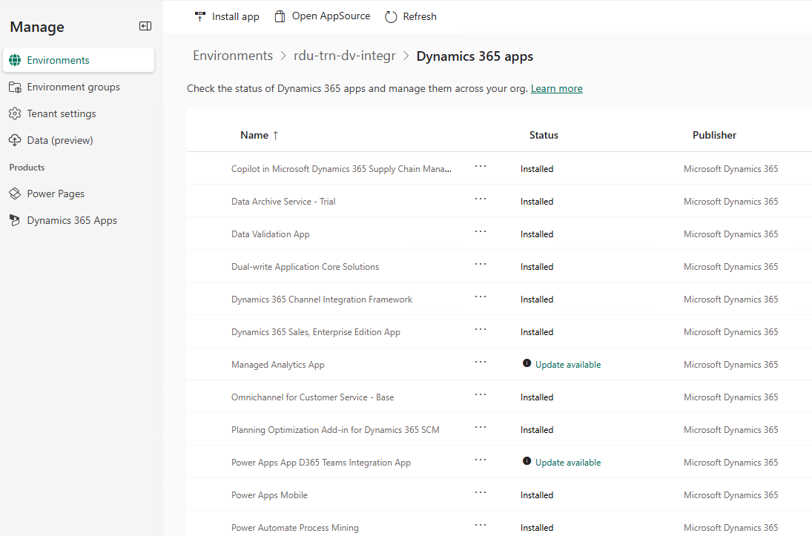

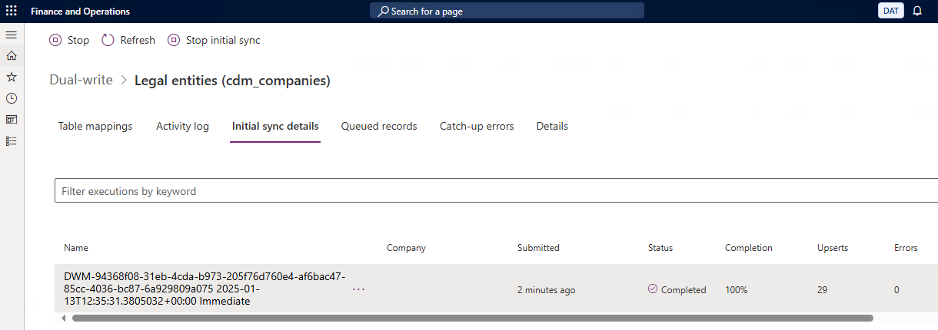

* + 1. Labs/Module02_Integrating_FinOps_w_PA/019/019_readme.md
  1. Virtual entities setup
     1. Labs/Module02_Integrating_FinOps_w_PA/020/020_readme.md

## Module 3

[Power Automate: Automation - Online Workshop - Training | Microsoft Learn](https://learn.microsoft.com/en-us/training/paths/robotic-process-automation-online-workshop/)

## Module 4

[Integrate Power Automate flows and Dataverse - Training | Microsoft Learn](https://learn.microsoft.com/en-us/training/paths/integrate-dataverse-power-automate/)

## Module 5

[Start using buttons in Power Automate - Training | Microsoft Learn](https://learn.microsoft.com/en-us/training/paths/get-started-power-automate-buttons/)

## Module 6

[Integrate SharePoint and Power Automate - Training | Microsoft Learn](https://learn.microsoft.com/en-us/training/paths/integrate-power-automate/)

## Module 7

[Share and collaborate with Power Automate - Training | Microsoft Learn](https://learn.microsoft.com/en-us/training/paths/share-collaborate-power-automate/)

## Module 8

[Build custom connectors for Microsoft Power Platform - Training | Microsoft Learn](https://learn.microsoft.com/en-us/training/paths/build-custom-connectors/)

1. - Rafal’s Dudzinski personal opinion.