Cairo University  
Faculty of Computers and Information



**CS251**

**Software Engineering I**

GoFo

Software Design Specifications

Version 2.0

April 2020

Contents

Team 3

Document Purpose and Audience 3

System Models 4

I. Class Diagram(s) 4

II. Class Descriptions 5

III. Sequence diagrams 6

Class - Sequence Usage Table 6

IV. User Interface Design 7

Tools 7

Ownership Report 7

References 7

Authors 7

# Team

|  |  |  |  |
| --- | --- | --- | --- |
| **ID** | **Name** | **Email** | **Mobile** |
| 20180250 | Mahmoud Ashraf | [ma5027300@gmail.com](mailto:ma5027300@gmail.com) | 01102488789 |
| 20180304 | Nader Fikry | [naderfikry245@gmail.com](mailto:naderfikry245@gmail.com) | 01097632795 |
| 20180193 | Fady Emad | [fadyemad14705@gmail.com](mailto:fadyemad14705@gmail.com) | 01203732443 |

# Document Purpose and Audience

* This document is an SDS document for a program that focuses on reducing the time and effort for booking a playground.
* It serves everyone interested in booking a playground and also the playground owners**.**

# System Models

## I. Class Diagram(s)

*Note: setters and getters were omitted for redundancy*

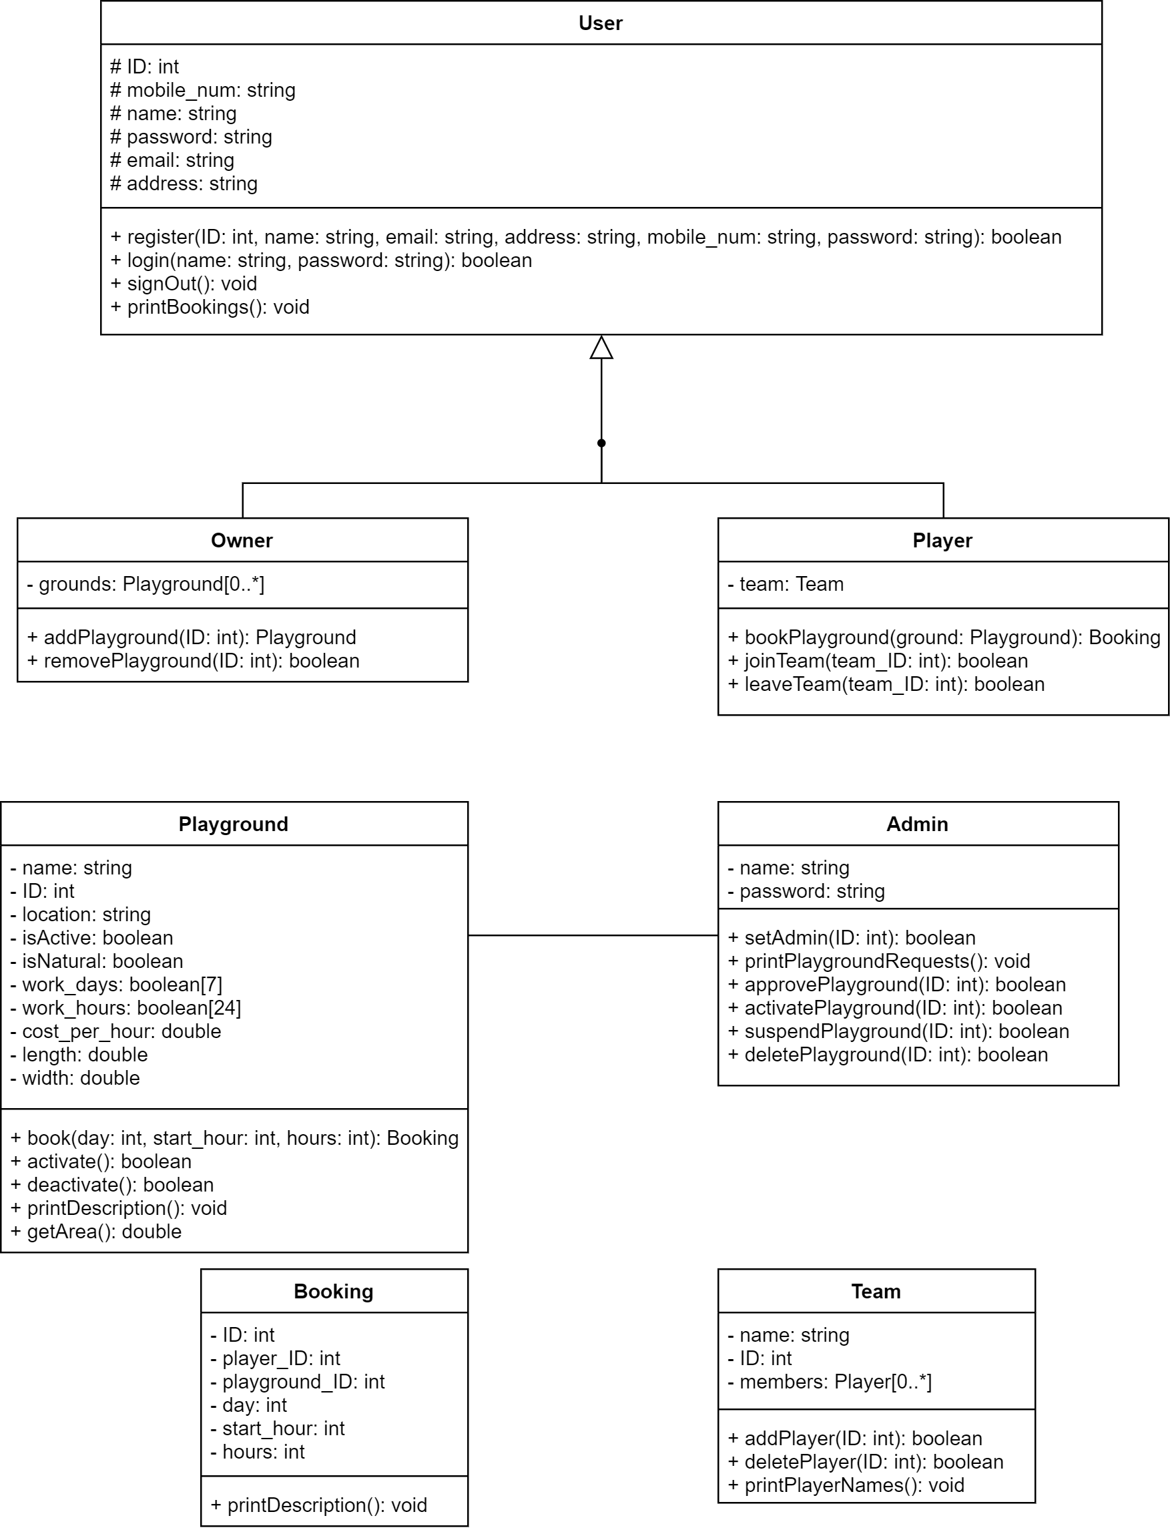

## II. Class Descriptions

| **Class ID** | **Class Name** | **Description & Responsibility** |
| --- | --- | --- |
| 1. | Adminstrator | The adminstrator is responsible for managing the software. He is also responsible for managing playgrounds and make sure they conform to the rules.  He is responsible for the following:   * Approve playground * Activate playground * Suspend playground * Delete playground |
| 2. | User | This class is used as to be inherited by both the Playground Owner and the Player. It resembles a user who can do basic actions like:   * Sign up * Login * Sign out * Change password * Change username |
| 3. | Playground Owner | The playground owner owns at least one playground in the database. He can do the following:   * Add new playground * Update attributes of an owned playground * Check eWallet |
| 4. | Player | The player is a user who has signed up and who now wants to find an available playground. Methods include:   * Book playground * Invite * Create team * Cancel booking * Edit info * View playing hours |
| 5. | Team | It is a class of a collection of players. The number of players is variable. Players can join and leave teams. |
| 6. | Playground | Holds description for each playground in the database Its attributes describe its:   * Name * Location * Active or not * Artificial or not * Vacation days * Cost * Area in m2 |
| 7. | Booking | The objects of this class each resembles a single booking made by a player for a specific playground. Each booking has a unique ID to be identified with. |