Harmattan Language Applets
Subsystem Architecture Specification

Document code: | DSAXXXXX-EN
Version: | [?Version?]
Status: | Draft
Save date:
Author: | Robert Manner
Approver: | ??
File: | 0000.doc
Lotus Notes Database: | ??

Change history:

Version | Date | Status | Author | Comments
0.1 | 24. 02. 2010 | Draft | Robert Manner | First draft

Table of Contents

1 Document control 4
1.1 References 4
1.2 Glossary 4
1.3 Summary of changes in current version 4
2 Introduction 4
3 Architecture 5
3.1 System Contents 5
3.1.1 Provided interfaces 5
3.1.2 Used interfaces 5
3.2 Behavioral, structural view 5
3.3 Licensing and IPR View 6
3.4 Development 6
3.5 User Data, Settings and Configurability 6
3.6 Packages 6
4 Performance 6
4.1 General Performance Considerations 6
4.2 Memory 6
4.3 Runtime 6
4.4 Power Consumptions 6
5 Security Impact 6
6 Open Items 7

Document control

References

Tag | Document name | Repository (with hyperlinks)
[ArchGoals] | Architecture Goals | http://wikis.in.nokia.com/MaemoSoftware/ArchitectureGoals
[SystemModel] | Maemo System Model | http://vawww004.ext.nokia.com/MagicDraw/official/Maemo%20Architecture/maemoarchitecture.html

Glossary

Acronym or term | Description
API | Application Programming Interface
Gconf | Application settings database
DBus | Inter-process communication system
UI | User interface

Summary of changes in current version

Introduction
This document is subsystem architecture specification of DUI display and input language applet/plugin. These applets are part of Harmattan and they implement graphical user interface to change the translation of the applications and the input language configuration.
Display language applet is used in the Dui Startup Wizard and in the Dui Controlpanel, keyboard language applet is only used by controlpanel.

Architecture

System Contents
Language plugins uses the controlpanel plugin library to integrate to the UI of duicontrolpanel (and duistartup). They obtain the available languages from checking files on the device, and use gconf to set the active language used by other programs.

Provided interfaces
No public API provided to applications.
Direct manipulation of the stored values (display language and input languages) gets noticed by the applet.
Those applications which need to pop up one of the applets can use the servicefw API of controlpanel for that purpose.

Used interfaces
- libduicontrolpanel for implementing its applet interface,
- directui framework for the UI elements,
- gconf for configuration handling

Behavioral, structural view
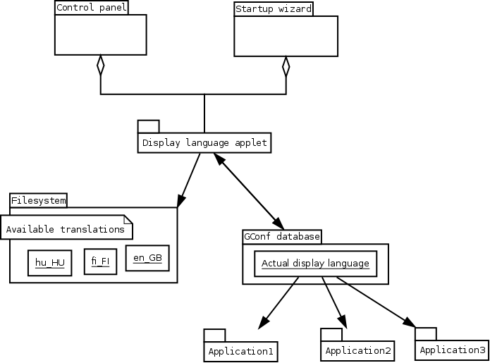
The language applets can embed into applications which supports using controlpanel plugins, this is currently the controlpanel and the startup wizard.
The display language applet
- checks the language list by checking the available translations on the filesystem,
- and provides a graphical way for the user to change the gconf values that represents the actual display language.
- Running applications notices this change by listening to the gconf key change signal (through dbus).
Keyboard language applet works the same way:
- parses the available input methods from the .xml files of the keyboard layouts (provided by ,
- stores the user configured value in gconf,
- which change gets noticed by the VKB by listenning to the gconf key change.

Licensing and IPR View

Development

User Data, Settings and Configurability
The actual display language, input languages are stored in gconf.

Packages
Source packages | Certification | Copyright | Code release | Binary packages/License/Dependency type
duicontrolpanel-languageapplet |  |  |  | Duicontrolpanel-displaylanguageapplet  duicontrolpanel-keyboardlanguageapplet

Performance

General Performance Considerations

Memory

Runtime

Power Consumptions

Security Impact
The configurations the applets are changing are changable from userspace, the applets requires no special privilages.

Open Items

# | Item | Status | Description
 | Performance of display language list loading |  | Loading the display languages list can take long if lot of translations are on the device, in a dirlist every file name gets checked one by one.  (Previously each translation was in the directory of its language, the format was:  <lang>/<app>_<lang>.qm  so only the directories were to be checked.)

