3.
Augmented Reality System
Augmented Reality (AR) is a technology that enables overlaying of extra text or objects that are computer-generated on top of the user’s real environment perception, in real time.
The AR software is meant to ease the lives of their users and provide extra information in day-to-day activities, thus having a lot of applications in different engineering fields such as language processing, image processing, audio processing, etc.
Augmented reality can be achieved in different ways, but the general concept behind this technology is that the virtual image is projected on a see-through medium, thus enabling the user to perceive both real and virtual image.
AR has its input composed of different sensors that enable the system to know the location or what the user perceives from the physical environment. Output devices are used so that the user can gain information and feedback from the AR system. Communication with the system can be done either tactile, visually or auditory.
Augmented reality can be achieved in different ways and a few of the methods widely used are:
- Video see-through AR: In this kind of implementation, the virtual reality content is added on top of a real-time video recording of what the user perceives and then displayed back to the user, with the added virtual elements.
- Optical see-through AR: With this kind of setup, the virtual image is projected on a semi-transparent surface. The user perceives the real environment, and the virtual image is added to its field of view.
- Projection based AR: Projected AR uses its environment as the surfaces onto which the virtual image is projected.
Out of the presented ways of achieving augmented reality, in my thesis project I have concentrated on the optical see-through AR. Even this kind of AR can be split into multiple ways of achieving it.
Optical AR can be engineered in two main ways:
- Free Space Optical Architecture – Uses a combination of the following components to achieve augmented reality: (micro)display, lens, mirror and a beamsplitter (semi-reflective medium).
- Waveguide-based Architecture – In the waveguide-based system, light that is transmitted by the display is guided through a transparent waveguide (system that resembles fiber optics, permitting nearly total light reflection) and then perceived by the human eye similarly as in a free space architecture.
In my implementation I have used the Free space architecture to construct the glasses.
Machine Translation
Machine Translation refers to different techniques of translating text from one language to another, using different computation techniques that consider morphology and sentence structure from each language. Even though computers are generating impressive results these days, they are still limited by certain factors regarding the translated language, such as grammar, language depth, etc.
Historically, there are multiple ways that computers have done translation. The major types of translation that also have different implementations are rule based machine-translation, statistical machine translation and neural machine translation.
- Rule based translation is the first way of translation implemented. This type of translation Is based on the linguistic information of both the source and target language. The information refers to morphological, semantic properties of the language.
- Statistical translation is the following approach after rule-based translation.
Instead of relying on specific rules to ensure translation is done, it relies on statistical models and the basis of those is the probability distribution: p(t | s) that means the probability of word ‘t’ in target language is the translation of word ‘s’ in the source language. Finding this probability was approached in multiple ways and one of those is based on Bayes Theorem that states that: p(t|s) ~ p(s|t)*P(t). This basically means the probability of source word ‘s’ to be the translation of the word ‘t’ from the target language and p(t) is the probability of the word ‘t’ in the target language. The models pick the word that would have the highest probability out of all the words in the dictionary. The problem becomes finding this word efficiently and ways to limit searching for this word. Those types of translation have evolved from word based to sentence based.
- Neural Machine translation uses artificial intelligence to predict the probability of a sequence of words, modeling entire sentences. Thus, a sentence in the source language is translated into the target language.
As in statistical translation, certain sentences are assigned a probability, and the highest one is chosen. In a nutshell, sentences are encoded into matrices or vectors by an encoder and then a decoder is used to obtain the target words, one at a time, considering previously produced words. This means that the process is auto regressive.

4.
4.Optics behind free space architecture-based AR Systems.
As mentioned in the previous chapter, I implemented in my design the free space architecture of the optical see-through architecture, which means that the virtual image of the display gets projected on a semi-transparent surface, right in front of the eye.
The whole optical system of this way of achieving augmented reality has the following components, regarding the path of the light, until it reaches the human eye: the display, used as the source of the virtual image formed on top of the physical environment, a lens, a mirror and a beamsplitter (semi-reflective surface).
Those were the chosen components of the system because of the way the light travels and certain properties regarding how the human eye creates the images on the retina.
Ray optics
To understand the optical aspect of the thesis, there are certain optical terms that need to be clarified:
- The Mirror and Reflections
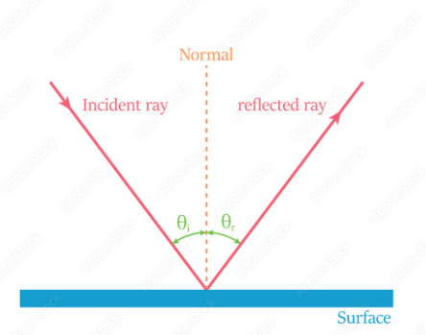
Glossy surfaces, such as a mirror have a predictable way of reflecting the light. In such a medium, the direction of the reflected ray is determined based on the angle at which it hits the reflective plane, relative to the surface normal (the line perpendicular to the reflective plane). For flat images, such as in image (nr reff), the image size is the same as the object size, appearing at the same distance.
- Refraction
In simple terms, refraction happens when light travels through a surface that changes its angle, due to a property of that surface called: index of refraction.
A device that bends the light, or, rather, creates converging or diverging light rays is called a lens.
Depending on the type of lens, a focal point is formed, on either side of the lens. The focal point is a point in which all the light rays concentrate. Relative to the focal point, the focal distance represents the distance between the focal point and the lens.
In convex lenses, lenses that concentrate the light in a single point, the light rays appear to be meeting in a single point in front of the lens, whilest in concave lenses, the light rays diverge to different directions, but they appear to diverge from the central point, called the focal point, which, in this case, sits behind the lens, not after it.
- Lenses and real/virtual images.
Due to the properties of certain convex and concave lenses, the image that we see is of one of the two categories: real or virtual.
Real images form after light passes through a lens. In case of convex lenses, if the object is put beyond the focal point (at a distance >f), the refracted rays meet at the opposite side of the lens, forming a real image. The image will be inverted when seen by the eye and is projected onto a surface.
Virtual images cannot be projected onto a surface. In the case of virtual images, the image appears to be formed on the same side of the lens, uninverted, for example: the image we see when we look in the mirror is a virtual image.
Given those explanations, convex lenses can create both virtual and real images, this depending on the distance of the object from the lens and the focal distance of the lens. When the object is at a distance bigger than the focal distance, a real, inverted image is formed. When the object is at exactly the focal distance, the object is considered at ‘infinity’. When the object is at a distance smaller than the focal distance, the image is virtual and also magnified, based on the distance and the focal distance.
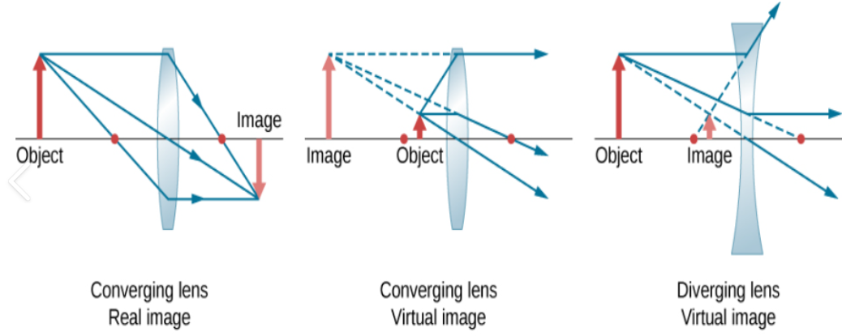
The image below showcase the differences:

The most important equation given the focal length and the distance of the object is the following: (f – focal distance, S1-object distance, S2-distance when image is formed after passing through the lens).
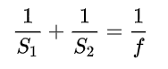
When S2 is negative, that means the image is virtual.
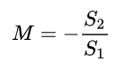
The next useful formula is the magnification formula, that is simply the ration between the size of the original object and the formed image, which can be written as the ration between the distances S1 and S2.
- The human eye
The final ‘component’ of the optical path involved in an AR system is the human eye.
The eyes constantly accomodate to objects, based on the distance of the object and the eyes. Given this fact, objects that are really close to the eye require a lot of accomodation and can cause muscle strain and eye issues if done for a lot of time. On top of that, the human eye cannot focus objects that are closer than 25-20 centimeters to the eye.

Normally, text or data that is really close to the eye, such as information displayed by digital display should not be focusable by the eye.
That is why an AR system takes advantage of the fact that when a virtual image is formed by a lens, given that the display sits at a distance equal or smaller than the focal distance, the human eye can focus on the image, without any strain. The resulting image is projected much further, or even at infinity, due to the properties of the rays traveling through the lenses, described earlier.
Translation
Out of the presented types of machine translation, I decided to implement a rule based translation from english to romanian. Even though it is the oldest type of translation, there are certain aspects of it that are at the basis of modern ways of translating and there are even neural models that choose a rule based approach for better accuracy in some situations, when a rule-based translation is considered more roboust.
On top of that, given that this translator was going to be embedded into the micro-processor or the phone application, keeping the power consumption as low as possible or the application small would be a must, as this would mean faster responses in the communication between the microprocessor and the phone. Moreover, low latency for real-time translation is preffered and in areas with no internet connection available, a local model is desired
Beside those advantages, there are certain disatvantages regarding this type of translation, especially for two very different languages as english and romanian. Romanian is a rich language when it comes to word morphology, whilest English has a more complex sentence and does not rely as much on the form of the words within the sentence.
(could say, this would be one of the scopes? To see if it fiesable to do this kind of translation for such diff languages?)
As said in the previous chapter, each type of translator has different implementations, raging from simple to more complex.
Rule Based Translators are divided into the next types:
- Direct Systems – The most simple, map directly the input to output, using most of the time a dictionary
- Transfer Based Systems – Besides doing direct translation, different morphological and syntactical modifications are applied to the source.
- Interlingual Systems – Those are the most complex. They use an auxiliary language that sits in-between the source and target language. The source language is firstly translated into the interlingua and after that, from the interlingua, the translation to the target language is done.
Several theoretical concepts are essential for understanding the principles and the pipeline behind rule-based translation. The pipeline resembles other rule-based translators, such as Apertium and has similar concepts.
In order to understand how the entire process of translation works, we must divide the process of translation into two: translating the words themselves, so the ‘structure’ of the words, which, in short,is called morphological transfer and translation of the relative position of the words in a sentence, refering to the structural translation. These are the two parts one must be concerned with when trying to develop a translating machine.
Given this separation of concerns, the process of translation can be divided into the next steps (each step will be described in more detail later):
- Tokenizing the sentences – This step refers to separating the words from a sentence, then feeding each word, or combination of words in the next step of the process.
- Morphological analysis – Taking each token from the previous step and separating it into a combination of the base of a word (lemma) and associated ‘tags’.
- Part of Speech Tagging – In case of ambiguities, an algorithm to determine the most fitting part of speech is used.
- Lexical transfer – This step envolves translating the words from the source language in the target language, this involving the tags created at the previous step.
- Structural transfer – Modifying the structure of the sentence so it makes sense in the target language. This step will be divided into two parts: shallow structural(syntactic) transfer and deep syntactic transfer which uses parse trees to translate from one language to the other.
- Morphological generator – After modifying the structure of the sentence, the words in the target language are changed into usable forms to be inserted into a a sentence.
- Assembling the final sentences/piece of text.

- Tokenization
The process of tokenization is just separating the words from a sentence. In the current implementation, simple sentences without punctuation was considered. All words are also transformed into lower-case.
- Morphological analysis –
This step of the process involves modifying the sentence words to their base form (lemma) and associated tags that give information about the initial form of the word. (dividing the word into morphemes).
For this step, there are several requirements. One of the first requirements is a lexicon for the source language and one for the target language.
In the context of rule based translation, a lexicon is a data structure that contains lemmas of words of the language aswell as additional information about the words, such as gender, part of speech, etc.
Morphological features can be modeled using finiste state transducers (FST). A transducer maps between two representations. A FST is a finite state automaton that generates pairs of strings: it associates those strings one with another. (One can visualize a FST as a machine that gets input a string and generates as output another one.
A FST has different parameters such as a set of states (Q), a set representing the input alphabet (Sigma), a finiste set representing the output alphabet (Delta), a start state(q0), a set of final states(F), transition function (function given a state, eg: g(q,w), q-state, w-string,returning a new state q’) and the final component: an output function that outputs the strings from a given state ( u(q,w)). (read left, write right from pair :)
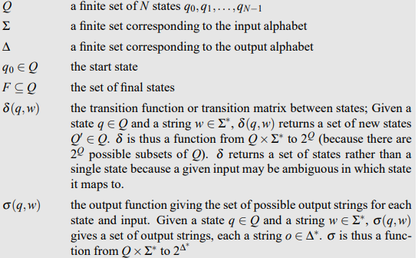
Thus, in the field of translation, FST will be used to map between the surface and lexical forms of a word. The surface form is a word as it would be used in a sentence (eg: ‘cats’), whilest the lexical form is the word divided into lemma and tags (cat+<pl>).
One advantage of finite state transducers is that they can be combined, via composition, so more fst’s can create a single one, through which words are modified or analyzed. On top of that, the process of a FST is reversible, so one should be able to go from lexical to surface form and in reverse easily.
The different rules from the grammar of both english and romanian will be implemented using FST’s, those being very appropiate for this task.
Thus, in order to create a reliable way of analyzing and generating the words, the most important thing is how the FST is designed. It should have appropiate states and transitions for managing certain rules from the language (for example, how most words in plural gain the ‘s’ prefix or ‘es’ for other words). All the letters from the alphabet will be considered finishing states as a word can end in any word. On top of that, special tags (<pl>, <3sg>) will be mapped as finishing states, those being at the end of the words, representing prefixes that will be mapped to certain letters, based on the context. The context is the part of the rules that is used to create the lexical form reliably. For example, a rule regarding plural words in english is that ends in ‘x’ is that ‘es’ is added, instead of just ‘s’. Thus, for this specific example, the context for this word is the letter ‘x’. In order to not mistake when needing to transition from a normal state to another state ,or from a letter part of a context, a certain algorithm is used to map the transitions of the FST.
The algorithm was originally made by Aho Corasick.
The algorithm was originally made to quickly search for string patterns in a text. The way the algorithm works is relatively simple. Each final node in the automaton created for the algorithm represents a pattern (in the case of FST’s, prefixes or suffixes) and there are intermediary nodes for each pattern. Besides the normal path to terminal nodes, there are also back edges(failure transitions) that backtrack to the longest previously matching suffix (that it is itself a prefix in the context of an FST), by removing the first character sequentially. So instead of resetting all the way to the start, the algorithm naturally backtracks to the most appropriate state from a given state, thus efficienty finding contexts for the rules required by the FST rules.

- POS Tagging
Part of Speech (POS) Tagging refers to the process of identifying the part of speech for each word in a sentence. There are many situations in which identifying the part of speech of a word is difficult and is dictated by context, thus tagging is necessary. On top of that, the current pipeline I am implementing permits the morphological analyzer to output a single word with multiple meanings.
Tagging can be done in two main ways: rule based tagging and stochastic tagging. Rule based tagging involves a lot of manual work and hard-coded rules for disambiguization of the difficult to classify words.
On the other hand, stochastic tagging is based on probabilities and one of the first steps in applying this type of tagging is loading a corpus with sentences and training a ‘model’ into finding the tag that is most probable for a word, given the previous contexts for that word in the training set.
The basis of the probabilistic model under stochastic tagging is the Bayesian inference, or classification. Thus, part of speech tagging is treated as a classification task for each word in the given context. In other words, we are searching for the sequence of words, each possibly being any part of speech, the sequence most likely to appear.
We denote:P(correct seq)=max[ P( tn | wn)] (1)– for a given tag sequence tn and n words, probability of tags tn appearing considering the words wn.(this value must be maximized). Given this is a hard probability to compute by itself, we use the Bayes transformation to simplify this equation: P(x|y) = P(y|x)*P(x)/P(y).
Then, this formula is applied to the initial formula (1):
P(correct_seq) = P(wn|tn)*P(tn)/P(wn).
The above equation can be simplified by dropping the denominator P(wn). The denominator can be simplified because, for each sequence of parts of speech, the P(wn) which represents ‘the probability of that sentence’, but since the sentence remains the same for all combinations of tags and given that for each sequence of tags, that value stays unchanged, then the equation is simplified to:
P(correct_seq) = P(wn|tn)*P(tn).
Even this formula is too complicated to be computed by itself, so 2 simplification is applied to it in order for it to be easily computable.
The first assumption is that a word appearing is dependent on its own tag, not on the other words around it,so thus, P(wn|tn) simplifies to: Prod[ P(wi|tn)]
The assumption that simplifies the equation is the following: instead of a tag depending on the other tags in the sentence, it will only depend on the previous tag (also called bigram assumption): P(tn) =Prod [ P(ti|ti-1 ].
Each of the two probabilities that form the probability can be computed via the corpus:
The Probability P(ti-1|ti) is simplified to: C(ti-1,ti)/C(ti-1), where the nominator means how many times is tag at index I preceeded by tag at index i-1, and the denominator means how many times does tag i-1 appear in the corpus.
The probability P(wi|ti), that represents the fact that given a word, it is associated with a certain tag can be computed similarly via counting with the following formula:
P(wi|ti) = C(ti,wi)/C(ti).
Now, for both probabilities we have a way to compute them.
The problem of choosing the best combination of tags is further narrowed down to the formal representation of a Hidden Markov Model (HMM), an extension of a Markov Chain.
A Markov Chain behaves like a system that moves from a state to another, where the next step only depends on current position, not on other states and has probabilities associated with its transition arcs.
A Hidden Markov Model behaves like a finite state automata, the main difference being that each arc in between states of the automata has an associated probability, thus each edge has a weight to it of how likely it is to be taken. From a single node, the sum of the probabilities is always 1. In a normal Markov chain, the input sequence determines which states the automaton goes through,whilest in a HMM, the states are not directly observable, only observations about them, emitted by the hidden states while going through them.
Applied to part of speech tagging, the possible states are the ‘unknown’ parts of speech that form a sentence.
On top of the hidden states, there is also the transition probability matrix that represents the probability of switching between the states. An emission probability matrix is also present, which has probabilities representing the likelihood of a word being generated in a hidden state (or the probability of a word being a certain part of speech).
Once the two matrices are computed based on a corpus, finding the tags that represent a sentence (the best sequence of hidden states for the given sentence) is called decoding.
One of the most common decoding algorithms is the Viterbi algorithm.
The algorithm has as input a HMM and a set of observed words (words that need identification) and returns the most probable tag sequence for that set of words inputted.
The HMM consists of two tables with probabilities: one with the hidden probabilites between the states p(ti|ti-1) and the other with the observed probabilites, eg the association between words and tags probability: p(wi|ti).
The algorithm is the following:
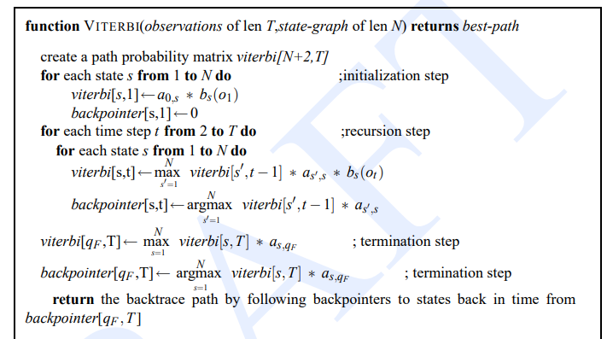
The main idea behind an algorithm is that the best path to a point includes the path to the previous point. Thus, the algorithm works this way: for the first word, the probability of being a part of speech is computed, then for word 2, the probability of being the part of speech is dependant on the tags of word 1 and the best is chosen. That step was for a single part of speech, this is repeated for other parts of speech for word 2 and for each part of speech at word 2, a backpointer to the best previous node is computed.
^^^^needs to be added a bit for the choosing the max, but other than that its good
At the end, the best path along all the paths is chosen. At the final word, after looking at all the possible tags for that word, the best one is chosen and the backpointers are followed from that cell until the first word is reached and this is the final output.
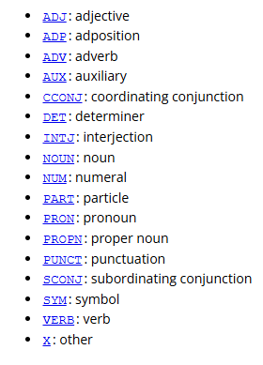
<<<used in the corpus, universal tags

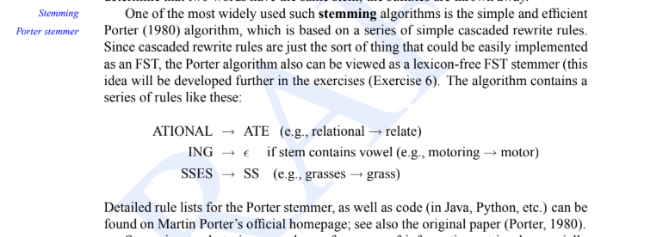

Cliticization(‘s), derivation, english

Stemming?

123 250, 390(teorie gramatica), 495 (teorie gramatica+impl), 650+,

Implementation
The lens used in my optical path to create the virtual image and the desired AR effect is a bi-convex lens with a focal distance of roughly 70-72 mm.

In the initial tests done in order to simulate the optical path of the rays travelling and reaching the eye I used the following structure:
(top view image of the system with longer back part)
Angular magnification??? Concerned with it??? Ill see

Machine translation:
Lexicon, how it is modeled. In my file
How did I choose the words.
Transducer implementation

References:
Use Case of the Application of the Optical-See-Through Augmented Reality Technology in the Engineering Context - ScienceDirect
Angular Magnification: Definition and Calculation Explained – ICO Optics
Geometrical optics - Wikipedia

Machine translation - Wikipedia
https://wiki.apertium.org/wiki/Main_Page
https://wiki.apertium.org/wiki/Apertium_New_Language_Pair_HOWTO
Speech and Language Processing, 2nd Edition
^chapter3-3.4, section 8, - 8.3, , chapter 13, 13.4, no structural transfer?^)

https://cp-algorithms.com/string/aho_corasick.html
https://www.nltk.org/book/ch03.html
https://kristopherkyle.github.io/Corpus-Linguistics-Working-Group/pos_tagging_1.html
pos tagging:
https://www.geeksforgeeks.org/nlp/part-of-speech-pos-tagging-with-hidden-markov-model/
https://kristopherkyle.github.io/Corpus-Linguistics-Working-Group/pos_tagging_1.html
https://github.com/UniversalDependencies/UD_English-EWT?utm
^training corpus
https://universaldependencies.org/u/pos/ <pos symbols

