AMBO UNIVERSITY HACHALU HUNDESSA CAMPUS

FROM  TO

INTERNSHIP REPORT

A report submitted for the Award of Degree of

**BACHELOR OF TECHNOLOGY in COMPUTER SCIENCE**

**by Adugna Tefera**

**ID: TUGR/7001/13**

**Under Supervision of**

**Mr Daniel Asefu**

**ICT Directorate ->ASTU (Duration: 21th july, 2022 to 21th Sept, 2022)**

Adama, Ethiopia Date 08/09/2022 GC

Acknowledgement

First I would like to thank our almighty GOD who lead me with great victory with in all educational life and in all our life. And also i would like to thank **Mr Taddesse**, the Acadamic Director of **Astu ICT Center** for giving me the opportunity to do an internship within the organization and for the facilities provided to accomplish this internship.

I would like to thank my Supervisor **Mr Daniel** for his constructive criticism throughout my internship.

I also would like to thank my friends **Amen** and **Aman** for them support and advise, for providing motivation to complete this project.

It is indeed with a great sense of pleasure and immense sense of gratitude that I acknowledge the help of these individuals.

ADUGNA TEFERA

(TUGR/7001/13)

**EXECUTIVE SUMMARY**

This internship report is all about my over all internship practice and experience in ASTU. It consists of four chapters which are explained here.And it’s all based on the practical session I tried not to explain theoretical parts more since the objective is not it.

The first chapter describes the background of my internship hosting company i.e. Adama Science and Technology University. And next I will try to explain more about the main section of this report in the second chapter. It describes my overall internship experience including the work flow in the section, the procedures and challenges that I have faced etc. Then the third chapter is going to describe the overall benefits I gained from the internship, about my improvement regarding my practical skills, theoretical knowledge, communication skills and other skills.

The last chapter is an important part of this report as well because without a conclusion and recommendation a report is not going to be valuable and effective. So in this fourth chapter I’m going to suggest some recommendations for the company from what I analyze throughout the four months period. Reference and Appendices parts are also included in this chapter.

Table of Contents

Chapter one 1

1. Introduction 1

1.1 Background of the organization 1

1.2 Background of project 1

1.3 Team composition 2

Table 1.1 Team composition 2

1.4 Statements of the problem 3

1.5 Scope and Limitation of the project 3

1.5.1 Scope of the project 3

1.5.2 Limitation 3

1.6 Objectives of the project 4

1.6.1 General objective 4

1.6.2 Specific objective 4

1.7 Risk assumption and constraint 4

1.7.1 Risk assumption 4

1.7.2 Constraints 4

1.8.1 Data collection methods: 5

1.8.2 Analysis methodology 5

1.8.4 Development Tools: 6

Table 1.2 *Development tools* 6

1.9 Cost of the project 6

Table 1.3 *Cost of project* 7

1.10 Task and schedule 7

Table 1.4 *Task and schedule.* 8

Chapter Two 8

2. Description of Existing System 8

2.1 Introduction of the Existing System 8

2.2 Major players of existing system 8

2.3 Major Function /Activities in Existing System like Inputs Process and Outputs. 10

2.3.1 Inputs: 10

2.3.3 Output 10

2.4 Business Rule: 11

2.4.1 Registration system: 11

2.4.2 Clearance System: 11

2.6 Forms and Other Documents of Existing System 12

2.7 Bottle necks of the Existing System. 16

2.7.1 Performance (Response time): 16

2.7.2 Input (inaccurate/redundant/inflexible) and Output (inaccurate) 16

2.7.3 Security and Control 16

2.8 Practices to be preserved 17

2.9 Proposed solution for the new system that addresses problems of the existing system. 17

2.10. Requirements of the Proposed System 17

2.10.1 Functional requirements 17

2.10.2 Nonfunctional requirements. 18

Chapter Three 20

3. System Analysis 20

3.1 Introduction 20

3.2 System Requirement Specification (SRS). 21

3.2.1 Use Case 21

3.2.2 Use Case Documentation. 22

3.2.3 Sequence Diagram 34

3.2.4 Activity Diagram 46

3.2.5 Analysis level class diagram (conceptual modeling) 59

3.2.6 User Interface Prototyping 60

3.2.7 Supplementary specifications. 64

Chapter Four 66

4. System design 66

4.1Introduction 66

4.2 Class Type Architecture 66

Fig 4.1 Class type architecture. 67

4.3 Class modeling 68

Fig 4.2 class modeling 69

4.4 State chart modeling 70

Fig 4.3 sign up state chart 70

Fig 4.5 grade submission state chart. 72

Fig 4.6 sign up collaboration model 74

Fig 4.7 Collaborationmodel of login. 75

Fig4.8 Manage system collaboration 76

4.6 Component Modeling 76

4.7 Deployment modeling 78

4.8User interface 80

Fig 4 .11 new student Registration form 80

5.4 User manual preparation 96

5.5 Training 96

5.6 Installation process 96

CHAPTER SIX 97

6. Conclusions and Recommandation 97

Appendix 98

Références 98

**Abbreviations (Acronyms)**

1. PHP …………………………....Hypertext PreProssecer
2. XAMPP…………………………Window Apache Mysql PHP
3. HTML………………………….Hypertext Markup Language
4. CSS……………………………..Cascading Style Sheet
5. ASTU……………………………Adama Science and Technology University
6. DB………………………………Database
7. GUI ……………………………Graphical User Interface

**WEEKLY OVERVIEW OF INTERNSHIP ACTIVITIES**

|  |  |  |  |
| --- | --- | --- | --- |
| **1st WEEK** | DATE | DAY | TASK COMPLETED |
|  |  |  |
|  |  |  |
|  |  |  |
|  |  |  |
|  |  |  |

|  |  |  |  |
| --- | --- | --- | --- |
| **2nd WEEK** |  |  |  |
|  |  |  |
|  |  |  |
|  |  |  |
|  |  |  |
|  |  |  |

|  |  |  |  |
| --- | --- | --- | --- |
| **3rd WEEK** |  |  |  |
|  |  |  |
|  |  |  |
|  |  |  |
|  |  |  |
|  |  |  |

|  |  |  |  |
| --- | --- | --- | --- |
| **4th WEEK** |  |  |  |
|  |  |  |
|  |  |  |
|  |  |  |
|  |  |  |
|  |  |  |

|  |  |  |  |
| --- | --- | --- | --- |
| **5th WEEK** |  |  |  |
|  |  |  |
|  |  |  |
|  |  |  |
|  |  |  |
|  |  |  |

|  |  |  |  |
| --- | --- | --- | --- |
| **6th WEEK** |  |  |  |
|  |  |  |
|  |  |  |
|  |  |  |
|  |  |  |
|  |  |  |

|  |  |  |  |
| --- | --- | --- | --- |
| **7th WEEK** |  |  |  |
|  |  |  |
|  |  |  |
|  |  |  |
|  |  |  |
|  |  |  |

# Chapter one

## 1. Introduction

Since there are lot of projects done by different professionals to address various problem in different topic in the real world . It is for the sack to reduce misuse of man power and to expand technology very past. In student information system the stake holders also intended to develop a system to manage process of recording data of each and individual students, to their educational status in easy method and being cleared property of university in a technological manner which is easy to manipulate.

## 1.1 Background of the organization

Adama Science and Technology University (ASTU) was first established in 1993 as Nazareth Technical College (NTC), offering degree and diploma level education in technology fields. Later, the institution was renamed as Nazareth College of Technical Teacher Education (NCTTE), a self-explanatory label that describes what the institution used to train back then: candidates who would become technical teachers for TVET colleges/Schools across the country.

In 2003, a new addition to NCTTE came about introduction of business education. Nonetheless, the new entries were solely meant for similar purposes: these graduates were also expected to help overcome the existing dearth of educators in vocational institutions.

Although it is an institution with a history of only two decades, ASTU is known for its dynamic past. It has always been responsive to the realization of national policies: training of technologists at its infant stage, and later shifting to training of technical trainers, as well as business educators, to fill the gap in TVETs. Following its inauguration in May 2006 as Adama University, the full-fledged university started opening other academic programs in other areas—an extension to its original mission.However, it was not until it was nominated by the Ministry of Education as Center of Excellence in Technology in 2008 that it opened various programs in applied engineering and technology. For its realization, it became a university modeled after the German paradigm: it not only became the only technical university in the nation, but also the only one led by a German professor.

Notwithstanding closure of some disciplines as per the new vision and mission, the ensuing three years saw flourishing of graduate programs, of which some (like a few in the undergraduate program) were exceptional to our university. The same period saw pioneering of the university in introducing PhD by Research and MA/MSC by Research programs. Before 2008, the university was stratified into faculties, and ASTU’s reach was limited to its only campus in Adama town. The university has now extended its reach to Asella, where two of the total seven schools are located. The faculties at the main campus include: School of Business, School of Engineering and Information Technologies, School of Humanities and Law, School of Natural Sciences, and School of Educational Science and Technology Teachers Education. On the other hand, the two schools in Asella are the School of Agriculture and School of Health and Hospital.

In addition to its main concern (academics), ASTU is also host of research Institutes and enterprises. In the main campus, apart from the Institute of Continuing and Distance Education (ICDE), there exist two others: the Further Training Institute (better known as FTI) and Adama Institute of Sustainable Energy. The sister town where the two schools are located, Asella, is also host to the Artificial Insemination Institute and Asella model Agricultural Enterprise.

Following its renaming by the Council of Ministers as Adama Science and Technology University in May 2011, the university has started working towards the attainment of becoming a center of excellence in science and technology, thereby allowing for the realization of goals set in the Growth and Transformation Plan (GTP). To this end, a South Korean has been appointed as President of the University. Currently, ASTU is setting up a Research Park, in collaboration with stakeholders and other concerned bodies: one of a kind in the Ethiopian context. The university is also venturing out to the wider community and is currently engaged in various joint undertakings.

1.2 Background of project

Each and individual Educational institutes works hard to produce competent, skilled and responsible graduates by providing quality and relevant education and to design project and community services that generate knowledge and address economic, social and cultural demands of the community. As attempted to express in above 2007 IT graduating group one students one of the outcome of educational institution so called wolaita Sodo University. This group initiated to give response for request of university community on the side of student, grade report and clearance for institution.

1.2.1 Initiation

The main reason that initiated to develop this system is:

* Students and officer may face variety of the problems like emergency, economical, family case…etc. that beyond their ability to attend.
* To reduce time that they pass on queue and by attending each office for clearance
* To save energy that loses, economy, extra usage of material. so this group initiated and retain this kind this problem by using automated system and to make our university better.

## 1.3 Team composition

**Team coordinator:**Afework Milkias

|  |  |  |  |  |  |
| --- | --- | --- | --- | --- | --- |
| Participants | ID Number | Data gathering | Documentation part | Coding and Designing | Testing |
| ABEL DESALEGN | BRT/0461/09 |  |  |  |  |
| ANISA BEKALU | NCS/R/240/04 |  |  |  |  |
| BIRUK WEDAJO | NCS/R/252/04 |  |  |  |  |
| TOLAWAK OLI | NCS/R/071/04 |  |  |  |  |
| ZELUL BIRHANU | NCS/R/259/04 |  |  |  |  |

## Table 1.1 Team composition

# 1.4 Statements of the problem

Although it is known that in the community of Ambo secondary school no such a system developed that facilitate, registration, grade report and clearance by an automated way. So the main purpose of this proposed system has to develop ability to register on line, to post the grade report and to be cleared from property of the university on the internet.

Some of the problems seen are:-

1. The registrar works by excel it slow registration process.
2. The manual system consumes man power more and materials to process any activity.
3. It is difficult to generate report manually.
4. Add and drop file is lost frequently.

# 1.5 Scope and Limitation of the project

# 1.5.1 Scope of the project

The intended system (student information system) is focused mainly ambo secondaryregular program students only. It includes a mechanism how to register on internet, how to see grade report on internet, how to be cleared from property of school on computer based way.

## 1.5.2 Limitation

* The internet connection must be available
* The student must be regular program rather than summer night and weekend program student.
* Clearance system also concern only regular student.
* System cannot be function for registration with penalties because its affairs incorporated with finance so it need direct contact of the concerned person
* System is not able to work grade but can operate grade report.

## 1.6 Objectives of the project

# 1.6.1 General objective

The general objective of the project is to automate a system for student information system or online registration grade report and clearance for Ambo secondary school.

# 1.6.2 Specific objective

In addition to the general objective the proposed system has to address some objectives

Among those are

* To enable registration of senior students on line
* To enable student to see their grade report on a time it posted on internet
* To enhance the capability of student to be cleared from property of school on a computer based away.
* Implement the system based on the current requirements.
* developing easily accessible system
* To develop a database that hold student information

# 1.7 Risk assumption and constraint

# 1.7.1 Risk assumption

Some of the problem that causes an effect while developing the project are:-

* The short schedule to develop the project
* Damage on the computers that the system is being developed
* Shortage of electric power

# 1.7.2 Constraints

* Lack of technical support concerned with computers.
* Lack of organizational support
* Lack of time

1.8 Methodologies used for the project

## 1.8.1 Data collection methods:

The main concerned body for data source areAmbo secondary school Registrar office and any concerned body.

1. **Interview**: this is used to understand the problem known by regarding person only

2. **Observation**: this is also the technique used see and solve problem simply.

# 1.8.2 Analysis methodology

There are many methodologies to carry out the system or project but the chosen one to implement the object oriented approach because of the following few reasons :

* The object oriented approach combines data and process or called methods in to single entities called objects which can be easy to show necessary operations .
* Object oriented approach makes system elements more reusable , thus improving system quality and the productivity of systems analysis and design .
* Describes the real world by its objects ,the attributes, services and relationships

1.8.3 Design methodology

It is a design approach that focuses on**:**

* The intended user of the service or product
* Advocates the active involvement of users throughout the design process
* Object oriented approach have been used during the development of the project

# 1.8.4 Development Tools:

|  |  |
| --- | --- |
| Activities | Tools/Programs |
| Client side coding | HTML/CSS |
| Client side Scripting | Java Scripting |
| Data Base Server | My SQL |
| Web Server | Xampp |
| Server side Scripting | PHP |
| Browsers | chrome |
| Documentation | MS Word 2007 |

## Table 1.2 *Development tools*

# 1.9 Cost of the project

The project i planning to do needs some software and hard ware. And also require other material such as paper, pen, pencil that are used when gathering the information, design our system manually and so on.

Generally, we can express in the following table.

|  |  |  |  |
| --- | --- | --- | --- |
| Item | Quantity | Unit cost per item(birr) | Total cost(birr) |
| Printing | 200 paper | 3 | 600.00 |
| Paper | 1 mass A4 | 200 | 400.00 |
| Pen | 8 | 15 | 60.00 |
| Mobile card | 10 | 25 | 250.00 |
| Flash Memory | 4 | 25 | 100.00 |
| Contingency |  |  | 165 |
| Total |  |  | 1265.00 |

## Table 1.3 *Cost of project*

## 1.10 Task and schedule

|  |  |
| --- | --- |
| Task | Schedule |
| Data collection(Requirements analysis) | July 25-Aug 05 2022E.C |
| Design | Dec.5-Feb.2/2007 E.C |
| Coding | Feb.4-March.18/2007 E.C |
| Testing | April 4-20 |
| Verification | April 22-May 2 |
| Documentation | May 4-May 30 |

## Table 1.4 *Task and schedule.*

## Chapter Two

# 2. Description of Existing System

# 2.1 Introduction of the Existing System

The existing system works in manual system in which the whole process worked or performed by paper based, that it needs number of work force, stationary material, file cabinet to store student file, time to prefer document of each student and also needs students attending on schedule. In the case of that the systems faces lot of problems.

# 2.2 Major players of existing system

The major players of the existing system (student information system) are:

**Associate Registrar**

* Prepare Class, grade point submission and examination schedule.
* Prepare ID cards to students. Guidelines on student’s admission, registration, courses and credit requirements.
* create and maintain up-to-date ,confidential and permanent records of all students result.

**Recorder**

* Take grade point and letter grade of each student from instructor.
* Posts the grade point of each course on notice board.
* Prepare and give the grade report to students.

**Department Head**

* Submit course offering to the registrar on time.
* Checks each and every students grade report .
* Differentiate fail, pass, and re-admission students from each batch.
* Decide on students affairs on his/her department.
* Check and approve admission form of fresh man students and submit to registrar.

**Instructor**

* Take course on time.
* Edit the grade of students if the mistake is done.
* Preparing assignment.
* Preparing exam.

**Student**

* Take the course properly.
* Fill personal information on time.
* View grade point and grade report on time.
* Accept course slip and register on schedule.

**Offices**:-

* Checks the records whether the students borrow property from their office.
  + They are:-
  + Department head
  + Dean of student
  + College dean .
  + Registrar

# 2.3 Major Function /Activities in Existing System like Inputs Process and Outputs.

In existing system there are lot of works done by paper and computer based but not web based. The method to identify existing system is inputs, process and output

# 2.3.1 Inputs:

* Admission form with filled information.
* Name of student and field of study sent from minister of education .
* Grade point of each course that had been taken.
* Status (fail, pass) of students recorded prior/currently.
* Clearance of last year if second and above year students.
* ID card of academic year student with direct attendance.
* Course slip of new(current) semester.

2.3.2 Process:

* Calculate semester grade point average (SGPA).
* Calculate cumulative grade point average (CGPA).
* Stamp on ID card and slip which confirm registration.
* Search property record of concerned student.

2.3.3 Output:

* Generate grade report for each academic year student.
* Return slip for student and department.
* Return ID card for student.
* Sign on clearance if there is no property record.

# 2.4 Business Rule:

The business rule of existing system of wolaita sodo university registrar registration system and clearance are:

# 2.4.1 Registration system:

* Student must attend on registration date.
* Department must know when students fill withdrawal form.
* student must hold his/her ID card , clearance and slip when appear to register.
* If student late for registration the candidate must register with penalty.
* Attempting to register for any other is impossible.
* Students must report within three weeks after registration if there is problem with grade or grade report.

# 2.4.2 Clearance System:

* Student must be cleared from university property at the end of academic year.
* Student must bring clearance form paper on the next year when appear to register.
* Using university property as a private property is impossible.
* Return the property of university on appointed date.

2.5 Reports Generated in Existing System

The reports that are generated by current system are:-

* The office of registrar submit to the VPAR (vice president of academic and research) timely progress reports on student admission, placement registration and academic performance.
* Submit to the VPAR regular reports on the activities of the office of registrar and its various units

# 2.6 Forms and Other Documents of Existing System

There are forms in current system they are:-

* 1. Admission form

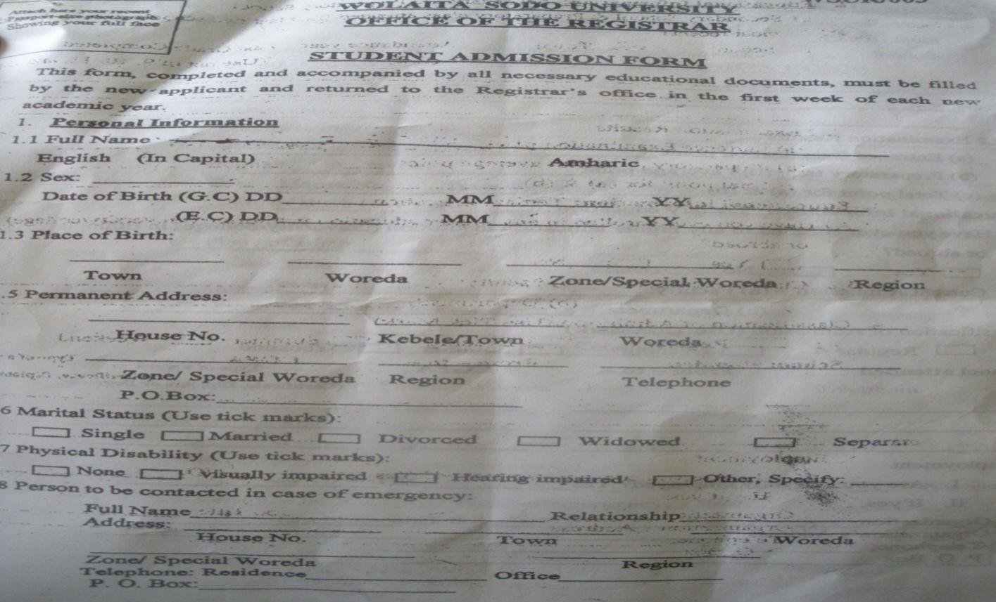

* 1. Clearance form.

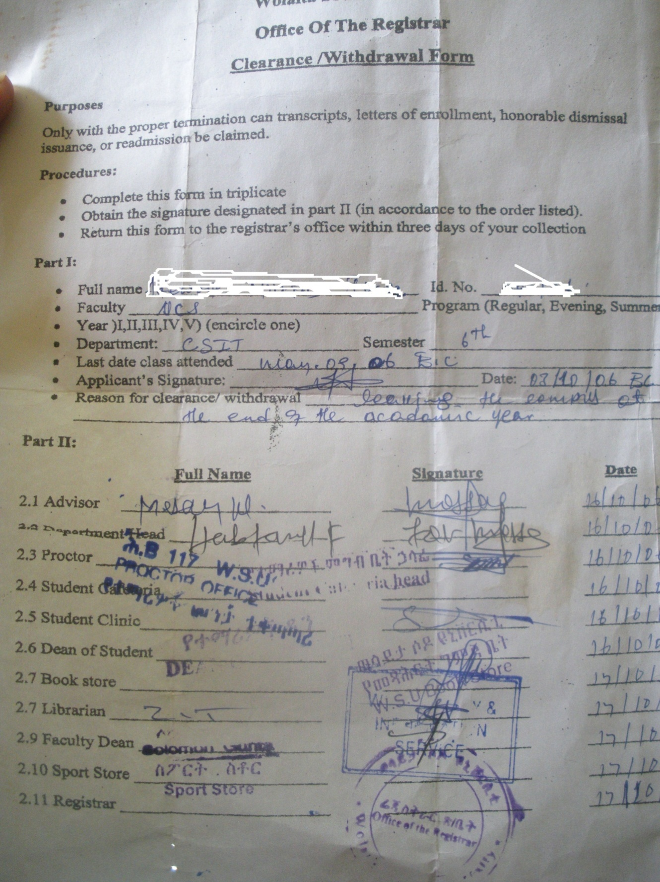

* 1. Grade report form.

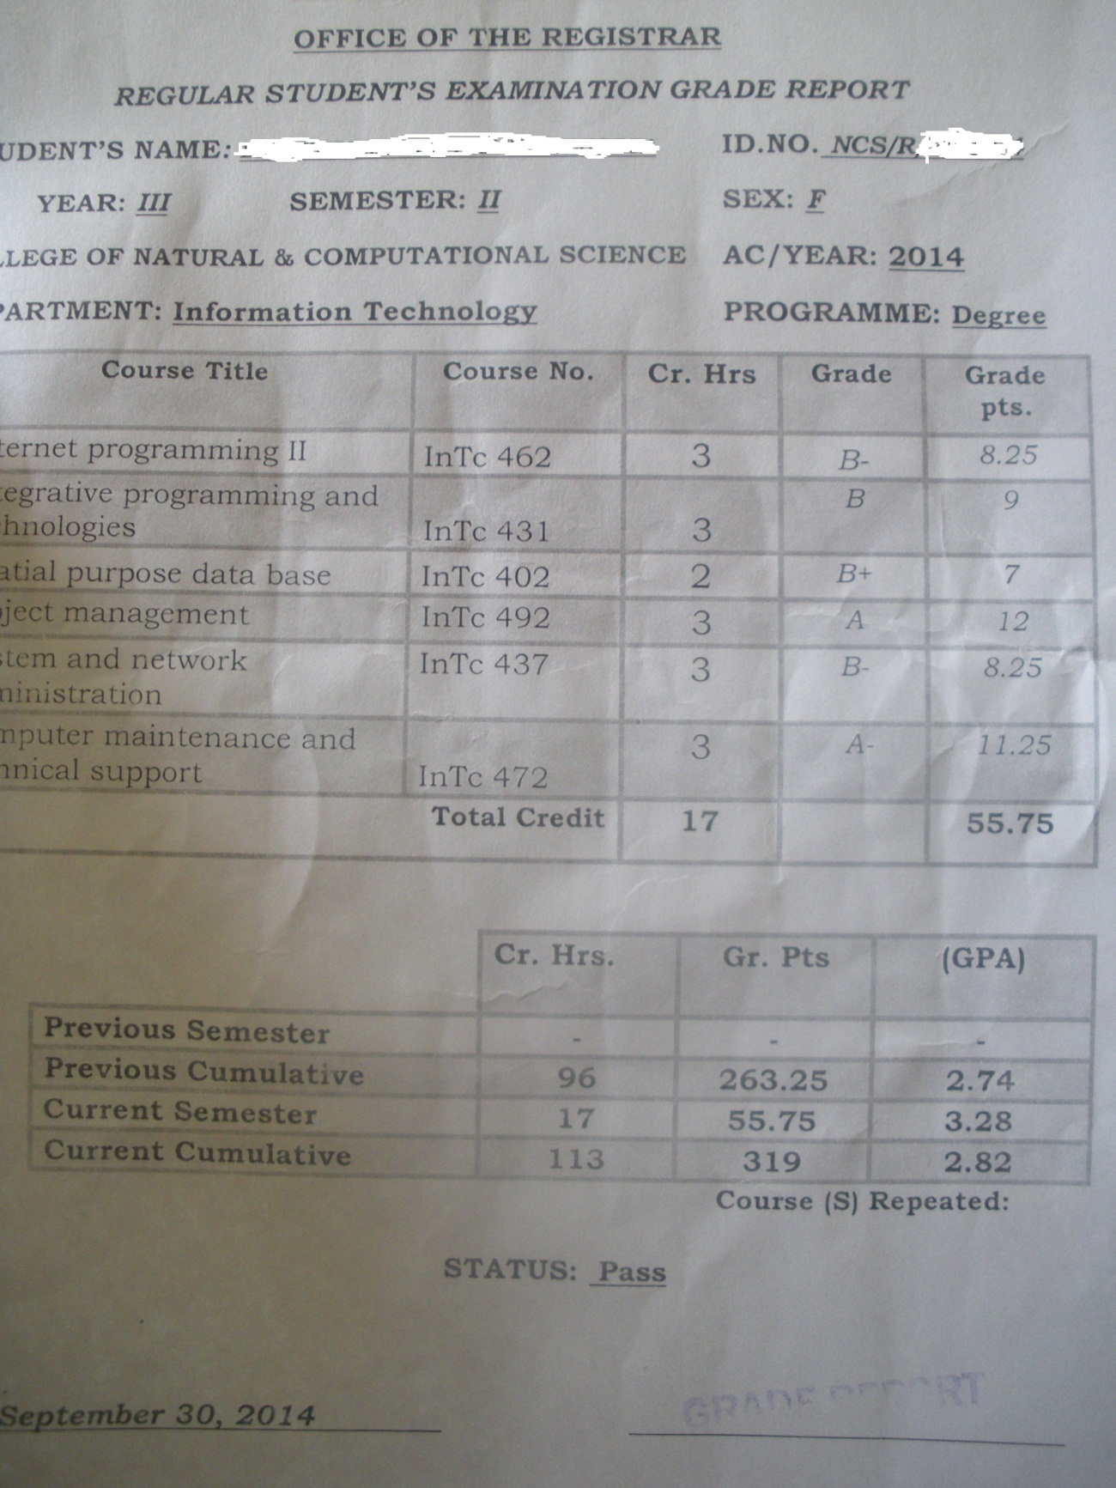

* 1. Course slips form.

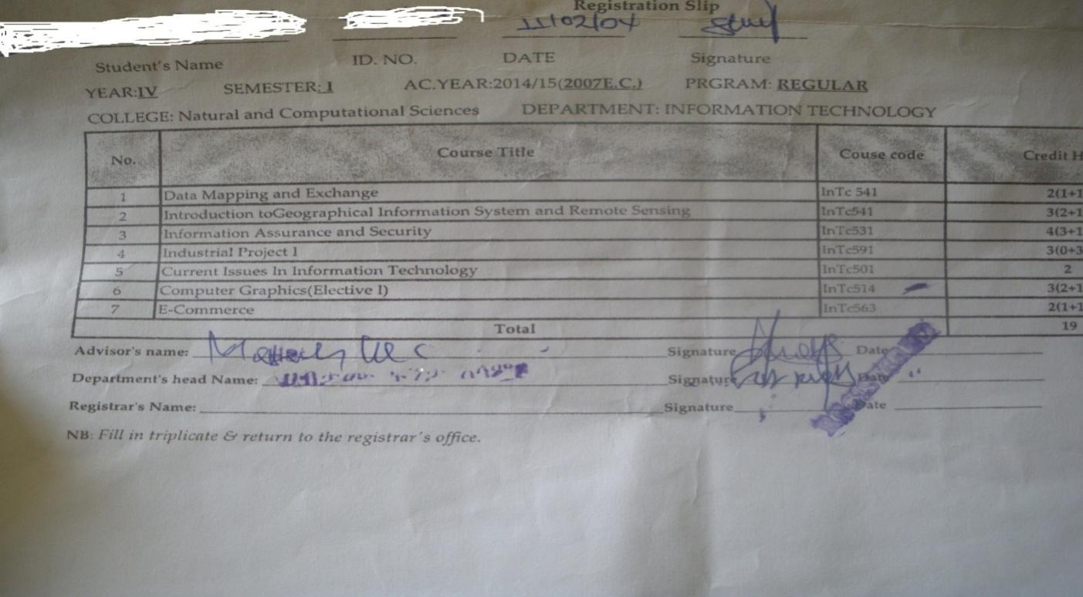

# 2.7 Bottle necks of the Existing System.

# 2.7.1 Performance (Response time):

* On the process of registration which takes long time to register whole batch students. So the process may not be completed in one or two day.
* On process of clearance it also takes time.

# 2.7.2 Input (inaccurate/redundant/inflexible) and Output (inaccurate)

* When registrar recorder calculate the grade point and converts it to letter grade as a input they may made mistake which in turn cause incorrect generation of grade report .
* when student fill the form, their hand write may be not accurate or not easy to understand.
* When taking the registration process with one or two recorder. The process is inflexible. Because it cannot be done as expected.

# 2.7.3 Security and Control

At level of security there is no system based security and control rather than user account of the desktop of each recorder to keep soft copy of student information .

In Generally, any ordinary person cannot access and manipulate any stored data , undocumented data without concerned recorder.

2.7.4 Efficiency

Current system is not efficient because it is more encountered to inaccuracy, redundancy and inflexible. And also does not successes the organizational mission expectedly. Because the work depended only on man power.

# 2.8 Practices to be preserved

The practices to be preserved for new proposed system are:-

* Calculating semester grade point average (SGPA).
* Calculating cumulative grade point average (CGPA).
* Checking status of each academic year student.
* Searching property record of concerned student.
* Generating grade report for each academic year student.

# 2.9 Proposed solution for the new system that addresses problems of the existing system.

**In existing system students are:**

* Registered by attending directly to registrar office.
* See their grade in notice board and takes grade report from their department.
* Clear from property by attending each and every concerned office.

**In proposed system students can:-**

* Register anywhere internet connection is available.
* See their grade and also grade report in internet.
* Clear from property in a web supported simple manner.

# 2.10. Requirements of the Proposed System

# 2.10.1 Functional requirements

* **Process requirements**
* Searching the status of each student in data base when in the time of registration progress.
* Searching of property record of each student to signature on clearance form.
* Calculating semester grade point average.
* Calculating cumulative grade point average.
* **Input related requirements**
* Full information of the student.
* Grade of each and every course that are offered in semester.
* Full information of student to be cleared from property.
* **Output related requirements**.
* The generation of grade report.
* Checking of clearance.
* Handling registration so that student can register in timely manner.
* Giving the system a different access hierarchy so that the recorder can do all operations such as add, edit, or delete operations on students’ data.
* **Storage related requirements.**
* student admission
* personal information
* Educational information.
* Employment.
* Family background.

# 2.10.2 Nonfunctional requirements.

* **Performance.**
* After completing the new system well organized way the proposed system will give efficient response to the problem that has been facing the existing system.
* After we have finished these applications we will familiarize and train the registrar system workers in charge of updating and controlling the registrar system.
* A direct link to the university website if a connection exists.
* **User Interface.**
* User interface, so users can use and navigate the system easily and effectively.
* **Security and Access permissions.**
* Those who are not wolaita sodo university student can’t access the system fully.
* Those who are not academic year student can’t access the system.
* The any actor this system must have account to access the system
* **Backup and Recovery.**
* The new proposed system can back up and recover the deleted files of the student.
* **Resources.**
* Digital camera or scanner is necessary for capturing students photo at the time of registration