js-view-wave.js

js-cpp-wave.html

data.txt

cpp-gen-wave.cpp

start

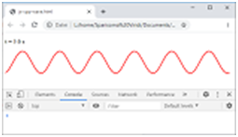

Internet browser

