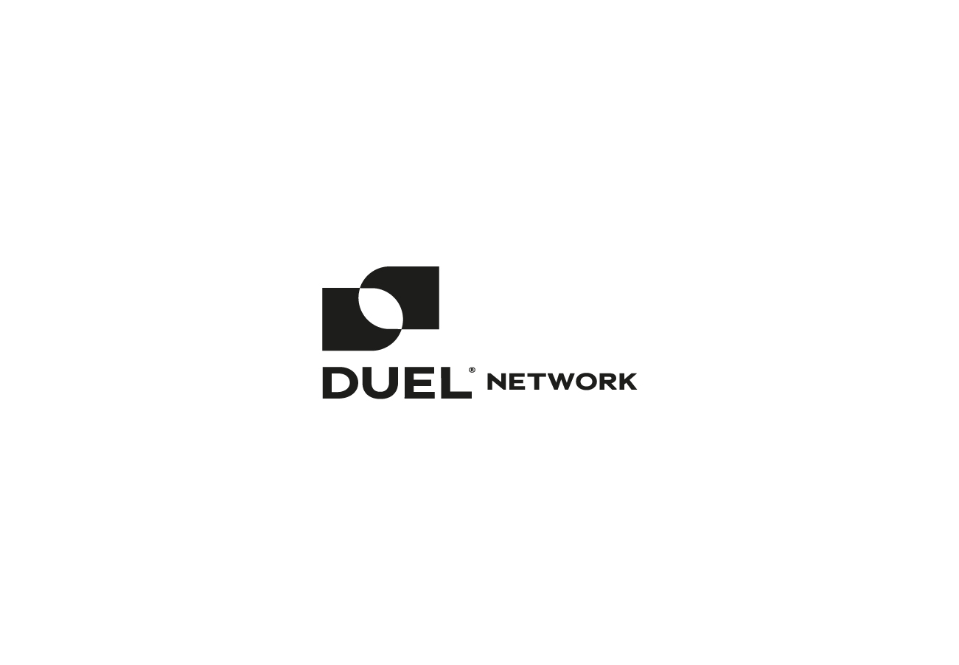

# **Introducing Duel Network**

Duel Network is a gaming token on Binance Smart Chain with a number of impressive features. It is a gaming token where you can play events that are suitable for voting, such as politics, finance, state elections, especially sports.

The most important feature of Duel Network is that you never lose. You will be able to do farming by entering pools through preferences and voting without losing your capital.

# **TLDR;​**

* Private Sale will be on Duel Network Platform
* IDO will be on ApeTools
* Duel Network (DUEL) — is a gaming token on Binance Smart Chain with a number of impressive features.
* Competitive Farming
* %99 Payout voting
* Lottery
* %0.5 Affiliate fee
* %0.5 fee on rewards to developer wallet
* Duel Network only supports MetaMask & TrustWallet
* Staking
* Gaming NFT
* Sustainable token economy

# **User Experience for Companies**

Thanks to Duel Network, companies will be able to choose the best product experience for themselves by using the preference survey pools they have created. Duel network users who participated in this survey will also be able to receive rewards.

For example, if the company is stuck between option A and option B, it will create two pools in option A and option B and allow 1 month. If there is more participation in Pool A, Pool A will win. The total reward of pools A and B will be distributed to pool A.

# **Competitive Farming**

Duel Network will allow you to play for the first time without losing your capital. Thanks to Competitive Farming, if you play on a match and you lose, you will only lose your bi-weekly pool reward. Your LPs will remain with you. If you win, the reward of the other pool will be distributed to your pool. The non-favourite team/person will have a higher aprs and

For example, let’s consider the final of the Euro 2020 championship, two pools named Italy and England will be opened with equal multiplier. Since there is no bookmaker in the system, the System will work naturally. The favorite team’s pool will have lower APR, while the non-Favorite team will have higher APR.

For example,  
2 groups predict bitcoin’s weekly candle forecast at $40,000 above and below,  
Main LP fund will not be lost in either group.  
Only the loser’s farm pool reward will be added to the winner’s farm reward.

In this way, perhaps for the first time in the world, we will create a voting system with a 99 percent payout. (0.5 percent of each pool reward will be sent to the developer wallet as a developer fee and 0.5 percent reward will be sent affiliate wallets.)

# **Digital Product Ratings**

The DUEL token will not only be used for farming and gaming, but also for various events. One of them is Digital product rating. DUEL Holders will be bounty hunters by participating in various rating events and can win DUEL rewards.

# **Staking**

Members can stake $DUEL for earn $DUEL on Duel Network platform, members able to evaluate their competitive farm rewards for stake.

# **Lottery**

One thing Duel Network is planning to bring will be the lottery system. The DUEL pool collected with the lottery to be organized every week will be given to the lucky people. If there is no winner in Lottery, this pool will be sent to burn adress.

# **Affiliate**

Duel Network will have an affiliate system. If you send a ref link to your friends and put them in the system, a certain percentage of the prizes they win will be sent to your wallet in each prize distribution. In this way, you will be able to win together with your friends.

# **Technical Operation Diagram**

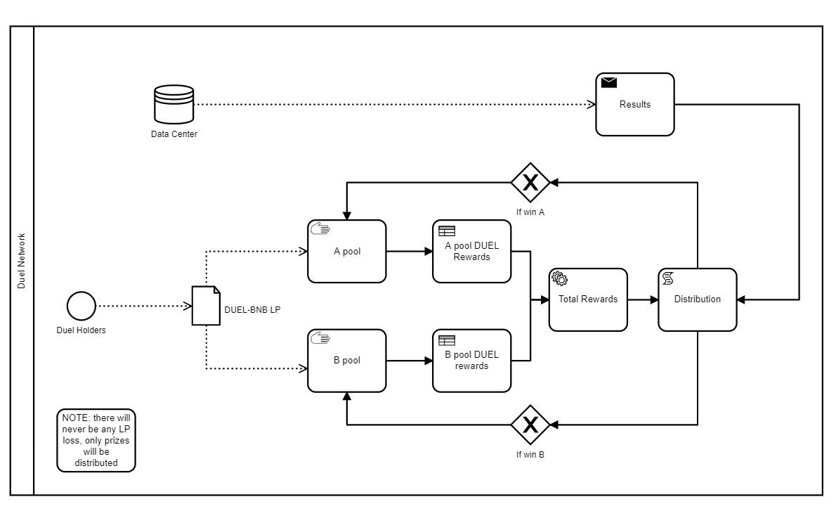

# **Roadmap**

* Website And Social Media Release
* Audit
* Private Sale
* ApeTools IDO
* ApeSwap Listing
* CoinGecko Listing
* CoinMarketCap Listing
* Partnership Announcements
* LaunchApp
* Competitive Farming
* User Experience survey activities
* Staking
* Gaming NFT
* Lottery System
* CEX Listing

# **Tokenomics**

# **Tokenomics Premint: 20,000,000 $DUEL**

# **Private Round: 4,000,000 $DUEL**

# **Price: $0,05**

# **Total fund raised: 200,000$ (%10 initial unlock , %15 release per 45 days for 9 months)**

# **Public Sale IDO ApeTools: 1,333,333 $DUEL**

# **Price: $0.075**

# **Public Sale IDO MacaronSwap: 3,999,999 $DUEL**

# **Price: $0.075**

# **Public Sale IDO Z Platform: 1,333,333 $DUEL**

# **Price: $0.075**

# **Total Fund Raised: 500,000$ (%20 initial unlock, %20 release per month for 4 months)**

# **Listing: $0,08**

# **DEX & CEX Liq: 1,000,000 $DUEL**

# **Team: 2,222,222 $DUEL (%10 initial unlock, %10 release per month for 9 months)**

# **Marketing: 2,222,222 $DUEL (%10 initial unlock, %10 release per month for 9 months)**

# **Strategic Wallet: 2,222,222 $DUEL (%5 initial unlock, %9.5 release per month for 10 months)**

# **Staking & Airdrop: 5,000,000 $DUEL**

# **Partnership**

Duel Network has legit partnership with ApeTools, ApeSwap, Hepa Finance, MacaronSwap.

# **Competitive Farming**

Duel Network aims to make high apr rates farm for its users by gamifying normal farming. And as a result of the voting, there will be no loss from the money invested. In the system where two or more pools are opened and the apr rates depend on the amount of lp deposited in the pools, the winning pool gets all the rewards.

# **Distribution Mechanism**

The rewards are distributed as xDuel, which is the governance token of the Duel Network, in order to prevent the price dumping by distributing the rewards accumulated in the pool for 1 week as a result of voting. xDuel charges a penalty fee for the first 30 days of trying to duel. This rate decreases every day, being 50 percent on the 1st day and 10 percent on the 30th day. Investors can earn Duel by staking xDuel. Thus, the distribution of Duel is arranged to spread over time and its sale depends on the investor. Additionally, it reduces the circulating amount of Duel by promoting Duel staking with xDuel.

# **Burning Mechanism**

The biggest problem of minted tokens is that they have an infinite supply. Therefore, they need automatic combustion mechanisms and combustion activities. As Duel Network, we have added an auto-burn mechanism to our smart contracts with this in mind.

First, the amount of Duel penalized in each turn from xDuel to Duel is burned directly. Secondly, it is planned to burn a certain part of the duels collected from the lottery system. Thirdly, a certain part of the Duel emission will be collected in the DuelDao and incineration events will be organized for the community.

# **Emmission Rates**

**75% Liquidity Providers & Staking:**To reward our fellow Duelists for staking their funds and adding liquidity into the Duel Network Ecosystem, 75 percent of the supply will be distributed as incentives via the Duel Gaming Pools (yield farming pools) and the xDuel stakings. **5% Marketing & Community Endowment:**In order to ensure Duel can get to as many people as possible, this allocation will be used for creating competitions such as our recent NFT Artwork Competition and other creative ideas that will drive community engagement, social media exposure, and help support content creators within the Duel Network Community. This allocation will allow us to organically grow the project, compensate designers, and community managers. **5% Team Allocation:**Given Duel’s mission is to continue pushing out excellent code and features for the coming decade, we will use this allocation to onboard new developers, designers, and marketers into the team and make sure everyone can be a full-time Duelist. This is distributed by the MasterDuelists rather than being minted beforehand, meaning there is no preallocation. **15% DuelDAO Treasury:**This allocation of the total supply will be held by the DuelDAO which will be free to use the funds for whatever the Duel Network Community sees fit in the future. They may be burnt, distributed, or used for creative proposals that our community will be able to vote on in the future. Given the project is in its early stages and the Duel DAO isn’t yet live, the funds will not be allocated yet to not make the circulating supply of DUEL appear larger than it really is.

# **Conclusion**

Duel Network is a farming game & using unique contracts.  
Unique projects have always attracted attention in the blockchain world, duel network will also attract attention, it will be a very long-term investment tool with its sustainable economy.

Duel Network, which will maintain a quality and transparent work, will rise rapidly.