YouTube Java

Manual
Installing and Starting to Use YouTube Java

Mark Howard and Neil Grogan
April 2009

Table of Contents
1. Installing YouTube Java 3
2. Using YouTube Java 3
3. Searching for a Video 4
4. Uninstallation 4
5. Feedback 4
6. License 5
7. Glossary of Terms 6

Installing YouTube Java

To use YouTube Java, you need the latest version of Java Virtual Machine (JVM) to run the program.
Please Visit: http://java.com/en/ and click the button which says “Free Java Download”. You will now be downloading Java, once this is complete; please double click on the installer file and follow the instructions to complete the installation of Java.

Get a copy of YouTube Java:
Go to our Website's Download section and get the file called YouTubeJava.jar :
http://code.google.com/p/itb-cs/downloads/list

Note: This is still Alpha quality software and has to go through a lot more testing and quality assurance.

Once you have a file called YouTube Java, simply double click on it to get it to launch. You should see a screen like this:
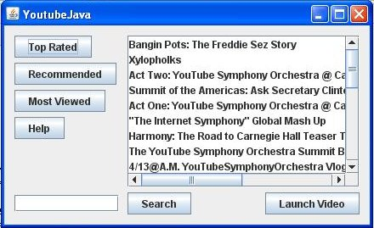

This completes the download and installation of YouTube Java!

Using YouTube Java

After you have have completed the installation and launched YouTube Java, you have many different options to view videos:
- Buttons along the right hand side, which you can select a new list of videos: Most Viewed, Top Rated, etc
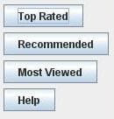

This will load a new list of videos like this:

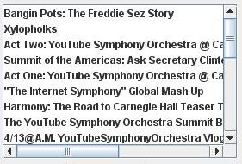
from which you can select a list item to play. Simply left click on which ever item on the list takes your fancy and it will open up a window and play.
2.3. Playing a Video:
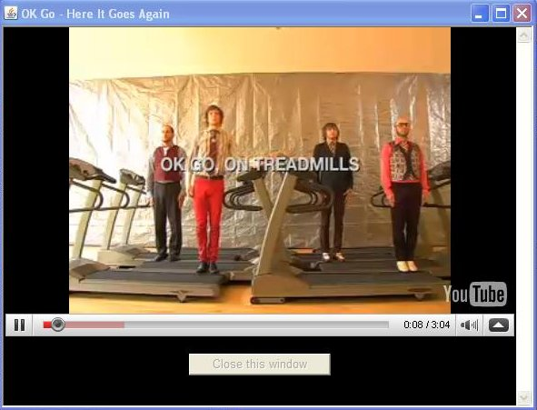
A Video now plays from the one you selected. You now have access to the video player controls using these buttons:
Play/Pause, a seek bar and an option to enlarge the video all appear and can be used.

Searching for a Video

When you start YouTube Java you should notice a search box in the bottom right-hand corner, like this which is highlighted

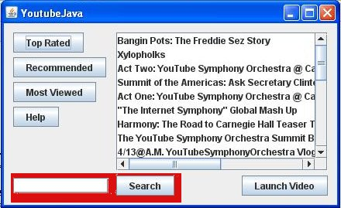

To Search you can simply enter in a term in the box; like: itb . This will populate the list with a bunch of videos that match the term you have entered:
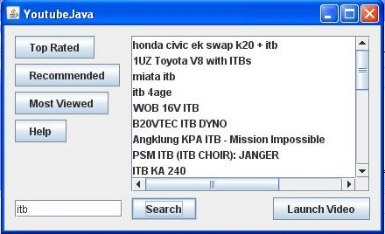
Now simply select a result from the list (or if you not happy with the result set, repeat step 3.2 with a different search term). The video will now play!

Uninstallation

To Uninstall YouTube Java; simply remove the YouTubeJava.jar that you downloaded in step 1.2. To do this; find the file named YouTubeJava.jar using your Search function, then right click on it and select delete. It will then appear in your Recycle Bin or Trash Can, from where you can permanently remove it.

Feedback
  - We the developers of YouTube Java, would be most grateful for any feedback you have about this program and how it works. It is an open source project at Google Code, so you can even inspect the source code to see how YouTube Java works.
  - Links
Google Code Project:
http://code.google.com/p/itb-cs/
Downloads:
http://code.google.com/p/itb-cs/downloads/list
Mailing List (Closed, Apply to join):
http://groups.google.com/group/itbcs
Bug Tracker:
http://code.google.com/p/itb-cs/issues/list
Source Code Repository:
http://code.google.com/p/itb-cs/source/checkout

License
  - This manual

You are free:

- to Share — to copy, distribute and transmit the work
- to Remix — to adapt the work

Under the following conditions:

- Attribution. You must attribute the work in the manner specified by the author or licensor
- Noncommercial. You may not use this work for commercial purposes.
- Share Alike. If you alter, transform, or build upon this work, you may distribute the resulting work only under the same or similar license to this one.
- For any reuse or distribution, you must make clear to others the license terms of this work.
- Any of the above conditions can be waived if you get permission from the copyright holder.
- Nothing in this license impairs or restricts the author's moral rights.

Full Legal Text Here: http://creativecommons.org/licenses/by-nc-sa/3.0/legalcode
FF

6.2 Source Code
YouTube Java – A Java Program for YouTube's Video Service
Copyright (C) 2009 Mark Howard, Neil Grogan

This program is free software: you can redistribute it and/or modify
it under the terms of the GNU General Public License as published by
the Free Software Foundation, either version 3 of the License, or
(at your option) any later version.

This program is distributed in the hope that it will be useful,
but WITHOUT ANY WARRANTY; without even the implied warranty of
MERCHANTABILITY or FITNESS FOR A PARTICULAR PURPOSE. See the
GNU General Public License for more details.

You should have received a copy of the GNU General Public License
along with this program. If not, see <http://www.gnu.org/licenses/>.

Glossary of Terms
- Java – The Computer Language YouTubeJava is written in. Developed by and a trademark of Sun Microsystems Inc.
- JAR – JavaARchive; a compressed (zipped) Java Program, which can be run directly by clicking on it.
- JVM – Java Virtual Machine, a piece of free downloadable software which allows programs in the Java Computer Language to be run on your computer.
- Youtube – A Video Sharing website where anyone can upload and distribute video clips. Owned by Google Inc.

End of the Manual for YouTube Java!

