08
Fall
University College Dublin
COMP40730 – High Performance Computing Assignment 4 – Neil Grogan - 13204052

For assignment 4, I had variant 1a, 2a, 3a (Matrix Multiplication and Col Max Norm). Using MPI, I set about calculating the time taken for a combination of multiplication and max column norm. For linear execution. I also did multiple runs to discount outliers (ie. Others on the machine at the same time). I then graphed OpenMP vs. OpenMPI:

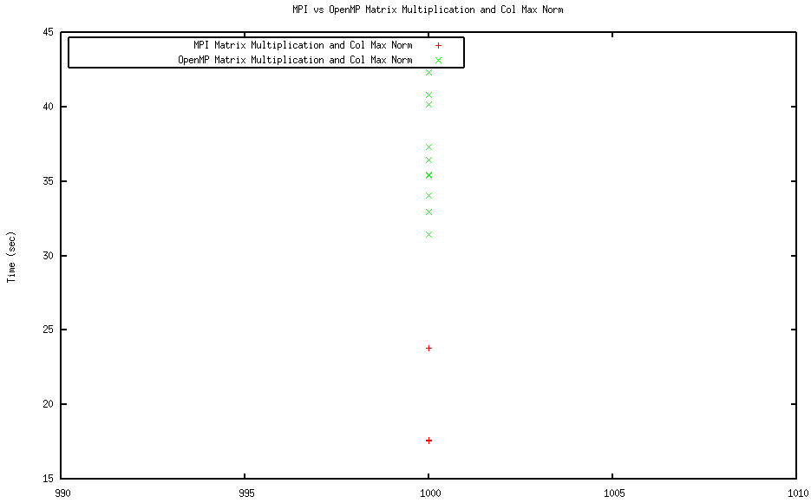

As we can see, for the same matrix size (graph rotated to show both at matrix size 100), the MPI runs were on average significantly faster. Not only that, the MPI version of the program was far more consistent in time taken. This is most likely due to improper running of OpenMP (assignment 3) in a non-parallel fashion. I did not face any bandwidth or congestion issues, and if I was to repeat this and have better control over the environment I would choose to insert noise to be more realistic of network conditions (unless the problem was only to be run on a closed single purpose cluster).

