**February**

1416

**University College Dublin**

COMP41610 – Practical 1 – Neil Grogan - 13204052

Neil Grogan

08

**Fall**

Q1. Cloud Deployment Models by Provider

|  |  |
| --- | --- |
| **Cloud Provider** | **Cloud Deployment Model Used** |
| Amazon EC2 | Public, Private, Hybrid and Other (IaaS) (Dzone) |
| Rackspace | Public, Private by provider, private on-premise, and hybrid (IaaS) (Dzone) |
| Windows Azure | Public, Private, Private on- premise, hybrid (IaaS) (Dzone) (Microsoft, 2014) |
| Google App Engine | Public (PaaS) (Google, 2014) |
| HP Cloud | Public, Private by provider, private on-premise, and hybrid (IaaS) (Dzone) |
| Salesforce Cloud | Public (SaaS) (Salesforce.com) |

Figure - Cloud Deployment Models listed by provider

Q2. Cloud Delivery Models by Provider

|  |  |
| --- | --- |
| **Cloud Provider** | **Cloud Delivery Model Used** |
| Amazon EC2 | Infrastructure-as-a-Service (IaaS) (Dzone) |
| Rackspace | Infrastructure-as-a-Service (IaaS) (Dzone) |
| Windows Azure | Infrastructure-as-a-Service (IaaS & PaaS) (Dzone) (Microsoft, 2014) |
| Google App Engine | Platform-as-a-Service (PaaS) (Google, 2014) |
| HP Cloud | Infrastructure-as-a-Service (IaaS) (Dzone) |
| Salesforce Cloud | Software-as-a-Service (SaaS) (Salesforce.com) |

Figure - Cloud Delivery Models per provider

Q3. Considerations in virtualizing a data centre

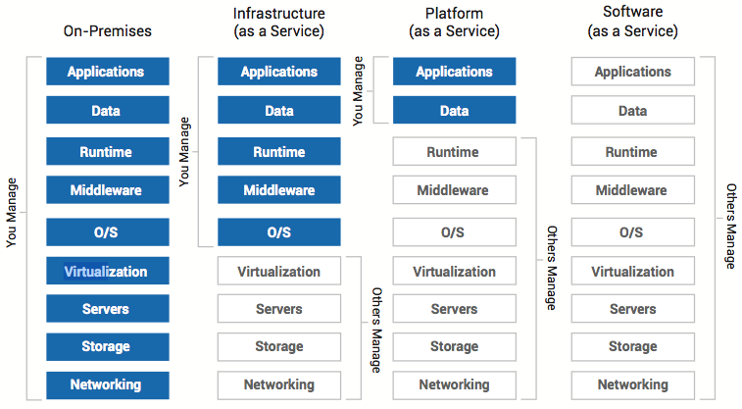

Figure – credit (Dzone)

In considering to virtualize a data centre, you have to first consider how much control you wish (or can afford) to relinquish. In Figure 1, we can see what we start off with that we manage in a pre-existing data centre:

|  |  |
| --- | --- |
| * Applications * Data * Runtime * Middleware * OS | * Virtualization * Servers * Storage * Networking |

Each of these areas needs an employee with familiarity of that area – which can be both an advantage and a disadvantage. First the business case must be made for which cloud deployment suits – can we have our infrastructure hosted elsewhere or under another company’s direct control?

Once the cloud deployment type is chosen (and sometimes this is very obvious based on industry, say healthcare vs. the local fast food outlet) – we can move on to choosing the cloud delivery model. The cloud delivery model is arguably as important if not more so then the cloud deployment model chosen. As clearly shown in Figure 1, the cloud delivery model dictates how much of your infrastructure you make the responsibility of others.

IaaS is more suited to a company with pure software experts and very few hardware gurus (as all the hardware is abstracted). IaaS still offers the flexibility down to the operating system level, so if you need to run legacy applications on a certain operating system for instance, IaaS is a good choice. PaaS takes this even further and you only ever worry about the direct applications you develop (say an accounting package) and deploy to a common middleware (say JEE Server Software). Auto-loading balancing and scaling (as provided through development by JEE Server) and the PaaS provider then worries about making this happen via the middleware.

|  |  |  |  |  |  |
| --- | --- | --- | --- | --- | --- |
| Provider | Applications | Data | Runtime | Middleware | OS |
| Amazon | Bring your own | Bring your own | OS or Middle- ware | Beanstalk | Linux/Windows |
| Google | Bring your own | Bring your own | App Engine | App Engine | Linux |
| Salesforce | Provided | n/a | n/a | n/a | n/a |
| Rackspace | Bring your own | Bring your own | Middle- ware or OS | Project Solum | Linux |
| HP Cloud | Bring your own | Bring your own | OS or Middle- ware | HP Cloud Application  Platform | Linux |
| Windows | Bring your own | Bring your own | OS or Middle- ware | App Services | Linux/Windows |

Figure - Comparison of Offerings of Cloud Providers at Each Level of the Stack (Part1)

|  |  |  |  |  |
| --- | --- | --- | --- | --- |
| Provider | Virtualization | Servers | Storage | Networking |
| Amazon | EC2 | EC2 | S3/Glacier | n/a |
| Google | Instances | Instances | Big Table |  |
| Salesforce | n/a | n/a | n/a | n/a |
| Rackspace | Cloud Server | Cloud Server | Cloud Files | Cloud Networks /DNS |
| HP Cloud | HP Cloud Compute | HP Cloud Compute | HP Cloud Storage | HP Cloud DNS |
| Windows | Yes |  | Windows Azure Drive | Virtual Network |

Figure - Comparison of Offerings of Cloud Providers at Each Level of the Stack (Part2)

Q4. Comparing cost of Google, Amazon and Windows Azure

I took the smallest instances available for each provider and compared the cost of each. It is not possible to do a very direct comparison as the specifications for the servers offered differ per provider.

**System Specs:**

|  |  |  |  |
| --- | --- | --- | --- |
| **Provider** | **CPU** | **RAM** | **Disk** |
| Amazon | 0.182 | 615 MB | Adding 20GB |
| Google | 0.502 | 1.7 GB | Adding 20GB |
| Windows Azure | 1 | 1.75 GB | 20GB |

Figure - System Specs as used for cost calculation

|  |  |  |  |
| --- | --- | --- | --- |
| **Provider** | **Server Cost** | **Storage Cost** | **Total Yearly Cost** |
| Amazon | $24.29  /mo (+$54.00  upfront)  (Amazon) | $58.24/mo | $241.48 (Server) + $698.88 (Storage) = $990.36 |
| Google | $39.45/mo | 0.13/GB/month = $2.16/mo | $473.4 (Server) +$31.20 (Storage) = $504.60 |
| Windows Azure | $43.83 | included | $525.96 |

Figure - Comparison of Costs of Smallest Cloud Instances for the Top 3 most well known providers

Q5. Which cloud provider to choose?

I would generally feel more comfortable in choosing a PaaS provider, purely due to peace of mind. I know the whole stack can be covered by an uptime guarantee and contractual obligations. Having said that, I would strictly choose a PaaS provider that is open source (or one where a migration plan is feasible due to standard components, such as a major database and middleware).

The thing that I have to worry about then becomes just the applications I develop and the services I provide – not the underlying details. This means – hopefully – I can spend much more time spending my focus on the value I can deliver to my customers. For this reason the frontrunner for me would be an OpenStack solution from Red Hat (with HP also offering OpenStack). There’s a lot of Java developers available and familiar with JEE technologies.

As a counter-point I would rule out Google’s PaaS offering due to the lock in brought by specific Google technology (such as the Big Table database). I would in future consider Amazon Elastic Beanstalk then as a competitor (also allows scaling, replication, and all the features a JEE ecosystem can give you).

# Bibliography

Amazon. (n.d.). *Amazon.com*. Retrieved from Amazon Cloud Cost Calculator: http://calculator.s3.amazonaws.com/calc5.html#key=my-free-website

Dzone. *DZone’s Definitive Guide to Cloud Providers.* Cary, NC: Dzone Research.

Google. (2014). *Google App Engine*. Retrieved from Google Developers: https://developers.google.com/appengine/?csw=1

Microsoft. (2014). *Windows Azure Infrastructure Services*. Retrieved from Microsoft.com: http://www.windowsazure.com/en-us/solutions/infrastructure/

Salesforce.com. (n.d.). *Salesforce SAAS*. Retrieved from Salesforce.com: http://www.salesforce.com/saas/