**February**

28

**University College Dublin**

COMP41610 – Practical 2 – Neil Grogan - 13204052

Neil Grogan

08

**Fall**



##  Date and time of this instance?

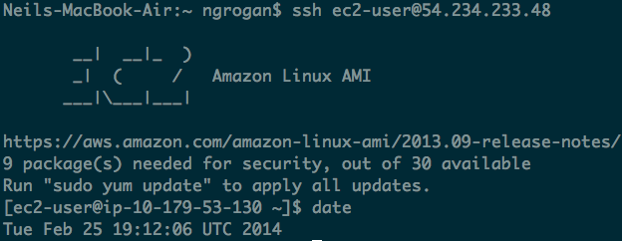

## Q How long has the system been running?

## 

## Q Name and version of Operating Systems running on this instance?

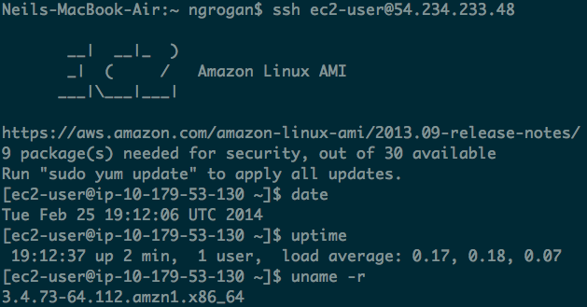

## Q Who is logged in?

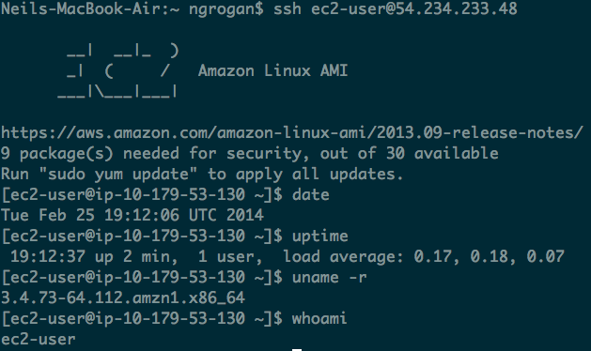

## Q Who is running what? (Hint: using *top* or *ps* command)

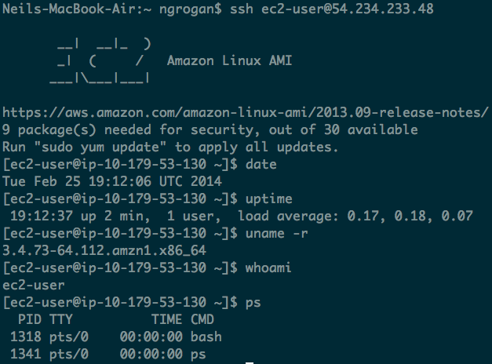

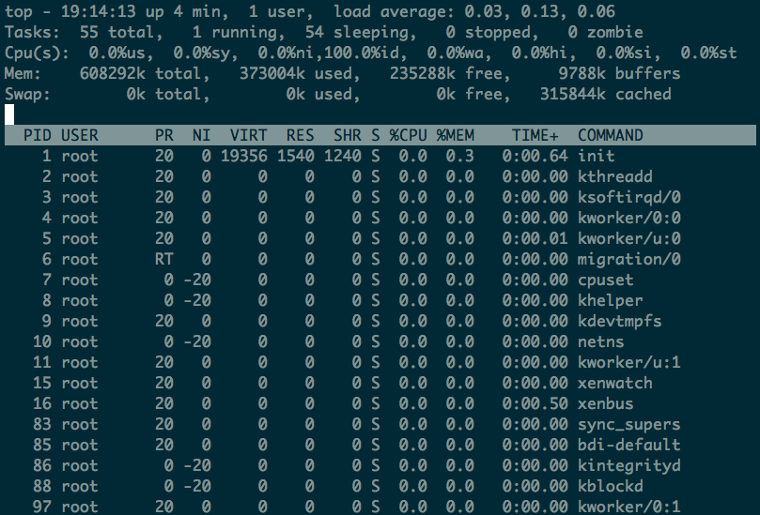

## Q Which devices are there?

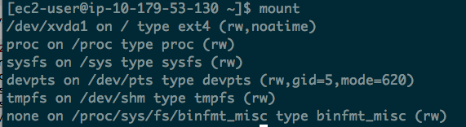

## Q What has the user been doing? (command-line history)

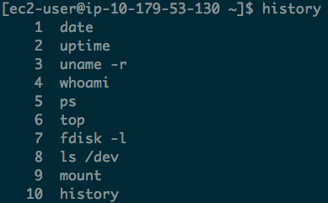

## Create the Domain Car

**All from Car:**

<SelectResponse xmlns="http://sdb.amazonaws.com/doc/2009-04-15/">

<script/>

<SelectResult>

<Item>

<Name>Audi</Name>

<Attribute>

<Name>Year</Name>

<Value>78</Value>

</Attribute>

<Attribute>

<Name>Year</Name>

<Value>73</Value>

</Attribute>

<Attribute>

<Name>Year</Name>

<Value>75</Value>

</Attribute>

<Attribute>

<Name>Year</Name>

<Value>70</Value>

</Attribute>

<Attribute>

<Name>mpg</Name>

<Value>23</Value>

</Attribute>

<Attribute>

<Name>mpg</Name>

<Value>20</Value>

</Attribute>

<Attribute>

<Name>mpg</Name>

<Value>24</Value>

</Attribute>

<Attribute>

<Name>Weight</Name>

<Value>2400</Value>

</Attribute>

<Attribute>

<Name>Cylinders</Name>

<Value>4</Value>

</Attribute>

<Attribute>

<Name>Cylinders</Name>

<Value>5</Value>

</Attribute>

<Attribute>

<Name>Power</Name>

<Value>102</Value>

</Attribute>

</Item>

<Item>

<Name>Chevrolet</Name>

<Attribute>

<Name>Year</Name>

<Value>78</Value>

</Attribute>

<Attribute>

<Name>Year</Name>

<Value>80</Value>

</Attribute>

<Attribute>

<Name>Year</Name>

<Value>77</Value>

</Attribute>

<Attribute>

<Name>mpg</Name>

<Value>17</Value>

</Attribute>

<Attribute>

<Name>Weight</Name>

<Value>2035</Value>

</Attribute>

<Attribute>

<Name>Weight</Name>

<Value>2051</Value>

</Attribute>

<Attribute>

<Name>Cylinders</Name>

<Value>6</Value>

</Attribute>

<Attribute>

<Name>Cylinders</Name>

<Value>4</Value>

</Attribute>

<Attribute>

<Name>Cylinders</Name>

<Value>8</Value>

</Attribute>

<Attribute>

<Name>Power</Name>

<Value>85</Value>

</Attribute>

</Item>

<Item>

<Name>Fiat</Name>

<Attribute>

<Name>Year</Name>

<Value>81</Value>

</Attribute>

<Attribute>

<Name>mpg</Name>

<Value>37</Value>

</Attribute>

<Attribute>

<Name>Weight</Name>

<Value>1867</Value>

</Attribute>

<Attribute>

<Name>Cylinders</Name>

<Value>4</Value>

</Attribute>

<Attribute>

<Name>Power</Name>

<Value>30</Value>

</Attribute>

</Item>

</SelectResult>

<ResponseMetadata>

<RequestId>e68293fc-b276-d52d-2f33-7b3a4fe9c94b</RequestId>

<BoxUsage>0.0000411449</BoxUsage>

</ResponseMetadata>

</SelectResponse>

## Query the Domain Car for all items with Year 78

Query is: **select * from Car where Year = '78'**

**Response:**

<SelectResponse xmlns="http://sdb.amazonaws.com/doc/2009-04-15/">

<script/>

<SelectResult>

<Item>

<Name>Audi</Name>

<Attribute>

<Name>Year</Name>

<Value>78</Value>

</Attribute>

<Attribute>

<Name>Year</Name>

<Value>73</Value>

</Attribute>

<Attribute>

<Name>Year</Name>

<Value>75</Value>

</Attribute>

<Attribute>

<Name>Year</Name>

<Value>70</Value>

</Attribute>

<Attribute>

<Name>mpg</Name>

<Value>23</Value>

</Attribute>

<Attribute>

<Name>mpg</Name>

<Value>20</Value>

</Attribute>

<Attribute>

<Name>mpg</Name>

<Value>24</Value>

</Attribute>

<Attribute>

<Name>Weight</Name>

<Value>2400</Value>

</Attribute>

<Attribute>

<Name>Cylinders</Name>

<Value>4</Value>

</Attribute>

<Attribute>

<Name>Cylinders</Name>

<Value>5</Value>

</Attribute>

<Attribute>

<Name>Power</Name>

<Value>102</Value>

</Attribute>

</Item>

<Item>

<Name>Chevrolet</Name>

<Attribute>

<Name>Year</Name>

<Value>78</Value>

</Attribute>

<Attribute>

<Name>Year</Name>

<Value>80</Value>

</Attribute>

<Attribute>

<Name>Year</Name>

<Value>77</Value>

</Attribute>

<Attribute>

<Name>mpg</Name>

<Value>17</Value>

</Attribute>

<Attribute>

<Name>Weight</Name>

<Value>2035</Value>

</Attribute>

<Attribute>

<Name>Weight</Name>

<Value>2051</Value>

</Attribute>

<Attribute>

<Name>Cylinders</Name>

<Value>6</Value>

</Attribute>

<Attribute>

<Name>Cylinders</Name>

<Value>4</Value>

</Attribute>

<Attribute>

<Name>Cylinders</Name>

<Value>8</Value>

</Attribute>

<Attribute>

<Name>Power</Name>

<Value>85</Value>

</Attribute>

</Item>

</SelectResult>

<ResponseMetadata>

<RequestId>7ae94e50-a76b-0b75-ed7d-23eb1ac1265f</RequestId>

<BoxUsage>0.0000320033</BoxUsage>

</ResponseMetadata>

</SelectResponse>

## Update the Weight attribute of Audi with 3000

**Update:**

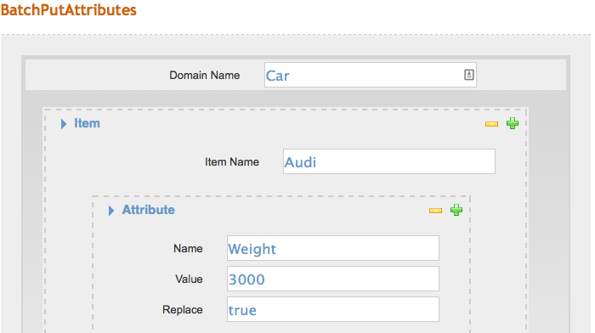

**Read it back:**

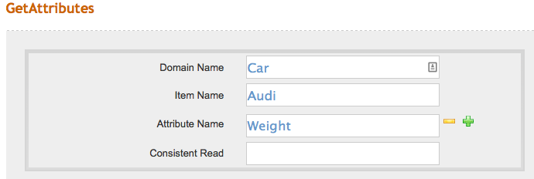

**Response:**

<GetAttributesResponse xmlns="http://sdb.amazonaws.com/doc/2009-04-15/">

<script/>

<GetAttributesResult>

<Attribute>

<Name>Weight</Name>

<Value>3000</Value>

</Attribute>

</GetAttributesResult>

<ResponseMetadata>

<RequestId>84d6654b-64aa-85cd-9479-c656592cb867</RequestId>

<BoxUsage>0.0000093222</BoxUsage>

</ResponseMetadata>

</GetAttributesResponse>

## Delete the value 8 from the Cylinders attribute of Chevrolet

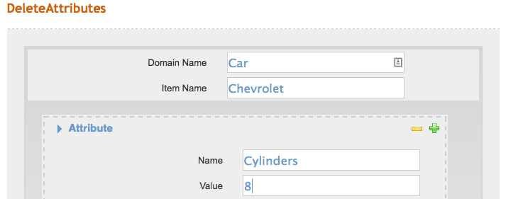

**Read it back:**

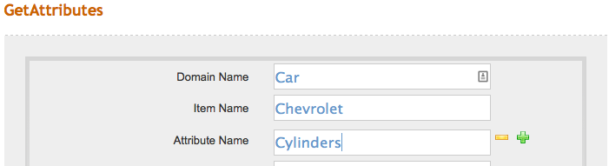

**Response:**

<GetAttributesResponse xmlns="http://sdb.amazonaws.com/doc/2009-04-15/">

<script/>

<GetAttributesResult>

<Attribute>

<Name>Cylinders</Name>

<Value>4</Value>

</Attribute>

<Attribute>

<Name>Cylinders</Name>

<Value>6</Value>

</Attribute>

</GetAttributesResult>

<ResponseMetadata>

<RequestId>f3bc16c4-ddfc-9a08-8ebc-f12d37ef77e4</RequestId>

<BoxUsage>0.0000093222</BoxUsage>

</ResponseMetadata>

</GetAttributesResponse>

## Delete the Domain Car

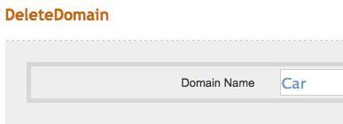

**Read it back:**

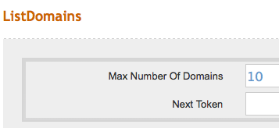

**Response:**

<ListDomainsResponse xmlns="http://sdb.amazonaws.com/doc/2009-04-15/">

<script/>

<ListDomainsResult/>

<ResponseMetadata>

<RequestId>6d9eab71-d5ab-1ac5-b3fd-d88fb355050d</RequestId>

<BoxUsage>0.0000071759</BoxUsage>

</ResponseMetadata>

</ListDomainsResponse>