# COMP30500 DS&A Part B Assignment 2

by Neil Grogan - 13204052

Q4. Algorithm

Difference(a,b)

Input: Two integers a and b

Output: The difference between a and b

if(a > b) then

return a-b

else

return b-a

(i) Test data can be: a=5 and b=6 **or** a=6 and b=5 and will produce:

|  |
| --- |
| Output |
| 1 |

(ii) Operation count:

Input - one operation

Comparison - one operation

Minus (calculate output) - one operation

return - one operation

(iii) “Big-Oh” for this algorithm is O(1)

Running Time = 0 (No Excel Graph)

Q6. Algorithm

MinValueIndex(A,n)

Input: An integer array of size n

Output: The position of the smallest value in A

minValueIndex <- 0

for k=1 to n-1 do

if(A[minValueIndex] > A[k]) then

minValueIndex <- K

return minValueIndex

(i) Test data can be: A = {5,4,3,2,1}, n=5 and will produce:

|  |  |  |  |  |  |
| --- | --- | --- | --- | --- | --- |
|  | k | a[minValueIndex] | A[k] | minValueIndex |  |
|  |  |  |  | 0 | Initial value |
| loop begins | 1 | 5 | 0 | 0 |  |
|  | 2 | 4 | 1 | 1 |  |
|  | 3 | 3 | 2 | 2 |  |
|  | 4 | 2 | 3 | 3 |  |
|  | 5 | 1 | 4 | 4 |  |

(ii) Operation count:

Initial array - one operation

Initial length - one operation

Initial minValueIndex - one operation

4*4 table - 16 operations

return minValueIndex - one operation

total: 20 operations

(iii) “Big-Oh” for this algorithm is O(nlogn)

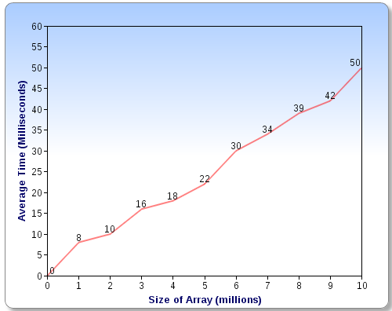

Running Time=519

Q10. Algorithm

LinearSearch(A,n)

Input: An integer array of size n and a query q we wish to search for.

Output: The position of q in A or -1 if not in A

index <- 0

while(index <n) and (A[index] <> q ) do

index <- index + 1

if(index = n) then

return -1

else

return index

(i) Test data can be: A = {5,4,3,2,1}, q=2 and will produce:

|  |  |  |  |  |  |
| --- | --- | --- | --- | --- | --- |
|  | k | a[index] | A[k] | q |  |
|  |  |  |  | 2 | Initial value |
| loop begins | 1 | 0 | 5 |  |  |
|  | 2 | 1 | 4 |  |  |
|  | 3 | 2 | 3 |  |  |
|  | 4 | 3 | 2 |  |  |
|  | 5 |  | 1 |  |  |

(ii) Operation count:

Initial array - one operation

Initial q - one operation

Initial length - one operation

4*5 table - 20 operations

return index of q - one operation

total: 24 operations

(iii) “Big-Oh” for this algorithm is O(nlogn)

Similar graph to 6 and Running Time is =529