Quick Summary of Articles/Book mentioned on moodle page below

<https://csimoodle.ucd.ie/moodle/mod/page/view.php?id=28299>

Contents

1 The UX Review 2

2 From Personas to User Stories 3

3 The UX Review other points 3

3.1 What is a Persona? 3

3.2 What is a user journey? 4

3.3 What is a sitemap? 4

3.4 What is a wireframe? 5

3.5 What is a prototype? 6

3.6 What is Google Analytics? 7

3.7 What is a user interview? 7

4 The UX of User Stories 7

5 Getting Real Book 9

I have taken what I feel is the most important extracts from each link and I will try to add more detail when presenting.

# The UX Review

<http://theuxreview.co.uk/user-stories-the-beginners-guide/>

What is a user story?

A user story is a short sentence which encapsulates a need or piece of functionality in the language of the end user. It sums up what the requirement or goal is and the reason for it. It also means requirements are presented in a user-centric way.

When do I create a user story?

The user story from a UX point of view is a discrete piece of functionality or user goal that you will have identified through your user research. This will include among others inputs from your personas, user journeysand even your information architecture.

What should a user story contain?

As a user I want to be able to <functionality/goal> so that <motivation/reason>

http://www.usabilitycounts.com/2013/10/11/why-i-love-user-stories/

User stories are an outgrowth of agile methodologies, and are used to state requirements without writing endless pages of documentation. Groups of user stories are called “epics”, and if a user story is too big, it can be broken up into smaller stories for the developers to work with.

This is an example of a user story format developed by Mike Cohn:

▪ As an actor, role, or persona, I want to complete a goal so that I achieve this value.

Example of user stories for a system would be:

▪ As a common user, I want to be able to sign in so I can use the system.

▪ As a shopper, I want to be able to checkout so I can purchase the items in my shopping cart.

[**Bill Wake**](http://xp123.com/)**has given us the**[**INVEST**](http://xp123.com/xplor/xp0308/index.shtml)**mnemonic to help remember the characteristics of a well-formed user story:**

* **I – Independent**
* **N – Negotiable**
* **V – Valuable**
* **E – Estimable**
* **S – Small**
* **T – Testable**

• User stories are written in plain English so both the product owners and engineers understand what is being achieved.

• The user story is tied to a persona, actor or role using the system, which should force upfront research.

• All user stories are a starting point.

• Less to maintain: The biggest waste of time I’ve ever gone through? Writing 1,200 pages of documentation for a software development project. Every time a feature changed, multiple pages had to be rewritten. Sometimes, I would be rewriting 500 words a day just in change requests.User stories are easy to maintain, and direct the effort to where it should go: on building the final product. Most of the time I’ve written user stories in Excel, and they’ve also made it to tools like Trello, Asana and Basecamp.

# From Personas to User Stories

<http://www.romanpichler.com/blog/personas-epics-user-stories/>

From Personas to User Stories

User stories are a powerful technique to capture the product functionality from the perspective of a user or customer. But how do we discover the right stories? When should they be written and how detailed should they be? Read this post to find out my answers to these questions.

Then describes what correlates to the invest principle.

# The UX Review other points

<http://theuxreview.co.uk/series/beginners-guide-to-ux/>

## What is a Persona?

Typically you will want to capture any number of the following attributes:

* A person’s goals on your website / service / product
* A person’s motivations for using it
* A person’s current pain points or frustrations
* Some demographic data such as age/location/sex
* A quote that captures their attitude in general, or towards the website / service / product
* A short bio about their background
* A person’s technical ability along with which devices they use and how often
* Other brands or websites they may like

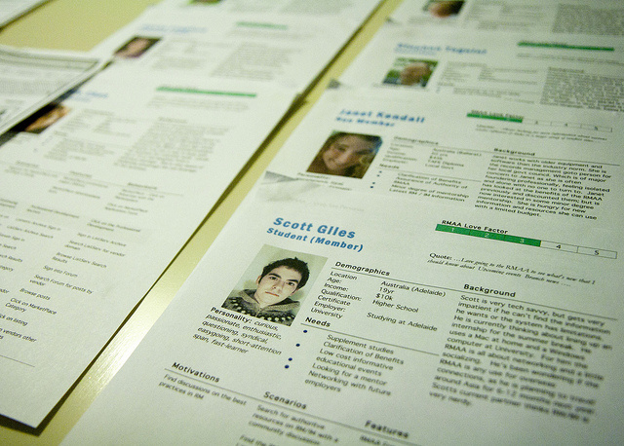

## What is a user journey?

A user journey is a series of steps (typically 4-12) which represent a scenario in which a user might interact with the thing you are designing. They can be used for 2 main things:

Demonstrating the way users currently interact with the service / website / product

Demonstrating the way users could interact with the service / website / product

Whichever layout or presentation style you choose you may want to include the following in some way:

A picture of the persona the journey relates to

A title summarising the journey e.g “Faster uploading with new CMS”

A series of steps in short, concise text

An illustration of what’s happening in the step (if deemed necessary)

## What is a sitemap?

Sitemaps are a hierarchical diagram showing the structure of a website or application. They are used by User Experience Designers and Information Architects to define the taxonomy through grouping of related content. They are an important step of the user centred process as they ensure content is in places users would expect to find it. They can also be used as a reference point for wireframes, functional specifications and content maps.

#### Why should I use a sitemap?

Sitemaps are useful in several ways:

* They show how the navigation should be structured
* They help identify where content will sit and what needs to be produced
* They help show the relationship between different pages
* They provide a structure upon which to begin estimates for development
* They are the first tangible deliverable showing what you will be creating

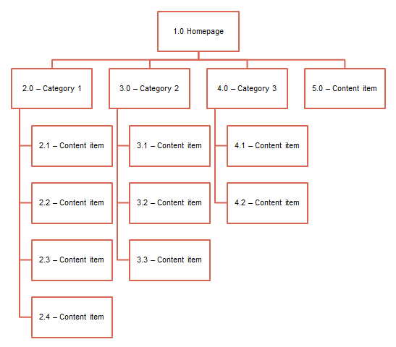

## What is a wireframe?

Basically mock ui as is

A wireframe is a visual representation of a user interface, stripped of any visual design or branding elements. It is used by UX Designers to define the heirachy of items on a screen and communicate what the items on that page should be based on user needs.

The wireframes are the floor plan for your website, creating a vessel for which design and content can flow into.

They are useful for a number of reasons:

* Giving visual designers a basis to begin creating screens
* Using as a reference point for functional specifications
* Communicating the functionality you are going to build with stakeholders without muddying the waters with visual design elements or branding
* Exploring ideas without the difficulty of change inherent in Photoshop mockups
* Using as a basis for prototyping and for user testing ideas early on

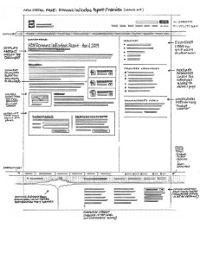

## What is a prototype?

A prototype is a quasi-realistic representation of what you are building that can be interacted with and tested on users in order to help validate your design.

They are useful for a number of reasons:

Help identify usability issues before going to code

Get early user feedback

Observe how users want to interact with your design

To work out complex functionality or screen flows

To help begin to define the interaction design

Faster to create than fully coded solutions (front and back end)

## What is Google Analytics?

Google Analytics is a free tool offered by Google which you insert on a website in order to get data about the number of people who visit your site, the systems they are using to access it and how they got there.

The use of Google Analytics is part science, part witchcraft

## What is a user interview?

A user interview is a common user research technique used typically to get qualitative information from either existing or potential users.

It is typically performed by one or two user experience consultants (one to interview and one to take notes) and can cover any range of topics from:

The person’s background

Their occupation

Their use of technology

Their goals

Their motivations

Their pain points

# The UX of User Stories

<http://www.andersramsay.com/2011/07/16/the-ux-of-user-stories-part-1/>

The UX of User Stories

1. Know What the Story Is

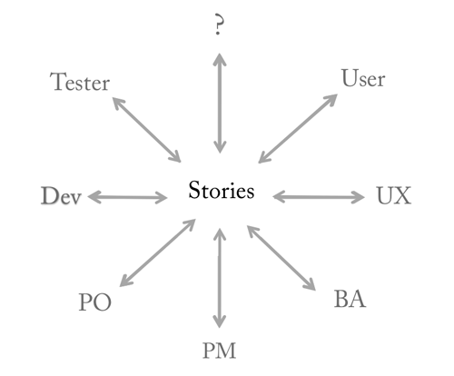

2. Make Personas the voice of the story

Eg. Becky says:

As a substitute teacher, I want to view a list of all students in my course, so that I can call on them by name.

3. Have users write the stories, not you ->interviews

4. Be sure to get your “so thats”

As a [user role]…I want to [be able to do something]…so that [it will provide value in this way].

5. Don’t confuse Story Maps with User Interface

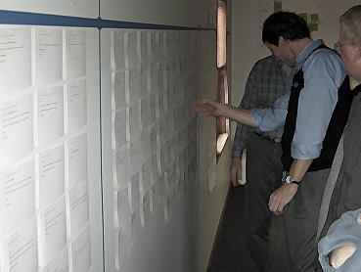

While a story wall provides a good overview of the product, it is much harder to evaluate for completeness compared to a user interface.

6. Iterate Story Development with UI Exploration ->develop mock ui with user stories

7. Make sure UI infrastructure stories get into the backlog

8. Be present during story estimation

9. Make sure testers are testing for usability

10. Read Mike Cohn’s book (INVEST is one of the big things in this)

# Getting Real Book

<https://basecamp.com/books/Getting%20Real.pdf>

First couple of pages of the Getting Real book (Think all of us should delve in to this further)

Want to build a successful web app? Then it’s time to Get Real.

* Getting Real is a smaller, faster, better way to build software.
* Getting Real is about skipping all the stuff that represents real (charts, graphs, boxes, arrows, schematics, wireframes, etc.) and actually building the real thing.
* Getting real is less. Less mass, less software, less features,less paperwork, less of everything that’s not essential (and most of what you think is essential actually isn’t).
* Getting Real is staying small and being agile.
* Getting Real starts with the interface, the real screens that people are going to use. It begins with what the customer actually experiences and builds backwards from there. This lets you get the interface right before you get the software wrong.
* Getting Real is about iterations and lowering the cost of change. Getting Real is all about launching, tweaking, and constantly improving which makes it a perfect approach for web-based software.
* Getting Real delivers just what customers need and eliminates anything they don’t.

No more bloat The old way: a lengthy, bureaucratic, we’re-doing-this-to-coverour-asses process. The typical result: bloated, forgettable software dripping with mediocrity. Blech.

Getting Real gets rid of...

* Timelines that take months or even years
* Pie-in-the-sky functional specs
* Scalability debates
* Interminable staff meetings
* The “need” to hire dozens of employees
* Meaningless version numbers
* Pristine roadmaps that predict the perfect future
* Endless preference options
* Outsourced support
* Unrealistic user testing
* Useless paperwork
* Top-down hierarchy

<http://www.37signals.com/> Basecamp, Campfire, Backpack, WriteBoard,Ta-da list and Ruby on the rail built by these guys.

Below are the other books mentioned not online

* **Don't Make Me Think**, Steve Krug  
  <http://www.amazon.co.uk/Dont-Make-Me-Think-Usability/dp/0321965515/ref=dp_ob_title_bk>
* **Usable Usability**, Eric Reiss  
  <http://www.amazon.com/Usable-Usability-Simple-Making-Better/dp/1118185471>
* **User and Task Analysis for Interface Design,**JoAnn T. Hackos, Janice C. Redish, 1998.  
  <http://www.amazon.com/User-Task-Analysis-Interface-Design/dp/0471178314>
* **User Stories Applied: For Agile Software Development**, Mike Cohn, 2004  
  <http://www.amazon.com/User-Stories-Applied-Software-Development/dp/0321205685>