Indiana Mesocosm Experiment

Laura Lopez & Meghan Duffy

23/04/2021 & Jan-June 2022

# Initial stuff, including loading packages and importing data

##loading packages

library(Hmisc)  
library(tidyverse)  
library(RColorBrewer)  
library(lsmeans)  
library(ggsignif)  
library(here)  
# library(cowplot)  
library(multcomp)  
library(multcompView)  
library(lme4)  
library(nlme)  
library(patchwork)  
# library(ggpubr)

## loading files

# Tell R where files are stored  
here::i_am("scripts/IndianaMesocosmExpt.Rmd")  
  
# Load the data  
indianadata<-readr::read_csv(here("data/indianadatano22.csv"))  
indianadata$chaoborusfactor<-as.factor(indianadata$chaoborus)  
summary(indianadata)

## time tank treatment sampleday   
## Min. :0 Min. : 1.00 Length:423 Length:423   
## 1st Qu.:2 1st Qu.:12.00 Class :character Class :character   
## Median :4 Median :27.00 Mode :character Mode :character   
## Mean :4 Mean :26.34   
## 3rd Qu.:6 3rd Qu.:41.00   
## Max. :8 Max. :52.00   
##   
## metsch chaoborus adultsinfected adultsnotinfected  
## Length:423 Min. :0.0000 Min. : 0.0000 Min. : 0.00   
## Class :character 1st Qu.:0.0000 1st Qu.: 0.0000 1st Qu.: 4.00   
## Mode :character Median :0.5000 Median : 0.0000 Median : 9.00   
## Mean :0.4064 Mean : 0.9622 Mean :13.54   
## 3rd Qu.:1.0000 3rd Qu.: 0.0000 3rd Qu.:19.00   
## Max. :1.0000 Max. :24.0000 Max. :76.00   
##   
## juvenilesinfected juvenilesnotinfected adultsinfectedadjusted  
## Min. : 0.0000 Min. : 0.00 Min. : 0.0000   
## 1st Qu.: 0.0000 1st Qu.: 7.20 1st Qu.: 0.0000   
## Median : 0.0000 Median : 36.00 Median : 0.0000   
## Mean : 0.9716 Mean : 43.94 Mean : 0.4894   
## 3rd Qu.: 0.0000 3rd Qu.: 70.00 3rd Qu.: 0.0000   
## Max. :51.0000 Max. :251.00 Max. :12.0000   
## NA's :1   
## adultsnotinfectedadjusted juvenilesinfectedadjusted  
## Min. : 0.000 Min. : 0.0000   
## 1st Qu.: 3.000 1st Qu.: 0.0000   
## Median : 7.200 Median : 0.0000   
## Mean : 7.808 Mean : 0.4917   
## 3rd Qu.:10.500 3rd Qu.: 0.0000   
## Max. :38.000 Max. :25.5000   
##   
## juvenilesnotinfectedadjusted totaldensity lndensity   
## Min. : 0.0 Min. : 0.00 Min. :-0.6931   
## 1st Qu.: 7.2 1st Qu.: 14.40 1st Qu.: 2.6672   
## Median : 21.5 Median : 31.00 Median : 3.4340   
## Mean : 25.7 Mean : 34.43 Mean : 2.9861   
## 3rd Qu.: 37.5 3rd Qu.: 51.25 3rd Qu.: 3.9367   
## Max. :154.0 Max. :166.00 Max. : 5.1120   
## NA's :1   
## logone adultdensity juveniledensity propinfected   
## Min. :0.000 Min. : 0.000 Min. : 0.00 Min. :0.00000   
## 1st Qu.:2.734 1st Qu.: 3.000 1st Qu.: 7.20 1st Qu.:0.00000   
## Median :3.434 Median : 7.200 Median : 22.00 Median :0.00000   
## Mean :3.072 Mean : 8.298 Mean : 26.13 Mean :0.02675   
## 3rd Qu.:3.951 3rd Qu.:11.250 3rd Qu.: 39.25 3rd Qu.:0.00000   
## Max. :5.118 Max. :38.000 Max. :154.00 Max. :0.80303   
##   
## densityinfected lndensityinfected infectedlnone propadults   
## Min. : 0.0000 Min. :-0.6931 Min. :0.0000 Min. :0.0000   
## 1st Qu.: 0.0000 1st Qu.: 0.0000 1st Qu.:0.0000 1st Qu.:0.1304   
## Median : 0.0000 Median : 0.0000 Median :0.0000 Median :0.2333   
## Mean : 0.9811 Mean : 0.2423 Mean :0.3134 Mean :0.2658   
## 3rd Qu.: 0.0000 3rd Qu.: 0.0000 3rd Qu.:0.0000 3rd Qu.:0.4000   
## Max. :27.5000 Max. : 3.3142 Max. :3.3499 Max. :1.0000   
##   
## chaoborusfactor  
## 0 :108   
## 0.1: 99   
## 0.5:108   
## 1 :108   
##   
##   
##

#Fix issue with weeks, so that they line up with this timeline:  
#week 0 = Daphnia added  
#week 1 = spores added  
#weeks 2-9 = sampling  
#based on the way the data are in the data sheet, week 0 doesn't need to be adjusted by the other weeks do  
indianadata <- mutate(indianadata, time = ifelse(time == 0, 0, time + 1))  
  
indianadata <- indianadata %>% mutate(metsch=recode(metsch,'No Parasites'='No parasites'))  
  
#Subset data  
indianadatametsch <- indianadata %>%  
 filter(metsch == "Parasites")  
  
indianadatanometsch <- indianadata %>%  
 filter(metsch == "No parasites")

# Plots and analysis related to figure 1: infection prevalence and infected host density

## Infections

### Plot

propinfovertimeplot<-ggplot(indianadatametsch,aes(time,y=propinfected,group=chaoborusfactor,color=chaoborusfactor,shape=chaoborusfactor)) +  
 stat_summary(fun="mean",geom="line",size=1,show.legend=FALSE) +  
 stat_summary(fun.data = "mean_se",show.legend=FALSE) +  
 stat_summary(fun="mean",geom="point",size=4) +  
 scale_shape_manual(values=c(15,16,17,18)) +  
 labs(color="Predation treatment", shape = "Predation treatment") +  
 scale_colour_manual(values=c("#6baed6", "#3182bd", "#08519c","black")) +  
 theme_bw()+theme(panel.grid = element_blank()) +  
 theme(legend.position = c(0.35, 0.75)) +  
 theme(legend.key.size = unit(0.05, 'cm'), legend.title = element_text(size=10), #change legend title font size  
 legend.text = element_text(size=8)) +  
 labs(x="Time (weeks)")+  
 labs(y="Proportion infected (I/N)") +   
 theme(axis.text.x = element_blank(),  
 axis.title.x = element_blank() ) +  
 scale_x_discrete(limits=c("1", "2","3","4","5","6","7","8","9"))   
propinfovertimeplot

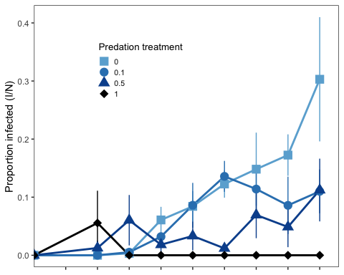

# ggsave(here("figures", "propinfovertimeplot.jpg"), propinfovertimeplot, units = "in", width = 6, height = 4, dpi = 300)  
  
#density of infected hosts  
infdensityovertimeplot<-ggplot(indianadatametsch,aes(time,y=infectedlnone,group=chaoborusfactor,color=chaoborusfactor,shape=chaoborusfactor)) +  
 stat_summary(fun="mean",geom="line",size=1, show.legend = FALSE) +  
 stat_summary(fun.data = "mean_se",show.legend=FALSE) +   
 stat_summary(fun="mean",geom="point",size=4,aes(shape=chaoborusfactor),show.legend=FALSE) +  
 scale_shape_manual(values=c(15,16,17,18)) +  
# labs(color="Predator density \n(per L)") +   
 scale_colour_manual(values=c("#6baed6", "#3182bd", "#08519c","black")) +   
 theme_bw()+theme(panel.grid = element_blank()) +   
 labs(x="Time (weeks)") +  
 labs(y="Infected prey density \n(I; LN prey per L + 1)") +   
 scale_x_discrete(limits=c("1","2","3","4","5","6","7","8","9")) +  
 theme(axis.text.x = element_blank(),  
 axis.title.x = element_blank() )   
infdensityovertimeplot

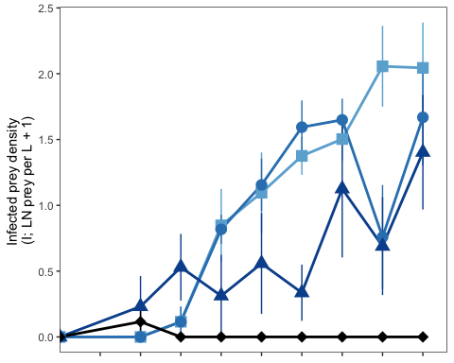

#inftimeseriesplot <- plot_grid(propinfovertimeplot, infdensityovertimeplot, labels = "auto", ncol = 1, align = "v")  
#inftimeseriesplot  
  
# ggsave(here("figures", "inftimeseriesplot.jpg"), inftimeseriesplot, units = "in", width = 4, height = 5.5, dpi = 300)

### Summarizing infection prevalence data for reporting values in manuscript

indianadatametsch$totalinfected <- indianadatametsch$adultsinfected + indianadatametsch$juvenilesinfected  
indianadatametsch$totaluninfected <- indianadatametsch$adultsnotinfected + indianadatametsch$juvenilesnotinfected  
  
# remove time 1 for analysis  
indianadatametschanalysis <- indianadatametsch %>%  
 filter(time > 1)  
  
indiana_infected_summary <- indianadatametschanalysis %>%  
 group_by(time, chaoborusfactor) %>%  
 summarise(meanpropinf = mean(propinfected), minpropinf = min(propinfected), maxpropinf = max(propinfected), meaninfdensity = mean(totalinfected), mininfdensity = min(totalinfected), maxinfdensity = max(totalinfected))

## `summarise()` has grouped output by 'time'. You can override using the  
## `.groups` argument.

indiana_infected_summary

## # A tibble: 32 × 8  
## # Groups: time [8]  
## time chaoborusfactor meanpropinf minpropinf maxpropinf meaninfdensity  
## <dbl> <fct> <dbl> <dbl> <dbl> <dbl>  
## 1 2 0 0 0 0 0   
## 2 2 0.1 0 0 0 0   
## 3 2 0.5 0.0125 0 0.075 0.5   
## 4 2 1 0.0556 0 0.333 0.167  
## 5 3 0 0.00333 0 0.02 0.167  
## 6 3 0.1 0.00521 0 0.0312 0.167  
## 7 3 0.5 0.0603 0 0.273 1   
## 8 3 1 0 0 0 0   
## 9 4 0 0.0608 0 0.117 3.5   
## 10 4 0.1 0.0321 0.0109 0.0597 2.67   
## # … with 22 more rows, and 2 more variables: mininfdensity <dbl>,  
## # maxinfdensity <dbl>

### Analysis

# Initial analysis of time series data -- massively overdispersed so abandoned this approach  
prevmodel1<-glm(cbind(totalinfected, totaluninfected) ~ chaoborus + (1|time), family=binomial(logit), data=indianadatametschanalysis)   
anova(prevmodel1, test="Chisq")

## Analysis of Deviance Table  
##   
## Model: binomial, link: logit  
##   
## Response: cbind(totalinfected, totaluninfected)  
##   
## Terms added sequentially (first to last)  
##   
##   
## Df Deviance Resid. Df Resid. Dev Pr(>Chi)   
## NULL 168 1453.5   
## chaoborus 1 155.31 167 1298.2 < 2.2e-16 ***  
## 1 | time 0 0.00 167 1298.2   
## ---  
## Signif. codes: 0 '***' 0.001 '**' 0.01 '*' 0.05 '.' 0.1 ' ' 1

summary(prevmodel1)

##   
## Call:  
## glm(formula = cbind(totalinfected, totaluninfected) ~ chaoborus +   
## (1 | time), family = binomial(logit), data = indianadatametschanalysis)  
##   
## Deviance Residuals:   
## Min 1Q Median 3Q Max   
## -6.0684 -2.2084 -0.7497 0.0215 13.2779   
##   
## Coefficients: (1 not defined because of singularities)  
## Estimate Std. Error z value Pr(>|z|)   
## (Intercept) -2.1430 0.0450 -47.62 <2e-16 ***  
## chaoborus -1.7778 0.1596 -11.14 <2e-16 ***  
## 1 | timeTRUE NA NA NA NA   
## ---  
## Signif. codes: 0 '***' 0.001 '**' 0.01 '*' 0.05 '.' 0.1 ' ' 1  
##   
## (Dispersion parameter for binomial family taken to be 1)  
##   
## Null deviance: 1453.5 on 168 degrees of freedom  
## Residual deviance: 1298.2 on 167 degrees of freedom  
## (1 observation deleted due to missingness)  
## AIC: 1615.5  
##   
## Number of Fisher Scoring iterations: 6

# Testing for overdispersion (using code from Ben Bolker via Michelle Fearon)  
overdisp_fun <- function(model) {  
 rdf <- df.residual(model)  
 rp <- residuals(model,type="pearson")  
 Pearson.chisq <- sum(rp^2)  
 prat <- Pearson.chisq/rdf  
 pval <- pchisq(Pearson.chisq, df=rdf, lower.tail=FALSE)  
 c(chisq=Pearson.chisq,ratio=prat,rdf=rdf,p=pval)  
}  
  
overdisp_fun(prevmodel1)

## chisq ratio rdf p   
## 1.565819e+03 9.376161e+00 1.670000e+02 1.350000e-225

# super overdispersed, going to focus on averages instead  
  
#looking at means to avoid overdispersion issue:  
infprevsummary <- indianadatametschanalysis %>%  
 group_by(chaoborusfactor, metsch, tank) %>%  
 summarise(meanpropinf = mean(propinfected))

## `summarise()` has grouped output by 'chaoborusfactor', 'metsch'. You can  
## override using the `.groups` argument.

infprevsummaryanalysis <- aov(meanpropinf~chaoborusfactor,data=infprevsummary)  
summary(infprevsummaryanalysis)

## Df Sum Sq Mean Sq F value Pr(>F)   
## chaoborusfactor 3 0.03494 0.011645 8.485 0.000779 ***  
## Residuals 20 0.02745 0.001372   
## ---  
## Signif. codes: 0 '***' 0.001 '**' 0.01 '*' 0.05 '.' 0.1 ' ' 1

overdisp_fun(infprevsummaryanalysis)

## chisq ratio rdf p   
## 0.027448566 0.001372428 20.000000000 1.000000000

#not overdispersed!  
  
# lsmeans(infprevsummaryanalysis,pairwise~chaoborusfactor,adjust="tukey")

## Average infection prevalence

meaninfprevplot <- ggplot(infprevsummaryanalysis,aes(x=chaoborusfactor,y=meanpropinf,color=chaoborusfactor)) +  
 geom_boxplot(show.legend=FALSE) +  
 geom_jitter(shape=17, position=position_jitter(width=0.2, height=0), alpha = 0.5, color = '#787878', size = 2) +  
 labs(y="Average \nproportion infected (I/N)") +  
 scale_color_manual(values=c("#6baed6", "#3182bd", "#08519c","black")) +  
 theme_bw() +  
 geom_text(data=infprevsummaryanalysis,x=2.3, y=0.18,label ="Predation: p = 0.0008", color="black",size = 2.5) +  
 ylim(0.0,0.2) +  
 theme(axis.text.x = element_blank(),  
 axis.title.x = element_blank() ) +  
 theme(panel.grid=element_blank())  
  
meaninfprevplot

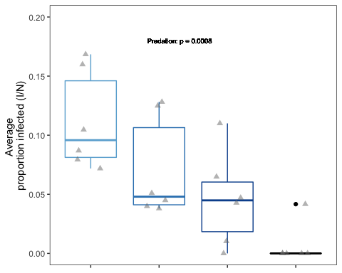

## Average LN infected host density

# weeks 2 through 9  
infdenssummary <- indianadatametschanalysis %>%  
 group_by(chaoborusfactor, tank) %>%  
 summarise(meaninfdens = mean(infectedlnone))

## `summarise()` has grouped output by 'chaoborusfactor'. You can override using  
## the `.groups` argument.

infdenssummaryanalysis <- aov(meaninfdens~chaoborusfactor,data=infdenssummary)  
summary(infdenssummaryanalysis)

## Df Sum Sq Mean Sq F value Pr(>F)   
## chaoborusfactor 3 4.38 1.460 15.21 2.17e-05 ***  
## Residuals 20 1.92 0.096   
## ---  
## Signif. codes: 0 '***' 0.001 '**' 0.01 '*' 0.05 '.' 0.1 ' ' 1

overdisp_fun(infdenssummaryanalysis)

## chisq ratio rdf p   
## 1.91985877 0.09599294 20.00000000 0.99999992

#not overdispersed  
  
# lsmeans(infdenssummaryanalysis,pairwise~chaoborusfactor,adjust="tukey")  
  
meaninfhostplot <- ggplot(infdenssummaryanalysis,aes(x=chaoborusfactor,y=meaninfdens,color=chaoborusfactor)) +  
 geom_boxplot(show.legend=FALSE) +  
 geom_jitter(shape=17, position=position_jitter(width=0.2, height=0), alpha = 0.5, color = '#787878', size = 2) +  
 labs(x="Predation treatment (predators per L)",y="Average infected prey density \n(I; LN prey per L + 1)") +  
 scale_color_manual(values=c("#6baed6", "#3182bd", "#08519c","black")) +  
 theme_bw() +  
 geom_text(data=infdenssummaryanalysis,x=1.8, y=0.18,label ="Predation: p < 0.0001", color="black",size = 2.5) +  
 ylim(0.0,1.6) +   
 theme(axis.text.x = element_blank(),  
 axis.title.x = element_blank() ) +  
 theme(panel.grid=element_blank())  
  
meaninfhostplot

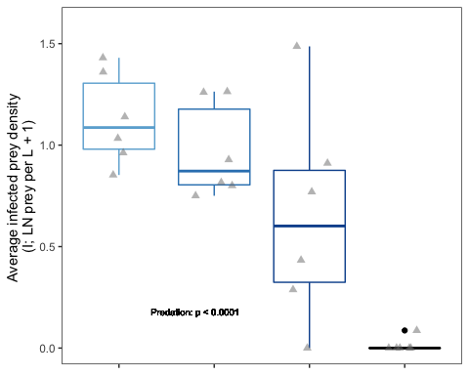

# Analyses and plots related to population density

## Plotting time series of density

indianadata$metsch <- as.factor(indianadata$metsch)  
  
popdensitytimeseriesmetsch <- ggplot(indianadatametsch, aes(x = time, y = (logone), color = chaoborusfactor, group = chaoborusfactor, shape = chaoborusfactor)) +   
 stat_summary(fun = "mean", geom="line", aes(group = chaoborusfactor)) +   
 stat_summary(fun.data="mean_se") +  
 stat_summary(fun="mean",geom="point",size=4,aes(shape=chaoborusfactor),show.legend=FALSE) +  
 labs(x="Time (week)",y="Prey density \n(N; LN prey per L + 1)") +   
 scale_x_discrete(limits=c("1", "2","3","4","5","6","7","8","9")) +   
 scale_color_manual(values=c("#6baed6", "#3182bd", "#08519c","black")) +  
 scale_shape_manual(values=c(15,16,17,18)) +  
 theme_bw()+theme(panel.grid = element_blank()) +  
 ylim(0,5.0) +  
 theme(axis.text.x = element_blank(),  
 axis.title.x = element_blank() ) +   
 theme(axis.title.y = element_blank() ) +  
 theme(legend.position = 'none')   
#+   
# ggtitle('Parasites') +  
# theme(plot.title = element_text(size = 10))   
  
popdensitytimeseriesmetsch

## Warning: Removed 1 rows containing non-finite values (stat_summary).  
## Removed 1 rows containing non-finite values (stat_summary).  
## Removed 1 rows containing non-finite values (stat_summary).

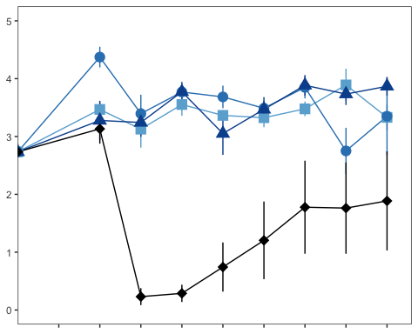

popdensitytimeseriesnometsch <- ggplot(indianadatanometsch, aes(x = time, y = (logone), color = chaoborusfactor, group = chaoborusfactor, shape = chaoborusfactor)) +   
 stat_summary(fun = "mean", geom="line", aes(group = chaoborusfactor)) +   
 stat_summary(fun.data="mean_se") +  
 stat_summary(fun="mean",geom="point",size=4,aes(shape=chaoborusfactor),show.legend=FALSE) +  
 labs(x="Time (week)",y="Prey density \n(N; LN prey per L + 1)") +   
 scale_x_discrete(limits=c("1", "2","3","4","5","6","7","8","9")) +   
 scale_color_manual(values=c("#6baed6", "#3182bd", "#08519c","black")) +  
 scale_shape_manual(values=c(15,16,17,18)) +  
 theme_bw()+theme(panel.grid = element_blank()) +  
 ylim(0,5.0) +  
 theme(axis.title.y = element_blank() ) +  
 theme(legend.position = 'none')  
  
#+   
# ggtitle('No parasites') +  
# theme(plot.title = element_text(size = 10))   
  
popdensitytimeseriesnometsch

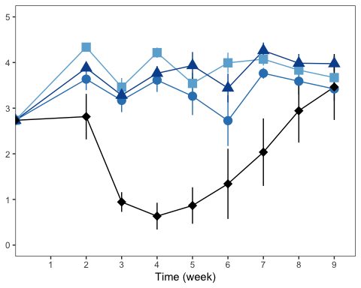

# ggsave(here("figures", "figure2.jpg"), figure2, units = "in", width = 6, height = 4, dpi = 300)

## Average total host density analysis

# remove time 1 for analysis  
indianadataanalysis <- indianadata %>%  
 filter(time > 1)  
  
densitysummary <- indianadataanalysis %>%  
 group_by(chaoborusfactor, metsch, tank) %>%  
 summarise(meandens = mean(logone))

## `summarise()` has grouped output by 'chaoborusfactor', 'metsch'. You can  
## override using the `.groups` argument.

densitysummaryanalysis <- aov(meandens~chaoborusfactor*metsch,data=densitysummary)  
summary(densitysummaryanalysis)

## Df Sum Sq Mean Sq F value Pr(>F)   
## chaoborusfactor 3 35.77 11.923 37.329 1.52e-11 ***  
## metsch 1 0.81 0.812 2.541 0.119   
## chaoborusfactor:metsch 3 0.79 0.262 0.821 0.490   
## Residuals 39 12.46 0.319   
## ---  
## Signif. codes: 0 '***' 0.001 '**' 0.01 '*' 0.05 '.' 0.1 ' ' 1

overdisp_fun(densitysummaryanalysis)

## chisq ratio rdf p   
## 12.4566367 0.3194009 39.0000000 0.9999839

#not overdispersed  
  
# lsmeans(densitysummaryanalysis,pairwise~chaoborusfactor*metsch,adjust="tukey")

## Average total host density plot

meandensityplot <- ggplot(densitysummaryanalysis,aes(x=chaoborusfactor,y=meandens, color=chaoborusfactor, fill = metsch)) +  
 geom_boxplot(lwd=0.75) +  
 geom_point(pch=17, position=position_jitterdodge(jitter.width = 0.2), alpha = 0.5, size = 2, color = 'black',show.legend=FALSE) +  
 labs(x="Predation treatment (predators per L)",y="Average prey density \n(N; LN prey per L + 1)") +  
 labs(color = "Predator density \n(per L)", fill = "Parasite treatment") +  
 scale_color_manual(values=c("#6baed6", "#3182bd", "#08519c","black"), guide="none") +  
 scale_fill_manual(values=c('white','gray')) +  
 theme_bw() +   
 geom_text(data=densitysummaryanalysis,x=2.7, y=0.5,label ="Predation: p < 0.0001\nParasitism: p = 0.12\nPred*Para: p = 0.49", color="black",size = 2.5) +  
 ylim(0.0,4.6) +   
 theme(panel.grid=element_blank()) +  
 theme(legend.position = c(0.2, 0.38)) +  
 theme(legend.key.size = unit(0.5, 'cm'), legend.title = element_blank(),  
 legend.text = element_text(size=7))   
  
meandensityplot

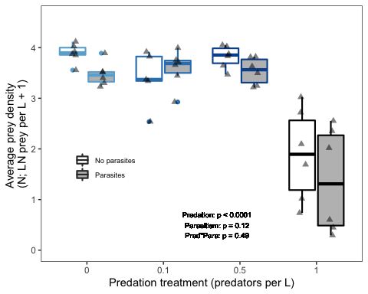

## Looking at evolution of resistance

## Clones over time: importing data, calculating weighted averages

evoldata<-readr::read_csv(here("data/genotype.frequencies_MHC_converted.csv"))

## Rows: 177 Columns: 15  
## ── Column specification ────────────────────────────────────────────────────────  
## Delimiter: ","  
## dbl (15): Parasites, predation, tank, week, Day, no.hosts.sampled, BD05.42, ...  
##   
## ℹ Use `spec()` to retrieve the full column specification for this data.  
## ℹ Specify the column types or set `show_col_types = FALSE` to quiet this message.

evoldata

## # A tibble: 177 × 15  
## Parasites predation tank week Day no.hosts.sampled BD05.42 BD08.46  
## <dbl> <dbl> <dbl> <dbl> <dbl> <dbl> <dbl> <dbl>  
## 1 1 0.1 1 -1 171 0 0.111 0.111  
## 2 1 0.1 1 1 182 6 0 0.5   
## 3 1 0.1 1 5 210 20 0 0   
## 4 0 0.1 2 -1 171 0 0.111 0.111  
## 5 0 0.1 2 1 182 5 0 0   
## 6 0 0.1 2 5 210 20 0 0.05   
## 7 0 0.1 2 8 231 14 0 0   
## 8 0 0.1 3 -1 171 0 0.111 0.111  
## 9 0 0.1 3 1 182 9 0 0.111  
## 10 0 0.1 3 5 210 7 0 0.286  
## # … with 167 more rows, and 7 more variables: BD19.64 <dbl>, CB24.68 <dbl>,  
## # DW22.58 <dbl>, DW29.75 <dbl>, IL14.43 <dbl>, ML30.82 <dbl>, ML32.84 <dbl>

#excluding tank 22  
evoldata2<-evoldata[!(evoldata$tank=="22"),]  
evoldata2$pred<-as.factor(evoldata2$predation)  
evoldata2$round<-evoldata2$week+1  
evoldata2$roundfactor<-as.factor(evoldata2$round)  
summary(evoldata2)

## Parasites predation tank week   
## Min. :0.0000 Min. :0.0000 Min. : 1.00 Min. :-1.000   
## 1st Qu.:0.0000 1st Qu.:0.0000 1st Qu.:13.00 1st Qu.:-1.000   
## Median :0.0000 Median :0.1000 Median :27.00 Median : 1.000   
## Mean :0.4913 Mean :0.3659 Mean :26.12 Mean : 3.081   
## 3rd Qu.:1.0000 3rd Qu.:0.5000 3rd Qu.:40.00 3rd Qu.: 5.000   
## Max. :1.0000 Max. :1.0000 Max. :52.00 Max. : 8.000   
## Day no.hosts.sampled BD05.42 BD08.46   
## Min. :171.0 Min. : 0.000 Min. :0.00000 Min. :0.0000   
## 1st Qu.:171.0 1st Qu.: 0.000 1st Qu.:0.00000 1st Qu.:0.0000   
## Median :185.0 Median : 7.000 Median :0.00000 Median :0.1110   
## Mean :198.5 Mean : 8.676 Mean :0.03163 Mean :0.1498   
## 3rd Qu.:213.0 3rd Qu.:17.000 3rd Qu.:0.11100 3rd Qu.:0.1667   
## Max. :234.0 Max. :20.000 Max. :0.11100 Max. :1.0000   
## BD19.64 CB24.68 DW22.58 DW29.75   
## Min. :0.00000 Min. :0.0000 Min. :0.00000 Min. :0.00000   
## 1st Qu.:0.00000 1st Qu.:0.0000 1st Qu.:0.00000 1st Qu.:0.00000   
## Median :0.00000 Median :0.1110 Median :0.00000 Median :0.00000   
## Mean :0.03753 Mean :0.1229 Mean :0.03757 Mean :0.07658   
## 3rd Qu.:0.11100 3rd Qu.:0.1250 3rd Qu.:0.11100 3rd Qu.:0.11100   
## Max. :0.25000 Max. :0.9000 Max. :0.25000 Max. :1.00000   
## IL14.43 ML30.82 ML32.84 pred round   
## Min. :0.0000 Min. :0.00000 Min. :0.0000 0 :47 Min. :0.000   
## 1st Qu.:0.0000 1st Qu.:0.07143 1st Qu.:0.0625 0.1:43 1st Qu.:0.000   
## Median :0.1000 Median :0.11100 Median :0.1110 0.5:48 Median :2.000   
## Mean :0.0957 Mean :0.27083 Mean :0.1772 1 :35 Mean :4.081   
## 3rd Qu.:0.1110 3rd Qu.:0.50000 3rd Qu.:0.2500 3rd Qu.:6.000   
## Max. :0.6667 Max. :1.00000 Max. :1.0000 Max. :9.000   
## roundfactor  
## 0:47   
## 2:44   
## 6:40   
## 9:42   
##   
##

evoldata2$para <- factor(evoldata2$Parasites, levels = c("1", "0"),  
 labels = c("Parasites", "No parasites"))  
  
evoldata2$para <- factor(evoldata2$para, c("No parasites", "Parasites"))

#Note: "inf" is infection rate, beta. It is the product of the per spore susceptibility and the susceptible feeding rate.  
BD0542inf <- 0.000000079776  
BD0846inf <- 9.81E-08  
BD1964inf <- 0  
CB2468inf <- 8.15E-08  
DW2258inf <- 1.69E-07  
DW2975inf <- 1.53E-07  
ML3082inf <- 4.98E-08  
ML3284inf <- 1.37E-07  
IL1443inf <- 1.80E-07  
   
BD0542inf_scaled <- 0.000000079776 * 10^7  
BD0846inf_scaled <- 9.81E-08 * 10^7  
BD1964inf_scaled <- 0  
CB2468inf_scaled <- 8.15E-08 * 10^7  
DW2258inf_scaled <- 1.69E-07 * 10^7  
DW2975inf_scaled <- 1.53E-07 * 10^7  
ML3082inf_scaled <- 4.98E-08 * 10^7  
ML3284inf_scaled <- 1.37E-07 * 10^7  
IL1443inf_scaled <- 1.80E-07 * 10^7  
  
evoldata2$infectionmean_scaled <- evoldata2$BD05.42*BD0542inf_scaled +  
 evoldata2$BD08.46*BD0846inf_scaled +  
 evoldata2$BD19.64*BD1964inf_scaled +  
 evoldata2$CB24.68*CB2468inf_scaled +  
 evoldata2$DW22.58*DW2258inf_scaled +  
 evoldata2$DW29.75*DW2975inf_scaled +  
 evoldata2$IL14.43*IL1443inf_scaled +  
 evoldata2$ML30.82*ML3082inf_scaled +  
 evoldata2$ML32.84*ML3284inf_scaled  
  
# checking if things would be different if we used just per spore susceptibility (p)  
BD0542p <- 5.54 * 10-4  
BD0846p <- 5.64 * 10-4  
BD1964p <- 0  
CB2468p <- 5.25 * 10-4  
DW2258p <- 6.88 * 10-4  
DW2975p <- 5.77 * 10-4  
ML3082p <- 8.58 * 10-4  
ML3284p <- 4.93 * 10-4  
IL1443p <- 1.17 * 10-3  
  
evoldata2$pmean <- evoldata2$BD05.42*BD0542p +  
 evoldata2$BD08.46*BD0846p +  
 evoldata2$BD19.64*BD1964p +  
 evoldata2$CB24.68*CB2468p +  
 evoldata2$DW22.58*DW2258p +  
 evoldata2$DW29.75*DW2975p +  
 evoldata2$IL14.43*IL1443p +  
 evoldata2$ML30.82*ML3082p +  
 evoldata2$ML32.84*ML3284p  
  
#answer: no significant evolution of p  
   
BD0542pred <- 0.0197  
BD0846pred <- 0.0134  
BD1964pred <- 0.0116  
CB2468pred <- 0.0062  
DW2258pred <- 0.0144  
DW2975pred <- 0.0082  
ML3082pred <- 0.0157  
ML3284pred <- 0.0096  
IL1443pred <- 0.016  
  
evoldata2$predationmean <- evoldata2$BD05.42*BD0542pred +  
 evoldata2$BD08.46*BD0846pred +  
 evoldata2$BD19.64*BD1964pred +  
 evoldata2$CB24.68*CB2468pred +  
 evoldata2$DW22.58*DW2258pred +  
 evoldata2$DW29.75*DW2975pred +  
 evoldata2$IL14.43*IL1443pred +  
 evoldata2$ML30.82*ML3082pred +  
 evoldata2$ML32.84*ML3284pred

evoldata2samplesizes <- evoldata2 %>%  
 filter (week > 0) %>%  
 group_by(tank, week) %>%  
 summarise(meanhosts = mean(no.hosts.sampled))

## `summarise()` has grouped output by 'tank'. You can override using the  
## `.groups` argument.

# Used this to write the above results to a csv file, then added missing rows to that (with 0 as sample size)  
# readr::write_csv(evoldata2samplesizes, here("data/evoldata2samplesizes.csv"))  
  
# Now re-importing the version with zeroes. Not elegant, but gets the job done.  
evoldata2samplesizeswithzeroes<-readr::read_csv(here("data/evoldata2samplesizeswithzeroes.csv"))

## Rows: 141 Columns: 5  
## ── Column specification ────────────────────────────────────────────────────────  
## Delimiter: ","  
## chr (1): para  
## dbl (4): tank, week, meanhosts, pred  
##   
## ℹ Use `spec()` to retrieve the full column specification for this data.  
## ℹ Specify the column types or set `show_col_types = FALSE` to quiet this message.

evoldata2samplesizeswithzeroessummary <- evoldata2samplesizeswithzeroes %>%  
 group_by(pred, para, week) %>%  
 summarise(meanhosts = mean(meanhosts))

## `summarise()` has grouped output by 'pred', 'para'. You can override using the  
## `.groups` argument.

evoldata2samplesizeswithzeroessummary2 <- evoldata2samplesizeswithzeroes %>%  
 group_by(pred, para) %>%  
 summarise(meanhosts = mean(meanhosts))

## `summarise()` has grouped output by 'pred'. You can override using the  
## `.groups` argument.

#readr::write_csv(evoldata2samplesizeswithzeroessummary, here("data/evoldata2samplesizeswithzeroessummary.csv"))  
  
genotypingsamplesizes <- evoldata2samplesizeswithzeroes %>%  
 summarise(meanhosts = mean(meanhosts))

## Evolution of infection resistance

evoldata2metsch <- evoldata2 %>%  
 filter(para == "Parasites")  
  
evoldata2nometsch <- evoldata2 %>%  
 filter(para == "No parasites")  
  
metschresevolplotmetsch <- ggplot(evoldata2metsch,aes(round,y=infectionmean_scaled,group=pred,color=pred,shape=pred)) +   
 stat_summary(fun="mean",geom="line",size=1,show.legend=FALSE) +  
 stat_summary(fun.data = "mean_se",show.legend=FALSE) +  
 stat_summary(fun="mean",geom="point",size=4,aes(shape=pred)) +  
 scale_shape_manual(values=c(15,16,17,18)) +  
 labs(color="Pred.", shape = "Pred.") +  
 scale_colour_manual(values=c("#6baed6", "#3182bd", "#08519c","black")) +  
 theme_bw() +  
 theme(panel.grid = element_blank()) +  
 ylim(0.5, 1.6) +  
 labs(x="Time (weeks)") +  
# labs(y=expression(paste("Ave. infection rate, "*beta*", ("*"*10"^"-7"*")"))) +   
 scale_x_continuous(breaks=c(0,2,6,9)) +  
 theme(axis.title.y = element_text(margin = margin(t = 0, r = 10, b = 0, l = 0))) +  
 theme(axis.title.x=element_text(margin=margin(t=10,r=0,b=0,l=0))) +  
 theme(axis.text.x = element_blank(),  
 axis.title.x = element_blank() ) +  
 theme(axis.title.y = element_blank() ) +  
 theme(legend.position = "none")   
#+  
# ggtitle('Parasites') +  
# theme(plot.title = element_text(size = 10))   
metschresevolplotmetsch

## Warning: Removed 2 rows containing non-finite values (stat_summary).  
## Removed 2 rows containing non-finite values (stat_summary).  
## Removed 2 rows containing non-finite values (stat_summary).

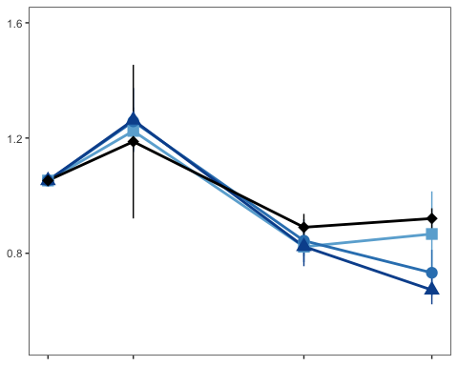

metschresevolplotnometsch <- ggplot(evoldata2nometsch,aes(round,y=infectionmean_scaled,group=pred,color=pred,shape=pred)) +   
 stat_summary(fun="mean",geom="line",size=1,show.legend=FALSE) +  
 stat_summary(fun.data = "mean_se",show.legend=FALSE) +  
 stat_summary(fun="mean",geom="point",size=4,aes(shape=pred)) +  
 scale_shape_manual(values=c(15,16,17,18)) +  
 labs(color="Pred.", shape = "Pred.") +  
 scale_colour_manual(values=c("#6baed6", "#3182bd", "#08519c","black")) +  
 theme_bw() +  
 theme(panel.grid = element_blank()) +  
 ylim(0.5, 1.6) +  
 labs(x="Time (weeks)") +  
# labs(y=expression(paste("Ave. infection rate, "*beta*", (L/hr/spore; "*"*10"^"-7"*")"))) +   
 scale_x_continuous(breaks=c(0,2,6,9)) +  
 theme(axis.title.y = element_text(margin = margin(t = 0, r = 10, b = 0, l = 0))) +  
 theme(axis.title.x=element_text(margin=margin(t=10,r=0,b=0,l=0))) +  
 theme(axis.title.y = element_blank() ) +  
 theme(legend.position = "none")   
#+  
# ggtitle('No parasites') +  
# theme(plot.title = element_text(size = 10))   
metschresevolplotnometsch

## Warning: Removed 2 rows containing non-finite values (stat_summary).  
## Removed 2 rows containing non-finite values (stat_summary).  
## Removed 2 rows containing non-finite values (stat_summary).

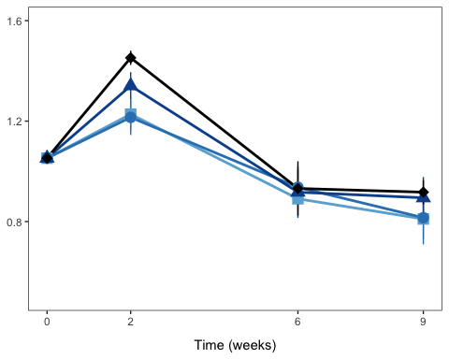

# ggsave(here("figures", "metschresevolplot.jpg"), metschresevolplot, units = "in", width = 6, height = 3.5, dpi = 300)  
  
## checking for consistency of pattern with just p:  
pevolplot <- ggplot(evoldata2,aes(round,y=pmean,group=pred,color=pred,shape=pred)) +   
 stat_summary(fun="mean",geom="line",size=1,show.legend=FALSE) +  
 stat_summary(fun.data = "mean_se",show.legend=FALSE) +  
 stat_summary(fun="mean",geom="point",size=4,aes(shape=pred)) +  
 scale_shape_manual(values=c(15,16,17,18)) +  
 labs(color="Pred.", shape = "Pred.") +  
 scale_colour_manual(values=c("#6baed6", "#3182bd", "#08519c","black")) +  
 theme_bw() +  
 theme(panel.grid = element_blank()) +  
 labs(x="Time (weeks)") +  
 labs(y="Per spore susceptibility") +   
 scale_x_continuous(breaks=c(0,2,6,9)) +  
 theme(axis.title.y = element_text(margin = margin(t = 0, r = 10, b = 0, l = 0))) +  
 theme(axis.title.x=element_text(margin=margin(t=10,r=0,b=0,l=0))) +  
 facet_grid(rows=vars(para)) +  
 theme(legend.position = "none")   
  
pevolplot

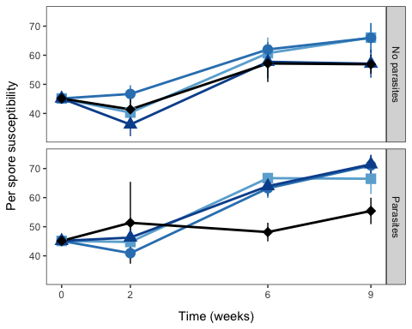

## Analysis related to Metsch susceptibility evolution

# removing week 0 for analysis  
evoldata3 <- evoldata2 %>%  
 filter(round != "0")  
  
#infection susceptibility trait evolution analysis  
infsuscmod1<-lme(infectionmean_scaled~pred+para+round+pred*para+pred*round+para*round+pred*para*round,random=~1|tank,data=evoldata3)  
summary(infsuscmod1)

## Linear mixed-effects model fit by REML  
## Data: evoldata3   
## AIC BIC logLik  
## 59.53469 108.1433 -11.76734  
##   
## Random effects:  
## Formula: ~1 | tank  
## (Intercept) Residual  
## StdDev: 1.201382e-05 0.2042162  
##   
## Fixed effects: infectionmean_scaled ~ pred + para + round + pred * para + pred * round + para * round + pred * para * round   
## Value Std.Error DF t-value p-value  
## (Intercept) 1.3273396 0.10660841 71 12.450608 0.0000  
## pred0.1 -0.0111244 0.15812583 39 -0.070351 0.9443  
## pred0.5 0.0973448 0.15076707 39 0.645664 0.5223  
## pred1 0.2479584 0.15230195 39 1.628071 0.1116  
## paraParasites -0.0352305 0.15686476 39 -0.224592 0.8235  
## round -0.0688667 0.01678647 71 -4.102510 0.0001  
## pred0.1:paraParasites 0.1013801 0.22329243 39 0.454024 0.6523  
## pred0.5:paraParasites 0.0155404 0.21757128 39 0.071427 0.9434  
## pred1:paraParasites -0.5068652 0.23316197 39 -2.173876 0.0358  
## pred0.1:round 0.0111218 0.02489836 71 0.446690 0.6565  
## pred0.5:round 0.0028847 0.02373966 71 0.121512 0.9036  
## pred1:round -0.0106084 0.02429437 71 -0.436662 0.6637  
## paraParasites:round 0.0081333 0.02436307 71 0.333837 0.7395  
## pred0.1:paraParasites:round -0.0281218 0.03518268 71 -0.799309 0.4268  
## pred0.5:paraParasites:round -0.0278051 0.03401662 71 -0.817399 0.4164  
## pred1:paraParasites:round 0.0565524 0.03727523 71 1.517157 0.1337  
## Correlation:   
## (Intr) prd0.1 prd0.5 pred1 prPrst round pr0.1:P  
## pred0.1 -0.674   
## pred0.5 -0.707 0.477   
## pred1 -0.700 0.472 0.495   
## paraParasites -0.680 0.458 0.481 0.476   
## round -0.892 0.602 0.631 0.625 0.606   
## pred0.1:paraParasites 0.477 -0.708 -0.338 -0.334 -0.703 -0.426   
## pred0.5:paraParasites 0.490 -0.330 -0.693 -0.343 -0.721 -0.437 0.506   
## pred1:paraParasites 0.457 -0.308 -0.323 -0.653 -0.673 -0.408 0.473   
## pred0.1:round 0.602 -0.892 -0.425 -0.421 -0.409 -0.674 0.632   
## pred0.5:round 0.631 -0.425 -0.892 -0.442 -0.429 -0.707 0.301   
## pred1:round 0.617 -0.416 -0.436 -0.878 -0.419 -0.691 0.294   
## paraParasites:round 0.615 -0.414 -0.435 -0.430 -0.898 -0.689 0.631   
## pred0.1:paraParasites:round -0.426 0.631 0.301 0.298 0.622 0.477 -0.894   
## pred0.5:paraParasites:round -0.440 0.297 0.623 0.308 0.643 0.493 -0.452   
## pred1:paraParasites:round -0.402 0.271 0.284 0.572 0.587 0.450 -0.412   
## pr0.5:P prd1:P pr0.1: pr0.5: prd1:r prPrs: p0.1:P:  
## pred0.1   
## pred0.5   
## pred1   
## paraParasites   
## round   
## pred0.1:paraParasites   
## pred0.5:paraParasites   
## pred1:paraParasites 0.485   
## pred0.1:round 0.295 0.275   
## pred0.5:round 0.618 0.288 0.477   
## pred1:round 0.302 0.574 0.466 0.489   
## paraParasites:round 0.647 0.604 0.465 0.487 0.476   
## pred0.1:paraParasites:round -0.448 -0.418 -0.708 -0.337 -0.330 -0.692   
## pred0.5:paraParasites:round -0.895 -0.433 -0.333 -0.698 -0.341 -0.716 0.496   
## pred1:paraParasites:round -0.423 -0.878 -0.304 -0.318 -0.652 -0.654 0.453   
## p0.5:P:  
## pred0.1   
## pred0.5   
## pred1   
## paraParasites   
## round   
## pred0.1:paraParasites   
## pred0.5:paraParasites   
## pred1:paraParasites   
## pred0.1:round   
## pred0.5:round   
## pred1:round   
## paraParasites:round   
## pred0.1:paraParasites:round   
## pred0.5:paraParasites:round   
## pred1:paraParasites:round 0.468   
##   
## Standardized Within-Group Residuals:  
## Min Q1 Med Q3 Max   
## -2.47592162 -0.50471567 -0.01639629 0.55667132 3.05799057   
##   
## Number of Observations: 126  
## Number of Groups: 47

anova(infsuscmod1)

## numDF denDF F-value p-value  
## (Intercept) 1 71 2927.5729 <.0001  
## pred 3 39 2.1633 0.1079  
## para 1 39 4.8609 0.0334  
## round 1 71 111.9952 <.0001  
## pred:para 3 39 1.5165 0.2254  
## pred:round 3 71 0.4746 0.7009  
## para:round 1 71 0.1346 0.7148  
## pred:para:round 3 71 2.1803 0.0979

# lsmeans(infsuscmod1,pairwise~round,adjust="tukey")  
# lsmeans(infsuscmod1,pairwise~para,adjust="tukey")  
  
  
pmod1<-lme(pmean~pred+para+round+pred*para+pred*round+para*round+pred*para*round,random=~1|tank,data=evoldata3)  
summary(pmod1)

## Linear mixed-effects model fit by REML  
## Data: evoldata3   
## AIC BIC logLik  
## 921.7923 970.4009 -442.8961  
##   
## Random effects:  
## Formula: ~1 | tank  
## (Intercept) Residual  
## StdDev: 6.433928 8.834202  
##   
## Fixed effects: pmean ~ pred + para + round + pred * para + pred * round + para * round + pred * para * round   
## Value Std.Error DF t-value p-value  
## (Intercept) 34.38998 5.307329 71 6.479715 0.0000  
## pred0.1 7.89879 7.872042 39 1.003397 0.3219  
## pred0.5 -1.70799 7.505697 39 -0.227560 0.8212  
## pred1 3.38017 7.569745 39 0.446537 0.6577  
## paraParasites 7.74927 7.792466 39 0.994456 0.3261  
## round 3.75860 0.726167 71 5.175948 0.0000  
## pred0.1:paraParasites -16.83824 11.102778 39 -1.516579 0.1374  
## pred0.5:paraParasites -0.51406 10.819335 39 -0.047513 0.9623  
## pred1:paraParasites 3.94551 11.691751 39 0.337461 0.7376  
## pred0.1:round -0.94743 1.077080 71 -0.879628 0.3820  
## pred0.5:round -0.64256 1.026955 71 -0.625696 0.5335  
## pred1:round -1.40902 1.060566 71 -1.328552 0.1883  
## paraParasites:round -0.67066 1.060551 71 -0.632366 0.5292  
## pred0.1:paraParasites:round 2.36031 1.530203 71 1.542480 0.1274  
## pred0.5:paraParasites:round 1.19652 1.476281 71 0.810498 0.4204  
## pred1:paraParasites:round -1.35708 1.716007 71 -0.790834 0.4317  
## Correlation:   
## (Intr) prd0.1 prd0.5 pred1 prPrst round pr0.1:P  
## pred0.1 -0.674   
## pred0.5 -0.707 0.477   
## pred1 -0.701 0.473 0.496   
## paraParasites -0.681 0.459 0.482 0.478   
## round -0.775 0.523 0.548 0.544 0.528   
## pred0.1:paraParasites 0.478 -0.709 -0.338 -0.335 -0.702 -0.371   
## pred0.5:paraParasites 0.491 -0.331 -0.694 -0.344 -0.720 -0.380 0.505   
## pred1:paraParasites 0.454 -0.306 -0.321 -0.647 -0.666 -0.352 0.468   
## pred0.1:round 0.523 -0.775 -0.370 -0.366 -0.356 -0.674 0.550   
## pred0.5:round 0.548 -0.370 -0.775 -0.384 -0.373 -0.707 0.262   
## pred1:round 0.531 -0.358 -0.375 -0.761 -0.362 -0.685 0.254   
## paraParasites:round 0.531 -0.358 -0.375 -0.372 -0.790 -0.685 0.555   
## pred0.1:paraParasites:round -0.368 0.546 0.260 0.258 0.548 0.475 -0.782   
## pred0.5:paraParasites:round -0.381 0.257 0.539 0.267 0.568 0.492 -0.398   
## pred1:paraParasites:round -0.328 0.221 0.232 0.470 0.488 0.423 -0.343   
## pr0.5:P prd1:P pr0.1: pr0.5: prd1:r prPrs: p0.1:P:  
## pred0.1   
## pred0.5   
## pred1   
## paraParasites   
## round   
## pred0.1:paraParasites   
## pred0.5:paraParasites   
## pred1:paraParasites 0.480   
## pred0.1:round 0.256 0.237   
## pred0.5:round 0.538 0.249 0.477   
## pred1:round 0.260 0.492 0.462 0.484   
## paraParasites:round 0.569 0.527 0.462 0.484 0.469   
## pred0.1:paraParasites:round -0.394 -0.365 -0.704 -0.336 -0.325 -0.693   
## pred0.5:paraParasites:round -0.783 -0.378 -0.332 -0.696 -0.337 -0.718 0.498   
## pred1:paraParasites:round -0.352 -0.785 -0.285 -0.299 -0.618 -0.618 0.428   
## p0.5:P:  
## pred0.1   
## pred0.5   
## pred1   
## paraParasites   
## round   
## pred0.1:paraParasites   
## pred0.5:paraParasites   
## pred1:paraParasites   
## pred0.1:round   
## pred0.5:round   
## pred1:round   
## paraParasites:round   
## pred0.1:paraParasites:round   
## pred0.5:paraParasites:round   
## pred1:paraParasites:round 0.444   
##   
## Standardized Within-Group Residuals:  
## Min Q1 Med Q3 Max   
## -2.46632199 -0.57654358 0.02406069 0.42253505 2.59996850   
##   
## Number of Observations: 126  
## Number of Groups: 47

anova(pmod1)

## numDF denDF F-value p-value  
## (Intercept) 1 71 2025.3550 <.0001  
## pred 3 39 1.8377 0.1563  
## para 1 39 2.8079 0.1018  
## round 1 71 131.1455 <.0001  
## pred:para 3 39 0.8214 0.4900  
## pred:round 3 71 2.2745 0.0873  
## para:round 1 71 0.0097 0.9216  
## pred:para:round 3 71 1.7527 0.1641

# lsmeans(pmod1,pairwise~round,adjust="tukey")  
# lsmeans(pmod1,pairwise~para,adjust="tukey")

## Plotting evolution of infection resistance grouping predation treatments

metschresevolplotgrouped <- ggplot(evoldata2,aes(round,y=infectionmean_scaled,group=para,color=para,shape=para)) +   
 stat_summary(fun="mean",geom="line",size=1,show.legend=FALSE) +  
 stat_summary(fun.data = "mean_se",show.legend=FALSE) +  
 stat_summary(fun="mean",geom="point",size=3,shape=21,aes(fill=para)) +  
 labs(color="Parasitism", fill="Parasitism") +  
 scale_colour_manual(values=c("black","black")) +  
 scale_fill_manual(values=c("white", "#857A8C")) +  
 theme_bw() +  
 theme(panel.grid = element_blank()) +  
 labs(x="Time (weeks)") +  
 labs(y=expression(paste("Ave. infection rate, "*beta*", ("*"*10"^"-7"*")"))) +   
 scale_x_continuous(breaks=c(0,2,6,9)) +   
 ylim(0.5, 1.6) +  
 geom_text(data=evoldata2,x=2.3, y=0.66,label ="Parasitism: p = 0.0334", color="black",size = 2.5) +  
 theme(axis.title.y = element_text(margin = margin(t = 0, r = 10, b = 0, l = 0))) +  
 theme(axis.title.x=element_text(margin=margin(t=10,r=0,b=0,l=0))) +  
 theme(legend.position = c(2.5, 0.7)) +  
 theme(axis.title.y = element_blank() ) +  
 theme(legend.key.size = unit(0.05, 'cm'), legend.title = element_blank(),  
 legend.text = element_text(size=8))   
  
metschresevolplotgrouped

## Warning: Removed 4 rows containing non-finite values (stat_summary).  
## Removed 4 rows containing non-finite values (stat_summary).  
## Removed 4 rows containing non-finite values (stat_summary).

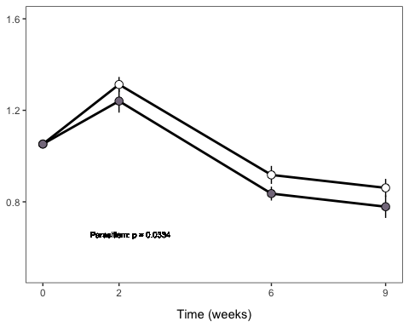

## Making one combined plot for figure 1

figure1 <- propinfovertimeplot + meaninfprevplot + infdensityovertimeplot + meaninfhostplot + (popdensitytimeseriesmetsch / popdensitytimeseriesnometsch) + meandensityplot + (metschresevolplotmetsch / metschresevolplotnometsch) + metschresevolplotgrouped +  
 plot_layout(ncol = 2) +   
 plot_annotation(tag_levels = list(c('a', 'b', 'c', 'd', 'e', ' ', 'f', 'g', ' ', 'h')))   
  
figure1

## Warning: Removed 1 rows containing non-finite values (stat_summary).  
## Removed 1 rows containing non-finite values (stat_summary).  
## Removed 1 rows containing non-finite values (stat_summary).

## Warning: Removed 2 rows containing non-finite values (stat_summary).  
## Removed 2 rows containing non-finite values (stat_summary).  
## Removed 2 rows containing non-finite values (stat_summary).  
## Removed 2 rows containing non-finite values (stat_summary).  
## Removed 2 rows containing non-finite values (stat_summary).  
## Removed 2 rows containing non-finite values (stat_summary).

## Warning: Removed 4 rows containing non-finite values (stat_summary).  
## Removed 4 rows containing non-finite values (stat_summary).  
## Removed 4 rows containing non-finite values (stat_summary).

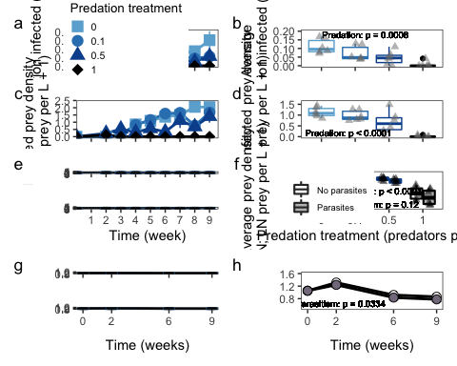

ggsave(here("figures", "figure1.jpg"), figure1, units = "in", width = 7, height = 11, dpi = 300)

## Warning: Removed 1 rows containing non-finite values (stat_summary).

## Warning: Removed 1 rows containing non-finite values (stat_summary).  
## Removed 1 rows containing non-finite values (stat_summary).

## Warning: Removed 2 rows containing non-finite values (stat_summary).  
## Removed 2 rows containing non-finite values (stat_summary).  
## Removed 2 rows containing non-finite values (stat_summary).  
## Removed 2 rows containing non-finite values (stat_summary).  
## Removed 2 rows containing non-finite values (stat_summary).  
## Removed 2 rows containing non-finite values (stat_summary).

## Warning: Removed 4 rows containing non-finite values (stat_summary).  
## Removed 4 rows containing non-finite values (stat_summary).  
## Removed 4 rows containing non-finite values (stat_summary).

# Note: I added a few of the labels in photoshop because I couldn't get it to look nice in R

# Analyses and figures related to Figure 3: chlorophyll and egg ratio

## Chlorophyll plot

chlorodata<-readr::read_csv(here("data/indychlorono22.csv"))

## Rows: 342 Columns: 10  
## ── Column specification ────────────────────────────────────────────────────────  
## Delimiter: ","  
## chr (4): treatment, day, date, metsch  
## dbl (6): time, tank, chlorophyll, chaoborus, chloroln, chlorolog  
##   
## ℹ Use `spec()` to retrieve the full column specification for this data.  
## ℹ Specify the column types or set `show_col_types = FALSE` to quiet this message.

chlorodata$chaoborus<-as.factor(chlorodata$chaoborus)  
chlorodata$time<- chlorodata$time+1  
chlorodata$time<-as.factor(chlorodata$time)  
summary(chlorodata)

## time tank treatment day   
## 2 :47 Min. : 1.00 Length:342 Length:342   
## 8 :44 1st Qu.:14.00 Class :character Class :character   
## 7 :43 Median :27.50 Mode :character Mode :character   
## 3 :42 Mean :26.67   
## 5 :42 3rd Qu.:40.00   
## 9 :42 Max. :52.00   
## (Other):82   
## date chlorophyll metsch chaoborus  
## Length:342 Min. : 0.350 Length:342 0 :96   
## Class :character 1st Qu.: 2.183 Class :character 0.1:87   
## Mode :character Median : 4.425 Mode :character 0.5:96   
## Mean : 6.815 1 :63   
## 3rd Qu.: 7.893   
## Max. :62.130   
##   
## chloroln chlorolog   
## Min. :-1.0498 Min. :-0.4559   
## 1st Qu.: 0.7805 1st Qu.: 0.3390   
## Median : 1.4872 Median : 0.6459   
## Mean : 1.4479 Mean : 0.6288   
## 3rd Qu.: 2.0659 3rd Qu.: 0.8972   
## Max. : 4.1292 Max. : 1.7933   
##

chlorodata$metsch <- factor(chlorodata$metsch, levels = c("metsch", "no metsch"),  
 labels = c("Parasites", "No parasites"))  
  
  
chlorodata$metsch <- factor(chlorodata$metsch, c("No parasites", "Parasites"))  
  
#Subset data  
chlorodatametsch <- chlorodata %>%  
 filter(metsch == "Parasites")  
  
chlorodatanometsch <- chlorodata %>%  
 filter(metsch == "No parasites")

chloroplotnometsch <- ggplot(chlorodatanometsch,aes(time,y=chloroln,group=chaoborus,color=chaoborus,shape=chaoborus)) +  
 stat_summary(fun="mean",geom="line",size=1,show.legend=FALSE) +  
 stat_summary(fun.data = "mean_cl_boot",show.legend=FALSE) +  
 stat_summary(fun="mean",geom="point",size=2,aes(shape=chaoborus)) +  
 scale_shape_manual(values=c(15,16,17,18)) +  
 labs(color="Pred. dens.", shape = "Pred. dens.") +  
 labs(y="LN chlorophyll \n(ug/L)") +  
 scale_colour_manual(values=c("#6baed6", "#3182bd", "#08519c","black")) +  
 theme_bw()+theme(panel.grid = element_blank()) +  
 theme(axis.title.y = element_text(margin = margin(t = 0, r = 10, b = 0, l = 0))) +  
 theme(axis.title.x=element_text(margin=margin(t=10,r=0,b=0,l=0))) +  
 theme(legend.position = "none") +  
 theme(axis.text.x=element_blank(),  
 axis.title.x=element_blank()) +  
 theme(axis.title.y=element_blank())   
  
chloroplotnometsch

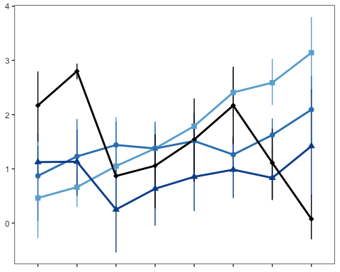

chloroplotmetsch <- ggplot(chlorodatametsch,aes(time,y=chloroln,group=chaoborus,color=chaoborus,shape=chaoborus)) +  
 stat_summary(fun="mean",geom="line",size=1,show.legend=FALSE) +  
 stat_summary(fun.data = "mean_cl_boot",show.legend=FALSE) +  
 stat_summary(fun="mean",geom="point",size=2,aes(shape=chaoborus)) +  
 scale_shape_manual(values=c(15,16,17,18)) +  
 labs(color="Pred. dens.", shape = "Pred. dens.") +  
 labs(y="LN chlorophyll \n(ug/L)") +  
 scale_colour_manual(values=c("#6baed6", "#3182bd", "#08519c","black")) +  
 theme_bw()+theme(panel.grid = element_blank()) +  
 theme(axis.title.y = element_text(margin = margin(t = 0, r = 10, b = 0, l = 0))) +  
 theme(axis.title.x=element_text(margin=margin(t=10,r=0,b=0,l=0))) +  
 theme(legend.position = "none") +  
 theme(axis.text.x=element_blank(),  
 axis.title.x=element_blank()) +  
 theme(axis.title.y=element_blank())   
  
chloroplotmetsch

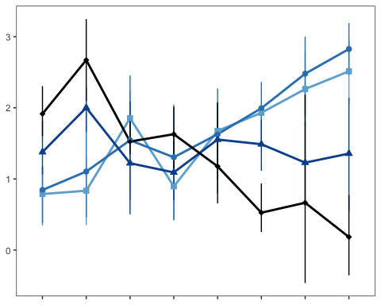

## Chlorophyll analysis

#chlorophyll did very different things in first and second halves of the experiment  
  
chlasummaryfirsthalf <- chlorodata %>%  
 filter(time == 2 | time == 3 | time == 4 | time == 5) %>%  
 group_by(chaoborus, metsch, tank) %>%  
 summarise(meanchla = mean(chlorophyll),meanlnchla = mean(chloroln))

## `summarise()` has grouped output by 'chaoborus', 'metsch'. You can override  
## using the `.groups` argument.

chlaov1 <- aov(meanchla~chaoborus*metsch,data=chlasummaryfirsthalf)  
summary(chlaov1)

## Df Sum Sq Mean Sq F value Pr(>F)   
## chaoborus 3 200.4 66.79 7.850 0.000323 ***  
## metsch 1 0.2 0.16 0.019 0.891683   
## chaoborus:metsch 3 57.5 19.16 2.252 0.097576 .   
## Residuals 39 331.8 8.51   
## ---  
## Signif. codes: 0 '***' 0.001 '**' 0.01 '*' 0.05 '.' 0.1 ' ' 1

overdisp_fun(chlaov1)

## chisq ratio rdf p   
## 3.318114e+02 8.507984e+00 3.900000e+01 4.203723e-48

# super overdispersed  
  
chlaov1b <- aov(meanlnchla~chaoborus*metsch,data=chlasummaryfirsthalf)  
summary(chlaov1b)

## Df Sum Sq Mean Sq F value Pr(>F)   
## chaoborus 3 6.337 2.1123 7.323 0.000522 ***  
## metsch 1 0.254 0.2539 0.880 0.353901   
## chaoborus:metsch 3 1.267 0.4224 1.465 0.239094   
## Residuals 39 11.249 0.2884   
## ---  
## Signif. codes: 0 '***' 0.001 '**' 0.01 '*' 0.05 '.' 0.1 ' ' 1

overdisp_fun(chlaov1b)

## chisq ratio rdf p   
## 11.2487636 0.2884298 39.0000000 0.9999961

# not overdispersed

## Plot of average chlorophyll

firsthalfchlsummaryplot <- ggplot(chlaov1b,aes(x=chaoborus,y=meanlnchla, color=chaoborus, fill = metsch)) +  
 geom_boxplot(lwd=0.75) +  
 geom_point(pch=17, position=position_jitterdodge(jitter.width = 0.2), alpha = 0.5, size = 2, color = 'black',show.legend=FALSE) +  
 geom_text(data=chlaov1b,x=1.75, y=2.5,label ="Predation: p = 0.0005\nParasitism: p = 0.35\nPred*Para: p = 0.24", color="black",size = 2.5) +  
 labs(x="Predator density (per L)",y="Average LN chlorophyll \nweeks 2-5 (ug/L)") +  
 labs(color = "Predator density \n(per L)", fill = "Parasite treatment") +  
 scale_color_manual(values=c("#6baed6", "#3182bd", "#08519c","black"), guide="none") +  
 scale_fill_manual(values=c('white','gray')) +  
 theme_bw() +   
 theme(panel.grid=element_blank()) +  
 theme(legend.position = "none") +  
 theme(axis.text.x=element_blank(),  
 axis.title.x=element_blank())  
  
firsthalfchlsummaryplot

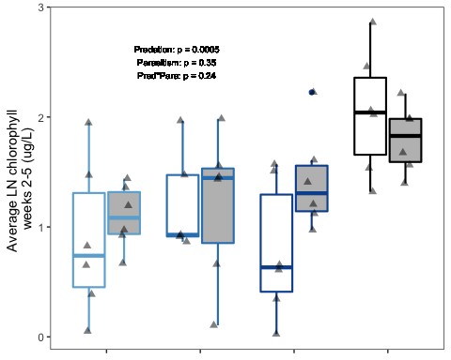

## Egg ratio plot

# Note added June 23 2022: discovered that the original eggdata.csv file was missing some data -- some data sheets didn't get entered (seems like they didn't get digitized and then data was entered from digitized data); recalculating averages from raw data; everything got thoroughly checked against raw data sheets in June 2022  
raweggs<-readr::read_csv(here("data/raweggdata_6_22_22.csv"))

## Rows: 4495 Columns: 12  
## ── Column specification ────────────────────────────────────────────────────────  
## Delimiter: ","  
## chr (6): day, date, metsch, size, infection, chaoborus_notes  
## dbl (6): time, tank, chaoborus, daphnia, serial, eggs  
##   
## ℹ Use `spec()` to retrieve the full column specification for this data.  
## ℹ Specify the column types or set `show_col_types = FALSE` to quiet this message.

raweggsummary <- raweggs %>%  
 group_by(tank, time) %>%  
 summarise(meaneggs = mean(eggs), n=n())

## `summarise()` has grouped output by 'tank'. You can override using the  
## `.groups` argument.

# Kludge-y workaround -- exporting to add treatments, then will reimport with treatments added to data sheet  
# readr::write_csv(raweggsummary, here("data/raweggsummary.csv"))  
  
# now import summary data  
eggs<-readr::read_csv(here("data/raweggsummary.csv"), na='.')

## Rows: 384 Columns: 6  
## ── Column specification ────────────────────────────────────────────────────────  
## Delimiter: ","  
## chr (1): para  
## dbl (5): tank, time, meaneggs, n, pred  
##   
## ℹ Use `spec()` to retrieve the full column specification for this data.  
## ℹ Specify the column types or set `show_col_types = FALSE` to quiet this message.

eggs$pred<-as.factor(eggs$pred)  
  
# remove tank 22  
eggs <- eggs %>%  
 filter(tank != "22")  
  
#Fix issue with weeks, so that they line up with this timeline:  
#week 0 = Daphnia added  
#week 1 = spores added  
#weeks 2-9 = sampling  
eggs$time <- eggs$time + 1  
  
eggs$time<-as.factor(eggs$time)  
  
summary(eggs)

## tank time meaneggs n pred   
## Min. : 1.00 2 :47 Min. :0.000 Min. : 0.00 0 :96   
## 1st Qu.:12.00 3 :47 1st Qu.:0.400 1st Qu.: 4.00 0.1:88   
## Median :27.00 4 :47 Median :0.800 Median :12.00 0.5:96   
## Mean :26.34 5 :47 Mean :1.091 Mean :11.55 1 :96   
## 3rd Qu.:41.00 6 :47 3rd Qu.:1.371 3rd Qu.:20.00   
## Max. :52.00 7 :47 Max. :9.000 Max. :32.00   
## (Other):94 NA's :49   
## para   
## Length:376   
## Class :character   
## Mode :character   
##   
##   
##   
##

#Subset data  
eggsmetsch <- eggs %>%  
 filter(para == "metsch")  
  
eggsnometsch <- eggs %>%  
 filter(para == "no metsch")

eggplotmetsch <- ggplot(eggsmetsch,aes(time,y=meaneggs,group=pred,color=pred,shape=pred)) +   
 stat_summary(fun="mean",geom="line",size=1,show.legend=FALSE) +  
 stat_summary(fun.data = "mean_cl_boot",show.legend=FALSE) +   
 stat_summary(fun="mean",geom="point",size=2,aes(shape=pred)) +   
 scale_shape_manual(values=c(15,16,17,18)) +   
 labs(color="Pred.", shape = "Pred.") +   
 scale_colour_manual(values=c("#6baed6", "#3182bd", "#08519c","black")) +   
 theme_bw()+theme(panel.grid = element_blank()) +   
 labs(y="Egg ratio \n(embryos per uninfected adult)") +   
 scale_y_continuous(limits = c(0, 10), breaks = seq(0, 10, by = 5)) +  
 theme(axis.title.y = element_text(margin = margin(t = 0, r = 10, b = 0, l = 0))) +   
 theme(legend.position = c(0.85, 0.64)) +  
 theme(legend.key.size = unit(0.05, 'cm'), legend.title = element_text(size=7), #change legend title font size  
 legend.text = element_text(size=6)) +  
 theme(axis.text.x=element_blank(),  
 axis.title.x=element_blank()) +  
 theme(axis.title.y=element_blank())   
  
eggplotmetsch

## Warning: Removed 32 rows containing non-finite values (stat_summary).  
## Removed 32 rows containing non-finite values (stat_summary).  
## Removed 32 rows containing non-finite values (stat_summary).

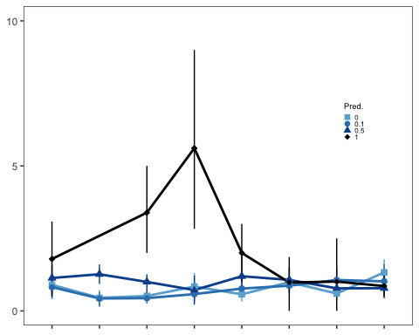

eggplotnometsch <- ggplot(eggsnometsch,aes(time,y=meaneggs,group=pred,color=pred,shape=pred)) +   
 stat_summary(fun="mean",geom="line",size=1,show.legend=FALSE) +  
 stat_summary(fun.data = "mean_cl_boot",show.legend=FALSE) +   
 stat_summary(fun="mean",geom="point",size=2,aes(shape=pred)) +   
 scale_shape_manual(values=c(15,16,17,18)) +   
 labs(color="Pred.", shape = "Pred.") +   
 scale_y_continuous(limits = c(0, 10), breaks = seq(0, 10, by = 5)) +  
 scale_colour_manual(values=c("#6baed6", "#3182bd", "#08519c","black")) +   
 theme_bw()+theme(panel.grid = element_blank()) +   
 labs(x="Time (weeks)") +   
 labs(y="Egg ratio \n(embryos per uninfected adult)") +   
 theme(axis.title.y = element_text(margin = margin(t = 0, r = 10, b = 0, l = 0))) +   
 theme(legend.position = "none") +  
 theme(axis.title.y=element_blank())   
  
eggplotnometsch

## Warning: Removed 17 rows containing non-finite values (stat_summary).

## Warning: Removed 17 rows containing non-finite values (stat_summary).  
## Removed 17 rows containing non-finite values (stat_summary).

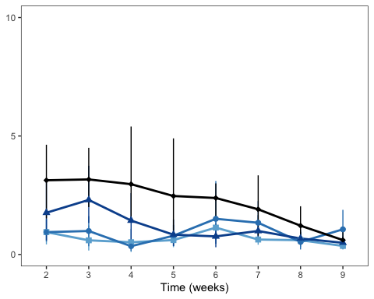

## Egg ratio analysis

eggsummary <- eggs %>%  
 drop_na() %>%  
 group_by(pred, para, tank) %>%  
 summarise(meaneggs = mean(meaneggs))

## `summarise()` has grouped output by 'pred', 'para'. You can override using the  
## `.groups` argument.

eggaov1 <- aov(meaneggs~pred*para,data=eggsummary)  
summary(eggaov1)

## Df Sum Sq Mean Sq F value Pr(>F)   
## pred 3 18.287 6.096 20.439 4.02e-08 ***  
## para 1 0.066 0.066 0.220 0.642   
## pred:para 3 0.178 0.059 0.199 0.897   
## Residuals 39 11.631 0.298   
## ---  
## Signif. codes: 0 '***' 0.001 '**' 0.01 '*' 0.05 '.' 0.1 ' ' 1

overdisp_fun(eggaov1)

## chisq ratio rdf p   
## 11.6314385 0.2982420 39.0000000 0.9999938

# not overdispersed  
  
  
eggsummary25 <- eggs %>%  
 filter(time == 2 | time == 3 | time == 4 | time == 5) %>%   
 drop_na() %>%  
 group_by(pred, para, tank) %>%  
 summarise(meaneggs = mean(meaneggs))

## `summarise()` has grouped output by 'pred', 'para'. You can override using the  
## `.groups` argument.

eggaov25 <- aov(meaneggs~pred*para,data=eggsummary25)  
summary(eggaov25)

## Df Sum Sq Mean Sq F value Pr(>F)   
## pred 3 52.01 17.338 18.500 1.27e-07 ***  
## para 1 0.49 0.495 0.528 0.472   
## pred:para 3 0.55 0.184 0.196 0.898   
## Residuals 39 36.55 0.937   
## ---  
## Signif. codes: 0 '***' 0.001 '**' 0.01 '*' 0.05 '.' 0.1 ' ' 1

## Average egg ratio plot, weeks 2-5

eggsummaryplot25 <- ggplot(eggaov25,aes(x=pred,y=meaneggs, color=pred, fill = para)) +  
 geom_boxplot(lwd=0.75) +  
 geom_point(pch=17, position=position_jitterdodge(jitter.width = 0.2), alpha = 0.5, size = 2, color = 'black',show.legend=FALSE) +  
 geom_text(data=eggaov25,x=1.5, y=4.45,label ="Predation: p < 0.0001\nParasitism: p = 0.47\nPred*Para: p = 0.90", color="black",size = 2.5) +  
 labs(x="Predator density (per L)", y="Average egg ratio weeks 2-5 \n(embryos per adult)") +  
 labs(color = "Predator density \n(per L)", fill = "Parasite treat.") +  
 scale_color_manual(values=c("#6baed6", "#3182bd", "#08519c","black"), guide="none") +  
 scale_fill_manual(values=c('white','gray')) +  
 theme_bw() +   
 theme(panel.grid=element_blank()) +  
 theme(legend.position = "none")   
  
  
eggsummaryplot25

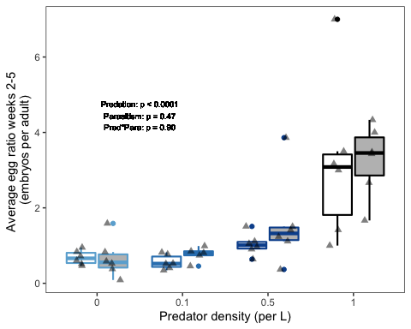

## Combining into figure 3

figure3panela <- (chloroplotmetsch / chloroplotnometsch)   
figure3panelc <- (eggplotmetsch / eggplotnometsch)  
  
  
figure3 <- (figure3panela | firsthalfchlsummaryplot) /  
 (figure3panelc | eggsummaryplot25) +  
 plot_layout(ncol = 1) +   
 plot_annotation(tag_levels = list(c('a', ' ', 'b', 'c', '', 'd')))   
  
figure3

## Warning: Removed 32 rows containing non-finite values (stat_summary).  
## Removed 32 rows containing non-finite values (stat_summary).  
## Removed 32 rows containing non-finite values (stat_summary).

## Warning: Removed 17 rows containing non-finite values (stat_summary).  
## Removed 17 rows containing non-finite values (stat_summary).  
## Removed 17 rows containing non-finite values (stat_summary).

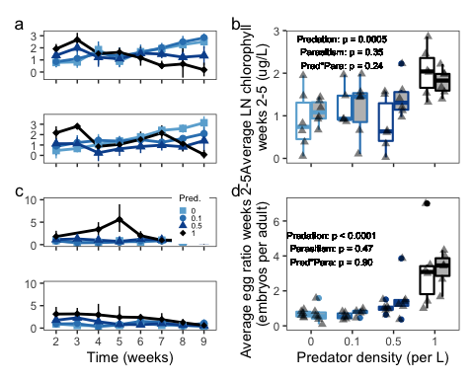

ggsave(here("figures", "figure3.jpg"), figure3, units = "in", width = 7, height = 6, dpi = 300)

## Warning: Removed 32 rows containing non-finite values (stat_summary).

## Warning: Removed 32 rows containing non-finite values (stat_summary).  
## Removed 32 rows containing non-finite values (stat_summary).

## Warning: Removed 17 rows containing non-finite values (stat_summary).  
## Removed 17 rows containing non-finite values (stat_summary).  
## Removed 17 rows containing non-finite values (stat_summary).

# Note: I added a few of the labels in photoshop because I couldn't get it to look nice in R

eggratiosamplesizes <- eggs %>%  
 group_by(pred, para, time) %>%  
 summarise(meanhosts = mean(n))

## `summarise()` has grouped output by 'pred', 'para'. You can override using the  
## `.groups` argument.

eggratiosamplesizes2 <- eggratiosamplesizes %>%   
 group_by(pred, para, time) %>%  
 summarise(meanhosts = mean(meanhosts))

## `summarise()` has grouped output by 'pred', 'para'. You can override using the  
## `.groups` argument.

eggratiosamplesizeshighpred <- eggratiosamplesizes %>%   
 filter(pred == 1) %>%  
 group_by(para, time) %>%  
 summarise(meanhosts = mean(meanhosts))

## `summarise()` has grouped output by 'para'. You can override using the  
## `.groups` argument.

# Supplement figure: Evolutionary analyses

## Correlations between traits

traitdata<-readr::read_csv(here("data/traits2.csv"))

## Rows: 9 Columns: 3  
## ── Column specification ────────────────────────────────────────────────────────  
## Delimiter: ","  
## chr (1): clone  
## dbl (2): pred.susc, inf.susc  
##   
## ℹ Use `spec()` to retrieve the full column specification for this data.  
## ℹ Specify the column types or set `show_col_types = FALSE` to quiet this message.

str(traitdata)

## spec_tbl_df [9 × 3] (S3: spec_tbl_df/tbl_df/tbl/data.frame)  
## $ clone : chr [1:9] "BD0542" "BD0846" "BD1964" "CB2468" ...  
## $ pred.susc: num [1:9] 0.0197 0.0134 0.0116 0.0062 0.0144 0.0082 0.0157 0.0096 0.016  
## $ inf.susc : num [1:9] 0.798 0.981 0 0.815 1.69 ...  
## - attr(*, "spec")=  
## .. cols(  
## .. clone = col_character(),  
## .. pred.susc = col_double(),  
## .. inf.susc = col_double()  
## .. )  
## - attr(*, "problems")=<externalptr>

traitsummary <- traitdata %>%  
 summarise(meaninf = mean(inf.susc))   
  
traitplot<-ggplot(traitdata, aes(x=inf.susc,y=pred.susc)) +  
 geom_point(shape=16, size=3, color='black') +  
 geom_smooth(method=lm,linetype='dashed', se=FALSE) +  
 theme_bw()+theme(panel.grid = element_blank()) +   
 labs(x=expression(paste("Infection rate, "*beta*", ("*"*10"^"-7"*")"))) +  
 labs(y=expression(paste("Pred. suscept., "*alpha*" ")))  
  
  
traitplot

## `geom_smooth()` using formula 'y ~ x'

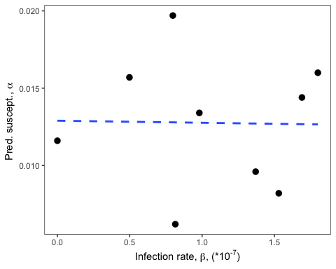

## Predation susceptibility

predresevolplot<-ggplot(evoldata2,aes(round,y=predationmean,group=pred,color=pred,shape=pred)) +   
 stat_summary(fun="mean",geom="line",size=1,show.legend=FALSE) +   
 stat_summary(fun.data = "mean_cl_boot",show.legend=FALSE) +  
 stat_summary(fun="mean",geom="point",size=4,aes(shape=pred)) +  
 scale_shape_manual(values=c(15,16,17,18)) +  
 labs(color="Pred. dens.", shape = "Pred. dens.") +  
 scale_colour_manual(values=c("#6baed6", "#3182bd", "#08519c","black")) +  
 theme_bw()+theme(panel.grid = element_blank()) +   
 labs(x="Time (weeks)")+  
 labs(y=expression(paste("Ave. pred. suscept., "*alpha*" "))) +  
 theme(axis.title.y = element_text(margin = margin(t = 0, r = 10, b = 0, l = 0))) +  
 theme(axis.title.x=element_text(margin=margin(t=10,r=0,b=0,l=0))) +  
 scale_x_continuous(breaks=c(0,2,6,9)) +  
 facet_grid(rows=vars(para)) +  
 theme(legend.position = "none")   
predresevolplot

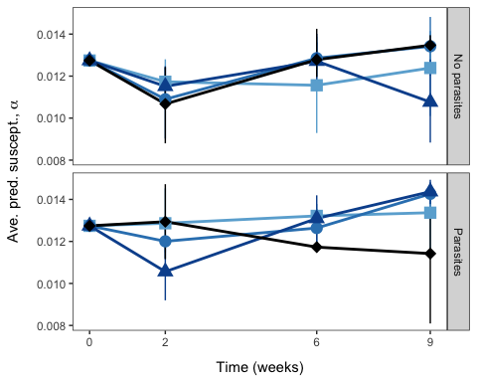

# ggsave(here("figures", "predresevolplot.jpg"), predresevolplot, units = "in", width = 6, height = 3.5, dpi = 300)

## Predation susceptibility analysis

predmod1<-lme(predationmean~pred+para+round+pred*para+pred*round+para*round+pred*para*round,random=~1|tank,data=evoldata3)  
summary(predmod1)

## Linear mixed-effects model fit by REML  
## Data: evoldata3   
## AIC BIC logLik  
## -980.9383 -932.3297 508.4692  
##   
## Random effects:  
## Formula: ~1 | tank  
## (Intercept) Residual  
## StdDev: 0.0008360058 0.001647428  
##   
## Fixed effects: predationmean ~ pred + para + round + pred * para + pred * round + para * round + pred * para * round   
## Value Std.Error DF t-value p-value  
## (Intercept) 0.011404768 0.0009252652 71 12.325945 0.0000  
## pred0.1 -0.001096170 0.0013723901 39 -0.798731 0.4293  
## pred0.5 0.000740137 0.0013085226 39 0.565628 0.5749  
## pred1 -0.001458845 0.0013208288 39 -1.104492 0.2761  
## paraParasites 0.001382357 0.0013617940 39 1.015100 0.3163  
## round 0.000086321 0.0001354178 71 0.637442 0.5259  
## pred0.1:paraParasites -0.000521197 0.0019382407 39 -0.268902 0.7894  
## pred0.5:paraParasites -0.003962706 0.0018885747 39 -2.098252 0.0424  
## pred1:paraParasites 0.001898721 0.0020363778 39 0.932401 0.3569  
## pred0.1:round 0.000280922 0.0002008570 71 1.398618 0.1663  
## pred0.5:round -0.000171290 0.0001915096 71 -0.894419 0.3741  
## pred1:round 0.000311580 0.0001970537 71 1.581192 0.1183  
## paraParasites:round -0.000019845 0.0001973576 71 -0.100552 0.9202  
## pred0.1:paraParasites:round -0.000026949 0.0002848391 71 -0.094610 0.9249  
## pred0.5:paraParasites:round 0.000653746 0.0002750017 71 2.377243 0.0201  
## pred1:paraParasites:round -0.000561101 0.0003113912 71 -1.801916 0.0758  
## Correlation:   
## (Intr) prd0.1 prd0.5 pred1 prPrst round pr0.1:P  
## pred0.1 -0.674   
## pred0.5 -0.707 0.477   
## pred1 -0.701 0.472 0.495   
## paraParasites -0.679 0.458 0.480 0.476   
## round -0.829 0.559 0.586 0.581 0.563   
## pred0.1:paraParasites 0.477 -0.708 -0.338 -0.334 -0.703 -0.396   
## pred0.5:paraParasites 0.490 -0.330 -0.693 -0.343 -0.721 -0.406 0.507   
## pred1:paraParasites 0.454 -0.306 -0.321 -0.649 -0.669 -0.377 0.470   
## pred0.1:round 0.559 -0.829 -0.395 -0.392 -0.380 -0.674 0.587   
## pred0.5:round 0.586 -0.395 -0.829 -0.411 -0.398 -0.707 0.280   
## pred1:round 0.570 -0.384 -0.403 -0.814 -0.387 -0.687 0.272   
## paraParasites:round 0.569 -0.384 -0.402 -0.399 -0.840 -0.686 0.590   
## pred0.1:paraParasites:round -0.394 0.585 0.279 0.276 0.582 0.475 -0.834   
## pred0.5:paraParasites:round -0.408 0.275 0.578 0.286 0.603 0.492 -0.424   
## pred1:paraParasites:round -0.361 0.243 0.255 0.515 0.533 0.435 -0.374   
## pr0.5:P prd1:P pr0.1: pr0.5: prd1:r prPrs: p0.1:P:  
## pred0.1   
## pred0.5   
## pred1   
## paraParasites   
## round   
## pred0.1:paraParasites   
## pred0.5:paraParasites   
## pred1:paraParasites 0.482   
## pred0.1:round 0.274 0.254   
## pred0.5:round 0.575 0.266 0.477   
## pred1:round 0.279 0.528 0.463 0.486   
## paraParasites:round 0.606 0.562 0.463 0.485 0.472   
## pred0.1:paraParasites:round -0.420 -0.389 -0.705 -0.336 -0.327 -0.693   
## pred0.5:paraParasites:round -0.835 -0.403 -0.332 -0.696 -0.338 -0.718 0.497   
## pred1:paraParasites:round -0.384 -0.827 -0.293 -0.308 -0.633 -0.634 0.439   
## p0.5:P:  
## pred0.1   
## pred0.5   
## pred1   
## paraParasites   
## round   
## pred0.1:paraParasites   
## pred0.5:paraParasites   
## pred1:paraParasites   
## pred0.1:round   
## pred0.5:round   
## pred1:round   
## paraParasites:round   
## pred0.1:paraParasites:round   
## pred0.5:paraParasites:round   
## pred1:paraParasites:round 0.455   
##   
## Standardized Within-Group Residuals:  
## Min Q1 Med Q3 Max   
## -2.31196253 -0.59891458 0.04302921 0.57167882 1.71803152   
##   
## Number of Observations: 126  
## Number of Groups: 47

anova(predmod1)

## numDF denDF F-value p-value  
## (Intercept) 1 71 4138.600 <.0001  
## pred 3 39 0.446 0.7217  
## para 1 39 4.461 0.0411  
## round 1 71 17.060 0.0001  
## pred:para 3 39 0.283 0.8373  
## pred:round 3 71 1.192 0.3192  
## para:round 1 71 0.340 0.5616  
## pred:para:round 3 71 5.499 0.0019

lsmeans(predmod1,pairwise~round,adjust="tukey")

## NOTE: Results may be misleading due to involvement in interactions

## $lsmeans  
## round lsmean SE df lower.CL upper.CL  
## 5.6 0.0124 0.000196 39 0.012 0.0128  
##   
## Results are averaged over the levels of: pred, para   
## Degrees-of-freedom method: containment   
## Confidence level used: 0.95   
##   
## $contrasts  
## contrast estimate SE df z.ratio p.value  
## (nothing) nonEst NA NA NA NA  
##   
## Results are averaged over the levels of: pred, para   
## Degrees-of-freedom method: containment

lsmeans(predmod1,pairwise~pred,adjust="tukey")

## NOTE: Results may be misleading due to involvement in interactions

## $lsmeans  
## pred lsmean SE df lower.CL upper.CL  
## 0 0.0125 0.000370 39 0.0118 0.0133  
## 0.1 0.0127 0.000387 39 0.0119 0.0134  
## 0.5 0.0122 0.000366 39 0.0114 0.0129  
## 1 0.0122 0.000439 39 0.0113 0.0131  
##   
## Results are averaged over the levels of: para   
## Degrees-of-freedom method: containment   
## Confidence level used: 0.95   
##   
## $contrasts  
## contrast estimate SE df t.ratio p.value  
## 0 - 0.1 -1.42e-04 0.000535 39 -0.265 0.9934  
## 0 - 0.5 3.69e-04 0.000520 39 0.711 0.8923  
## 0 - 1 3.36e-04 0.000574 39 0.585 0.9360  
## 0.1 - 0.5 5.11e-04 0.000532 39 0.960 0.7724  
## 0.1 - 1 4.77e-04 0.000585 39 0.816 0.8465  
## 0.5 - 1 -3.38e-05 0.000571 39 -0.059 0.9999  
##   
## Results are averaged over the levels of: para   
## Degrees-of-freedom method: containment   
## P value adjustment: tukey method for comparing a family of 4 estimates

lsmeans(predmod1,pairwise~para,adjust="tukey")

## NOTE: Results may be misleading due to involvement in interactions

## $lsmeans  
## para lsmean SE df lower.CL upper.CL  
## No parasites 0.0120 0.000271 39 0.0115 0.0126  
## Parasites 0.0127 0.000282 39 0.0122 0.0133  
##   
## Results are averaged over the levels of: pred   
## Degrees-of-freedom method: containment   
## Confidence level used: 0.95   
##   
## $contrasts  
## contrast estimate SE df t.ratio p.value  
## No parasites - Parasites -0.000717 0.000391 39 -1.832 0.0746  
##   
## Results are averaged over the levels of: pred   
## Degrees-of-freedom method: containment

## Plotting susceptibility to predation over time all on one panel

predresevolplottogether<-ggplot(evoldata2,aes(round,y=predationmean,group=para,color=para,shape=para)) +   
 stat_summary(fun="mean",geom="line",size=1,show.legend=FALSE) +  
 stat_summary(fun.data = "mean_cl_boot",show.legend=FALSE) +  
 stat_summary(fun="mean",geom="point",size=3,shape=21,aes(fill=para)) +  
 labs(color="Parasitism", fill="Parasitism") +  
 scale_colour_manual(values=c("black","black")) +  
 scale_fill_manual(values=c("white", "#857A8C")) +  
 theme_bw() +  
 theme(panel.grid = element_blank()) +  
 labs(x="Time (weeks)") +  
 labs(y=expression(paste("Ave. pred. suscept., "*alpha*" "))) +  
 theme(axis.title.y = element_text(margin = margin(t = 0, r = 10, b = 0, l = 0))) +  
 scale_x_continuous(breaks=c(0,2,6,9)) +  
 theme(axis.title.x=element_text(margin=margin(t=10,r=0,b=0,l=0))) +  
 theme(legend.position = c(0.3, 0.8)) +  
 theme(legend.key.size = unit(0.05, 'cm'), legend.title = element_blank(),  
 legend.text = element_text(size=8))   
predresevolplottogether

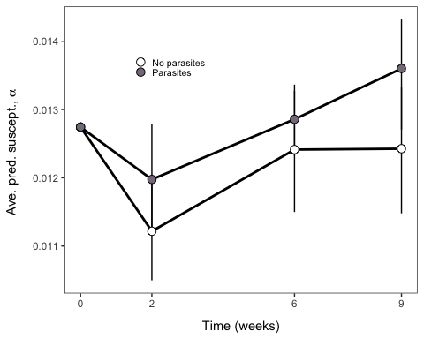

## Combining to make supplement figure S1

evolutionplot <- traitplot + predresevolplot + predresevolplottogether +  
 plot_layout(ncol = 1) +   
 plot_annotation(tag_levels = 'a')   
evolutionplot

## `geom_smooth()` using formula 'y ~ x'

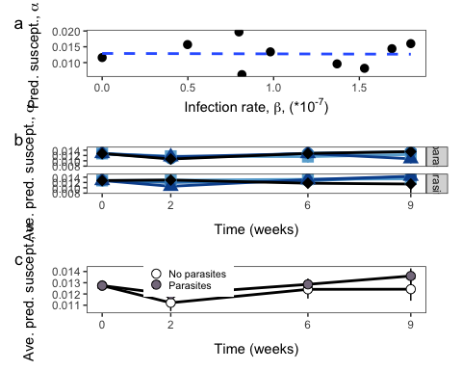

ggsave(here("figures", "evolutionplot.jpg"), evolutionplot, units = "in", width = 3, height = 7, dpi = 300)

## `geom_smooth()` using formula 'y ~ x'

# Stage structure – this is Figure S2

stagetimeplot <- ggplot(indianadata, aes(x = time, y = (propadults), color = chaoborusfactor, group = chaoborusfactor, shape = chaoborusfactor)) +   
 stat_summary(fun = "mean", geom="line", aes(group = chaoborusfactor)) +   
 stat_summary(fun.data="mean_se") +  
 stat_summary(fun="mean",geom="point",size=4,aes(shape=chaoborusfactor),show.legend=FALSE) +  
 facet_grid(rows=vars(metsch)) +  
 labs(x="Time (week)",y="Proportion adults") +   
 scale_x_discrete(limits=c("1", "2","3","4","5","6","7","8","9")) +   
 scale_color_manual(values=c("#6baed6", "#3182bd", "#08519c","black")) +  
 scale_shape_manual(values=c(15,16,17,18)) +  
 labs(color="Pred.", shape = "Pred.") +  
 theme_bw()+theme(panel.grid = element_blank()) +  
 theme(legend.position = c(0.07, 0.63)) +  
 theme(legend.key.size = unit(0.05, 'cm'), legend.title = element_text(size=10),   
 legend.text = element_text(size=8))   
  
stagetimeplot

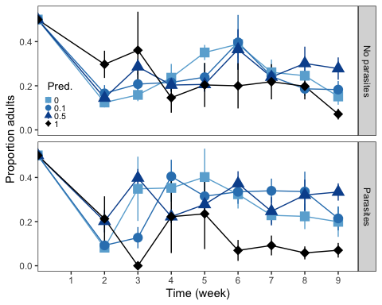

ggsave(here("figures", "SuppAgeStructure.jpg"), stagetimeplot, units = "in", width = 5, height = 4, dpi = 300)