Week 3 LLM Monitoring Experiment
-D. Mohit Venkat Sai
-2520030106

Aim
To build a provider based LLM client that sends prompts to AI models, measures each interaction, and stores the results in MongoDB.
Objectives
- Connect a Python program to hosted and local LLM providers.
- Generate responses using Gemini and Ollama.
- Record prompts, responses, token counts, and cost information.
- Verify that interactions from both providers are saved in MongoDB.
Software and Tools
- Python and Visual Studio Code
- Ollama with the llama3.2 model
- Gemini API with the gemini-3.8-flash model
- MongoDB Community Server and MongoDB Compass
- Python packages: google-genai, python-dotenv, pymongo, and requests
System Design
The program uses a common provider interface so the client can work with different LLM providers.
- OllamaProvider sends prompts to the local Ollama service.
- GeminiProvider sends prompts to the hosted Gemini API.
- LLMClient calls the selected provider and prepares interaction metrics.
- MongoLogger saves each interaction in MongoDB.
Procedure
- Installed Ollama and downloaded the llama3.2 model.
- Confirmed that the MongoDB service was running.
- Created the Week 3 Python project and installed the required packages in the virtual environment.
- Added the provider, client, cost calculation, and MongoDB logging code to the project.
- Ran the program and selected Ollama. Entered a prompt and received a response from llama3.2.
- Ran the program again and selected Gemini. Entered a prompt and received a response from gemini-3.8-flash.
- Opened MongoDB Compass and verified that both interactions were saved.
Results
Both provider runs completed successfully. MongoDB Compass showed two documents in the llm_calls collection: one for Ollama and one for Gemini.
Ollama Output
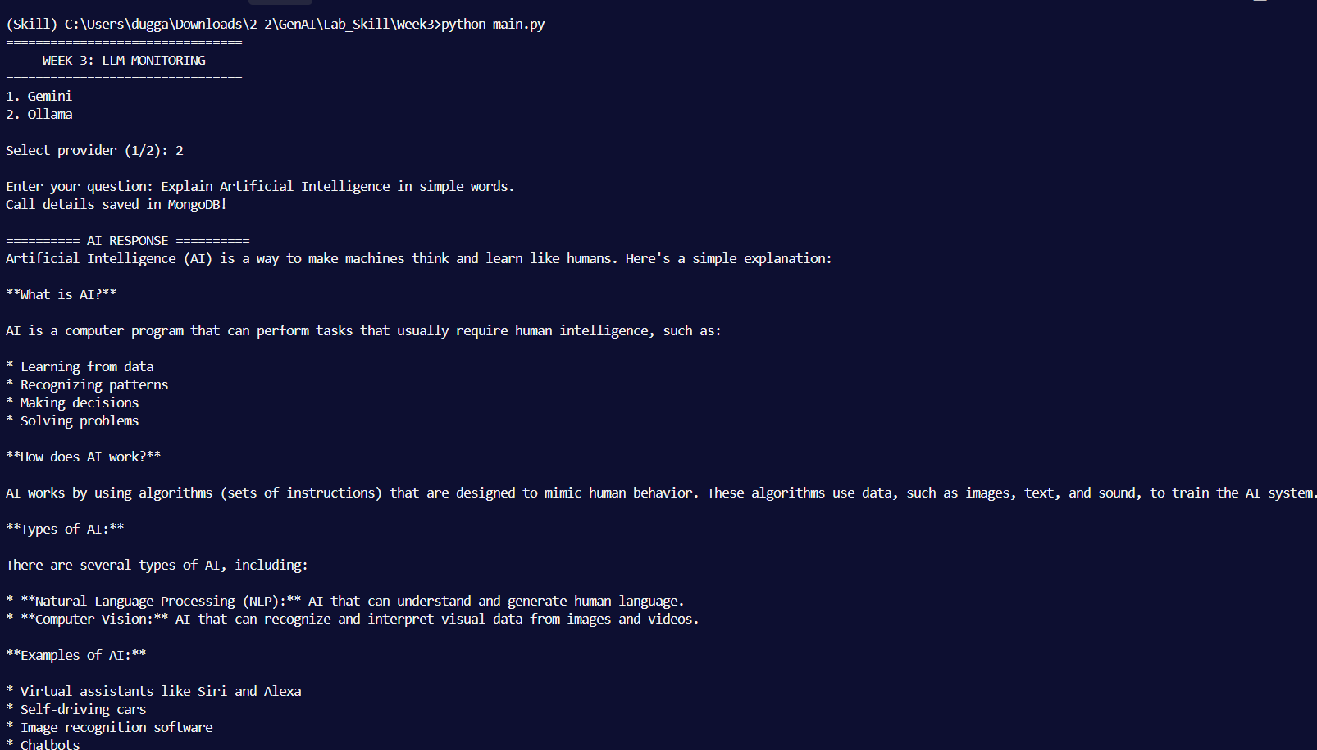
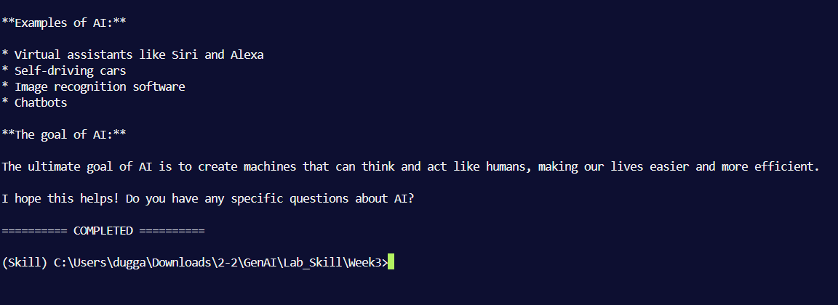

Gemini Output
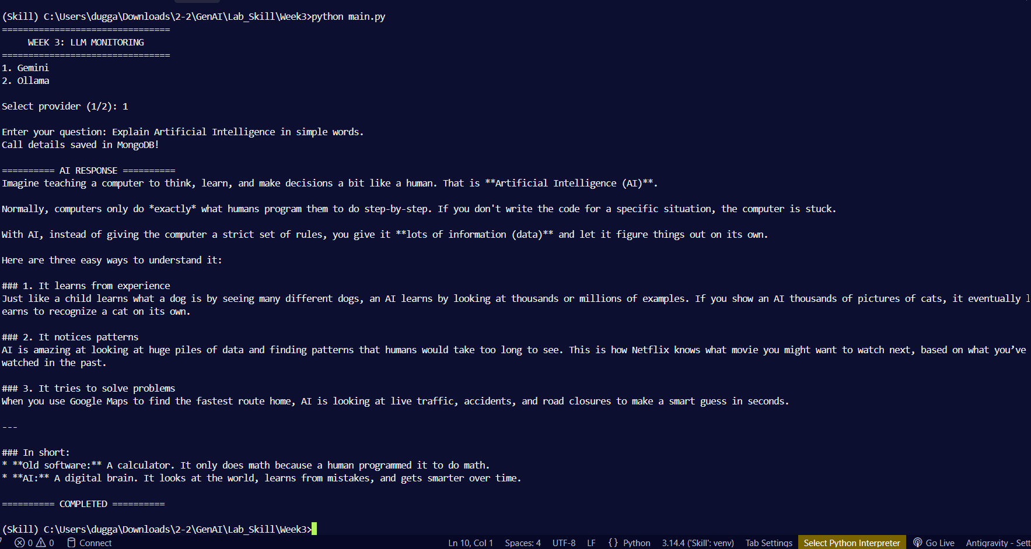

Provider | Model | Prompt | Result
Ollama | llama3.2 | “Explain AI” | Response generated and logged
Gemini | gemini-3.8-flash | “Explain AI” | Response generated and logged
The Ollama run reported 28 prompt tokens, 711 completion tokens, 739 total tokens, and a cost of $0.00. The Gemini document also contains token and cost fields; their values were not expanded in the Compass screenshot.
The records were saved in the MongoDB database genai_logs, collection llm_calls. Each record includes a timestamp, provider, model, prompt, response, token information, and cost information.
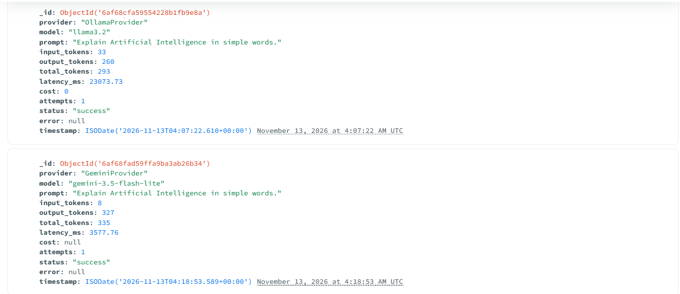
Conclusion
The experiment successfully demonstrated provider based LLM monitoring. The same program generated responses using both a local Ollama model and the hosted Gemini API, then saved both interactions in MongoDB. The Compass records confirm that the logging workflow works for both providers.

