Week 2 Provider Based LLM Client
-D. Mohit Venkat Sai
-2520030106

Aim
To build a provider based Python client that can send prompts to either a hosted Gemini model or a locally running Ollama model.
Objectives
- Define a common interface for different LLM providers.
- Generate a response using Ollama and the llama3.2 model.
- Configure Gemini as an alternative provider.
- Select a provider when the program runs.
Software and Requirements
- Visual Studio Code and Python
- A Python virtual environment
- Ollama with the llama3.2 model
- A Gemini API key for the Gemini option
- Python packages: python-dotenv, google-genai, and requests
System Design
The program separates provider-specific requests from the common client.
- LLMProvider defines the shared generate method.
- OllamaProvider sends prompts to the local Ollama service.
- LLMClient calls the selected provider through the shared interface.
This design allows the program to switch providers without changing how the client submits a prompt.
Procedure
- Installed Ollama and downloaded the llama3.2 model.
- Created a week-2 project folder in Visual Studio Code.
- Activated the project’s virtual environment.
- Installed the required packages:
python -m pip install -r requirements.txt
- Created llm_client.py with the shared provider interface, Gemini provider, Ollama provider, and common client.
- Created main.py to load the API key, ask the user to choose a provider, accept a prompt, and print the response.
- Added the Gemini key to .env for use with the Gemini option.
- Ran the program:
python main.py
- Selected ollama, entered a prompt, and received a response from the local model.
Provider Interface
The common interface lets both providers use the same method name:
from abc import ABC, abstractmethod

class LLMProvider(ABC):
@abstractmethod
def generate(self, prompt):
pass
The Ollama provider sends a request to the local Ollama service:
import requests

class OllamaProvider(LLMProvider):
def __init__(self, model="llama3.2"):
self.model = model
self.url = "http://localhost:11434/api/generate"

def generate(self, prompt):
response = requests.post(
self.url,
json={
"model": self.model,
"prompt": prompt,
"stream": False,
},
timeout=120,
)
response.raise_for_status()
return response.json()["response"]
The common client delegates prompt generation to the selected provider:
class LLMClient:
def __init__(self, provider):
self.provider = provider

def generate(self, prompt):
return self.provider.generate(prompt)
Result and Observation
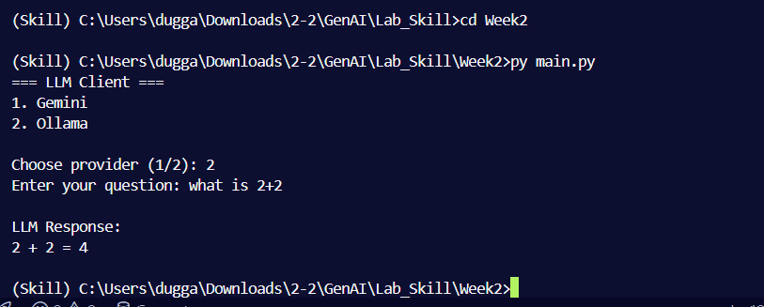
The program displayed a provider selection prompt. The Ollama option successfully generated a response using llama3.2.
The Gemini option was included in the program. The Week 2 run documented here verified Ollama; Gemini was tested separately during the Week 3 experiment.
Conclusion
The experiment successfully demonstrated a provider based LLM client. A shared interface allowed the same client to work with the local Ollama provider, while keeping provider-specific request handling inside each provider class. The Ollama response confirmed that the local model connection was working.

