Database Systems Engineering and Distributed Backend Development(25CS1302E)
Roll No: 2520030106
Name: D. Mohit Venkat Sai
PRACTICAL WEEK – 2

1.Connect to the MySQL Server:
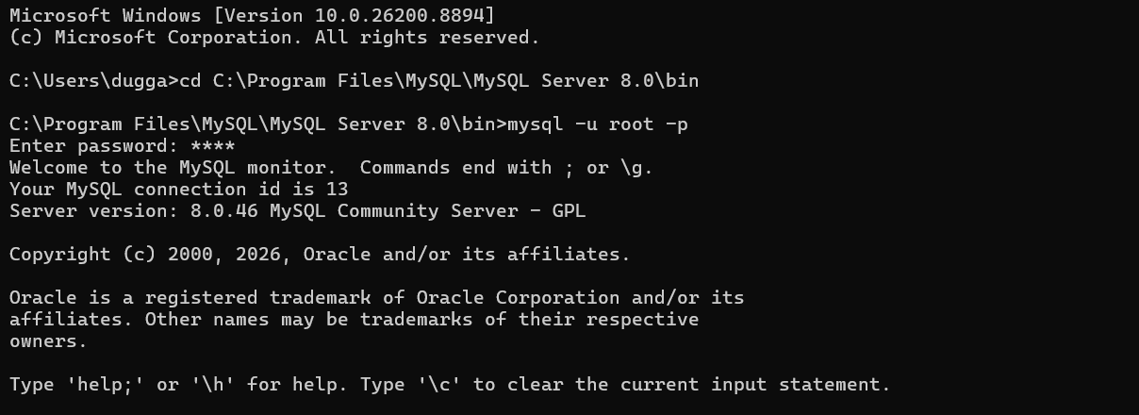

Step 1 — Create Database:
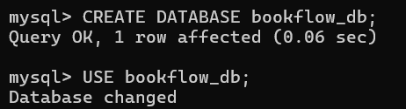
Step 2 — Create Books Table (DDL + Constraints):

Step 3 & 4 — Insert Books and Display:
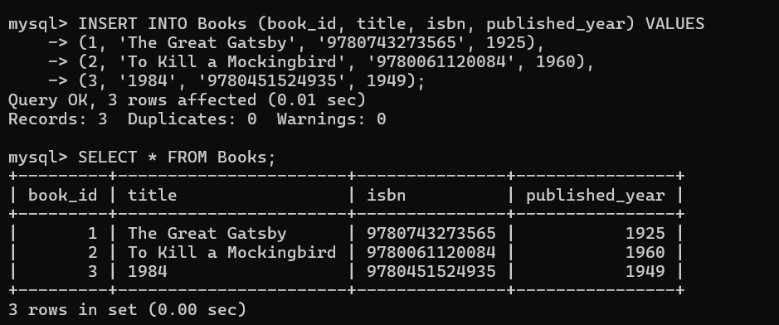

Step 5, 6 & 7 — Members Table: Create, Insert, Display:
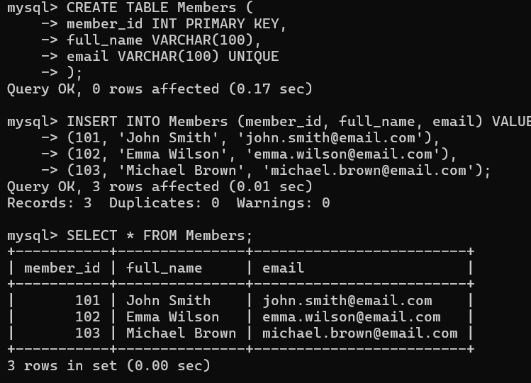

Step 8 — Create Loans Table (FOREIGN KEYS):
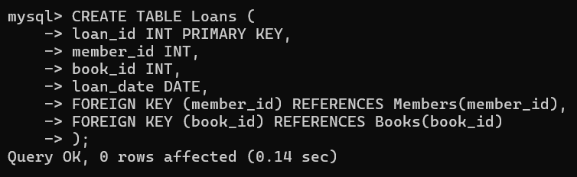
Step 9 & 10 — Insert 10 Loans and Display:
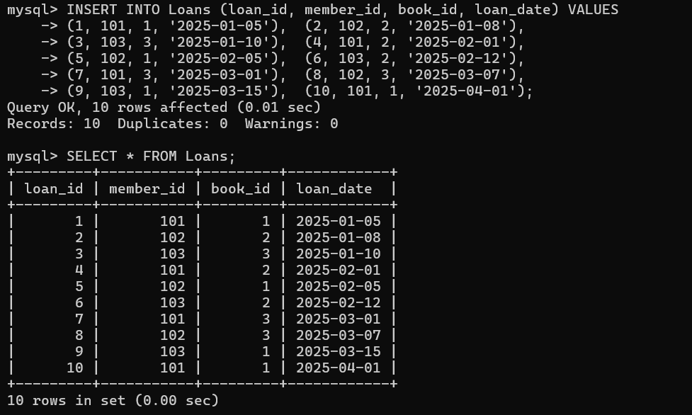

Step 11 — JOIN Query (Who Borrowed What):
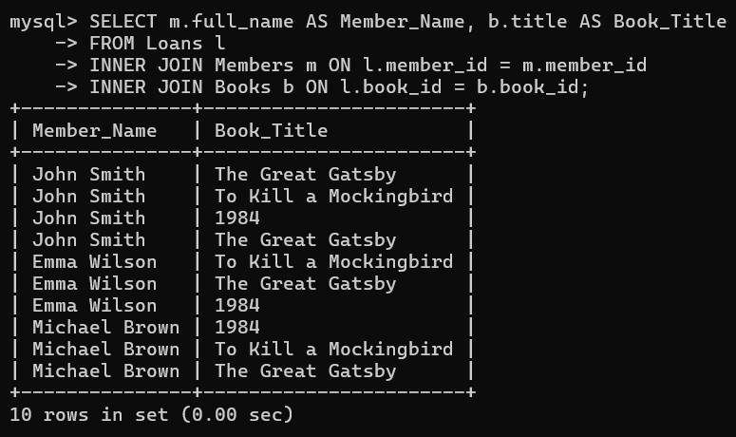
Step 12 — GROUP BY Query (Books per Year):
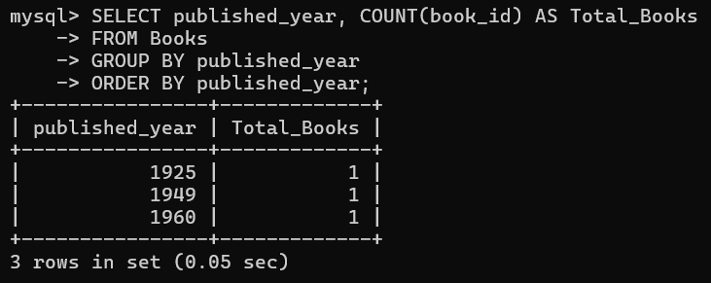

Step 13–16 — Donation via TRANSACTION (Atomicity):
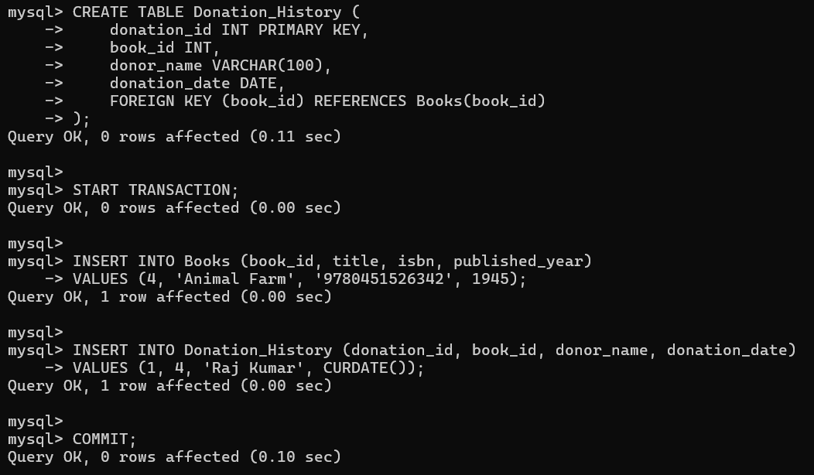
Step 17 & 18 — Index on ISBN + Fast Search:
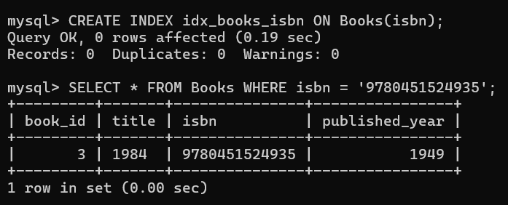

Final State of All Tables:
Books
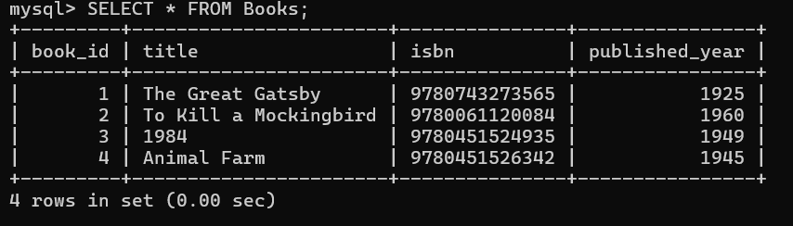
Members
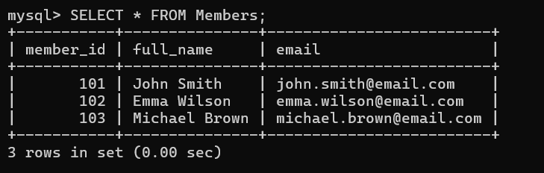
Loans
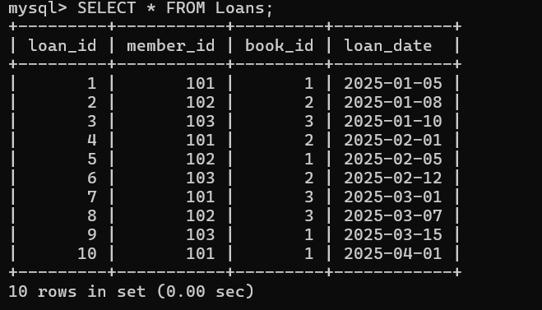
Donation History
