

Public Safety Communications Research

Architecture & Software Design

<System ID: ITT-ASD>

ISSI Test Tools

Version 1.2

May 27, 2009

Table of Contents

1 Table of Contents 2
2 List of Figures 3
3 List of Tables 4
4 Introduction 5
5 Intended Audience 5
6 Requirements 5
7 ISSI Test Tools Architecture 7
7.1 Conformance Test System 7
7.2 Trace and Performance Analyzer 10
8 ISSI Test Tools Design 10
9 ITT Deployment 12
10 ITT Configuration 13
10.1 Daemon Properties 13
10.2 Startup Configuration 13
10.3 Tester Topology 13
10.4 Test Suites 14
10.5 Test Topology 14
10.6 Test Script 14
10.7 Test Registry 14
10.8 Global Topology 14
10.9 System Topology 15
11 ITT User Interface 15
11.1 Conformance Tester GUI 15
11.2 Trace Analyzer GUI 16
12 ITT Classes 18
12.1 ISSI Conformance Tester 18
12.2 Trace Analyzer 22
12.3 P25 Stack 24
13 ITT Interfaces 26
13.1 External Interfaces 26
13.2 Internal Interface 27
14 ITT Output 27
15 User’s Guide 28
16 Feature Mapping 28

List of Figures

Figure 1: ITT Conformance Test System Architecture 7
Figure 2: Emulated RFSS Architecture 8
Figure 3: Trace and Performance Analyzer Architecture 10
Figure 4: Conformance Tester GUI 16
Figure 5: Trace Analyzer GUI 17
Figure 6: Conformance Tester UML Diagram 19
Figure 7: Trace and Performance Analyzer UML Diagram 22
Figure 8: P25 Stack UML Diagram 25

List of Tables

Table 1: Test Configuration External Interfaces 26
Table 2: Test Control External Interfaces 27
Table 3: Test Control Internal Interfaces 27
Table 4: User’s Guide 28
Table 5: Traceability Matrix 30

Introduction

The intent of this document is to describe the architecture and design of the ISSI Test Tools (ITT). ITT is a test framework for the system employing ISSI technologies. ITT consists of a distributed test system for conducting conformance test and a trace analysis tool to calculate performance parameters. The requirements of the ITT are defined in the ISSI specifications. The ITT architecture and software implementation based on the requirements will be described. The internal and external interfaces between the software modules will also be defined.

Intended Audience

The objectives of ITT are to facilitate conformance testing, subsystem interoperability testing, and performance testing of Radio Frequency Sub-systems (RFSS). The intended audience includes the researcher, developer, tester and designer of the systems employing the ISSI Technologies.

Requirements

The set of applicable standards documents that will be used as a basis for implementing the fundamental components of ITT are listed below. These documents were created by the standards body known as the Telecommunication Industry Association (TIA) TR-8.

- TIA-102.BACA-A (Project 25 Inter-RF Subsystem Interface Messages and Procedures for Voice Services)
- TIA-102.CACC (Project 25 Inter-RF Subsystem Interface Conformance Test Procedures)
- TIA-102.CACB (Project 25 Inter-RF Subsystem Interface (ISSI) Performance Recommendations for Voice Services)
- TIA-102.CACA (Project 25 Inter-RF Subsystem Interface (ISSI) Measurement Methods for Voice Services)
- TIA-102.BACA-2 (Project 25 Inter-RF Subsystem Interface Messages and Procedures — Addendum 2 — Trunked Console ISSI)
- TIA-102.CACB-1 (Project 25 Inter-RF Subsystem Interface Performance Recommendations for Voice Services — Addendum 1 — Trunked Console)
- TIA-102.CACA-1 (Project 25 Inter-RF Subsystem Interface Measurement Methods for Voice Services — Addendum 1 — Trunked Console)

In addition, the ISSI Test Tools are designed based on the requirements in:
- ISSI Test Tools – Software Analysis Requirements Process, Public Safety Communications Research, July, 2009.

ISSI Test Tools Architecture

[ASD-0700]
The ITT consists of Conformance Test System and Trace Analysis System. The conformance test system can be further classified either as distributed system and emulation system. The emulation system allows the conformance tests to be emulated in a standalone PC platform without the required implementations.

Conformance Test System

[ASD-0710]
The distributed architecture for conformance test system is shown in Figure 1.

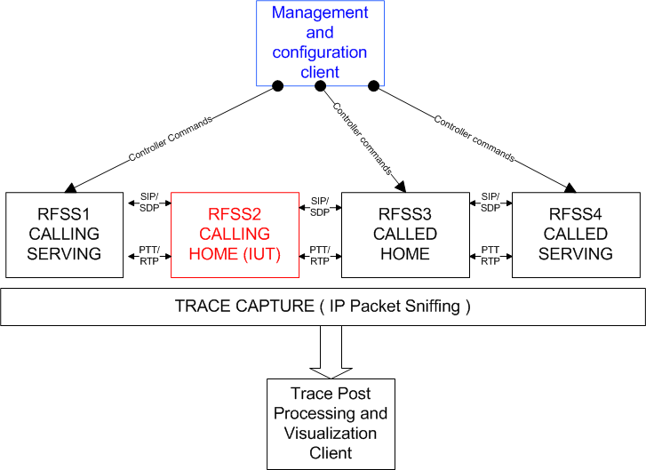

Figure 1: ITT Conformance Test System Architecture

This architecture depicts a central management and configuration client with multiple RFSSs, one of which can be the implementation under test (IUT). It is important to mention that the RFSS can be either an emulated RFSS or a real implementation (commercial RFSS). Only the emulated RFSSs can be configured using the controller commands via the management client. The RFSSs will interact with each others using the pre-defined internet protocols. In a conformance test, only one of the RFSSs can be a real implementation. While in subsystem interoperability test, more than one will be a real RFSS.

[ASD-0711]
As a special case, all RFSSs can be emulated in a single host running in standalone mode. Each emulated RFSS will be associated with same IP address with a unique port number.

The emulated RFSS architecture is shown in Figure 2.

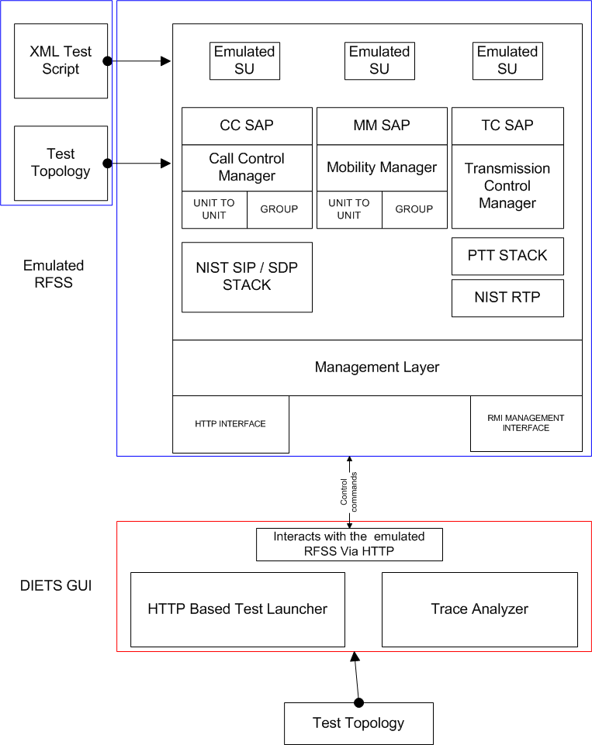

Figure 2: Emulated RFSS Architecture

[ASD-0712]
The GUI front-end serves as a test console to handle and process a user’s input. Based on test selection, it will communicate with the local and distributed emulated RFSS to load and run a given test scenario.

[ASD-0713]
The service access points (SAP) include the Call Control Manager, Mobility Manager, and Transmission Control Manager operating on top of the SIP and PTT/RTP protocol stacks.

Trace and Performance Analyzer
[ASD-0720]
The Trace and Performance Analyzer architecture is shown in Figure 3.

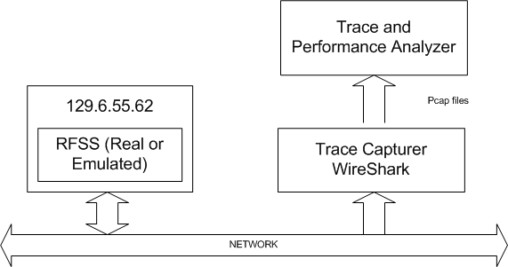

Figure 3: Trace and Performance Analyzer Architecture

For the system under test, the message traces can be captured using a popular network protocol analyzer such as WireShark into message files. The message files can be analyzed by the Trace and Performance analyzer. When the test is setup in accordance to the ISSI Performance Test Procedure, the performance parameters can also be calculated from the trace messages.

ISSI Test Tools Design

The ISSI Test Tools (ITT) consists of a set of software modules designed to emulate and test systems employing ISSI technologies. The objectives of ITT are to facilitate conformance testing, subsystem interoperability testing, and performance testing of a commercial ISSI contained in a Radio Frequency Subsystem (RFSS). It is also suitable to use the ITT during the research and development of ISSI compliant systems.

[ASD-0800]
Based on the requirements defined in the ISSI specifications, the ITT adopts the following existing technologies in its implementation:

Source Code Repository (https://p25-wireline.dev.java.net )
Subversion - Version control system (http://subversion.tigrid.org )
JUDE - Design and Communication tool (http://jude.change-vision.com )
IzPack - Package once, Deploy everywhere. (http://izpack.org )
ANT - Software build tool (http://ant.apache.org )
JDK 6 – software development (http://java.sun.com/javase/downloads/index.jsp )
Platform – Window XP and Linux (CentOS)

SIP stack (e.g. JAIN-SIP from NIST https://jain-sip.dev.java.net )
RTP stack (e.g. JRTP from NIST https://jrtp.dev.java.net )
Jetty web server for HTTP protocol (http://jetty.mortbay.org )
Jython embedded scripting capability (http://www.jython.org )
XMLBeans for XML manipulation (http://xmlbeans.apache.org )
WireShark network protocol analyzer (http://www.wireshark.org )
Jpcap - java library for capturing and sending network packets( http://netresearch.ics.uci.edu/kfujii/jpcap/doc/download.html )

[ASD-0801]
The JUDE, IzPack, ANT, and Subversion are tools used to create UML diagram, build, and package the ITT for deployment. Java will be the primary software development language.

[ASD-0802]
The JAIN-SIP is a widely used protocol in VOIP domains. The SIP protocol is determined to be appropriate for ITT.

[ASD-0803]
The JRTP, which is grown out of the ITT software development, is released and made available in java.net. The Push-To-Talk(PTT) protocol defined in the ISSI specification is implemented on top of the RTP stack.

[ASD-0804]
Jetty is an open-source, small-footprint web server component and servlet container suitable for a range of applications from embedded systems to clustered enterprise applications. Written in Java, developers can embed a Jetty container as an object, instantly adding network and web connectivity to a stand-alone Java app.

[ASD-0805]
Jython is a programming hybrid. It is an implementation of the Python scripting language written in 100% pure Java that runs under any compliant Java Virtual Machine (JVM). Jython is complementary to Java and is especially suited for the following tasks: embedded scripting, interactive experimentation, and rapid application development.

[ASD-0806]
XMLBeans is a technology that makes it incredibly easy for developers to access and manipulate XML data and documents in Java. XMLBeans provides an object-based view of the underlying XML data, without losing access to the original XML structure.

[ASD-0807]
WireShark, which is a very popular network protocol analyzer, can be used to capture network packets into pcap file. The pcap file will then be analyzed to evaluate the ISSI performance measurements. jpcap is a java library used in the Trace and Performance Analyzer to playback the captured network packets from pcap data file.

[ASD-0808]
The ITT software modules can operate in either distributed, standalone, or performance analysis modes. Once installed, these modules can be directly accessed from the desktop icons or the pull-down menu.

[ASD-0809]
In the distributed mode, the IUT can be a real RFSS or emulated (a different PC). The communication between the emulated RFSSs is performed by the HTTP protocol (using GET and POST method). A list of all conformance tests will be available. The reference traces can be generated for selected test and compared against the test traces.

[ASD-0810]
In standalone mode, all RFSSs are emulated by the same host using different ports. It is most useful to study RFSS behavior based on the request/response messages under different scenario. It is also cost effective to use the emulator in software development.

[ASD-0811]
The performance analysis allows the user to evaluate the performance of RFSS using the message traces (pcap file) captured by the WireShark. This module is kept as a separate module from the conformance test module in order to simplify the user interface. It also allows a third party ISSI system to be analyzed from the captured network traces. ISSI and CSSI performance analysis are supported.

ITT Deployment

[ASD-0901]
The ITT software is built by using ANT script and packaged by using the IzPack tool. The ITT source code is managed by Subversion under the java.net project repository. The complete source code can be obtained using the subversion. The installation jar file can also be downloaded from the java.net. Once installed, the ITT can be launched either from the desktop icon or the pull-down menu.

ITT Configuration

[ASD-1000]
The ITT configuration is encapsulated in either properties fie or an XML document. They can be created or modified by using an editor. In addition, these XML documents are defined by the DTD (located in the dtd directory) or by the XSD (located in the schema/xsd directory). Depending on the situation, the XML document is parsed by the corresponding XML parser or XMLBeans. In most cases, the XML documents are loaded, updated, persisted and distributed automatically through the web services in the application. A detailed description of the DTD is provided in the doc/dtddoc/index.html.

Daemon Properties
[ASD-1001]
The daemon properties, which is a standard java properties file, defines the IPaddress and port of the embedded HTTP server running in the localhost. The default HTTP port is 8763. The default IP address is initially assigned as 127.0.0.1 in the software distribution; it is updated to the actual IP address of the localhost. The properties filename is startup/diets.daemon.localhost.properties.

Startup Configuration
[ASD-1002]
The startup configuration, which is a standard java properties file, defines the test mode, daemon properties and the system topology to be used. There are two startup configurations: the startup/diets-standalone.properties for distributed mode and the startup/diets-emulator.properties for emulation mode of operation.

Tester Topology
[ASD-1003]
The tester topology, which is an XML document, defines all HTTP daemons physical properties including the IP address, port and operation mode. The tester topology is located in the testerconfig directory. Two unique files are available for distributed mode (testerconfig/standalone-configuration.xml) and emulation mode (testerconfig/emulator-configuration.xml) of operation.

Test Suites
[ASD-1004]
The test suites, which are a set of XML documents, are basically scripts for the conformance (testsuites/conformance) and emulation (testsuites/emulator) tests. Within each test subdirectory, the scripts are organized by test category and test cases (for example, group_call_setup_confirmed_successful). These special directory structures are referenced in the test registry.

Test Topology
[ASD-1005]
The test topology, which are a set of XML documents, are basically specialized scripts containing unique RFSS, group, and subscriber settings for each test case. For each test, there are one or more topology.xml files corresponding to each test profile and scenario. It can be viewed as a specialization of global topology. The document is test case and scenario dependent and located under the test case specific directory:
testsuites/conformance/testscripts/su_registration_failed/topology1.xml.

Test Script
[ASD-1006]
The test script, which is an XML document, defines the event-trigger asynchronous action for each test case. Events can include message arrivals and global time events. The scripting actions are specified using xml tags and their associated parameters. All call setup actions can be specified using tags. In addition, a fragment of jython code, which may invoke some java functions, can be executed as actions. The filename is: testsuites/conformance/testscripts/su_registration_failed/testscript.xml.

Test Registry
[ASD-1007]
The test registry, which is an XML document, summarizes all test cases currently available to users. It serves as a catalog of test cases. The detailed test description and procedures are provided for each test case. The filename is: testsuites/conformance/testscripts/testregistry.xml.

Global Topology
[ASD-1008]
The global topology, which is an XML document, defines the RFSSs and subscribers physical properties and their relationships in a test environment. It can be viewed as a specialization of the system topology. The filename is testsuites/conformance/testscripts/globaltopology.xml.

System Topology
[ASD-1009]
The system topology, which is an XML document, defines the RFSSs and the Wide Area Communication Networks (WACN) physical properties and their relationships. It also contains a boolean field to indicate whether the RFSS is emulated or real. The filename is testsuites/conformance/systemtopology.xml.

ITT User Interface
[ASD-1100]
User interaction is performed by the SWING Graphical User Interface. Java2D will be adopted to render the SIP/PTT traces. The main objectives are to: maximize the test topology information, minimize the data entry, automate the test setup, scenario loading, and test tear-down as well as the startup/shutdown of the embedded HTTP server.

Conformance Tester GUI
[ASD-1111]
The Conformance Tester console consists of a menu bar and four quadrants:
- Upper left quadrant for conformance test cases
- Upper right quadrant for test configuration and layout
- Lower left quadrant for SIP and PTT traces
- Lower right quadrant for trace annotations
- Menu bar to configure test options

A sample of the Conformance Tester console is shown in Figure 4.

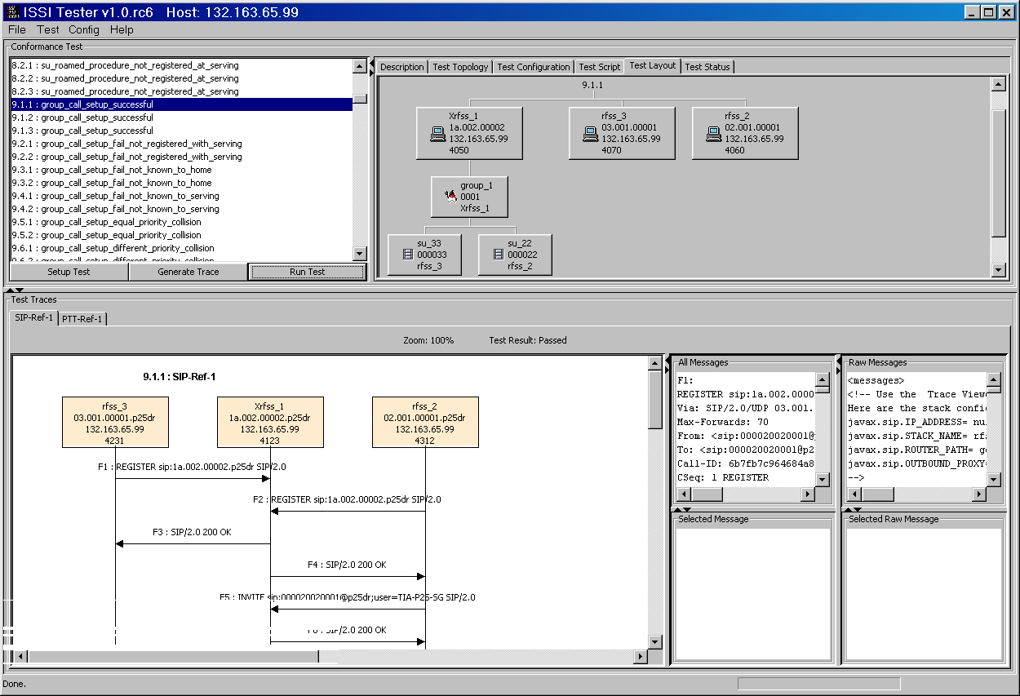

Figure 4: Conformance Tester GUI

[ASD-1112]
For a selected test case, the corresponding configuration and topology will be derived and presented for possible modification and update. Based on user input, the affected XML document will be updated and distributed automatically.

[ASD-1113]
Typically, user will setup test, generate reference trace, and run test using the buttons in the lower portion of the test case tree. Upon completion of testing or analysis, the results will be processed and presented to user in the graphical or tabular formats

Trace Analyzer GUI
[ASD-1121]
The Trace and Performance Analyzer console consists of a menu bar and two quadrants:
- Upper quadrant for auto-detected RFSS information
- Lower left quadrant for SIP and PTT traces
- Lower right quadrant for trace annotations
- Menu bar to analyze pcap file or performance analysis

A sample of Trace Analyzer console is presented in Figure 5.

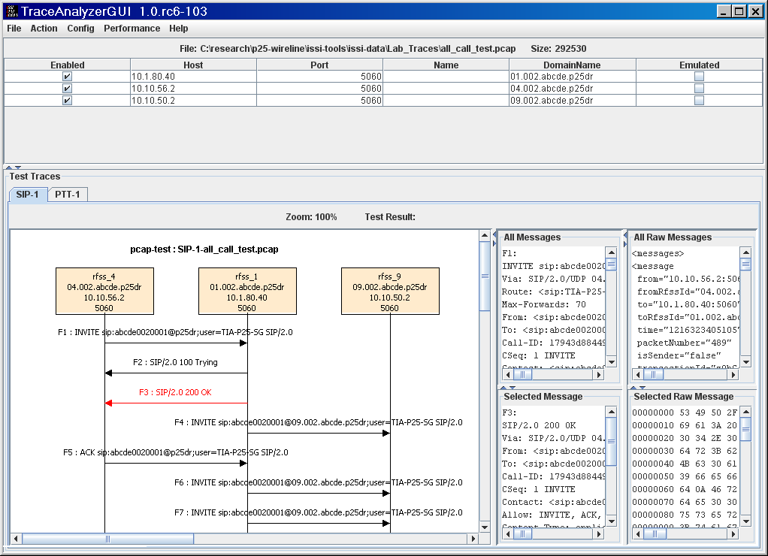

Figure 5: Trace Analyzer GUI

[ASD-1122]
For a given trace message file, the analyzer will auto-detect the participating RFSSs and present the endpoints information. The trace messages will be analyzed and displayed on demand.

[ASD-1123]
From the performance pull-down menu, the user can activate the setup menu for conducting the ISSI or CSSI performance analysis of multiple message files in an ensemble averaged fashion.

[ASD-1124]
The types of performance analysis include:
- Group Call Setup Delay (GCSD – confirmed or unconfirmed)
- Group Call Message Transfer Delay (GMTD)
- SU-to-SU Call Setup Delay (UCSD – direct call or availability check)
- SU-to-SU Call Message Transfer Delay (UMTD)

The delays specified in the TIA specifications can be recalled on demand.

ITT Classes

[ASD-1200]
The UML diagram of the ITT classes is developed using the JUDE tool. The documentation of these java classes is provided in the doc/javadoc/index.html.

ISSI Conformance Tester
[ASD-1210]
The UML diagram of the Conformance Tester is shown in Figure 4. The detailed class information (attributes and methods) can be visualized using the JUDE tool and doc/design/testerGUI.jude file.

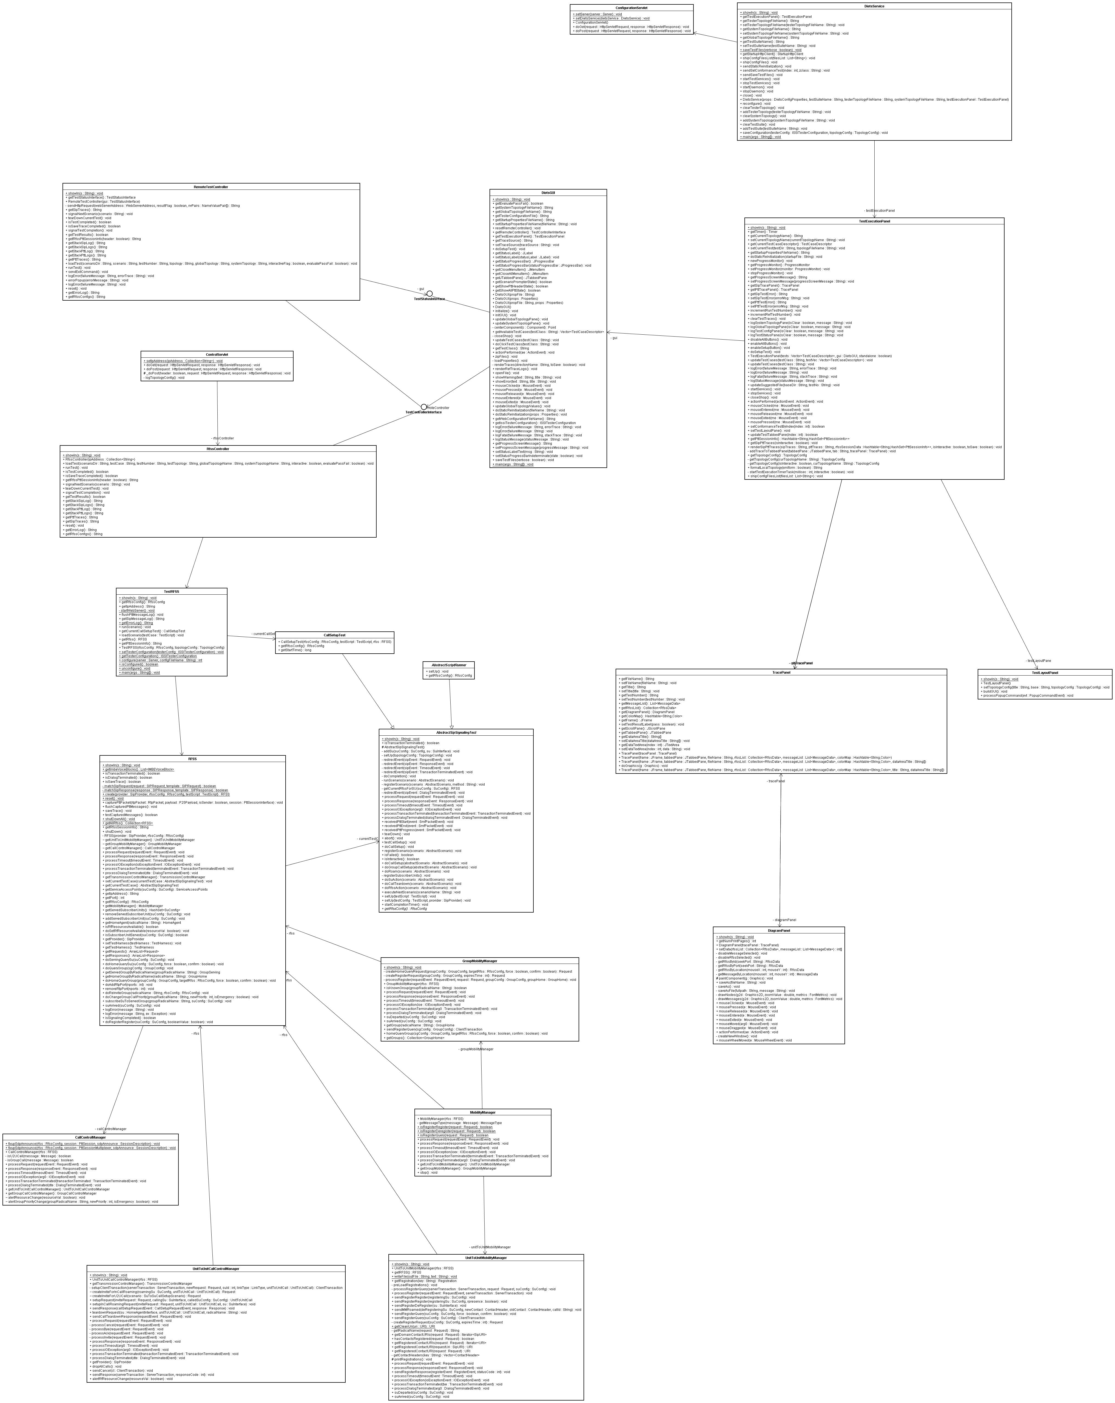

Figure 6: Conformance Tester UML Diagram

In this subsection, the main classes in the tester are described:

[ASD-1211]
The DietsGUI is the main class responsible for servicing the user interface of the conformance test execution in either distributed or standalone mode. It calls on the DietsService and TestExecutionPanel class to startup the interfaces and perform the test execution.

[ASD-1212]
The DietsService class encapsulates the startup and shutdown services of the Jetty webserver which provides the HTTP services to the application. The HTTP requests are to be serviced by the ConfigurationServlet.

[ASD-1213]
The TestExecutionPanel interacts with user to setup test configuration and initiates test execution by delegating to the appropriate test controller. Upon the completion of a test, it processes the SIP and PTT traces, analyzes the test results against reference traces, and derives a pass/fail test result.

[ASD-1214]
The TestControllerInterface (either the RemoteTestController in distributed mode or the RfssController in standalone mode) is responsible for loading and executing the test scenario using the services provided by the TestRFSS and RFSS classes. The TestRFSS is the test proxy wrapper class to load and run test scenario. It manages an instance of the HTTP server, SipProvider, RfssConfig, CallSetupTest and RFSS. The RFSS is the main class that encapsulates the behavior of an RFSS and performs the conformance test based on the specification defined in the test script.

[ASD-1215]
The TracePanel and DiagramPanel are the classes used to present the analysis results to end user. The results will include the SIP and PTT messages, message annotations, and the conformance test status. The panel also provides a mean to save the results to a file on demand.

[ASD-1216]
The TestRFSS is the test proxy wrapper class. For a given test case, the HTTP server is first started. The requests are to be serviced by the ControlServlet. The test case is launched by invoking the loadScenario and runScenario methods. When loading a test, an instance of RFSS and CallSetupTest are instantiated. Upon the completion of test, the test results can be retrieved by the getSipMessageLog, getPttSessionInfo, and getErrorLog methods.

[ASD-1217]
The RFSS is the RFSS emulation class. It provides functions for the management interface. It registers a SIP listener and receives SIP Events via the SIP listener. It classifies the request/response event type of the incoming SIP request and directs these to appropriate handlers. It has an instance of MobilityManager, CallControlManager, and TransmissionControlManager to service the incoming SIP messages.

[ASD-1218]
The CallSetupTest inherits from the AbstractSipSignalingTest class which in turn inherits from the TestCase class. The AbstractSipSignalingTest which implements the SipListener and SmfRxListener classes, provides the API to setup the test topology, register scenario, run scenario, add subscriber, do call setup, do roam, and tear down test.

[ASD-1219]
The CallControlManager serves as a back-to-back SIP user agent. It handles all SIP INVITEs, SIP responses to INVITEs, ACKs, BYEs etc. In addition, it interacts with the TransmissionControlManager to setup RTP ports on which to listen and modify the SDP announce for media stream.

The TransmissionControlManager, which also serves as the RTP listener, manages the RTP sessions. When an RTP packet arrives, it finds the corresponding point-to-multipoint session to forward the packet for processing.

The MobilityManager classifies the type of incoming message and delegates to either the GroupMobilityManager or the UnitToUnitMobilityManager for processing.

The ConfigurationServlet and ControlServlet classes are responsible for servicing the HTTP requests to configure a test and control RFSSs. The detailed interfaces are described in the Section 13.

Trace Analyzer
[ASD-1220]
The UML diagram of the Trace and Performance Analyzer is shown in Figure 5. The detailed class information (attributes and methods) can be visualized using the JUDE tool and doc/design/analyzerGUI.jude file.

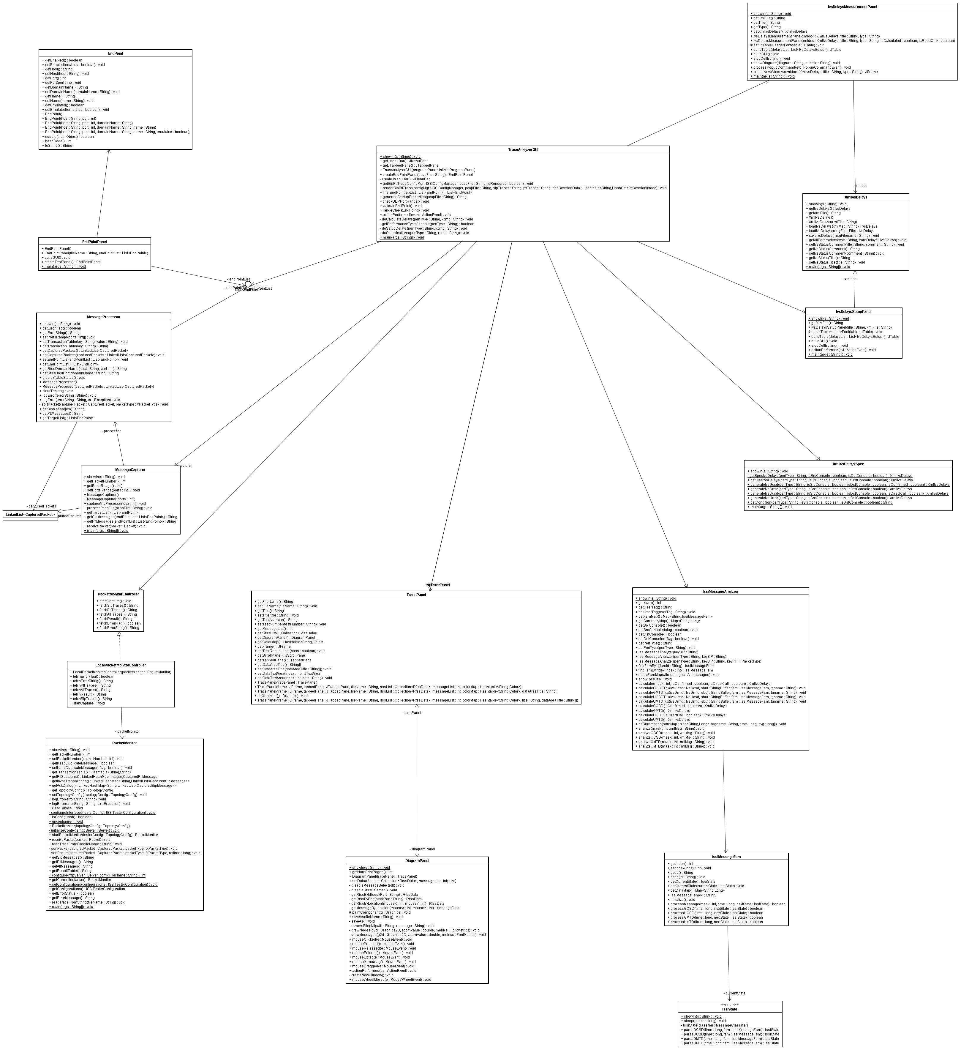

Figure 7: Trace and Performance Analyzer UML Diagram

In this subsection, the main classes in the analyzer are described:

[ASD-1221]
The TraceAnalyzerGUI is the main class responsible for the trace and performance analysis of messages captured in the pcap file. It performs auto-detection of the identification of RFSSs from traces. It filters, sorts and renders the SIP and PTT traces after the analysis.

[ASD-1222]
The MessageCapturer implements the jpcap’s PacketReceiver interface to receive the packet from the pcap data file and delegates the packet to MesaageProcessor class for processing. The processor analyzes the traces to filter and detect any valid RFSS endpoints. The auto-detected endpoints are subsequently returned for further processing.

[ASD-1223]
The EndPointPanel class is used to display the EndPoint list representing the RFSS detected from the trace messages. The EndPointPanel is also responsible for accepting the user modifications of the RFSS attributes such as host, port and name, which will be displayed in the trace diagram.

The TracePanel and DiagramPanel classes developed in the Conformance Tester are being reused to display the message traces.

[ASD-1224]
The LocalPacketMonitorController implements the PacketMonitorController interface by using the PacketMonitor class. The PacketMonitor, which is a super MessageCapturer, is designed to capture, analyze, and service the HTTP requests of SIP and PTT traces. Note not all the capabilities of the PacketMonitor are used in the application.

[ASD-1225]
The XmlIvsDelays class encapsulates the ISSI Voice Services (IVS) Delays for group call setup, group call message transfer, SU-to-SU call setup, and SU-to-SU call message transfer. The XmlIvsDelaysSpec class defines the IVS delays recommended by the specification TIA-102.CACB.

[ASD-1226]
The IvsDelaysSetupPanel is used to setup and modify the delay default values to be used in the performance analysis. The IvsDelaysMeasurementPanel is used to display the results of the performance analysis based on the traces from the pcap files.

[ASD-1227]
The IssiMessageAnalyzer is a class for calculating the IVS delays using the IssiMessageFsm and IssiState classes. The IssiMessageFsm class is the finite state machine. The IssiState class defines the states of the ISSI messages and the corresponding actions when state changes.

P25 Stack
[ASD-1230]
The P25 stack encapsulates the PTT protocol. The P25Payload class, which encapsulates the ISSI messages, is shown in Figure 8. It is intended to be an introduction of P25 payload components instead of being exhaustive. All relevant P25 payload classes are grouped under the gov.nist.p25.issi.p25payload and gov.nist.p25.issi.p25body packages.

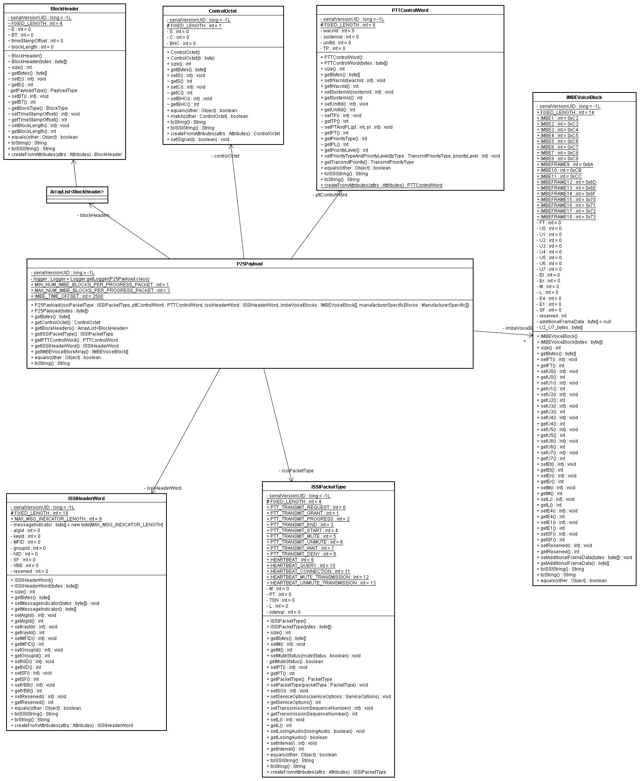

Figure 8: P25 Stack UML Diagram

[ASD-1231]
The P25Payload class contains one or more P25 block objects such as ControlOctet, BlockHeader, ISSIPacketType, PTTControlWord, and an array of IMBEVoiceBlock as defined in TIA-102.BACA. A detailed description of these classes can be found in the doc/design/p25payload.jude file.

ITT Interfaces

External Interfaces
[ASD-1301]
The ITT console (DietsGUI class) instantiates two interfaces for internal and external communication during the startup. The interfaces are typically used for test setup and control. The HTTP protocol is provided by the embedded Jetty web server. Both the GET and POST methods are supported.

Test Configuration: http://host:port/diets/controller

Command | Arguments | Output
startServices | testerDaemonTopology=testerconfig/emulator-configuration.xml | none
stopServices | none | none
setConformanceTest | testIndex=36  testClass=Conformance | none
saveTestFiles | none | none
getGlobalTopology | none | xml
getSystemTopology | none | xml
getTesterConfig | none | xml

Table 1: Test Configuration External Interfaces

The ConfigurationServlet class will service all these test configuration requests.
For example, to retrieve global topology, the GET request will be:

http://hostname:8763/diets/controller?command=getGlobalTopology

RFSS Control: http://host:port/rfss/control

Command | Arguments | Output
load | scenarioDir=testsuites/emulator/testscripts  testCase=su_registration_successful/testscript.xml  testNumber=4.2.1  topology=su_registration_successful/topology.xml  globalTopology=testsuites/emulator/globaltopology.xml  systemTopology=testsuites/emulator/systemtopology.xml | none
tear-down-test | none | none
run | none | none
isTestCompleted | none | True  or  False
Exit | none | none
getTestResults | none | Passed  or  Failed
getRfssConfig | none | xml
getRfssStatusInfo | none | xml
getSipTrace | none | xml
getPttTrace | none | xml
getErrorLog | none | xml

Table 2: Test Control External Interfaces

The ControlServlet class will service all these RFSS control requests. For example, to retrieve the SIP trace from the current test run, the GET request will be:

http://hostname:8763/rfss/control?command=getSipTrace

Internal Interface
[ASD-1302]
The TestExecutionPanel class will use these internal interfaces to initialize and refresh its internal states and configurations.

Command | Arguments | Output
updateConfigurationFile | fileNameToUpdate=file-list | none
staticReinitialization | startupFile=startup/diets-standalone.properties | none
redraw | startupFile=startup/diets-standalone.properties | none

Table 3: Test Control Internal Interfaces

The ConfigurationServlet class will service all these test configuration requests.

ITT Output

[ASD-1401]
The ITT software modules conduct conformance tests, render the SIP and PTT traces, and derives a pass/fail test result. The ITT output typically includes the graphical traces display, human readable form of the traces, and tabular tables. All output can be saved to files on demand.

User’s Guide

[ASD-1501]
The user’s guide can be accessed in the tool using the pull-down menu or directly from the HTML pages.

ITT Tool | Pull-down Menu | HTML Page
Conformance Tester | Help → Documentation | doc/documentation.html
Trace Analyzer | Help → Documentation | doc/tadocumentation.html

Table 4: User’s Guide

Feature Mapping
[ASD-1601]
The following table shows the relationship between TIA specifications, the high level ITT software requirements and the ITT Architecture & Software Design. In certain cases, the ITT high level software requirements do not correlate to a TIA specification. The grey boxes in the TIA specification column of the table indicate the no correlation condition.

TIA Specification | High Level ITT Software Requirements (This Document) | Description of High Level Requirement | ITT Software Architecture & Details Design Requirements
 | SRQ 101-102 | SIP Stack | ASD-0711  ASD-0802
TIA-102.BACA-A, Section 3 | SRQ 103 | SIP Stack | ASD-1230  ASD-1231
TIA-102.BACA-A, Section 6 | SRQ 104  SRQ 204 | SIP & RTP Stack | ASD-1219  ASD-1231
TIA-102.BACA-A, Section 5 | SRQ 105 | SIP Stack | ASD-1219 to  ASD-1231
 | SRQ 201-202 | RTP Stack | ASD-0711  ASD-0803
TIA-102.BACA-A, Section 4 | SRQ 203  SRQ 302 | RTP & PTT Stack | ASD-1231
 | SRQ 301 | PTT Stack | ASD-0711  ASD-0803
TIA-102.BACA-A, Section 7 | SRQ 303 | PTT Stack | ASD-1231
 | SRQ 401  SRQ 402 | External Interfaces | ASD-1301
 | SRQ 501 - 503 | Internal  Interfaces | ASD-1302
TIA-102.CACC | SRQ 601 - 603 | ISSI Conformance Test Case Engine | ASD-1004  ASD-1007  ASD-1111
 | SRQ 604 - 616 | ISSI Conformance Test Case Engine | ASD-1210 to  ASD-1219
 | SRQ 701 - 732 | GUI - Conformance | ASD-0901  ASD-1111  ASD-1112  ASD-1113
 | SRQ 801 - 808 | ITT Output - Conformance | ASD-1401
 | SRQ 901 - 929 | Trace Analyzer | ASD-1121  ASD-1220
 | SRQ 1001 – 1006  SRQ 1008  SRQ 1010  SRQ 1012  SRQ 1014  SRQ 1016  SRQ 1018  SRQ 1019  SRQ 1021  SRQ 1023  SRQ 1025  SRQ 1027  SRQ 1029  SRQ 1030 | ISSI Performance Test Case Engine | ASD-1220 to  ASD-1227
TIA-102.CACB | SRQ 1007  SRQ 1009  SRQ 1011  SRQ 1013  SRQ 1015  SRQ 1017  SRQ 1020  SRQ 1022  SRQ 1024  SRQ 1026  SRQ 1028 | ISSI Performance Test Case Engine | ASD-1225 to  ASD-1227
TIA-102.CACA | SRQ 1031 - 1036 | ISSI Performance Test Case Engine | ASD-1226
 | SRQ 1101 – 1107  SRQ 1109  SRQ 1111  SRQ 1113  SRQ 1115  SRQ 1117  SRQ 1119  SRQ 1120  SRQ 1122  SRQ 1124  SRQ 1126  SRQ 1128  SRQ 1130  SRQ 1131 | Trunked Console Performance Test Case Engine | ASD-1220 to  ASD-1227
TIA-102.CACB-1 | SRQ 1108  SRQ 1110  SRQ 1112  SRQ 1114  SRQ 1116  SRQ 1118  SRQ 1121  SRQ 1123  SRQ 1125  SRQ 1127  SRQ 1129 | Trunked Console Performance Test Case Engine | ASD-1225 to  ASD-1227
TIA-102.CACA-1 | SRQ 1132 - 1137 | Trunked Console Performance Test Case Engine | ASD-1226
 | SRQ 1201 - 1210 | Operating Environment | ASD-0800
 | SRQ 1301 - 1308 | User’s Guide | ASD-1501
 | SRQ 1401 | Prioritization of ITT Requirements for Implementation | N/A

Table 5: Traceability Matrix

