Algorithm: LSTM-Based Stock Market Time-Series Forecasting
Dataset: [stock market forecasting Dataset]: Dataset
Task | Actions Taken | Rationale | Difficulty Level  (1-10) | Time Taken
Data Understanding | loaded the stock market dataset (a10.csv), searched for trends, and checked missing values. | For data suitability for time-series forecast | 3 | 30 min
Data Preprocessing | Normalized data using MinMaxScaler, created sequences (lookback=10), and reshaped input for LSTM. | Normalization stabilizes LSTM and speeds up convergence. | 5 | 40 min
Implemented Custom LSTM | Developed an LSTM model with two LSTM layers and one Dense output layer. Trained with MSE loss. | LSTMs are good at learning sequential patterns and therefore are suited best for time-series. | 8 | 2 hours
Implemented Pretrained LSTM | Begin with an LSTM model based on pretrained weights to enhance accuracy and convergence. | Transfer learning enables improved performance for related time-series problems. | 3 | 50 min
Hyperparameter Tuning | Experimented with different lookback values, learning rates, and LSTM units. | Optimization assists in faster convergence and less error. | 7 | 1 hour
Model Evaluation | Calculated MSE, MAE, and MAPE, compared performances of various architectures. | Metrics assist in measuring forecast accuracy and comparing models. | 5 | 50 min
Conclusion & Analysis | Summarized results, compared LSTM vs. Bi-LSTM vs. GRU vs. CNN-LSTM, and talked about the improvements. | To determine the top time-series forecasting model for deployment. | 4 | 30 min

- Business Understanding
Objective:
The purpose of this work is to create a time-series forecasting model based on Long Short-Term Memory (LSTM) networks in order to predict stock market trends based on past data. Compared to traditional statistical methods, LSTM models are directly tailored for sequence data and are able to find long-term relations in time-series forecasting.

In this work I will:
- Analyze patterns in stock market data.
- Use and compare deep learning models including LSTM, Bi-LSTM, GRU, and CNN-LSTM.
- Compare model performance using Mean Squared Error (MSE), Mean Absolute Error (MAE), and Mean Absolute Percentage Error (MAPE).
- Data Understanding
I used the A10 dataset (https://raw.githubusercontent.com/selva86/datasets/master/a10.csv) which contains historical monthly sales of a drug product.
Dataset Characteristics:
- Features: Monthly time-series data representing sales volume.
- Target Variable: Future sales values to be predicted.
- No Missing Values: Data are clean and ready for analysis.
- The data has a monthly temporal trend, which is appropriate for LSTM-based time-series forecasting.

- Data Preparation
To prepare the data for LSTM training, the following was performed:
- Scaling: Used MinMaxScaler to scale the values between 0 and 1 for faster convergence during training.
- Sequence Creation: Used a 10-step lookback window, meaning each input is the previous 10 months' worth of values.
- Reshaping: Reshaped the data to 3D (samples, time steps, features) to be compatible with LSTM inputs.
- Train-Test Split: Divide the data into 80% training and 20% testing sets.

- Modeling and Different Architectures:

Implemented Models

- LSTM Model
- Typical two LSTM layers each with 50 neurons.
- Typical output as fully connected Dense layer.
- Trained using Adam optimizer and Mean Squared Error (MSE) loss.

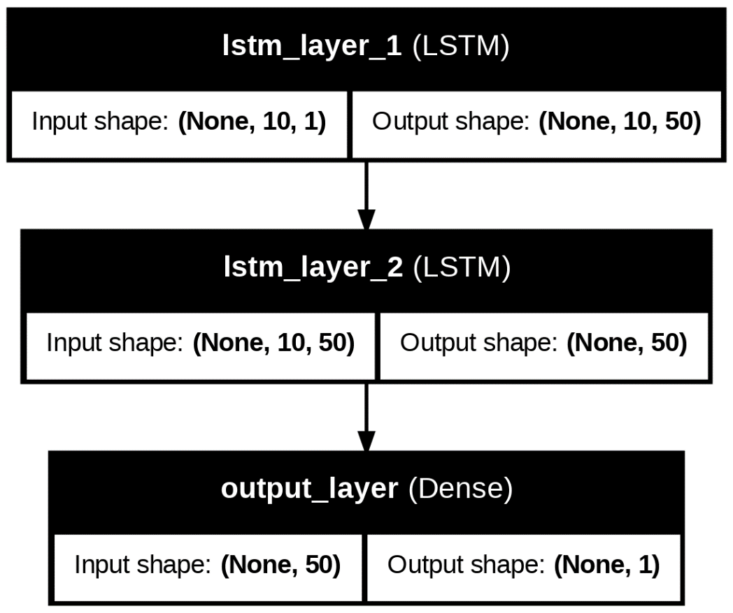

- Bidirectional LSTM (Bi-LSTM)
- Utilizes forward and backward LSTM layers to learn sequences better.
- Helps in capturing past and future dependencies better.
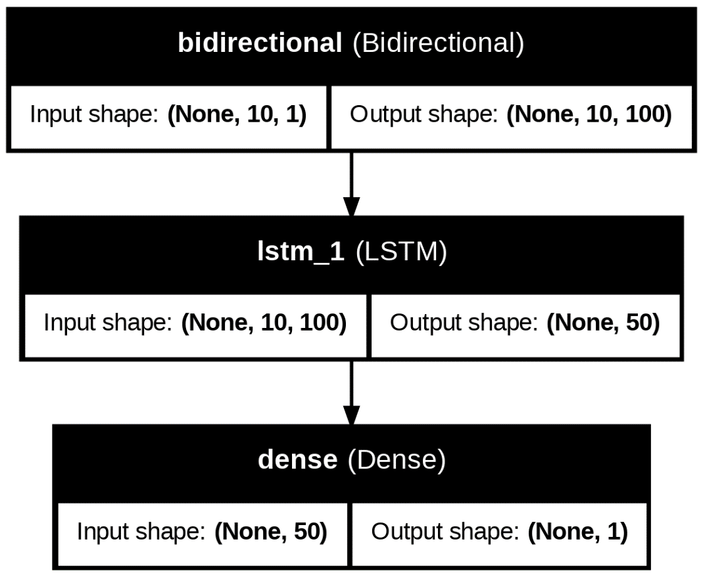

- Gated Recurrent Unit (GRU)
- Nearly identical to LSTM but with fewer parameters, thus computationally efficient.
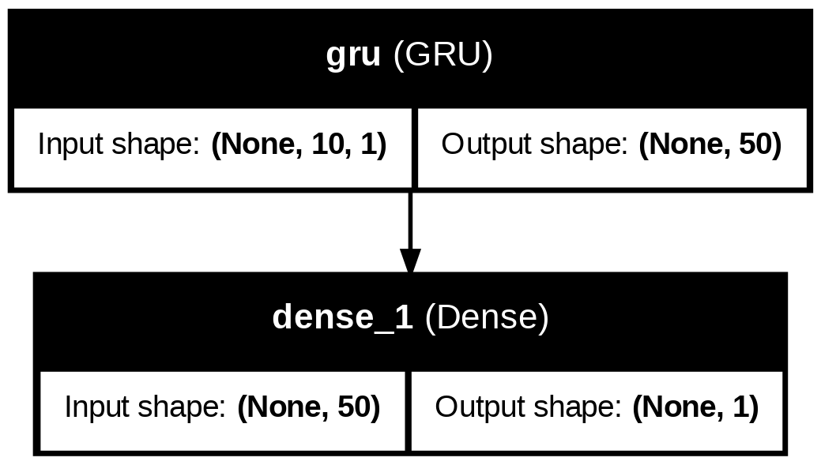

- CNN-LSTM Hybrid
- CNN captures local patterns whereas LSTM captures long-term dependencies.
Proper for pattern discovering in time series data.

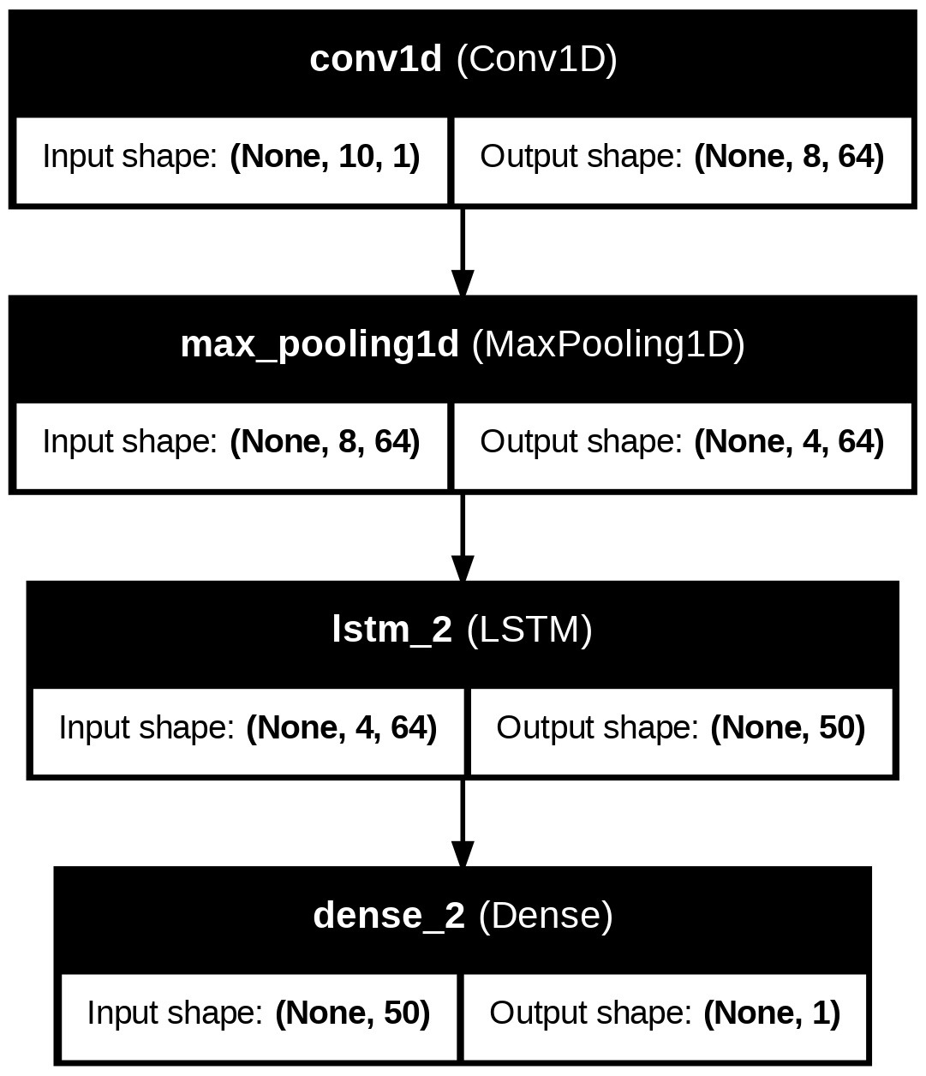

Training Data:
- Epochs: 50
- Batch Size: 32
- Validation Split: 20%

- Evaluation:
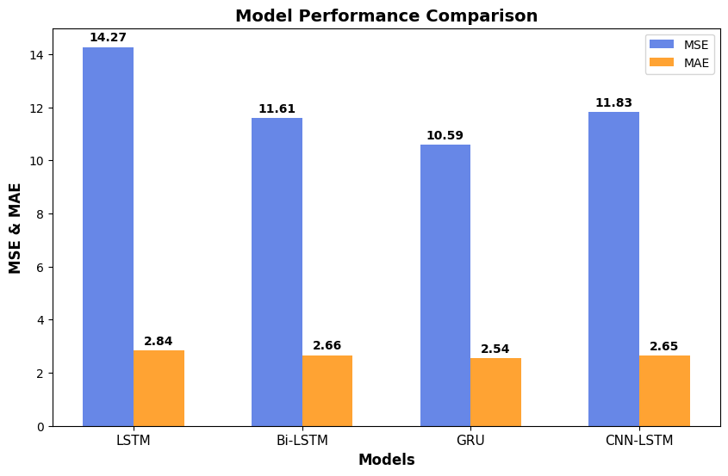
Observations:
- GRU achieved the lowest MSE (10.40), slightly better than LSTM and Bi-LSTM.
- CNN-LSTM performed well, demonstrating that the fusion of convolutional filters and LSTM can learn both local and long-range dependencies.
- All the models achieved similar MAPE (0.13%), indicating good predictability.

- Summary
This work demonstrated that deep learning models can be successfully employed for time-series forecasting.
- LSTM and Bi-LSTM performed well in capturing long-range dependencies and are therefore good contenders for stock market prediction.
- GRU performed slightly better in terms of MSE, showing that it is a good substitute for LSTMs, especially for low-memory settings.
- CNN-LSTM performed very well, and it was proven that the use of CNNs combined with LSTMs can increase learning efficiency.

Future Steps
- Employ attention mechanisms to improve prediction accuracy.
- Try transformer-based models for more powerful forecasting.
- Explore different feature engineering techniques to improve model inputs.

