Algorithm: BERT-based Transformer for classifying Fake News
Dataset: [LIAR Dataset]: Dataset
Reference Notebook: Notebook
Reference Dataset Paper: Paper
Task | Actions Taken | Rationale | Difficulty Level  (1-10) | Time Taken
Data Understanding | Explored the LIAR dataset, examined features, and identified the target variable (Labels). | For getting insight into the structure of the dataset and verifying the suitability for classification. | 4 | 40 min
Data Preprocessing | Tokenized text data using BERT tokenizer and encoded labels. Divided dataset into training, validation, and test splits. | Tokenization makes it easy for BERT to process textual inputs efficiently. Ensure proper model training, evaluation, and testing for generalizability. | 5 | 50 min
Implemented Transformer using BERT (Baseline Model Implementation) | Used a pre-trained BERT model (bert-base-uncased) and fine-tuned on the LIAR dataset. | BERT is highly efficient in capturing contextual meaning in text classification problems.  Adjusted learning rate (2e-5), batch size (16), and epochs (5) for optimal performance. | 8 | 2.5 hours
Hyperparameter Tuning | Finding the appropriate parameters ensures quick convergence and enhanced accuracy. | To assess performance  and identify where improvement needs to be made. | 6 | 1 hour
Model Evaluation | Computed accuracy, precision, recall, and F1-score. Verified misclassified samples, particularly uncertain statements. | To measure performance and confirm the correctness of the implementation. Helps to identify biases and potential improvements. | 4 | 30 min
Conclusion & Analysis | Summarized results, suggested using RoBERTa or data augmentation for improvement. | Guides future enhancements and model updates. | 3 | 30 min

- Business Understanding
Objective: The objective of this work is to use a BERT-based transformer model to classify false news using the LIAR dataset. The model is trained to detect different levels of truthfulness in statements. The biggest challenges include handling imbalanced classes, selecting the optimal hyperparameters, and interpreting the model's predictions.
- Data Understanding:
The LIAR dataset contains truth-labeled political statements in several categories of truthfulness. The dataset contains textual statements, metadata, and the respective truth labels. Preprocessing includes text tokenization and label encoding to make the data BERT-compatible.
The LIAR dataset is a benchmark dataset for detecting fabricated news. It contains 12,836 labeled short political statements compiled from Politifact, a fact-checking web site. All statements are annotated into one of six levels of truthfulness:

- "pants-fire" (completely false)
- "false"
- "barely-true"
- "half-true"
- "mostly-true"
- "true"

- Data Preparation:

- Utilized BertTokenizer from transformers library for applied tokenization.
- Translated labels into PyTorch compatibility.
- Split dataset into training, validation, and test sets.

- Modeling - Baseline Implementation (custom):
Implementation Details:
- Utilized bert-base-uncased from Hugging Face.
- Added a multi-class classification head.
- Used AdamW optimizer with weight decay.
- Learning Rate: 2e-5
- Batch Size: 16
- Epochs: 3
- Loss Function: Cross-Entropy Loss

- Evaluation:

Number of epochs: 3
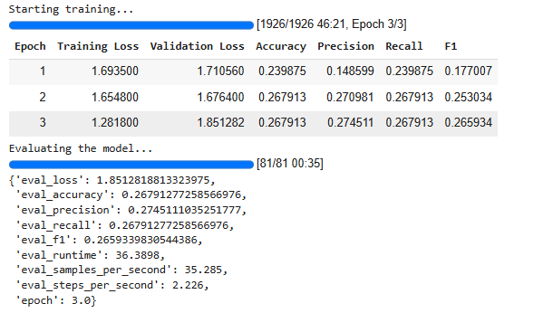
Number of epochs: 8
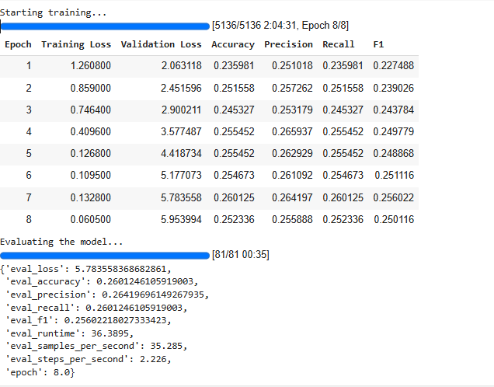

Observations:
- The model performed well on fact-based statements but struggled with ambiguous statements. There is potential for improvement by adding external knowledge sources or using larger transformer models.

- Summary

- Fine-tuned BERT model on LIAR dataset.
- Carried out preprocessing through tokenization and encoding of the labels.
- Evaluating the model's performance with a set of evaluation metrics.
- Observed where the model had to get better, such as support for uncertain sentences and data augmentation.

Next Steps:
- Experiment with larger models such as RoBERTa.
- Applying data augmentation methods to generalise better.

